|  |  |  |  |  |  |
| --- | --- | --- | --- | --- | --- |
| Name: | Roman Kovtun | DSI#: | D40685801 | Date: | 4/6/2019 |

**WEB375 Week 5 Lab Report—Configuring an Apache Server**

**Lab 5 Grading Rubric**

|  |  |
| --- | --- |
| **Category** | **Points** |
| Task A: Step 6: httpd server status | 10 |
| Task B: Step 5: accessing Apache remotely | 15 |
| Task C: Step 7: listing of virtual host index.html files | 15 |
| Task D: Step 1: accessing www.yourFirstName.com | 10 |
| Task D: Step 2: accessing www.yourLastName.com | 10 |
| Total | 60 |

**Task A: Step 6**

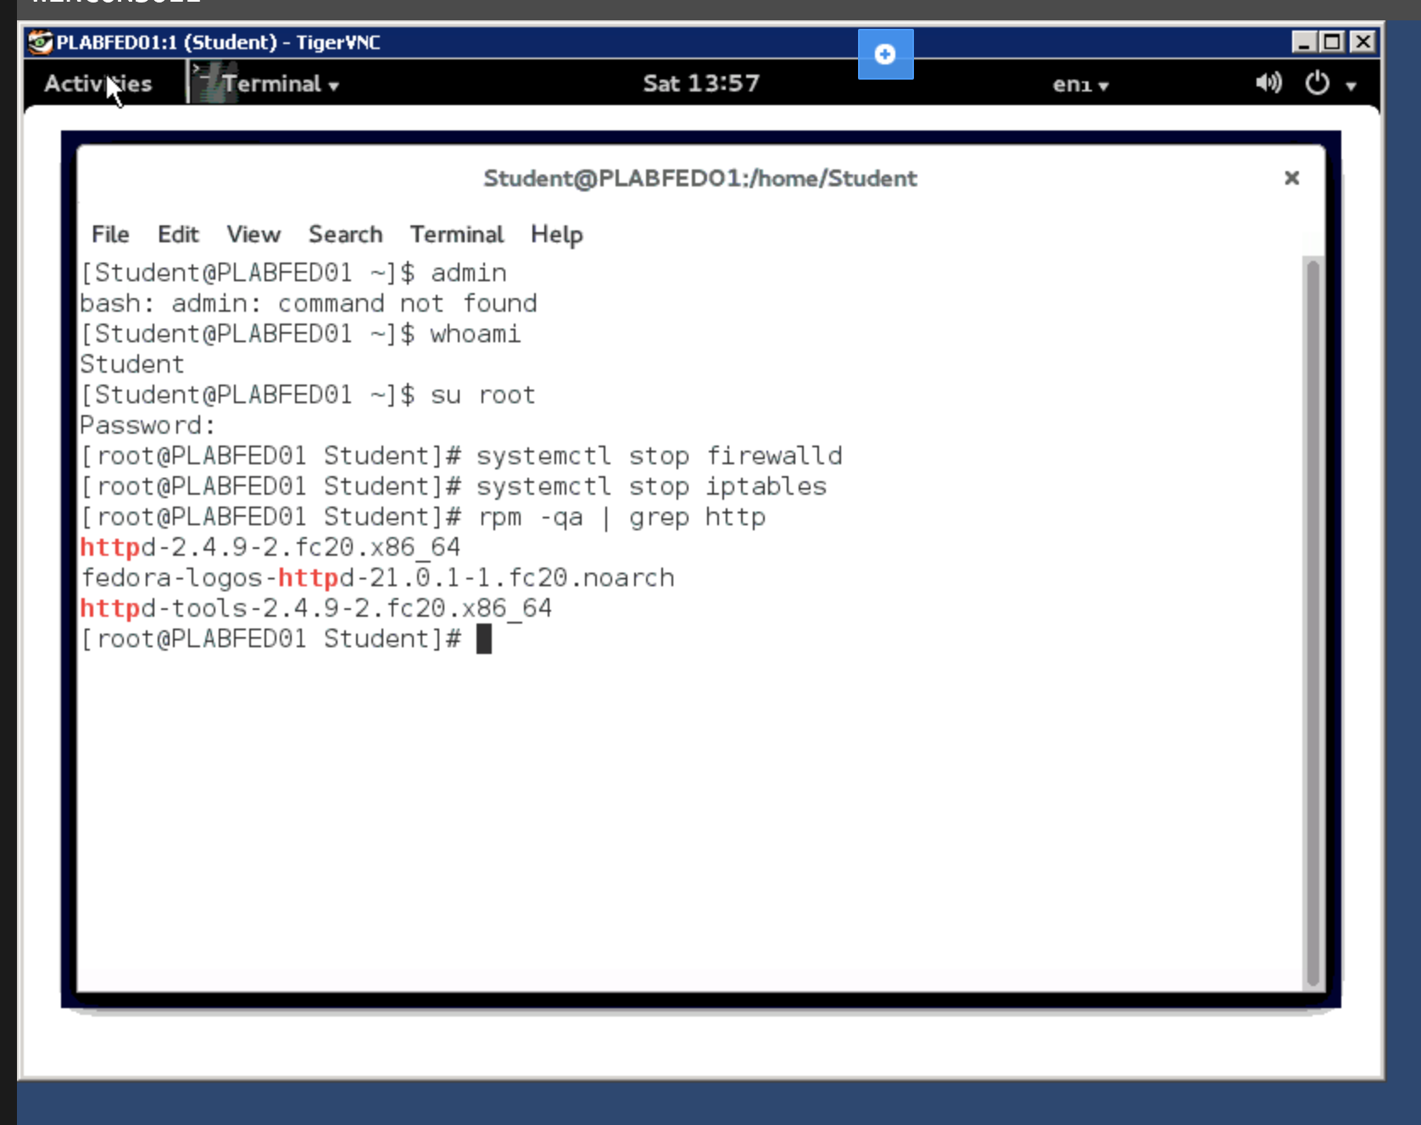

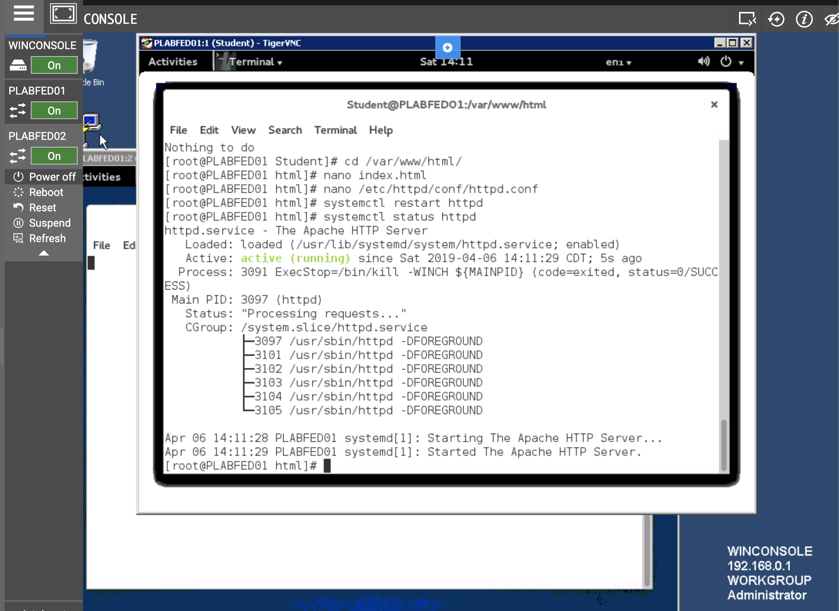

**Task B: Step 5**

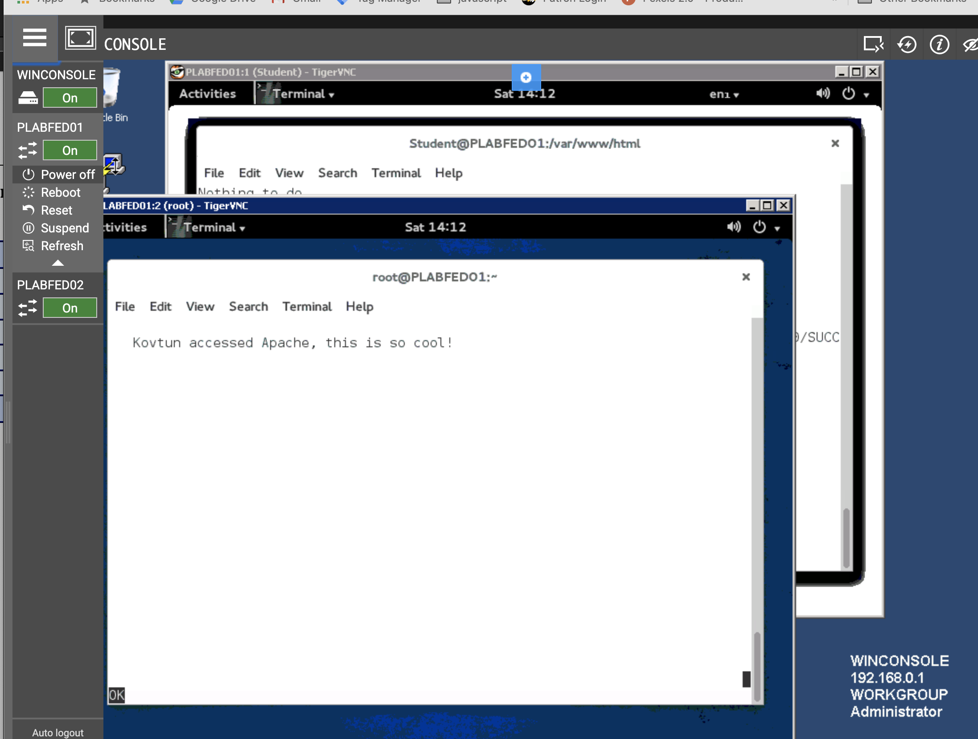

**Task C: Step 7**

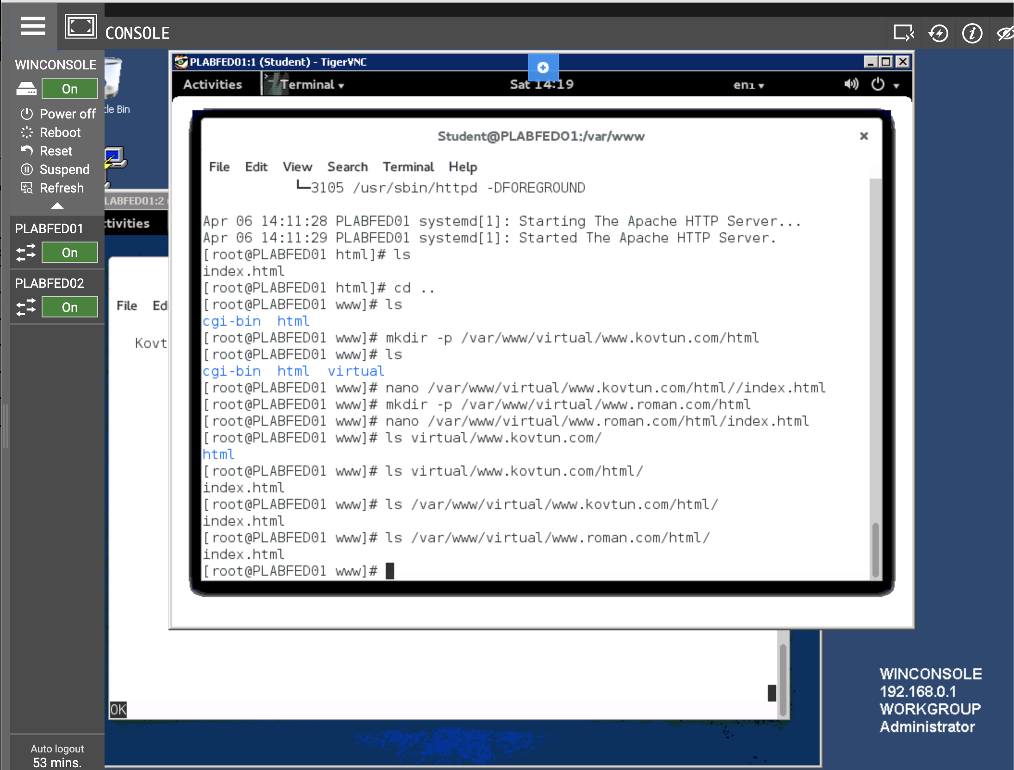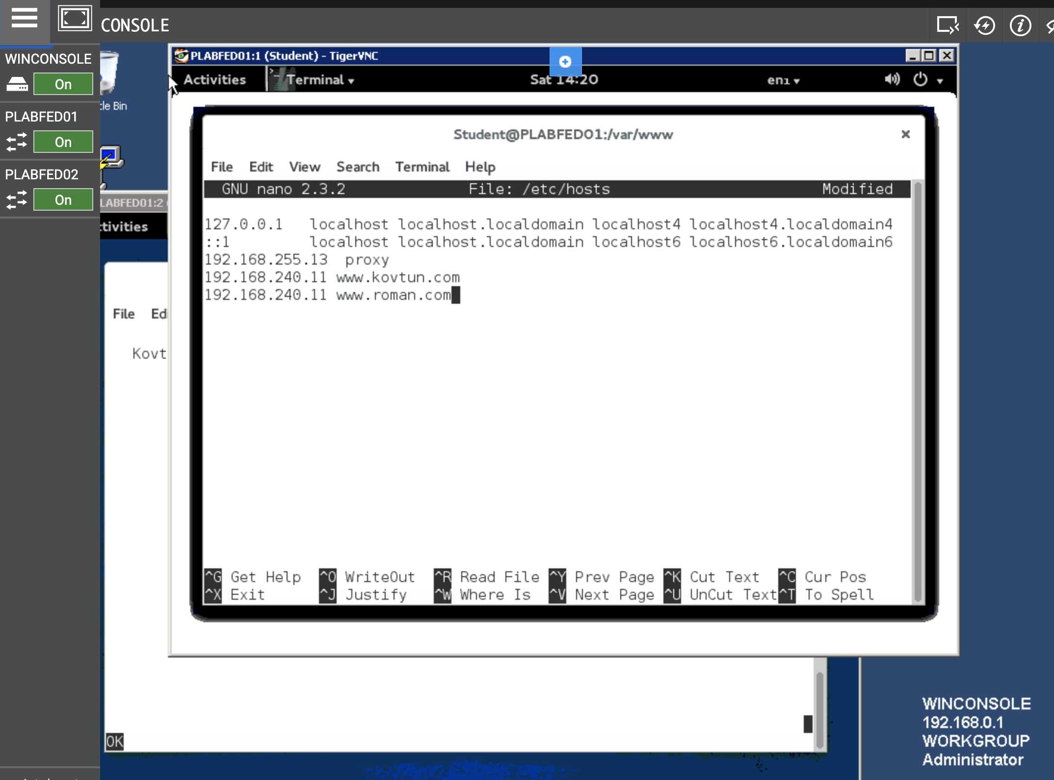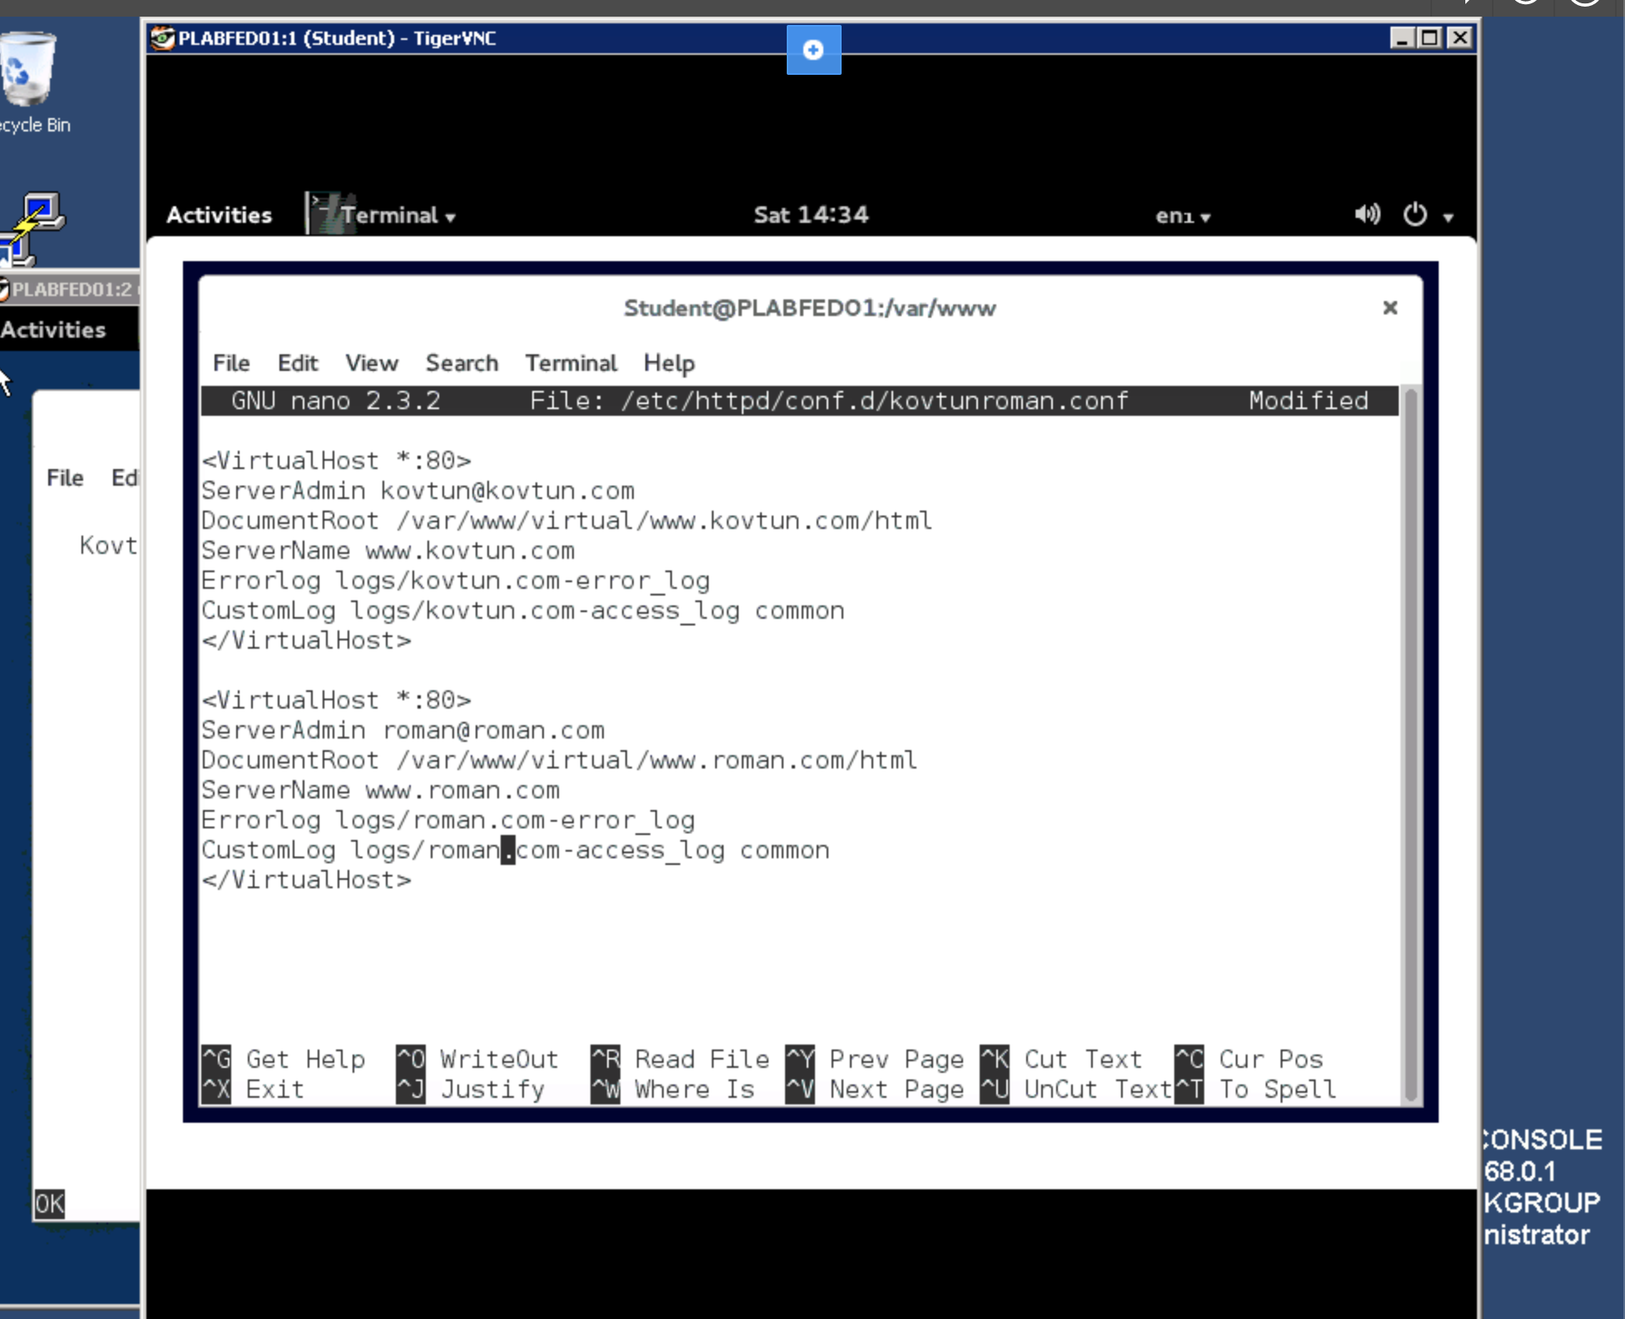

**Task D: Step 1**

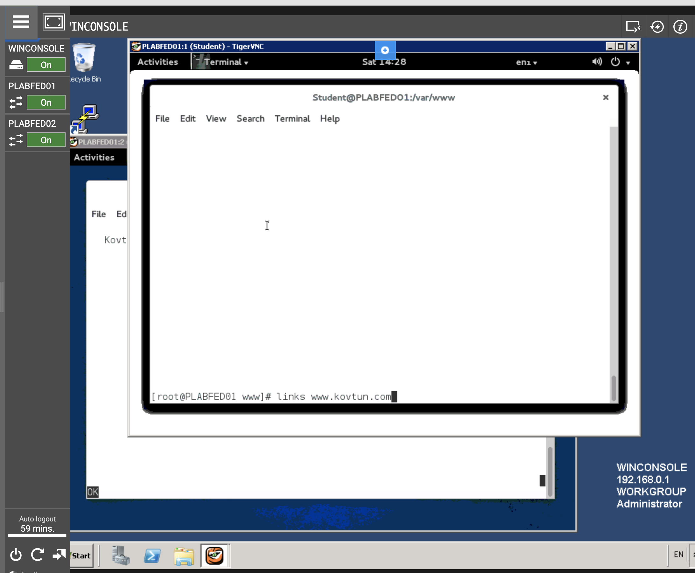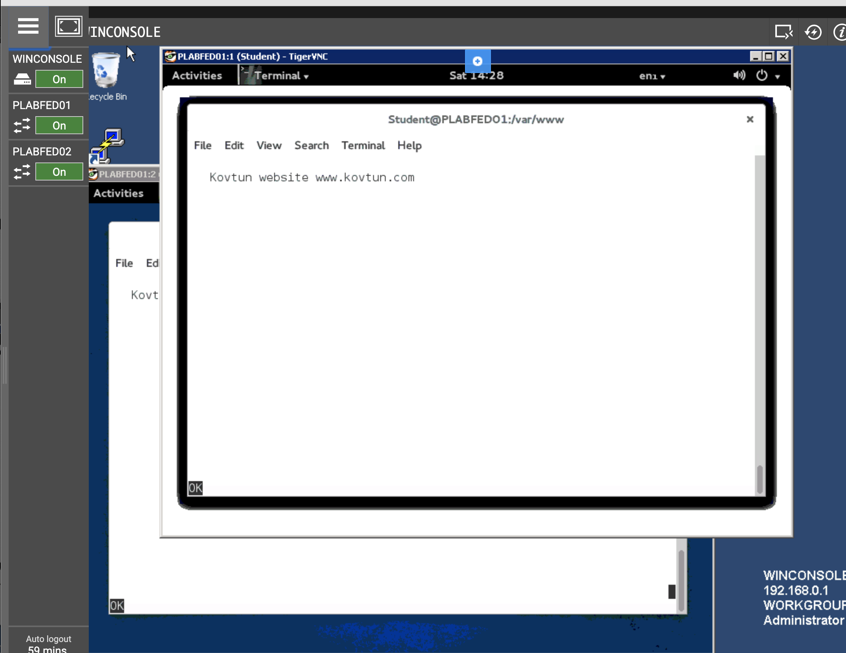

**Task D: Step 2**



