|  |  |  |  |  |  |
| --- | --- | --- | --- | --- | --- |
| Name: | Roman Kovtun | DSI#: | D40685801 | Date: | 04/13/2019 |

**WEB375 Week 6 Lab Report—Configuring a MYSQL Server**

**Lab 6 Grading Rubric**

|  |  |
| --- | --- |
| **Category** | **Points** |
| Task C: Step 1: MySQL Server status | 15 |
| Task C: Step 2: root login to server | 15 |
| Task C: Step 3: database listing | 15 |
| Task C: Step 4: Employees table listing | 15 |
| Total | 60 |

**Task C: Step 1**

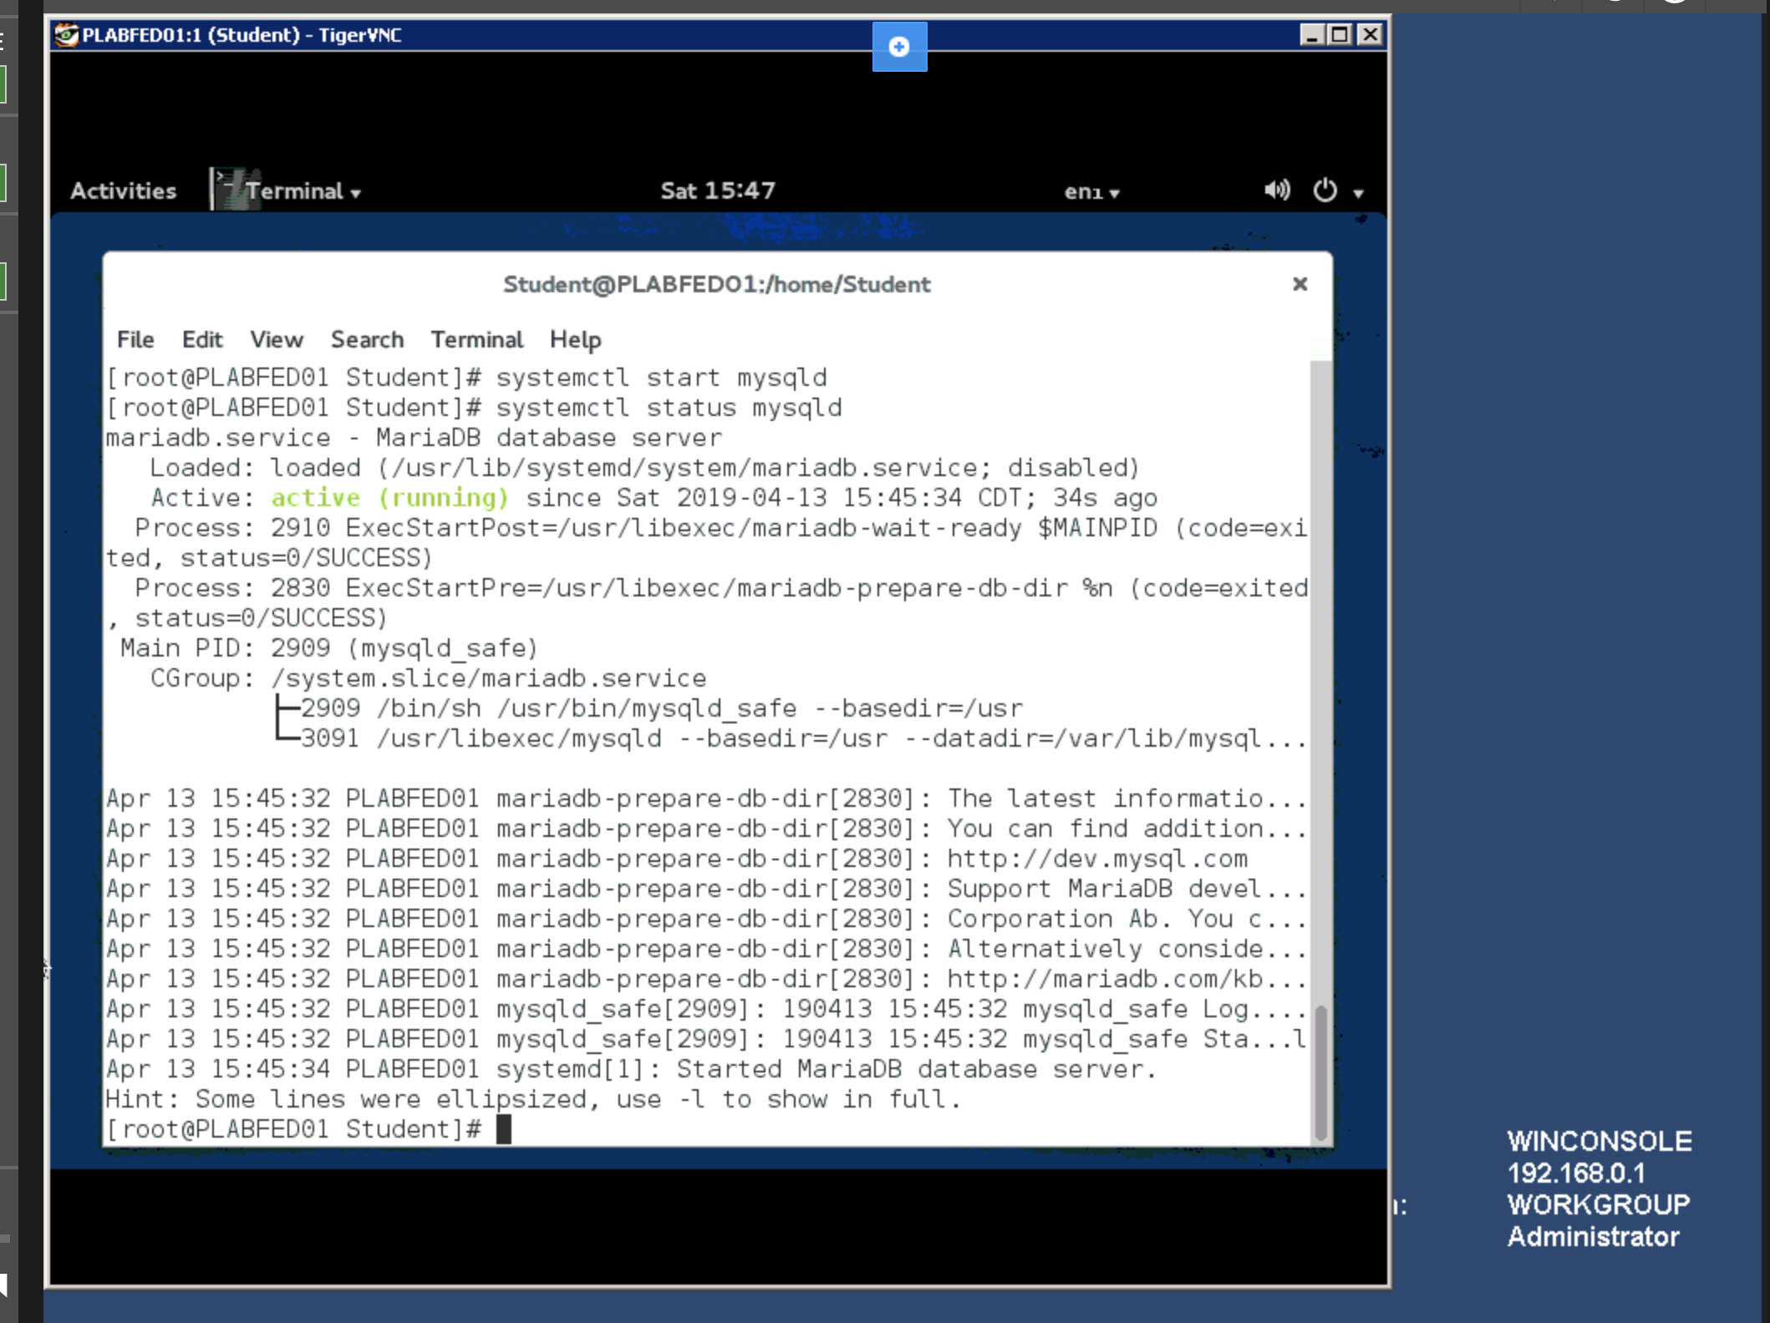

**Task C: Step 2**

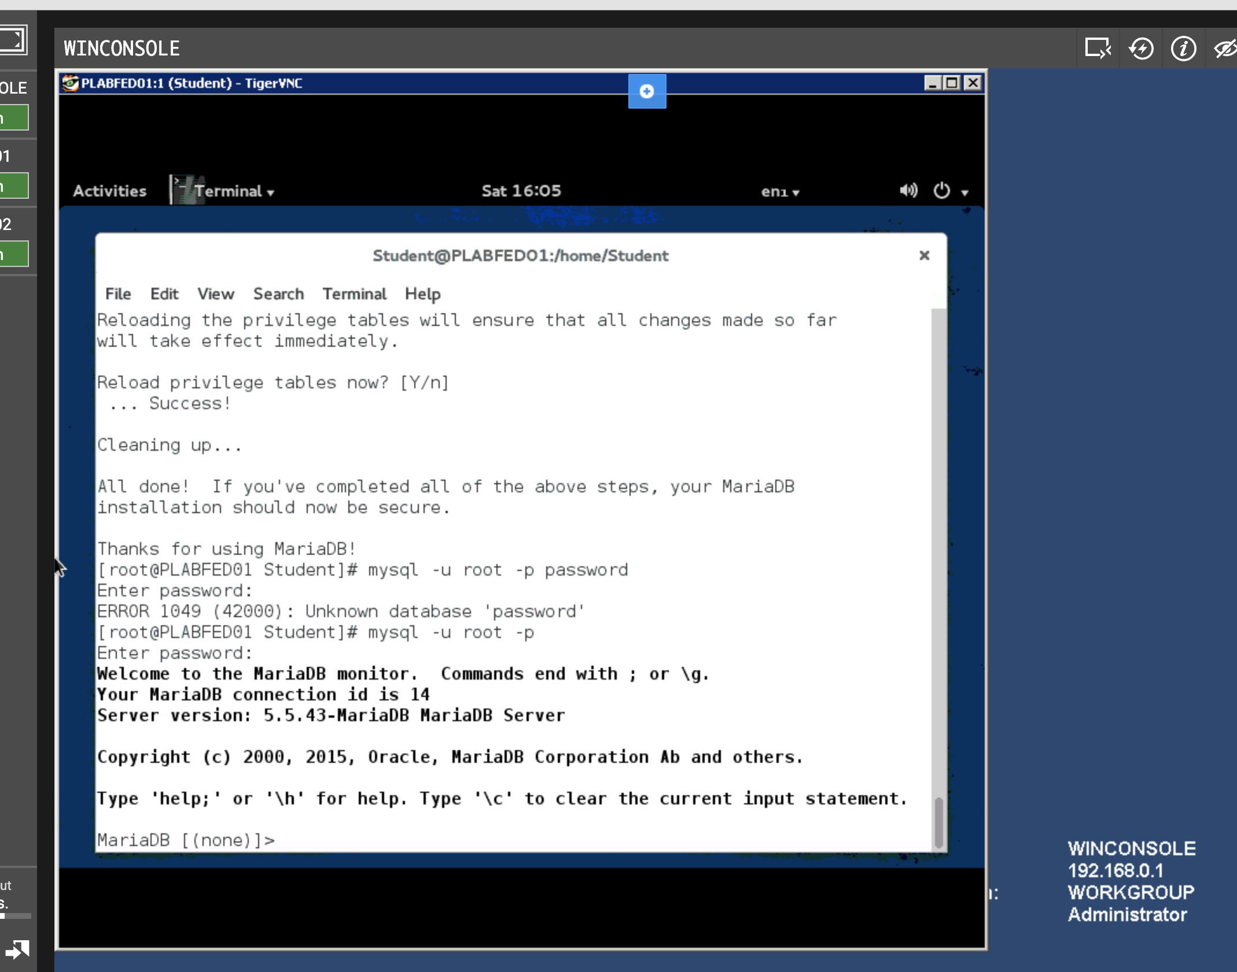

**Task C: Step 3**

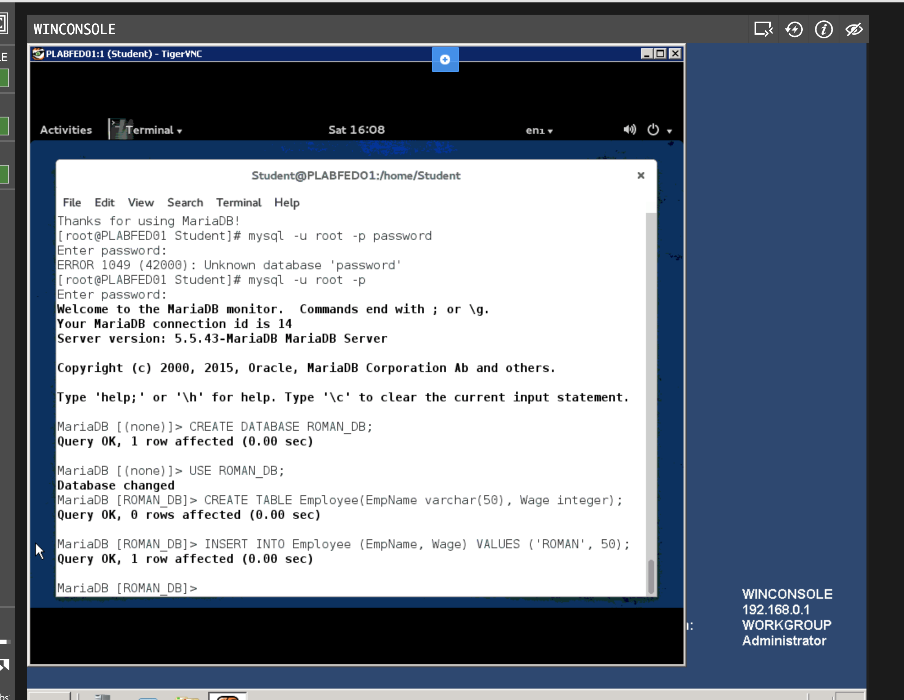

**Task C: Step 4**

