|  |  |  |  |  |  |
| --- | --- | --- | --- | --- | --- |
| Name: | Roman Kovtun | DSI#: | D40685801 | Date: | 04/19/19 |

**Web375 Week 7 Lab Report—Configuring a Linux DNS Server**

**Lab 7 Grading Rubric**

|  |  |
| --- | --- |
| **Category** | **Points** |
| Task C: Step 1: listing of named.conf file (capture last 15 lines) | 10 |
| Task C: Step 2: listing of forward.zone file | 10 |
| Task C: Step 3: listing of reverse.zonf file | 10 |
| Task C: Step 4: listing of hosts file | 10 |
| Task C: Step 5: listing of resolv.conf | 10 |
| Task C: Step 6: results of testing name resolution | 10 |
| Total | 60 |

**Task C: Step 1**

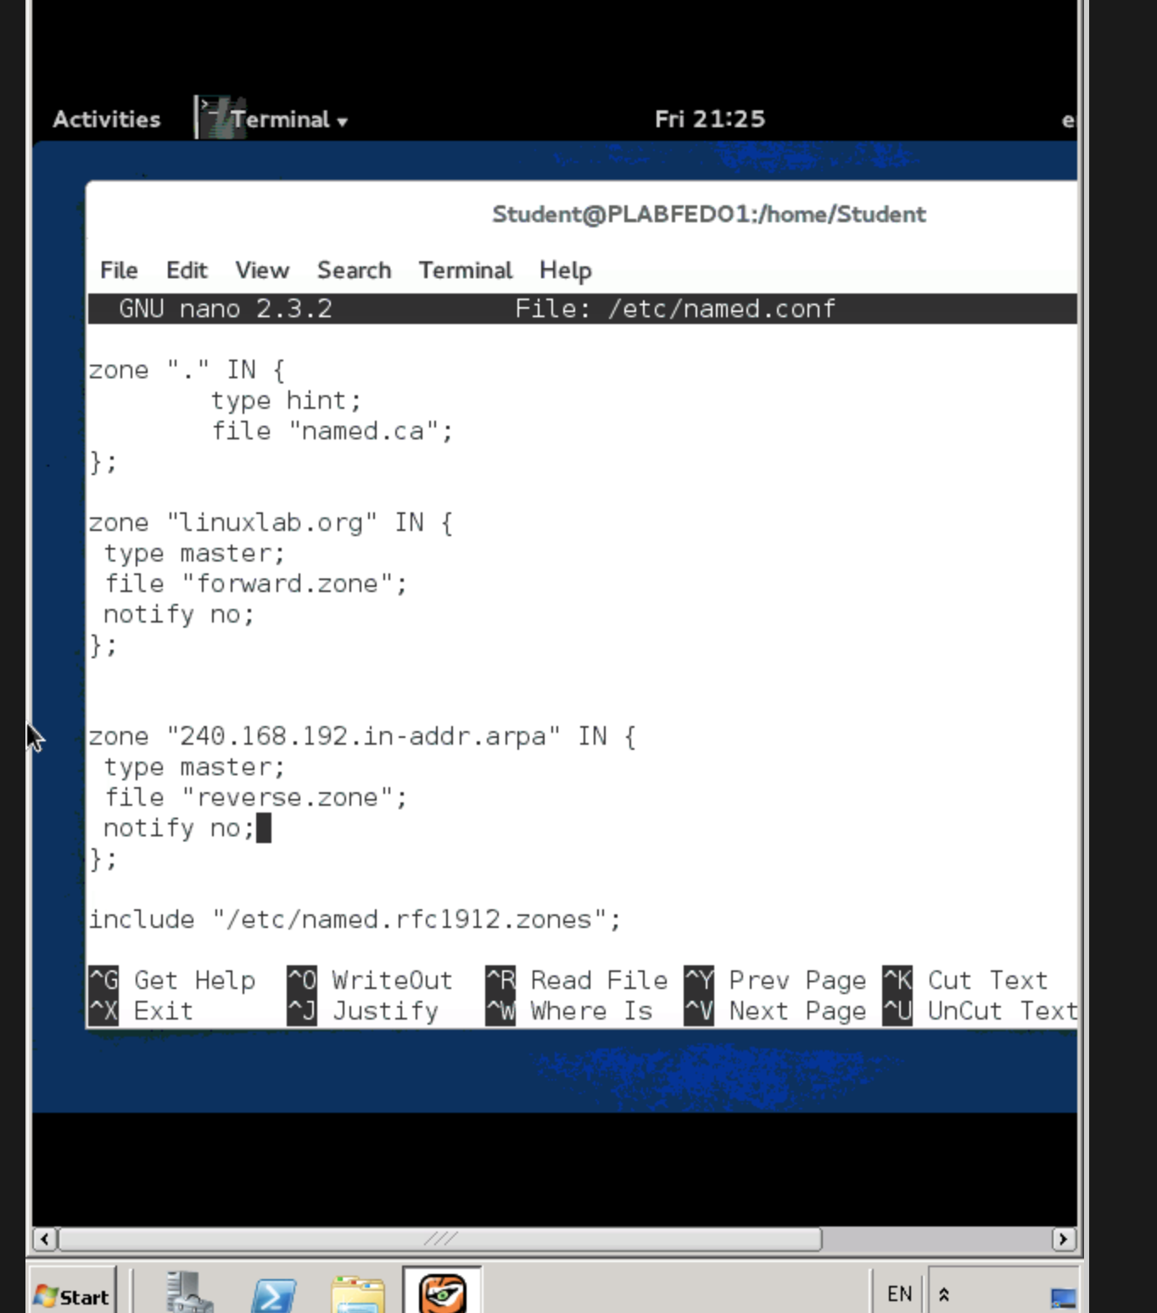

**Task C: Step 2**

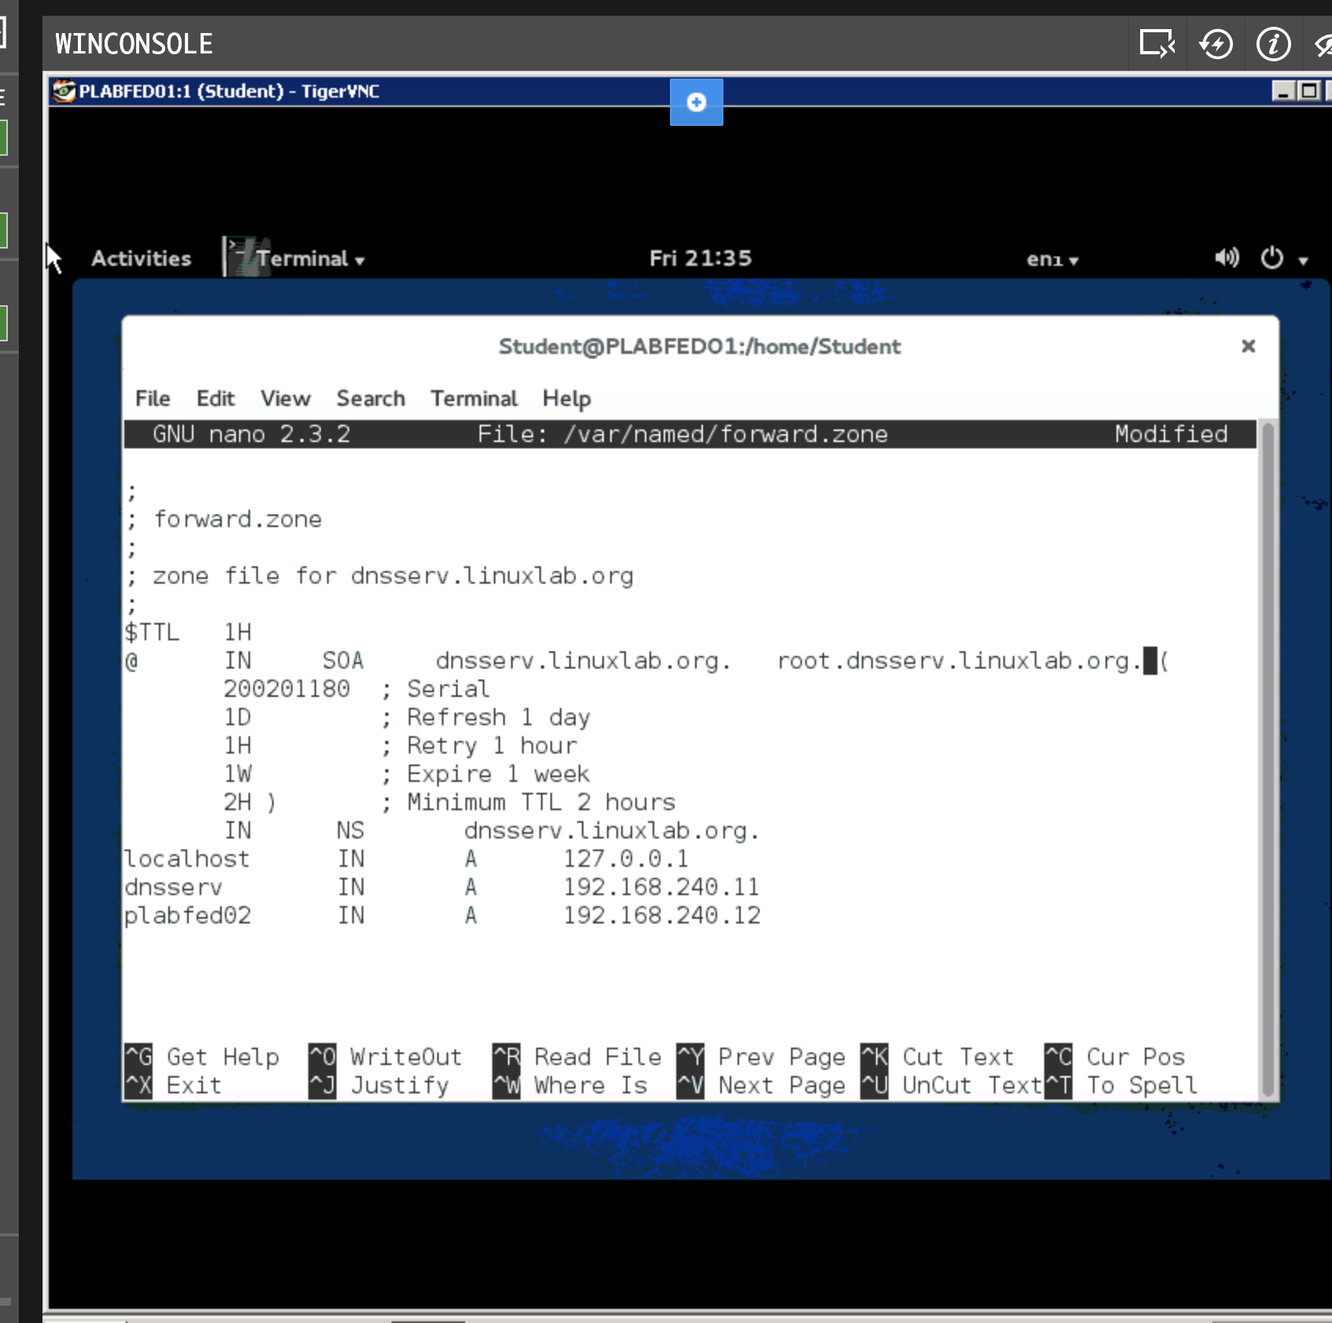

**Task C: Step 3**

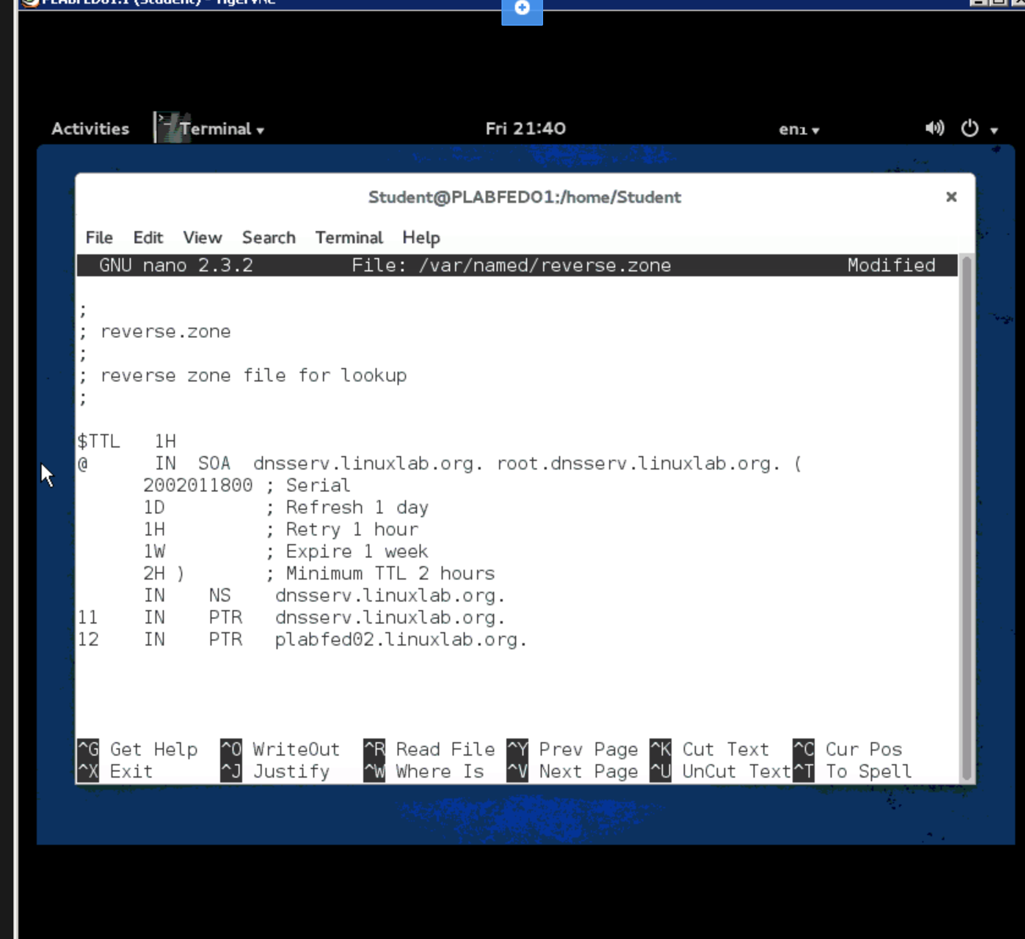

**Task C: Step 4–5**

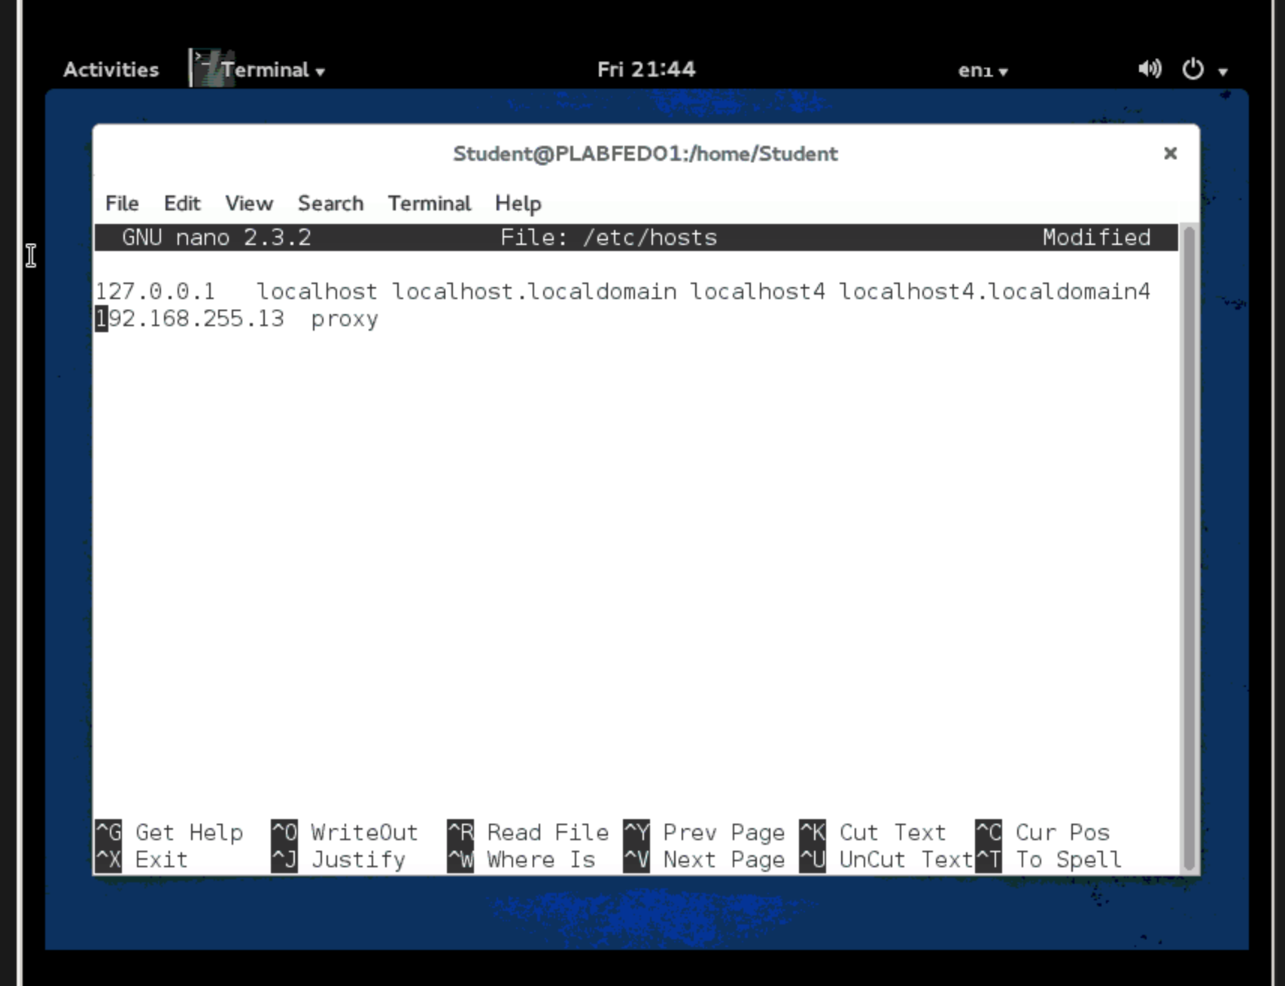

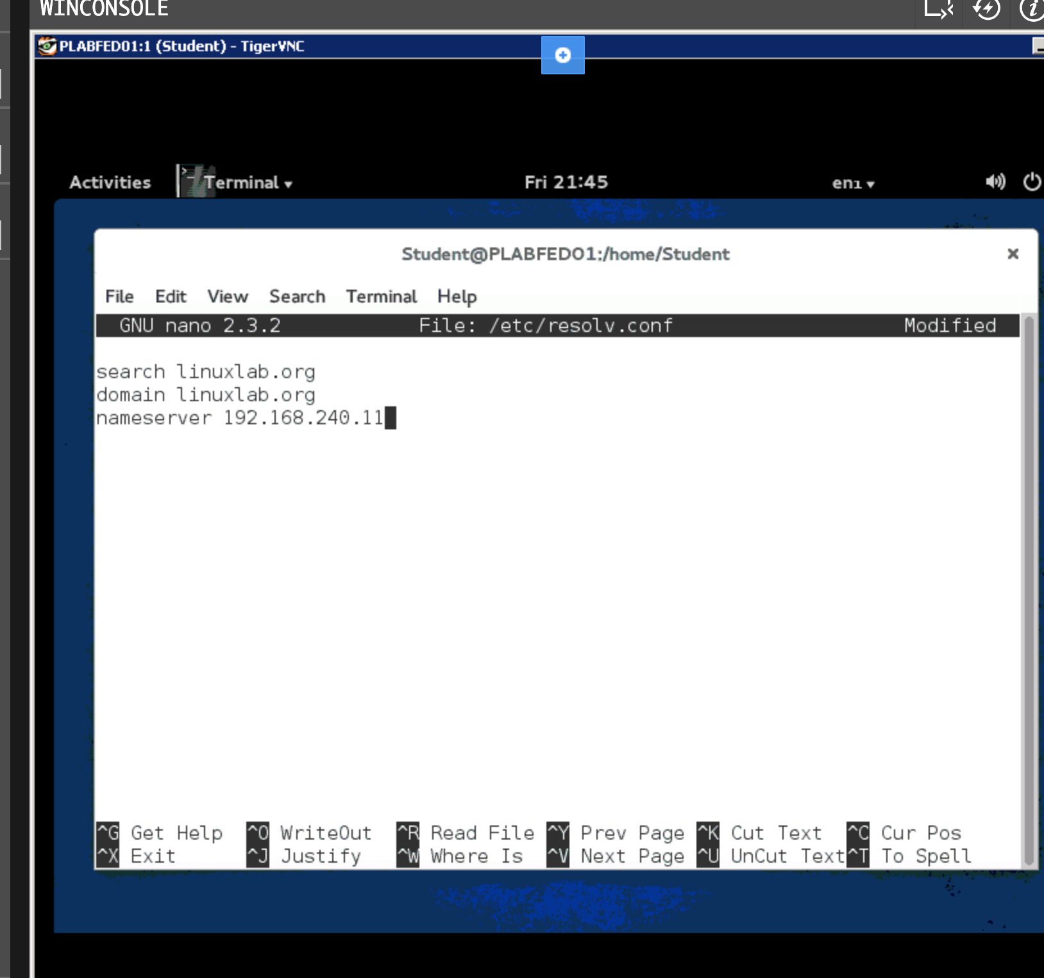

**Task C: Step 6**

