MORTISE CAPITAL  Weekly Recap  22 Jun – 26 Jun 2026 · Issue 27 June 2026 | 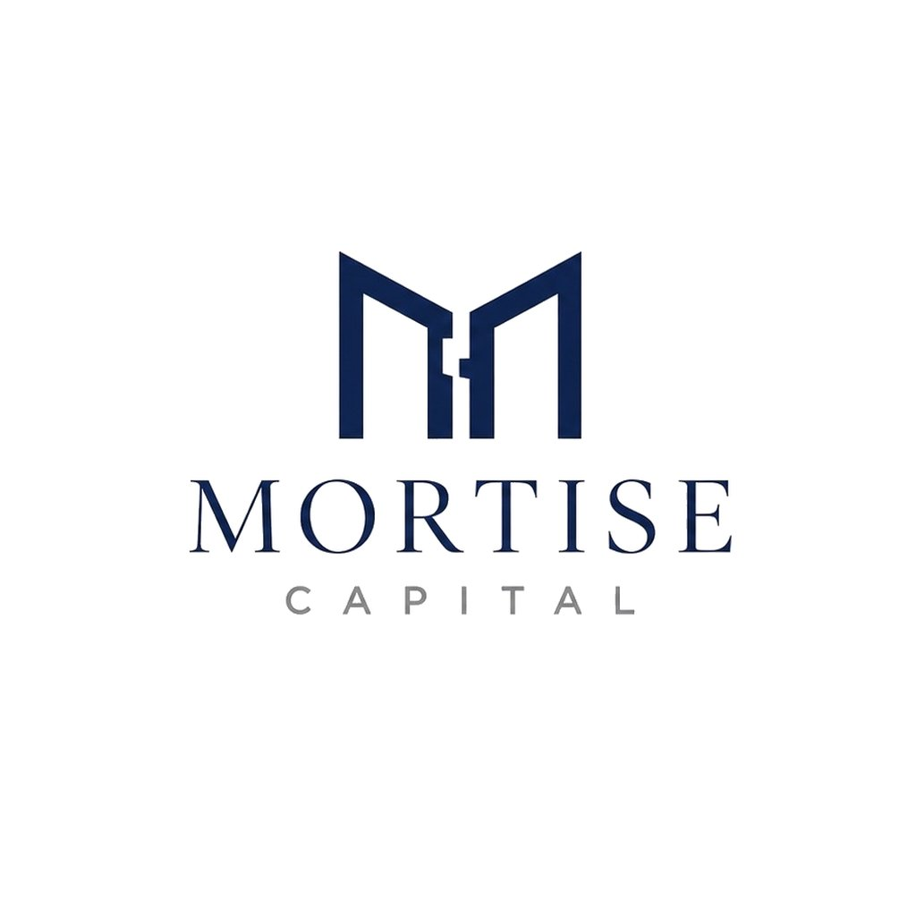  Data: 27 Jun 2026  Edited by: [George ZHU]  Mortise Capital Research

Weekly View  AI De-rating Spreads as Oil Relief Cushions Rotation  Global markets spent the week repricing a hawkish Fed backdrop and a sharp break in AI leadership. The stress started in U.S. tech: on Tuesday, the Nasdaq fell 2.2%, the S&P 500 lost 1.4%, and SOXX dropped 7.9% as investors cut crowded semiconductor exposure. By Friday, the pressure had spread across the global AI chain, with South Korea’s KOSPI down 5.8%, Japan’s Nikkei off about 4%, and European chip names also lower. Macro offered little relief. May U.S. headline PCE rose 4.1% year over year and core PCE rose 3.4%, while Q1 GDP was revised up to 2.1% annualized but consumer spending slowed to just 0.5%.  The week still looked more like rotation than a broad risk-off break. The S&P 500 closed down 2.0% for the week, while the Nasdaq lost 4.6%; the Dow gained 0.6% and the Russell 2000 rose 1.0%. Lower oil prices and easing Treasury yields helped cushion non-tech cyclicals, even as AI-linked equities de-rated globally. Micron was the key stock: after falling 13.2% in Tuesday’s sell-off, it reported fiscal Q3 EPS of $25.11, revenue of $41.46bn, and an 84.6% gross margin, confirming tight AI memory supply. The market’s divide is now clearer: upstream memory and components retain pricing power, while consumer hardware and AI applications face higher costs and tougher monetization tests. Positioning should stay selective: profitable AI infrastructure and quality cyclicals over high-multiple AI applications.  Top Headlines  MONDAY 22 JUN  1. S&P 500 -0.4%, Nasdaq -1.3%, Dow +0.3%, Russell 2000 +0.8% - rotation away from AI. 2. OFAC grants a 60-day waiver for Iranian oil sales and dollar payments through Aug. 21.  3. U.K. Prime Minister announces resignation  TUESDAY 23 JUN  1. Korean chip rout triggers KOSPI circuit breaker; Samsung and SK Hynix fall over 12%. 2. DXY rose to 101.24, its highest since May 2025, on hawkish repricing and higher Treasury yields.  3. Southbound Stock Connect saw HKD 8bn in net inflows on June 23, the largest in recent weeks. 4. Philadelphia Semiconductor Index sank 7.9% on June 23, its worst drop of the recent cycle.  WEDNESDAY 24 JUN  1. Micron’s fiscal Q3 earnings beat estimates by a wide margin. 2. Wendy’s surged over 40% on a WallStreetBets-driven “Save Wendy’s” campaign.  3. Oil fell about 5%, with WTI at $69.80/bbl and Brent near $73/bbl. 4. Gold fell 3% to $4,010/oz, briefly breaking below $4,000 for the first time since November 2025.  THURSDAY 25 JUN  1. May PCE inflation hit a fresh three-year high. Headline PCE: 4.1% YoY. Core PCE: 3.4% YoY. 2. Apple fell 6% after raising products prices over AI-driven memory costs, citing soaring chip costs.  3. Iran reportedly struck the Singapore-flagged Ever Lovely in the Strait of Hormuz. 4. Bitcoin briefly fell to $58,000, its lowest since 2024 and over 50% below its 2025 peak.  FRIDAY 26 JUN  1. Fed Governor Williams stated current monetary policy is "well positioned" to bring inflation to 2%. 2. OpenAI is reportedly delaying its IPO from H2 2026 to 2027.  3. Russell reconstitution takes effect after Friday’s close; Alphabet joins the Dow, replacing Verizon. 4. Samsung to unveil a $646bn 10-year spending plan at Monday’s Blue House briefing with SK Hynix. |  | Market Data  US EQUITIES Fri close WoW  S&P 500 7,354 ▼ 1.95%  Nasdaq 25,298 ▼ 4.60%  Dow Jones 51,876 ▲ 0.60%  EUROPE Fri close WoW  Euro Stoxx 50 6,212 ▼ 1.11%  DAX 24,671 ▼ 1.25%  CAC 40 8,385 ▼ 0.43%  ASIA Fri close WoW  Nikkei 225 69,361 ▼ 2.65%  Hang Seng 22,672 ▼ 5.24%  CSI 300 4,868 ▼ 1.48%  KOSPI 8,411 ▼ 7.08%  BONDS 10Y Fri close WoW  US 10Y 4.37% ▼ 7.8 bps  German 10Y 2.86% ▼ 16.4 bps  China 10Y 1.75% ▼ 4.3 bps  FX Fri close WoW  EUR/USD 1.1390 ▼ 0.68%  USD/JPY 157.08 ▲ 2.62%  USD/CNY 6.7982 ▼ 0.42%  COMMODITIES Fri close WoW  Gold USD/oz 4,103 ▼ 3.37%  WTI USD/bbl 71.92 ▼ 6.11%  Source: Yahoo Finance. Fri close vs prior Fri close. Bonds in bps.

