- On a channel with bandwidth of 10k Hz, for achieving 300Kbps data rate, what is the minimum requirement of signal-to-noise ratio (in unit of dB)?

- A communication channel has a bandwidth of 100 kHz and a measured signal-to-noise ratio (SNR) of 255.
  - Using the Shannon theorem, calculate the theoretical maximum channel capacity (in kbps) for this channel.
  - To achieve the theoretical maximum capacity calculated in part (1), determine the minimum discrete level (signaling level) to be used in the communication.

- A communication link is designed to operate at a signal rate of 28 kbaud using 16-QAM modulation. What is the system's bit rate?

- How many different signals are defined in a QAM-64 system. If the data rate a QAM-64 system supported is 4k bps, what is the corresponding baud rate?
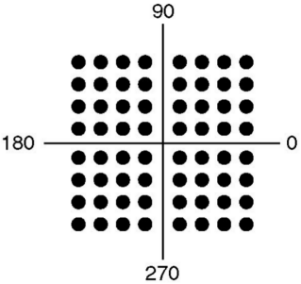

- In a CDMA system, a Station P is assigned the chip sequence (0100 0010). If the received code is (-1 +1 -1 +1 +1 +1 -1 -1), determine which binary bit (1 or 0) station P has just sent. Explain your reasoning.

