- Please use Manchester Encoding and Differential Manchester Encoding for representing a bit string: 1010

- If the following frame arrives at bridge X’s interface X₁₁, please explain how it will be forwarded and how bridge X will update its MAC table.(5 marks)
Frame:
... | 0001-0001-0001 | 0002-0002-0002 | ... | ...
... | Source Address | Destination Address | Payload data | ...
MAC table:
MAC Address | Port/Interface
0003-0003-0003 | X₁₂
0004-0004-0004 | X₁₃

- A CSMA/CD network has: Bandwidth: 200 Mbps; Maximum distance: 100 meters; Signal speed: 200 m/μs. What is the minimum frame length required?

- Please use Dijkstra to compute a sink tree consisting all the shortest paths rooted at node A?
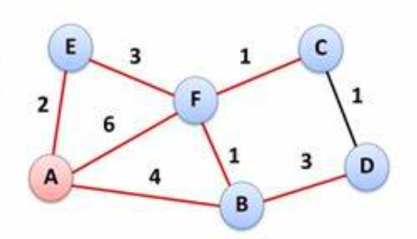

- Router C receives distance vectors from neighbors B, D, and E :
​​From B: (A:5, B:0, C:8, D:12, E:6, F:2)
​​From D: (A:16, B:12, C:6, D:0, E:9, F:10)
​​From E: (A:7, B:6, C:3, D:9, E:0, F:4)
The delays from C to its neighbors D, D and E are measured as: C→B: 6; C→D: 3; C→E: 5. Please update Router C’s distance vector.​​

- For an IP address 172.16.20.200, please tell which Class it belongs to, and what is its corresponding network address and broadcast address.

- For a network IP 202.38.197.0, if 2 bits are borrowed as subnet ID, how many subnets can be created? And totally how many valid host IP addresses can be supported?

- An Internet Service Provider (ISP) has been allocated the address block 172.20.0.0/16.A customer requires the following three networks, with the number of hosts indicated:
Network X – 2000 hosts
Network Y – 1000 hosts
Network Z – 4000 hosts
Using CIDR/VLSM to save address space, allocate subnets from the 172.20.0.0/16 block.
List the network address and subnet mask for each network (X, Y, Z).

