## 5.3 model 3

结构策略影响着成功的团队合作，作为一名成功的教练应该具备较好的统筹规划，协调合作，人员安排能力。我们认为，具体的结构策略应该最主要体现在以下两个个方面：球员位置安排和球队阵型。此外，还应考虑球员间默契度，主客场影响，教练安排。

The structure strategy affects the successful team cooperation, as a successful coach should have better overall planning, coordination, cooperation, personnel arrangement ability.In our opinion, the specific structure strategy should be mainly reflected in the following two aspects: player position arrangement and team formation.In addition, should also consider the understanding between the players, home and away influence, coach arrangement.

### 5.3.1 位置evaluation engineering

在考虑球员位置安排时，需要计算守门员，前锋，中场，后卫四个位置不同球员的贡献值。我们在数据集中采集哈士奇球队30位球员的EventType，并以其为横轴，球员编号为纵轴，统计出每个球员在整个赛季中每个EventType次数，用颜色的深浅来表示次数的多少，以下分别为前锋，中场和后卫的EventTypes统计图：

When considering the arrangement of players' positions, it is necessary to calculate the contribution value of different players in the positions of goalkeeper, striker, midfielder and defender. We collect the eventtypes of 30 players in the husky team in the data set, and use them as the horizontal axis and player number as the vertical axis to count the number of each eventtype of each player in the whole season, and use the depth of color to express the number of times. The following are the eventtypes statistics of forwards, midfielders and defenders:

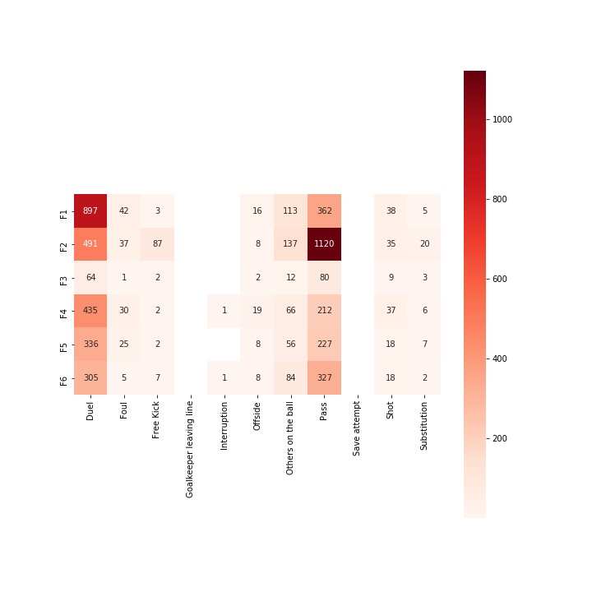 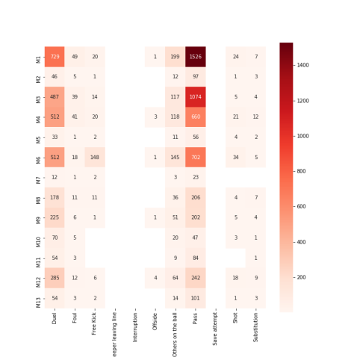 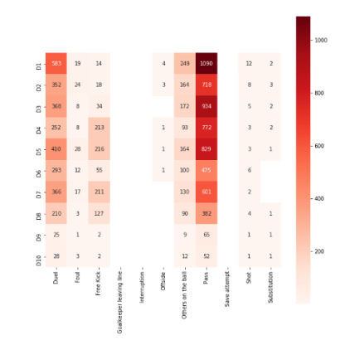

前锋&中场&后卫EventTypes统计图

由以上四个图，我们可以看出F中贡献最大的是F2，其次是F1,F6,F5,F4。M中贡献最大的是M1，其次是M3,M4,M6。D中贡献最大的是D1，其次是D3,D5,D4,D2,D7,D6,D8。

From the above four figures, we can see that the largest contribution of F is F2, followed by F1, F6, F5, F4. In M, M1 is the largest contributor, followed by M3, M4 and M6. In D, the largest contribution is D1, followed by D3, D5, D4, D2, D7, D6, D8.

我们希望能有实际的模型来对不同球员球员在不同位置表现进行量化评价。此时需要结合实际知识，分析不同位置各自的重要数据，通过不同EventTypes权重分配、结合球员各种能力performance，进行计算，作为evaluation of球队的29位球员（除守门员）分别在G,F,M位置上的表现情况。下图中，颜色越红表示越适合这个位置，反之越蓝则表示越不适合。

We hope to have a practical model to evaluate the performance of different players in different positions. At this time, it is necessary to analyze the important data of different positions in combination with practical knowledge, calculate the weight distribution of different event types, and combine the performance of various abilities of players. The performance of 29 players (except goalkeepers) as evaluation of the team in G, F, m positions respectively. In the following figure, the more red the color is, the more suitable the position is; otherwise, the more blue it is, the less suitable it is.

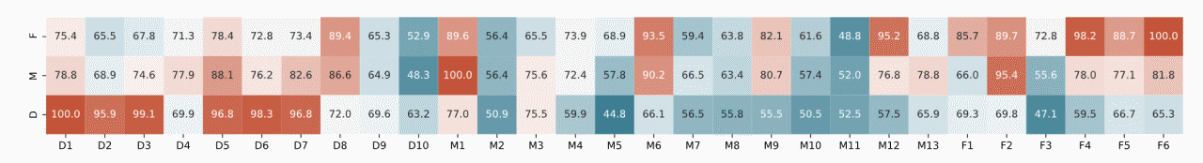

不同球员在不同位置评分表

### 5.3.2 基于SA算法优化排列组合

我们分析整个赛季38场比赛中主力阵容/首发阵容line-up，希望建立模型为教练建议最好的球队阵容该模型的目标是要找到一个最优的有序组合，使场上11人在各自位置的能力之和最大。把场上11个位置有序排列，用11位的30进制格雷码表示当前状态；例如格雷码0A1GRD739KI表示11个位置依次有第0,10,1,16,26,13,7,3,9,11,18号球员。在搜索树极为庞大、算力资源有限的情况下，我们选择模拟退火算法。模拟退火算法主要优点之一就是能以一定的概率接受目标函数值不太好的状态，且在迭代的过程中不断能够接受使目标函数向好的方向前进的解。模拟退火算法的具体步骤如下：

We analyze the line-up of the main lineup / starting lineup in 38 games of the whole season, and hope to build a model to suggest the best team lineup for the coach. The goal of this model is to find an optimal orderly combination, so that the sum of the abilities of 11 players in their respective positions is the largest. The 11 positions on the field are arranged in order, and the current status is represented by the 30 digit gray code; for example, the gray code 0a1grd739ki indicates that there are players 0, 10, 1, 16, 26, 13, 7, 3, 9, 11 and 18 in turn. In the case of huge search tree and limited computing resources, we choose simulated annealing algorithm. One of the main advantages of the simulated annealing algorithm is that it can accept the state with a certain probability that the value of the objective function is not good, and it can continuously accept the solution that makes the objective function move in a good direction in the process of iteration. The specific steps of simulated annealing algorithm are as follows:

1. 给定冷却进度表参数及迭代初始解 $x_{0}$.以及 $f(x_{0})$,其中冷却进度表参数包括：控制参数 $T$ 的初值 $T_{0}$，衰减函数，终值以及链长度；

1. Give the parameters of cooling schedule and initial solution of iteration $x_{0}$，and $f(x_{0})$, the parameters of cooling schedule include: Initial value $T_{0}$ of control parameter $T$, attenuation function, final value and chain length of control parameters $L_{k}$;

1. 参数 $T=T(k)$ 时，按照如下过程作 $L_{k}$ 次试探搜索：
   1. 根据当前解 $X_{k}$ 的性质，产生一个随机偏移量 $m$，从而得到一个当前解邻域的新的试探点 $X_{k}$；
   2. 产生一个在 $\left(0,1\right)$ 区间上均匀分布的随机数 $θ$,计算出在给定当前迭代点 $X_{k}$ 和温度 $T_{k}$ 下与接受准则相对应的转移概率 $P$：
 $$P=\left\{\begin{aligned}1, 当f\left(X_{k}^{'}\right)<f\left(X_{k}\right)时 \\ \exp\left(\frac{f\left(X_{k}\right)-f\left(X_{k}^{'}\right)}{T_{\begin{aligned}k \\ \end{aligned}}}\right), 当f\left(X_{k}^{'}\right)<f\left(X_{k}\right)时\end{aligned}\right.$$

 $$Attitude\left(X_{k}\right)=\left\{\begin{aligned}Accept,θ<P \\ Reject,θ≥P\end{aligned}\right.$$

 3. 试探搜索小于 $L_{k}$ 次，返回步骤1，否则进入步骤3；

2. When the parameter $T=T(k)$, perform $L_{k}$ exploratory searches as follows:

a) According to the properties of the current solution $X_{k}$, a random offset $m$ is generated, and a new trial point $X_{k}$ of the neighborhood of the current solution is obtained;

b) Generate a random number $θ$ uniformly distributed on the interval $\left(0,1\right)$, and calculate the transfer probability $P$ corresponding to the acceptance criteria given the current iteration point $X_{k}$ and temperature $T_{k}$:

$$P=\left\{\begin{aligned}1, 当f\left(X_{k}^{'}\right)<f\left(X_{k}\right)时 \\ \exp\left(\frac{f\left(X_{k}\right)-f\left(X_{k}^{'}\right)}{T_{\begin{aligned}k \\ \end{aligned}}}\right), 当f\left(X_{k}^{'}\right)<f\left(X_{k}\right)时\end{aligned}\right.$$

$$Attitude\left(X_{k}\right)=\left\{\begin{aligned}Accept,θ<P \\ Reject,θ≥P\end{aligned}\right.$$

c) If the exploratory search is less than $L_{k}$ times, return to step 1, otherwise go to step 3;

1. 根据给定的温度衰减函数产生新的温度控制参数 $T_{k+1}$，及链长度 $L_{k+1}$，转入步骤2，进入下一温度点的平衡点寻优。

3. According to the given temperature decay function, a new temperature control parameter $T_{k+1}$ and chain length $L_{k+1}$ are generated. Turn to step 2, and enter the optimization of the equilibrium point of the next temperature point.



图 2 SA Flowchart

在实际试探搜索中，我们很可能现入局部最优，需要进行判定以退出。当前解的优化程度小于当前最优解的优化程度的时候,新解被接受的概率为 $100\%$,而当温度足够低的时候，较差解被接受的概率趋近于 $0$。依据最近的 $K$ 次搜索中都没有优化程度更高的解出现这一特征，可以根据具体问题确定阐值而后判定搜索己经进入局部最优。

In the actual exploratory search, we are likely to enter the local optimum, and need to make a decision to exit. When the optimization degree of the current solution is less than that of the current optimal solution, the probability of the new solution being accepted is, while when the temperature is low enough, the probability of the worse solution being accepted tends to be. According to the feature that there is no more optimized solution in the recent sub search, the elucidation value can be determined according to the specific problem and then it can be determined that the search has entered the local optimum.

### 5.3.3 其他结构策略因素

考虑完主要策略后，我们考虑以下四个次要影响因素：球员间默契度，主客场影响和教练安排。

After considering the main strategy, we considered the following four secondary factors: players' rapport, home and away influence, and coaching arrangements.

首先，选择默契度高的小分队有利于提高传球和进球的效率。默契度高的小组往往配合能力较强，有助于比赛的成功。传球效率较高的球员往往适应能力较强，与其他球员的配合度也较好。

First of all, choosing a team with a high degree of understanding is conducive to improving the efficiency of passing and scoring.Teams with a high degree of tacit understanding often have a strong ability to cooperate, which contributes to the success of the game.Players with higher passing efficiency tend to be more adaptable and cooperate better with other players.

主客场因素也是必须要考虑的，有的球员适应性较强，在主场和客场都能较好的发挥出原有的水平，而有些适应性较差的球员只在主场发挥出原有的水平，环境对他的表现有较大的影响。那么在主客场时，应该安排不同的球员上场。

Home and away factors must also be considered, some players are more adaptable, at home and away can better play the original level, while some players are less adaptable only at home to play the original level, the environment has a greater impact on his performance.Then at home and away, different players should play.

最后，教练安排上，整个赛季中，Coach 1,Coach 2,Coach 3,分别指导了9,5,24场比赛，通过我们在第二题中的数据分析也可得出，Coach 3的水平较高。

Finally, in terms of Coach arrangement,Coach 1,Coach 2 and Coach 3 respectively guided 9,5 and 24 games in the whole season. According to the data analysis in the second question, it can also be concluded that Coach 3 has a higher level.

### 5.3.4 structural strategy conclusion

纵观整个模型，为了在下个赛季中提高球队成功率，我们团队给出的建议是，球队聘用Coach 3作为球队主教练，采用442的line-up，将F1,F6,F2,M3,M1,M6,D3,D1,D2,D5作为主力球员，命名该阵容为 $lineup_{0}$，他们的位置按下图安排：

Throughout the entire model, in order to improve the success rate next season, our advice is to hire Coach 3, the team Coach, use the 442 line - up,make  F1, F2, F6, M3, M1, M6,, D1, D2, D3 and D5 as main force, naming the formation as $lineup_{0}$，Their positions are arranged according to the figure below：

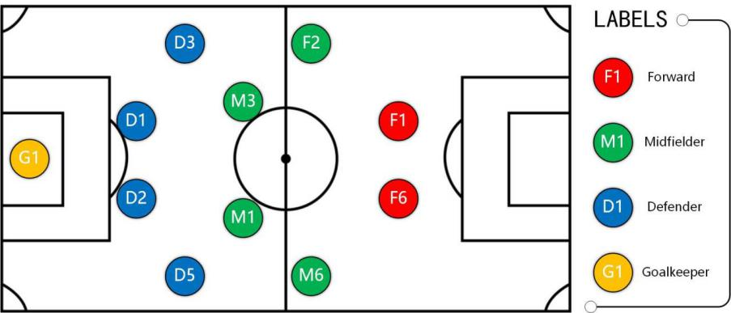

球员阵型图

根据赛季数据的评价，F2球员作为一名前锋，拥有很强中场的能力，在尝试将他安排在中场时取得了显著的新最优解，这说明每个人的任一位置评价较为重要，侧面indicate我们的模型因素考虑完善。

According to the evaluation of the season data, F2 player, as a striker, has a strong ability in the midfield. When trying to arrange him in the midfield, a significant new optimal solution is obtained, which indicates that the evaluation of any position of everyone is more important.

综上，该阵型的个人能力总分为 $PersonalScore\left(lineup_{0}\right)=94.43$，团队配合得分为 $CoordinationScore\left(lineup_{0}\right)=90.17$，按照 $\left\{\begin{aligned}0.7,Personal \\ 0.3,Coordination\end{aligned}\right.$ 进行加权平均，最后得到综合评分为 $TotalScore\left(lineup_{0}\right)=93.152$。实际比赛中与此相似的阵型取得很好的战果，也验了我们的评价模型和模拟退火算法的可行性和准确性。

To sum up, the total score of personal ability of the formation is $PersonalScore\left(lineup_{0}\right)=94.43$, the score of team cooperation is $CoordinationScore\left(lineup_{0}\right)=90.17$, and the weighted average is based on $\left\{\begin{aligned}0.7,Personal \\ 0.3,Coordination\end{aligned}\right.$, and the final comprehensive score is $TotalScore\left(lineup_{0}\right)=93.152$. In the actual competition, the formation similar to this has achieved good results, and also verified the feasibility and accuracy of our evaluation model and simulated annealing algorithm.