## 5.1 model 1

为了构造结构化的传球网络，用来分析球员间传球配合的默契程度，应在不同多维度、状态变化情况下进行分析。例如从微观上两两球员之间的行为，到宏观上多个球员之间的行为；以及时间尺度从比赛中的单位时刻到整个赛季。

In order to construct a structured passing network, which is used to analyze the tacit understanding of passing between players, it should be analyzed in different dimensions and states. For example, from the behavior between two players at the micro level, to the behavior between multiple players at the macro level; and the time scale from the unit time in the game to the entire season.

### 5.1.1 传球评价Index（PEI）

两人传球评价指数 $PassValue(p_{i}, p_{j})$，用于评价两人配合程度。在一场球赛中，宏观来看，球员相对于球场可以视为一个个节点，球场可以视为一个网络，每一次传球可以视为节点之间的连线。以两人之间每次传球累计评价 $PassValue\left(p_{i}, p_{j}\right)$ 作为2人的传球评价指数。在多人传球评价体系中，将三个节点连接成闭合环路，边权之和即为3人传球评价指数。

The evaluation index of pass between two players $PassValue(p_{i}, p_{j})$ is used to evaluate the degree of cooperation between them. In a game, from a macro perspective, players can be regarded as nodes, the field can be considered as a network, and each pass can be considered as the connection between the nodes. We regard $PassValue\left(p_{i}, p_{j}\right)$, cumulatively evaluated for each pass, as the pass evaluation index. In a multiplayer pass evaluation system, three nodes are connected into a closed loop, and the sum of edge weights is the 3-player pass evaluation index.

$$PassValue\left(p_{i},p_{j},p_{k}\right)= EdgeValue\left(i,j\right)+EdgeValue\left(i,k\right)+EdgeValue\left(j,k\right)$$

通过生活经验和数据挖掘所发现的规律可以构建PEI计算模型：

According to the experience of life and the rules discovered by data mining, a PEI calculation model can be constructed as follows:

1. 传球类型权重表：

(1) Weight table of pass types:

$$α_{i} is constant for i in Pass Types.$$

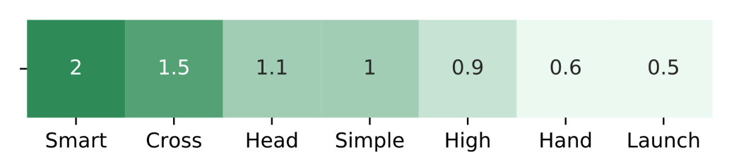

1. 计算传球或接球时分别受到的防守压力 $DefPress\left(p_{i}\right)$

(2) Calculate pressure from defenders when passing or receiving

$$DefPress\left(p_{i}\right)=1-\frac{1}{2}\tan{[\frac{11}{6}×(\frac{x_{p_{i}}}{100}-0.6)]}$$

其中，x为球员到对方球门的横坐标，与受到的防守压力成负相关

Among them, x is the abscissa from the player to the opponent's goal, and it is negatively related to the pressure from defenders.

1. 两人之间的边权 $EdgeValue\left(i,j\right)$，即单次传球评价，为此次传球类型的权重乘以防守压力加权平均数，量化为以下公式。

（3）Single pass evaluation, $EdgeValue\left(i,j\right)$, is the weight of the pass type multiplied by weighted average of the pressure from defenders, quantified as the following formula:

$$\left\{\begin{aligned}EdgeValue\left(i,j\right)=PassValue\left(p_{i}, p_{j}\right) \\ PassValue\left(p_{i}, p_{j}\right)=\sum_{i in Pass}{α_{i}*\left(DefPress\left(p_{i-from}\right)*0.3+DefPress\left(p_{i-to}\right)*0.7\right)}\end{aligned}\right.$$

根据这一传球评价指数模型，统计出一定时间范围内所有参与比赛的 $N$ 个球员的邻接矩阵数据 $Arr$。由 $Arr\left[i, j\right]=PassValue\left(p_{i}, p_{j}\right)$ 得每两人之间所有传球价值评价总和图:

According to this pass evaluation index model, an adjacency matrix $Arr$ of all N players participating in the game within a certain time range is calculated. From $Arr\left[i, j\right]=PassValue\left(p_{i}, p_{j}\right)$, we can get the sum of all values of pass evaluations between each two players:

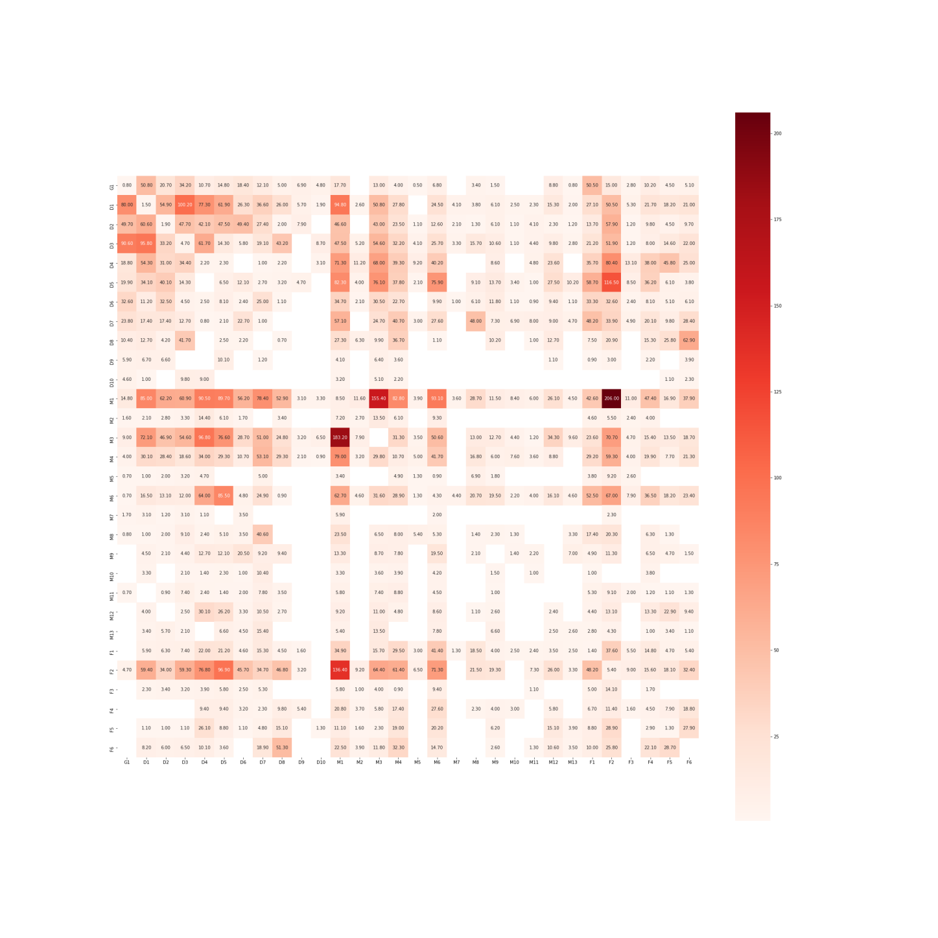

整个赛季单次评价图

### 5.1.2 传球网络模型构建及识别网络模式

网络上两两球员之间的联系，宏观上体现为球员间传球的评价总和。筛选两人传球评价超过一定阈值的边，运用图论的方法选择性剔除交叉边，将基于传球评价指数构建的line-up传球网络可视化，用线的深浅表示

The connection between two players on the network, Macroscopically, it is the sum of the evaluation of passing between players. Screening the edges whose pass evaluation exceeds a certain threshold, using graph theory methods to selectively remove the crossing edges, and visualize the line-up passing network constructed based on the pass evaluation index, which is expressed by the shades of the line.

$PassValue\left(p_{i}, p_{j}\right)$：

$$\left\{\begin{aligned}lighter,PassValue\left(p_{i}, p_{j}\right) is less \\ deeper,PassValue\left(p_{i}, p_{j}\right)is more\end{aligned}\right.$$

$${Color}_{Pass}\left(i,j\right)=Palette\left(\frac{PassValue\left(p_{i}, p_{j}\right)-\min_{\left\{\begin{aligned}a≠b \\ a,b in players\end{aligned}\right.}{PassValue\left(p_{a}, p_{b}\right)}}{\max_{\left\{\begin{aligned}a≠b \\ a,b in players\end{aligned}\right.}{PassValue\left(p_{a}, p_{b}\right)}-\min_{\left\{\begin{aligned}a≠b \\ a,b in players\end{aligned}\right.}{PassValue\left(p_{a}, p_{b}\right)}}\right)$$

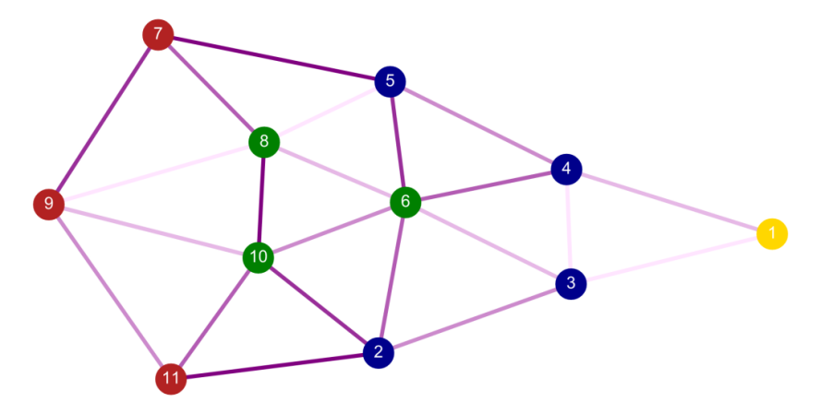

单场比赛的两两传球网络图

从这一模型的可视化中，我们可以直观地分析传球配合频繁和默契地球员，还可以直观的看出主力球员中多人传球配合的组合。

From the visualization of this model, we can intuitively analyze the players who pass frequently and tacitly, and can also see the combination of multiple passing cooperation among the main players intuitively.

|  |  |  |  |  |  |
| --- | --- | --- | --- | --- | --- |
| **N** | **Players** | | | | **Score** |
| **2** | M1 | F2 |  |  | 342.4 |
| M1 | M3 |  |  | 338.6 |
| D5 | F2 |  |  | 213.4 |
| **3** | M1 | M3 | F2 |  | 816.1 |
|  | D5 | M1 | F2 |  | 727.8 |
| **4** | D5 | M1 | M3 | F2 | 1113.5 |

### 5.1.3 时间尺度上传球状态波动

传球频率会在时间尺度上进行波动。定义 $Passes\left(0,t\right)$

Passing frequency fluctuate on the time scale. $Passes\left(0,t\right)$

$$Passes\left(0,t\right) is the sum of passes before t.$$

并以 $Passes\left(0,t\right)$ 作为球队实时状态的指标。球赛刚开始时，球员身体还未warm up，导致传球概率密度较小，5—10分钟过后，传球效率逐渐提高并大致趋于稳定，即：

$Passes\left(0,t\right)$ is used as an indicator of the team's real-time status. At the beginning of the game, the players' bodies were not warmed up, resulting in a low probability of passing. After 5-10 minutes, Passing efficiency gradually improved and generally stabilized, that is:

$$\left\{\begin{aligned}Passes^{'}\left(0,t\right)>0 \\ Passes^{''}\left(0,t\right)<0 \\ \lim_{t→t_{0}}{Passes}\left(0,t\right)=P_{0} \\ t_{0}<\frac{Halftime}{2}\end{aligned}\right.$$

As the time goes，球员们体力消耗，传球密度降低，即传球数量的增速减缓（虽然一场球赛中成功传球次数仍在增加，但传球失败频率开始增加），此后传球密度呈现下降趋势，即：

As the time goes, the players' physical strength and the pass density decrease, that is, the increase in the number of passes slows down (although the number of successful passes in a game is still increasing, the frequency of pass failure begins to increase), after that the pass density Showing a downward trend, that is:

$$\left\{\begin{aligned}Passes^{'}\left(0,t\right)<0 \\ Passes^{''}\left(0,t\right)>0 \\ \lim_{t→t_{0}}{Passes}\left(0,t\right)=P_{1}<P_{0} \\ t_{0}>\frac{Halftime}{2}\end{aligned}\right.$$

纵观整个赛季中38场球赛球员们的传球频率密度，整体上看可以与单场球赛所展示出的频率密度变化趋势相同。以时间为横坐标，成功传球密度为纵坐标作图：

Looking at the pass frequency density of players in 38 games throughout the season, one the whole the trend of frequency density is the same as that showes in a single game. Plot with time as the abscissa and successful pass density as the ordinate:

$$Passes\left(t_{1},t_{2}\right)=\int_{t_{2}}^{t_{1}}{PassDiv\left(t\right)dt}$$

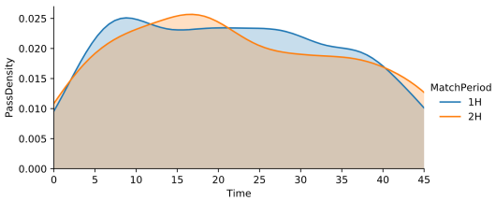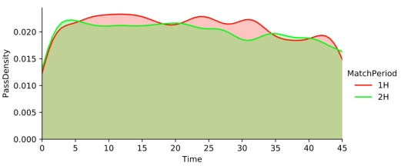

第1场比赛传球密度 整个赛季传球密度

总体来说，传球的密度在时间尺度上相对稳定。若使用Monte Carlo method对每次传球进行模拟，设定在上一次传球后下一次传球还需要的时间概率分布服从 $N\left(θ,1\right)$，其中 $θ$ 为统计的平均传球间隔时间，则在样本规模 $N$ 满足 $\log_{10}{N}≈2$ 时会近似与左图的分布；随着样本规模增加，当满足 $\log_{10}{N}>4$ 后则会近似与右图的分布。因此我们可以认为每一个时间点发生传球事件的概率服从 $N\left(0,1\right)$。

Generally, the density of passes is relatively stable in a time scale. If we use the Monte Carlo method to simulate each pass, the time probability distribution for the next pass after the last pass is set to obey $N\left(0,1\right)$, where $θ$ is the statistical average of interval time of pass. Then when the sample size N satisfies $\log_{10}{N}≈2$, it will approximate the distribution on the left graph; as the sample size increases, when $\log_{10}{N}>4$ is satisfied, it will approximate the distribution on the right graph. Therefore, we can consider that the probability of passing events at each time point obeys $N\left(0,1\right)$.