## 4.4 model 4

在对于哈士奇球队的研究中，我们了解到一些影响成功团队合作的因素，例如传球网络、个人能力、教练等等。这些因素可以和团队动力学进行联系，用来分析为什么这些足球方面的因素对球队的表现有贡献。以及我们可以探索考虑什么样的因素可以补充到我们解释优秀团体，并推广到社会上各种各样的团体。

In the research of huskies, we found some factors that affect the successful team cooperation, such as passing network, personal ability, coach and so on. These factors can be linked to group dynamics to analyze why these football field factors contribute to team performance. And we can explore what factors can be considered to supplement our interpretation of excellent groups and spread them into various groups in society.

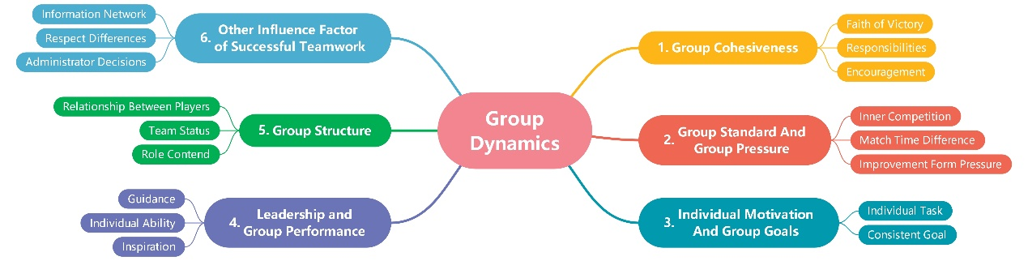

Figure 1 Group Dynamics Mind Map

### 4.4.1 团体动力学与soccer team

团体动力学主要包括五个方面的内容：团体内聚力，群体压力和群体标准，个人动机和群体目标，领导与群体性能以及群体的结构性。

Group dynamics mainly includes 5 aspects: group cohesiveness, group pressure and group standards, individual motivation and group goals, leadership and group performance and group structure.

#### 4.4.1.1 群体内聚力group cohesiveness

群体内聚力可以指球队想赢的信念，群体压力是来自外界的压力。提高群体内聚力是提高球队赢球信念的良性循环。责任性行为体现在每个球员各司其职。成员之间的相互影响表现在球员间的相互鼓励，相互进步。

Group cohesion can be regarded as the belief that the team wants to win. Group pressure comes from the outside. Improving group cohesion is a virtuous circle to inspire the team's winning belief. Responsible behavior is reflected in each player's performance. The mutual influence among the members is reflected in the mutual encouragement and progress among the players.

Huskies在比赛中承担着对手的压力，同时也充满着求胜的斗志。在Huskies球队的数据分析中，每个人场均acceleration、跑动距离和热点图的有效面积等数据都可以反映每个人在球场上的态度和努力。在落后、平局、领先的情况下，团队承受着不同的外在压力，球员反映态度的数据也会波动，若能在平局和落后的情况下依然有着不逊领先时候的positive数据，那我们可以认为群体内聚力强大。

The Huskies is under the pressure of their opponents in the competition, but also full of victorious spirit to win. In data analysis of Huskies, each players' average acceleration, running distance and effective area of heatmap can reflect the particular player's attitude and effort on the court. In the situation of backwardness, draw and lead, the team bears varying degrees of external pressure, as the result, the data of players' attitude will fluctuate. If there is still positive data in the situation of draw and backwardness, we can consider that the group cohesion is really strong.

#### 4.4.1.2 群体标准和群体压力Group standard and Group pressure

群体标准可以帮助球队和球员更有压迫感，相互竞争是提高个人能力，由此观之，适当的群体压力是有必要的，有竞争才会有发展。

Group standards can help teams and players to feel more oppressive and to compete with each other, which helps improve personal ability. From this point of view, appropriate group pressure is necessary, and only when there is competition can there be development.

在Huskies球队中存在出场时间的差异，核心球员和边缘球员的出场时间差距巨大，导致了边缘球员在球队中会受到核心球员技术、地位上的压力，但这也激励了他们努力获得出场时间来证明自己。可以分析每个球员每一场比赛评价的趋势，尤其是不能获得稳定出场时间的球员们，他们的评价若能在有限的出场中得到一定提升，则可以认为对内竞争带来的压力使他们进步。

For Huskies, there are differences in minutes. There is a huge gap between the core players and the edge players, which leads to the edge players in the team will be under the pressure of the core players' ability and status, but it also encourages them to strive to get playing time to prove themselves. We can analyze the evaluation trend of every game of players, especially the players who can't get stable playing time. If their evaluation can be improved in limited playing chances, we can think that the pressure brought by internal competition makes them progress in a way.

#### 4.4.1.3 个人动机和群体目标Individual motivation and group goals

群体目标影响群体行为，当球队的目标和球员的目标达成一致时，球员会表现出最为强烈的求胜动机，努力为进球而拼搏。

Group goals affect group behavior. When team goals and players' goals are consistent, players will show the strongest motivation to win and strive for goals.

球队每个位置的球员有不同的职责，而胜利则是所有球员都较为完美地完成了自己的任务。因此每个人在胜利的目标上是相同的，而且每个人对自己的职责存在一定的期望，当所有人同时为着自己任务完成的期望而努力，群体目标便达成一致。

Players in every position of the team have different responsibilities, and the victory is that all players have completed their tasks perfectly. Therefore, everyone is the same in the goal of victory, and everyone has certain positive expectations for their own tasks. When everyone works hard for the expectation of completing their own tasks at the same time, the group goals will reach an agreement.

#### 4.4.1.4 领导与群体性能 Leadership and group performance

在球队中，领导者有两种，可以是为球员提供训练，赛前指导和赛后总结的教练，也可以是在赛场上鼓舞士气，树立榜样和调度指挥的队长。领导者的能力会影响球队的发挥和球队的进步。此外，教练和队长对球员的关照可以很好地鼓提高队内活力。

There are two kinds of leaders in the team, they are the coaches who provide training, pre-match guidance and post-match summary for the games, or the leaders who inspire morale, set an example and dispatch the command on the field. The ability of leaders will affect the team's performance and progress. In addition, the coach and the captain's help to the players can improve the team's vitality.

#### 4.4.1.5 群体的结构性Group structure

当一个球队在球员关系稳定时，拥有了一定的球队结构。稳定的结构有利于培养球员间默契，从而有更大的概率赢得球赛。可以认为团队不同高低的地位的人数服从上三角形型分布，而若地位极差太大或太小，都不利于团队的稳定性。此外，若球队某一位置竞争极大，而其他位置竞争极小，则会产生结构不平衡的问题，引发结构变化。

When a team has a stable relationship between players, it has a team structure. Stable structure is conducive to the cultivation of tacit understanding among players, so as to have a greater probability of winning the game. It can be convinced that the number of people in different positions of a team obeys the upper triangle distribution, and if the position range is too large or too small, it is not conducive to the stability of the team. In addition, if the competition in one position of the line-up is too great and the competition in other positions is very small, there will be structural imbalance and structural change.

### 4.4.2 successful团队合作其他影响因素Other influence factor of successful teamwork

团队之间还需要有密切、畅通的信息交流网。国际化球队需要确保球员之间的语言交流，能够在球场内外沟通顺畅；此外还要多进行联谊活动，提升队内融洽氛围。这样才能在比赛时做到有效的交流和配合。

领导和每一个人都应该尊重他人与自己间存在的不同，在保持群体目标和内聚力的情况下，通过接受人们之间的差异来改善团队氛围。

管理层要能清晰地认识团队内部的情况，并且有能力为现状变化做调整。

There is also a need for close and unblocked information exchange network between teams. International teams need to ensure that the language communication between players can be smooth on and off the court; in addition, they need to carry out more friendship activities to improve the harmonious atmosphere within the team. In this way, we can communicate and cooperate effectively in the competition.

Leaders and everyone should respect the differences between others and themselves, and improve the team atmosphere by accepting the differences between people while maintaining group goals and cohesion.

Administrators should have a clear understanding of the situation and be able to make adjustments to the situations.