“They departed into their own country another way.”

Our encounter with the Nativity of Christ must change our way. “Twelve Days of Christmas. Day 03”

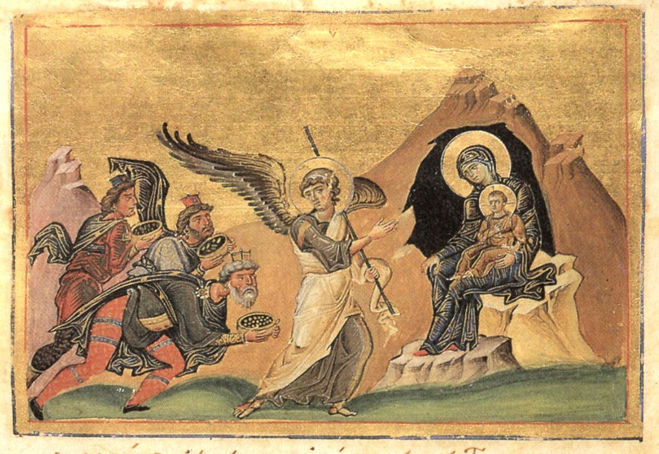

And being warned of God in a dream that they should not return to Herod, they departed into their own country another way. (Matthew 2:12)

This scripture describes what we must do if there is to be a “nativity” in our hearts. As we celebrate the season of the Nativity of the Lord, we must also be continually having a nativity occurring in us. It is described in a previously commented upon hymn regarding the feast:

“Be glad, O human nature, thou barren desert, for the master hath come to make thee bear many children.”

For the event of our Lord’s nativity to have ANY personal meaning for us, our human nature must bear many children – it must give birth to many virtues. This begetting of children by us is the reason why our Lord became incarnate.

This is only possible if we live according to the spiritual meaning of the historical event of the departure of the wise men; it is an imperative to our soul: we must live in “another” way. This way is published all over the Prophets, and especially in the Gospel. It is the way of truth, and light. This way is a difficult one, and not natural to us in the beginning. As we give birth to the virtues, they become easier for us to perform. Make no mistake – we must perform them. Today’s Epistle makes that plain enough:

“Even so faith, if it hath not works, is dead, being alone.” (James 2:17)

May God help us to live in “another way”, which He showed to us, taught us, and enabled us to perform.

“NB” is shorthand for “nota bene” ,which is Latin for “Note well”. These shorter posts are meant to be “noted well” more often because they are briefer than the usual blog posts. I have “noted well” that many of my flock do not read the longer posts. I have a lot of stuff to tell you, so there will still be longer posts, but I also plan to post shorter “snippets” which will have “NB:” in the title.

Priest Seraphim Holland 2010. St Nicholas Russian Orthodox Church, McKinney, Texas

This article is at: http://www.orthodox.net/journal/2010-01-11-nb-they-departed-into-their-own-country-another-way+matthew2-12.doc
&
https://www.orthodox.net/post.html?they-departed-into-their-own-country-another-way-our-encounter-with-the-nativity-of-christ-must-change-our-way-twelve-days-of-christmas-day-03&id=677ed302a1322e0001a24fe0
Use this for any edifying reason, but please give credit, and include the URL of the article. This content belongs to the author. We would love to hear from you with comments! (seraphim@orthodox.net)

From James 2:14-26, read on the 32nd Monday after Pentecost.

