"Oh me of little Faith"

An account of a change of heart at an Abortion clinic
December, 2012

This story, from a sidewalk counselor who prays almost daily at Dallas area abortion clinics, is posted with permission. I have shared a sidewalk with her many times. I hope that especially those who believe the propagandistic lies that people who pray at these clinics harass those entering them will read this. The Abortion industry is filled with many lies, and this one is among them. Read with an open mind. We all pray on these sidewalks, and some of us talk to those who approach us. I don't much have the gift for this, but this woman does; she can tell you stories! The one below is one of them. Priest Seraphim.

...

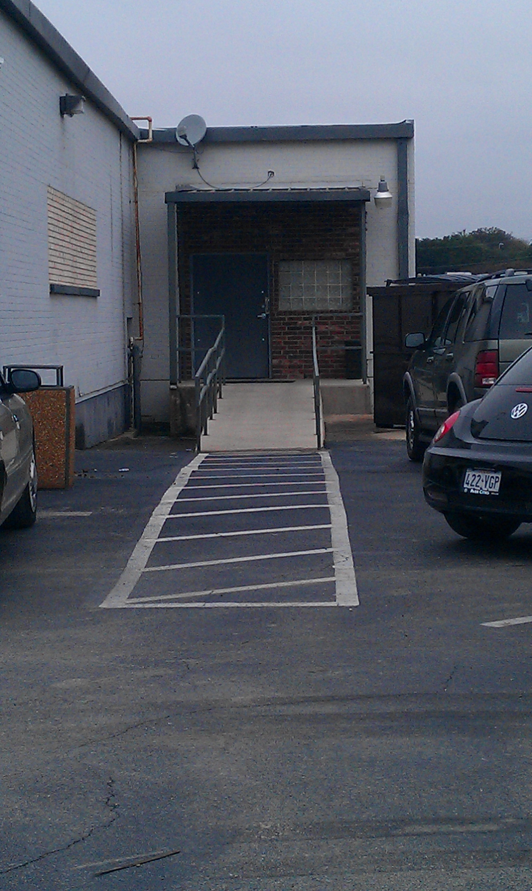
Yesterday. I talked with a young man (I'll call him Samuel) who had just exited from the abortion facility. I remembered the couple coming in... had talked with them a little bit maybe. I think they took literature. Now sitting there in his car, he looked so sad... hurting... somber. A nice looking man... cleanly shaven, neatly dressed, healthy, strong (20's? 30s?), striking features... and somber. Sad eyes... but composed. Samuel smoked a cigarette (not unusual for the fathers to do that), but smoking didn't look to be something he did very much. She had just gone "to the back" (to the abortion room). Now the wait.

I told him we can "hope for a miracle" that she will come out... "Jesus can do that!" (Oh dear God, please come into her heart, protect her, give her strength... bring her out" )

It was the end of our day and though we seldom (almost never but in rare occasions like this one) give out post-abortion/Rachel Vineyard info. We always hope that an abortion won't happen. Samuel had told me that they were recently married. He didn't say "who" was to blame. ("Oh Lord... WHY DID THEY COME HERE???" I cried in my heart.) But for some reason it was placed in my heart to talk about what happens afterwards... not wanting them to just "go away" without having somewhere someone someplace to turn to for help. They would need help, especially if she didn't come out of there soon. It was highly possible the procedure had already started.

This abortion would change their relationship. I explained, "she is going to be 'different' afterwards... and so will you." Samuel kept a steady gaze down at the ground... occasionally looking up. He was open to talk and willing to hear, "Your marriage is going to change. You will both have to forgive each other... for even thinking of doing this. And this may sound harsh..." I paused and he looked straight into my eyes. "You will both have blood on your hands... from now on... with an abortion between you both."

He nodded. He knew. We were both speaking quietly with one another. Some more was said, and both Maria and I had to go... appointments. Many times it is hard to leave the sidewalk. It was particularly hard this time.

Today. We saw one of the women who promised she would call the WRC (women's resource center) for an appointment. We thought yesterday she was a turn-away, as she was crying and said that she "couldn't do it now" after she had seen her baby in the sonogram. She was grateful to know there was free help for her. But today she came in for an abortion instead. The friend with her was smiling and telling us that she worked inside the clinic (she didn't).

Another young woman whose mother had been with her on the previous day, did not return for the abortion. (Praise God!) We were not sure if they would be back for the abortion... or not... a "hopeful".

And yet a different woman approached Maria (SWC) with tears in her eyes. She needed help and Maria walked with her to the nearby WRC. (Praise God! She had already had her 1st appointment at the abortion clinic the day before, but now needed help.) We vaguely remembered her from yesterday... thought she had been alone. We weren't sure. So many come each day. After a few days, we have seen over 100 women plus whoever was with them. Many are repeat "customers".

Again, our time to be out there was almost over and both of us were committed again to be elsewhere. I went back to the WRC to do a little paper work. Finishing up, the sound of a man's voice drifted from somewhere down the hall. I hurriedly stuffed the paperwork in the file cabinet to leave and go to that appointment. Near the front door was the woman who had come crying asking Maria for help less than an hour before. She started crying when she saw me, and started to say those words, "... if you hadn't been there... " There was the man with her (the voice I heard) ... her husband... Samuel! It was Samuel!!

I can not describe the feeling in my heart. I can not describe. I felt myself pulling air into my mouth several times and not being able to let it out... We hugged... all three of us... just holding each other... joyful. We whispered praises to each other. Praises and thanksgivings to God and to each other.

What Happened???!!!

Somehow... somehow the clinic had messed up some paperwork yesterday and the procedure was canceled/postponed (never never heard of that happening before) ... and she came out... into the loving arms of her husband. She and Samuel left that skanky horrible place... and came back today for help... for their baby... for themselves. "What would have happened if.... " she said. It didn't. Open hearts... protected... strengthened... The Lord poured graces in great abundance.

Praising Holy Triune God... still...this night... with all our hearts.

Priest Seraphim Holland 2012 St Nicholas Russian Orthodox Church, McKinney, Texas

This article is at:
http://www.orthodox.net/articles2012-12-14+o-ye-of-little-faith+miracle-at-an-abortion-clinic.html

http://www.orthodox.net/articles2012-12-14+o-ye-of-little-faith+miracle-at-an-abortion-clinic.doc

New Journal entries, homilies, etc. are on our BLOG: http://www.orthodox.net/redeemingthetime
Articles Archive: http://www.orthodox.net/articles
Journal Archive: http://www.orthodox.net/journal

Blog posts & local parish news are posted to our email list. Go to here: http://groups.google.com/group/saint-nicholas-orthodox-church to join.

Redeeming the Time BLOG: http://www.orthodox.net/redeemingthetime
Use this for any edifying reason, but please give credit, and include the URL of the article. This content belongs to the author. We would love to hear from you with comments! (seraphim@orthodox.net)

the picture is of the back door ar Robinson's abortion clinic, where the women are wheeled out after their abortion. If you look at the eyes of the women, before they enter the "back room" and as they are leaving it, you will know how evil abortion is.
One way that you can describe how is that "This was a "God" thing" (priest seraphim)

