"Philip findeth Nathanael, and saith to him, "We have found the One of Whom Moses in the law, and the prophets, wrote— Jesus the son of Joseph, Who is from Nazareth." ⁴⁶ And Nathanael said to him, "Out of Nazareth can there be any good thing?" Philip saith to him, ‘Come and see.’" John 1:45-46

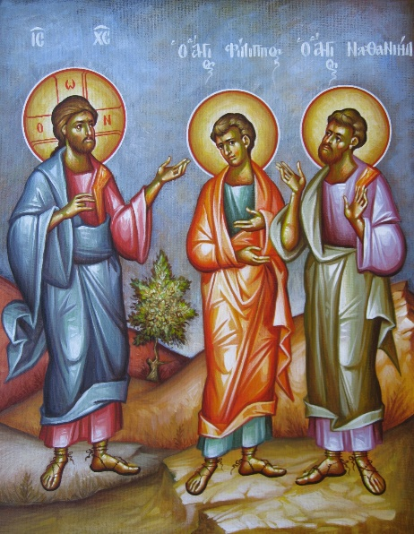
This exchange between Philip and Nathaniel contains all of the Christian life in microcosm.

Because of our passions, ignorance, and laziness, we are beset with doubts. Everyone has them. Those who live a stricter internal life have fewer of them, and when they do have doubts, they know exactly what to do with them. But most of us do not know how to deal with our doubts, often because we do not recognize them.

Most people allow their lives to be riddled with doubts, but most of our doubts are not expressed as discrete thoughts that we can be aware of. They are expressed more often in our attitudes and priorities, and the things we value and the things we do not value. Most of our doubts are not expressed exactly as Nathaniel expressed his doubt. He knew Nazareth was a place of ill repute riddled with Gentiles, and it was hard for his Jewish mind to comprehend that the Messiah could come out of such a squalid place. That's why he said: "Can any good thing come out of Nazareth?"

We have doubts that are not so clearly expressed. We express those doubts when we choose something worldly rather than something spiritual. Why do we choose it? Because we get a result from the worldly things faster, and the things that we do that are spiritual do not give immediate results.

And so we equate results with efficacy. Actually, the fruits of the spiritual life manifest slowly, and usually not immediately after our exercises. because we are accustomed to getting results from things that are secular very quickly, we often reject the spiritual life, but not outrightly. Our rejection of the spiritual life is not where we say: “I don’t believe this,” but where we act like we don’t believe. Our rejection stems from our prioritizing of secular things over spiritual matters, and our inability to maintain a regular prayer life or read regularly (DAILY!) the Psalter and Gospels. Our rejection is in saying that we have “things to do” and therefore cannot go to the service. Our rejection is in indulging our thoughts about someone, such as anger, lust, or judgment, and not forcing ourselves to think and act in a Christian way.

Of course, we don't consider ourselves to be unbelievers, but when we live in a secular way, we are basically unbelievers. When we value business or pleasure or the drumming of life more than our prayer rule, then we are basically living like unbelievers.

Therefore, there is a lot of Nathaniel in all of us, at least the part that doubts. May we also have the part of Nathaniel that Christ complemented, that we would be a person without guile. Could you imagine being without guile: that you would never lie to yourself about anything, and you would always believe that exact spiritual truth of everything? And of course, if we believe the truth about everything, then we would be true to everyone else as well. All we would be without guile! And we would see God because Scripture tells us that “blessed are the pure in heart for they shall see God,” and a pure heart is completely without guile.

Of course, the fruit of Nathaniel's meeting with Philip and hearing his challenge was that Nathaniel met Christ, became a disciple, and later an apostle, saw amazing things, and had his soul changed to become perfected forever. This is the Christian Life. We do things that are the right thing to do, even though we do not get immediate results from them, and we become changed and eventually perfected.

There is no belief without experience. God manifests himself to us, but not in the ways that we might expect. He often manifests Himself to us when we are laboring, when we have difficulties, when we are sad and even despondent, and often, very tired in our spirit, and when we have a “Nazareth” in front of us and we believe that it is or we are too broken for us to receive any benefit from it. That Nazareth can be our life situation, relationships that have gone awry, or just the feeling in the soul when it is at loose ends, not feeling the love of God very much. That and many other things are our Nazareth, and we must take the instruction of Philip to heart and “come and see.”

We come and see by having a regular prayer rule, by reading the psalter and the gospels every day, by praying for others even when they don't seem to be getting any better, or perhaps they're dead and they died in a bad state! We come and see by being kind to those who are unkind, by not judging those who judge us, and by being quiet when we are slandered, even though it hurts. We come and see by acting like Christ to the best of our poor abilities when we want to lash out as a man of the world. And perhaps we do not receive our answer immediately as Nathaniel did, but we will receive our answer.

Remember that Nathaniel saw Christ and was amazed and recognized something holy in Him right away, but then he went through three and a half years of training and there were a lot of disappointments in that training, and he was just like the other apostles who ran away when the Lord was captured in Gethsemane. But he had learned a lot of things up to that point, and he was willing to wait, afraid for his life, to see what would transpire. And he saw a horrific false trial, and his Lord crucified naked on the cross, and put in a tomb and apparently, all good things coming to an end. But still, because he had experienced so many things, he waited in order to see what would transpire. And of course, then the resurrection, and the visitations of Christ, his Ascension, and then finally the sending of the Holy Spirit, and Nathaniel truly was rewarded for his patience.

Let’s be like Nathaniel! Let’s be patient. Let’s come and see, and let that be our watchword for every single thing we do during the day. and let us also have his virtue, even if only in a small measure, that we would be honest with ourselves and others, and God will enter our heart and we will experience Him from within. And any experience of God within the heart cannot be gainsaid or explained away, and it will not fade like worldly pleasure, but it will be permanent and all succeeding experiences of God will build us up to perfection where there will be no darkness in our heart, and no sickness or sighing in our soul, but only life everlasting.
Document:
https://www.orthodox.net/posts/come-and-see-recognize-and-resist-your-nazareth-john-1-56-46
http://www/orthodox.net/articles/come-and-see_john1-46-47.docx
http://www/orthodox.net/articles/come-and-see_john1-46-47.pdf

