PRAYER OF HABBAKUK - Not the most famous part, but the most important conclusion.

Dec 2/15 2023
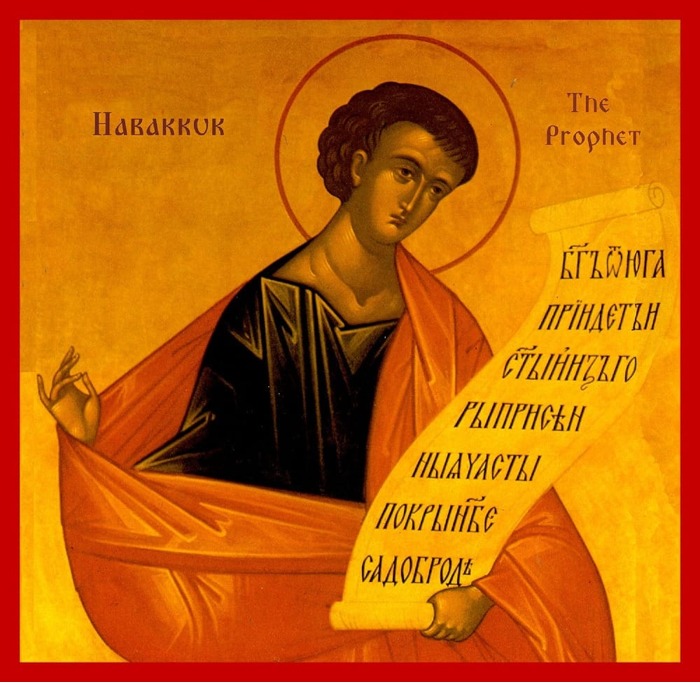

“For though the fig-tree shall bear no fruit, and there shall be no produce on the vines; the labour of the olive shall fail, and the fields shall produce no food: the sheep have failed from the pasture, and there are no oxen at the cribs; 18 yet I will exult in the Lord, I will joy in God my Saviour. 19 The Lord God is my strength, and he will perfectly strengthen my feet; he mounts me upon high places, that I may conquer by his song.” Habbakuk 3:17-19

The prophet Habakkuk is commemorated today, Dec 2/15. This is the end of his famous prayer. It seems to me that we could repeat this prayer every day because surely there will come a time when our soul will be sorely afflicted, and we will need to remember God's mercy will not be stopped by anything. I consider it to be a recapitulation of the beginning of the prayer, when Habakkuk, with complete confidence, says: "When my soul is troubled, thou wilt in wrath remember mercy."

The hope and patience of Habakkuk are manifest here, and we should emulate him. It is a dogmatic truth, a moral certitude, that when the Christian soul is troubled, and yet believes and hopes in God, there will be mercy. We need patience, and patience is only born from experience and endurance. Only those who live by faith will have enough endurance to amass enough experience to truly know God and His mercy.

......

We regularly hear a portion of the beginning of his prayer in the fourth Ode of the Matins canon. It is a prophecy about the coming of Christ: "O Lord, I have heard thy report, and was afraid: I considered thy works, and was amazed." Below is a fuller excerpt to give context. These words are beautiful and mysterious.

“3:1 A PRAYER OF THE PROPHET AMBACUM, WITH A SONG. 2 O Lord, I have heard thy report, and was afraid: I considered thy works, and was amazed: thou shalt be known between the two living creatures, thou shalt be acknowledged when the years draw nigh; thou shalt be manifested when the time is come; when my soul is troubled, thou wilt in wrath remember mercy. 3 God shall come from Thaeman, and the Holy One from the dark shady mount Pharan. Pause. 4 His excellence covered the heavens, and the earth was full of his praise. And his brightness shall be as light; there were horns in his hands, and he caused a mighty love of his strength. 5 Before his face shall go a report, and it shall go forth into the plains, 6 the earth stood at his feet and trembled: he beheld, and the nations melted away: the mountains were violently burst through, the everlasting hills melted at his everlasting going forth. 7 Because of troubles I looked upon the tents of the Ethiopians: the tabernacles also of the land of Madiam shall be dismayed.”

Thaeman means "South". The beginning of his prayer describes the coming of the Messiah, the God-man Jesus Christ. This prophecy has not been completely fulfilled, as in his first coming, Jesus came as a poor man and as a persecuted king, and in the next coming, he will be completely Victorious, and all who love him will worship Him. The second Canon in the 4th Ode of the Nativity Matins Canon cannons explains the prophecy of Habakkuk a little bit:

Canon II of the Nativity, in Tone I Irmos:
Singing of the restoration of the human race of old, the Prophet Habakkuk, vouchsafed to behold the figure ineffably, uttered prophecy. For the Word, a little Babe, is come forth from a mountain —the Virgin —unto the renewal of peoples. If you look carefully, there are several Prophets commemorated during the Nativity fast.

