The Legend of the Wheat Famine

In addition to several stories that speak of St. Nicholas, the guardian of sailors, there is also the legend that credits him with powers to multiply grain during a period of famine. This is one of the oldest St. Nicholas legends. Three early Byzantine versions exist.

According to The Golden Legend:

“It was so on a time that all the province of S. Nicholas suffered great famine, in such wise that vitaille failed. And then this holy man heard say that certain ships laden with wheat were arrived in the haven. And anon he went thither and prayed the mariners that they would succour the perished at least with an hundred muyes of wheat of every ship. And they said: ‘Father we dare not, for it is meted and measured, and we must give reckoning thereof in the garners of the Emperor in Alexandria.’ and the holy man said to them: ‘Do this that I have said to you, and I promise, in the truth of God, that it shall not be lessed for minished when ye shall come to the garners.’ And when they had delivered so much out of every ship, they came into Alexandria and delivered the measure that they had received. And then they recounted the miracle to the ministers of the Emperor, and worshipped and praised strongly God and his servant Nicholas. Then this holy man distributed the wheat to every man after that he had need, in such wise that it sufficed for two years, not only for to sell but also to sow.” (Jacobus de Voragine, “The Golden Legend: Lives of the Saints,” translated by William Caxton, pp. 64-65)

Another version states that during a period of famine in Lycia, a grain ship, which is about to call at the port of Andriake, is hit by a violent storm. It’s pierced by a rock and sinks in the bay. Bishop Nicholas himself appears at the shore and, after much difficulty, the entire crew is saved.

The bishop, however, remains in prayer on the quay; he stills the waves, which then recede. The storm ceases to roll the waters in the harbor, the level of the sea falls, and the wrecked vessel and its spilled cargo become visible.

When the bay is entirely dry, a new miracle comes to pass: the grain sows itself! It shoots up, grows and ripens before the astonished eyes of the people on shore. The people who until then have watched in awe hurriedly begin to reap the rich harvest, only to discover that a divine hand is assisting them again. The threshing and storing is done in the same miraculous way, so that when Nicholas gives the sign and the sea reclaims its rights, the storehouses of Myra are full of precious grain.

Another version of the legend states that five years after Nicholas died, there’s a dangerous famine. St. Nicholas appears as a phantom to a man called Theodolus, and urges him to hold a service of petition at his tomb in Myra. The congregation complies and gathers that night at the tomb. There’s a fierce earthquake at midnight, the coffin opens, and the odor of myrrh that comes from it satiates the starving and helps the blind and the lame.

A few days later, St. Nicholas appears as a patriarch, wearing a miter that seems to be made of fiery flames. He walks across the water to board five grain ships traveling from Cyprus to Constantinople. He purchases grain, makes a down payment, and urges the captains to take their boats to Myra. But the devil convinces them that the whole thing is a fraud, and they refuse to change course. When a storm arises and then quiets down, they change their minds and follow St. Nicholas’ orders after all.

They land in Myra, calm the population, tell them what has happened, and sell the grain to them. When they visit the tomb of St. Nicholas, they recognize that it was he who appeared to them. They place the down payment on his grave as an offering, and the people hold a feast in his honor.

St. Nicholas emerges from these legends as a forceful and resourceful hero, a fighting Saint who defeats his enemies, and who stands by his people in times of need – by normal as well as miraculous means, during his lifetime and even after his death.

Thought to Ponder: As early as the 1830s newspapers in America were filled with blandishments designed with “Christmas shoppers” in mind. Everything from raisins for baked goods to pianofortes for the parlor to uplifting books for the mind and soul were pushed via the papers. Merchants were quick to realize the potential of the gift-giving season and capitalize on the growing importance of Christmas. Santa Clauses had begun to appear on street corners and in stores by 1850. Philadelphia storeowners were among the first to offer seasonal employment to those willing to impersonate Santa.

The trend did not go unnoticed. A Terre Haute (Ind.) newspaper editor commented on the frivolity associated with the 1855 season. He was bemused by the “gambol,” gift exchanges, and the person of “Santa Clause” that seemed to dominate the holiday. He wondered if such behavior was the proper way of celebrating the birth of Christ. In a telling comment, he noted that it was probably already too late to change things, as the trend was already well established.

Thought to Discuss around the Dinner Table: While others are pushing and shoving, how can we each remind the cashiers and sales clerks that the real reason for the season is the birth of our Lord and God and Savior, Jesus Christ?

How can we do this all year round? Perhaps by sharing with them what this holy season is all about. How can we find ways to share our joy as Ephrem the Syrian did?

“The Lofty One became like a little child, yet hidden in Him was a treasure of Wisdom that suffices for all. He was lofty but He sucked Mary’s milk, and from His blessings all creation sucks. He is the Living breast of living breath; by His life the dead were suckled, and they revived. Without the breath of air no one can live; without the power of the Son no one can rise. Upon the living breath of the One Who vivifies all depend the living beings above and below. As indeed He sucked Mary’s milk, He has given suck – life to the universe. As again He dwelt in His mother’s womb, in His womb dwells all creation. Mute He was as a babe, yet He gave to all creation all His commands.” (Ephrem the Syrian, Hymns, Hymn 4:148-155)

“You are the Son of the Creator, Who resembles His Father. As Maker, He made Himself in the womb; He put on a pure body and emerged; He made our weakness put on glory by the mercy that He brought from His Father’s presence.” (Ephrem the Syrian, Hymns, Hymn 9:2)

The Legend of the Wheat Famine

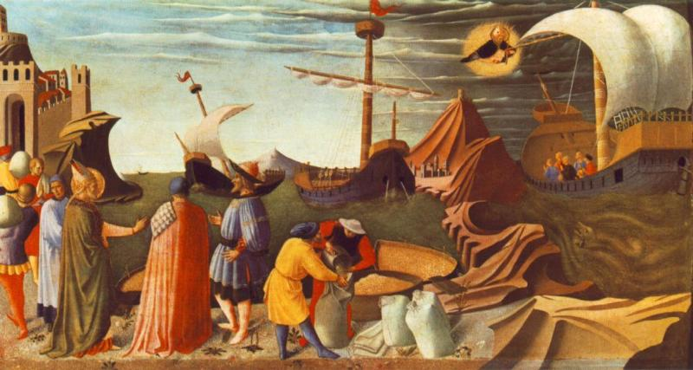
It’s so easy to lose sight of the Lord during the Christmas season when you’re overwhelmed with commercials, errands to run, presents to purchase and wrap, meals to prepare, and decorations to hang. In the legend of the wheat famine, St. Nicholas teaches us that trusting the Lord is more important than all the business matters around us.

