11
AKATHIST HYMN TO THE THEOTOKOS,
THE INEXHAUSTIBLE CUP

Commemorated: May 5/18
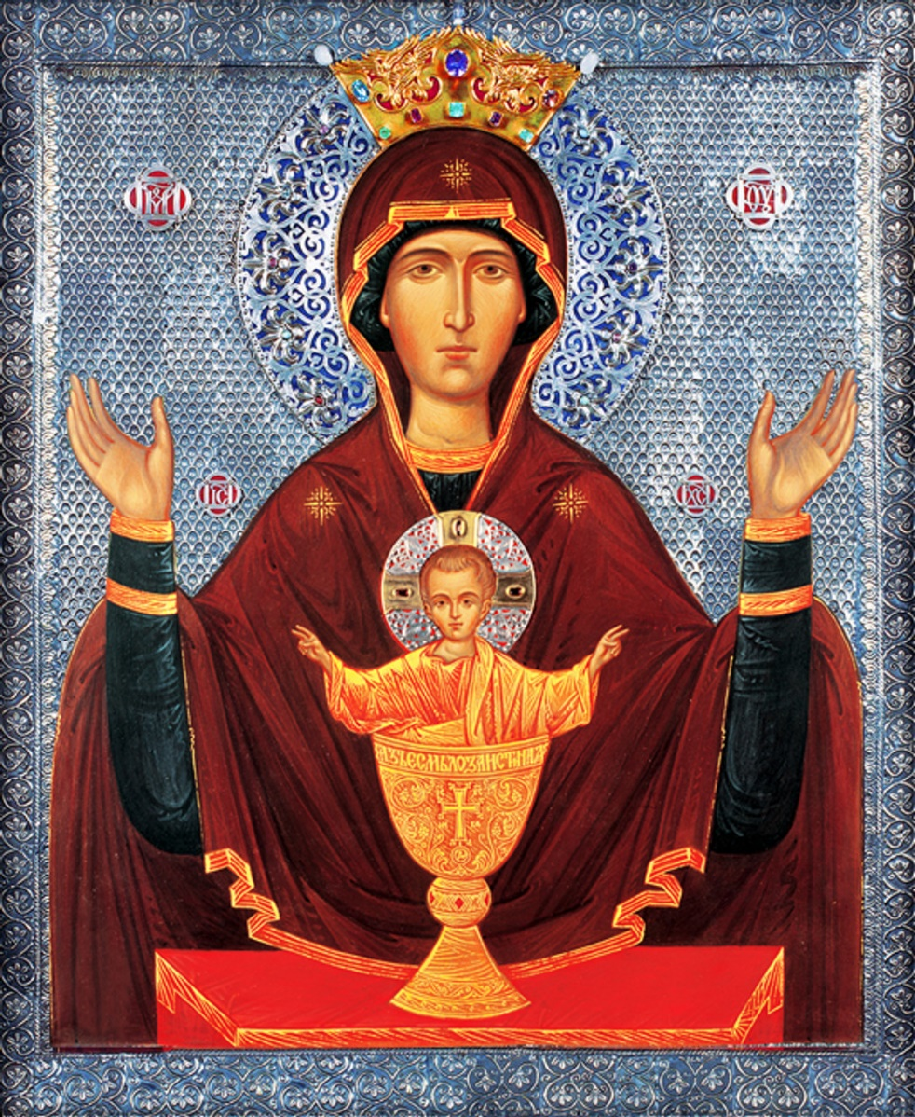

Story: https://orthochristian.com/93802.html
Fellowship: https://www.inexhaustiblecup.org/
This document: http://www.orthodox.net/services/akathist-hymn-to-the-theotokos-inexhaustible-cup.docx
http://www.orthodox.net/services/akathist-hymn-to-the-theotokos-inexhaustible-cup.pdf

Troparion tone 4:

Today we faithful come to the divine and miraculous Icon of the Most Holy Theotokos, who fills the faithful from the Inexhaustible Cup of her mercy and shows them great miracles; and we who have seen them and heard of them rejoice in our heart and cry out, with deep feeling and devotion: O all-merciful sovereign Lady, heal our ills and our passions by praying to thy Son, Christ our God, that He may save our souls!

Kontakion 1
A wonderful and marvelous healing has been given to us through thy holy icon, O Sovereign Lady Theotokos. By its appearance we have been delivered from spiritual and physical afflictions, and from sorrowful circumstances. Therefore we bring thee our grateful praise, O all-merciful Protectress. O Sovereign Lady of “The Inexhaustible Cup”: bend down thine ear and mercifully hear our sighs and heartfelt cries that we bring to thee, and give deliverance to those who suffer from drunkenness, so that we may call to thee with faith:
Rejoice, O Sovereign Lady, Thou Inexhaustible Cup that quenches our spiritual thirst!

Ikos 1
The angelic powers and requires of the righteous unceasingly glorify thee, O Theotokos, Queen of all, Intercessor for us sinful Christians wallowing in lawlessness and continuing in sin. It is for our consolation and salvation that thou in thy mercy didst give unto us thy miraculous icon. Looking at it, as at the brightest star amidst a multitude of stars, we may fall down before thy holy icon of “The Inexhaustible Cup”, calling out from the depths of our hearts:
Rejoice, dwelling-place of the unapproachable Godhead.
Rejoice, our constant wonder in goodness.
Rejoice, for thou dost make our sorrow wipe away our sins.
Rejoice, for thou dost make our grief heal our afflictions.
Rejoice, through thy miraculous icon, thou dost give us thy heavenly mercy.
Rejoice, through thine intercession, thou dost give peace to our troubled heart.
Rejoice, our wonderful reconciliation with God
Rejoice, Queen who opens the gates of Paradise.
Rejoice, O Sovereign Lady, Thou Inexhaustible Cup that quenches our spiritual thirst!

Kontakion 2
Upon seeing the profound sorrow and grief of people possessed by the destructive ailment of drunkenness, and also seeing their true repentance, thou hast willed, most holy Lady, to show thy mercy to the blessed city of Serpoukhov by the appearance of thy miraculous icon, “The Inexhaustible Cup.” All that fall down before it with faith and a contrite heart will receive healing from this grievous illness, and thus may cry to God with adoration: Alleluia.

Ikos 2
Having understood the meaning of the threefold apparition of Saint Varlaam, and his order to go to the city of Serpoukhov, the man possessed by the illness of alcoholism obeyed. There, in a monastery, he found thy holy icon called “The Inexhaustible Cup.” Beholding such mercy bestowed upon us sinners, we cry out to thee with veneration:
Rejoice, through pious people, thou showest us sinners the glory of thy marvelous work.
Rejoice, by thy wise guidance, thou showest us the way of salvation.
Rejoice, by thy goodness, thou attracts us to thyself and dost teach us purity.
Rejoice, by bestowing upon us thy rich blessings, thou dost teach us gratitude.
Rejoice, by making us see hope beyond doubt, thou dost give us gladness of heart.
Rejoice, by healing our infirmities, thou dost renew our zeal for the Kingdom.
Rejoice, for thou dost destroy our destructive passions.
Rejoice, for thou dost help us in our good intentions.
Rejoice, O Sovereign Lady, Thou Inexhaustible Cup that quenches our spiritual thirst!

Kontakion 3
The power of the Almighty and the grace of the Sovereign Mother of God strengthened a man suffering from alcoholism. In obedience to an order of the Theotokos, given to him by Saint Varlaam, despite his paralyzed legs, he set out for the city of Serpoukhov. Upon his arrival, he found the icon of the most pure Theotokos, and was healed from illness of the soul and of the body. Therefore, he fervently cried to God in thanksgiving: Alleluia.

Ikos 3
Thou art an inexhaustible fountain, O Theotokos, a cup of heavenly gifts who always remains full. The people of the city of Serpoukhov, as well as all the Orthodox from every city and village that come to thy most wonderful icon, “The Inexhaustible Cup,” are thereby healed. For this cause, with grateful lips we call to thee:
Rejoice, vessel of holy water which dissolves our sorrow.
Rejoice, cup by whom we receive the joy of our salvation.
Rejoice, for thou dost attend to our spiritual and physical ills.
Rejoice, for thy prayers tame our passions.
Rejoice, for thou dost give to each according to his needs.
Rejoice, for thou dost give generously to all who repent.
Rejoice, for thou hast opened for us the treasury of thy compassion.
Rejoice, for thou dost show tender mercy to the fallen ones.
Rejoice, O Sovereign Lady, Thou Inexhaustible Cup that quenches our spiritual thirst!

Kontakion 4
People laden with passions and addictions, doubting of ever finding deliverance, come with repentance to thine inexpressible mercy. Thus, having been healed, with all their mind and soul they cry out in reverence to our Savior born of thee: Alleluia.

Ikos 4
Upon seeing the sorrow and tears of parents, spouses and children whose family member is possessed by the passion of addiction, the Lord gave us thy icon, O Theotokos. All that come to it receive consolation and spiritual joy. We therefore cry out to thee with tears of gratitude:
Rejoice, lamb, for thou gavest birth to the Lamb of God.
Rejoice, ladle who draws up joy from the source of immortality.
Rejoice, alleviation of the grief of sorrowing mothers.
Rejoice, abundant hope of the hopeless.
Rejoice, for thou dost compassionately bestow joy upon those in grief.
Rejoice, for thou dost graciously protect those that show thee reverence.
Rejoice, for thy helping hand is there for those that seek it.
Rejoice, for thy heavenly protection shelters mortals in distress.
Rejoice, O Sovereign Lady, Thou Inexhaustible Cup that quenches our spiritual thirst!

Kontakion 5
Most gracious Lady, thou hast shown thy holy icon to be the star that leads to God. Beholding the icon and praying to thee, we cry: O Theotokos, give healing to those that are suffering from drunkenness and any other illness of mind and body. Teach us all to praise thy Son and our God, singing: Alleluia.

Ikos 5
Mother of God, upon seeing the wonders granted to those that humbly venerate thee, and the healings that pour forth from thy icon that miraculously appeared in Serpoukhov, and also from those that were copies of it, we rightfully cry out to thee:
Rejoice, for thou dost protect the destitute that bow to thee in supplication.
Rejoice, for thou dost hear our simple prayers.
Rejoice, for thou hast blessed the city of Serpoukhov.
Rejoice, for thou hast revealed the glory of thy miracles among the people of Moscow.
Rejoice, strength and refuge of those that strive for sobriety.
Rejoice, almighty help to those that fight against the world, the flesh, Satan, and addictions.
Rejoice, defender of those that lead a virtuous life in this world.
Rejoice, support of those that resist the lures of the devil.
Rejoice, O Sovereign Lady, Thou Inexhaustible Cup that quenches our spiritual thirst!

Kontakion 6
Lady Theotokos, we proclaim thy wonders that pour forth from thy icon, “The Inexhaustible Cup.” With tears we pray to thee: Save us all from the passion of drunkenness and from other addictions and sins. Teach us, O pure one, to abstain from all impurity, so that we may sing to God: Alleluia.

Ikos 6
In the light of the divine glory, thou dost look at thy Son, the Eternal God and Lord Jesus Christ, standing in the chalice as shown on thy icon mysteriously called “The Inexhaustible Cup.” Hence, thou dost graciously pour forth deliverance from drunkenness to those that run to thee and bring this unceasing praise:
Rejoice, for the angelic powers and the human race rejoice together because of thee.
Rejoice, for thy glory surpasses both human and heavenly praise.
Rejoice, for thou hast revealed to us the mystery of the Divine Eucharist by showing the image of thy Son in the chalice.
Rejoice, for thou dost show us the Lamb born of thee, Who is always eaten but never consumed.
Rejoice, for thou dost fill our thirsty souls with water from the Fountain of Immortality.
Rejoice, for through thy maternal love, thou dost receive the forlorn and deserted.
Rejoice, for thou dost not withhold thy blessings even from the most rejected and despised.
Rejoice, for by thy compassion, thou dost pull us all out of the pit of perdition.
Rejoice, O Sovereign Lady, Thou Inexhaustible Cup that quenches our spiritual thirst!

Kontakion 7
A man wanted to thank thee, O Theotokos, for healing him from alcoholism, and so he adorned thy miraculous icon that is in Serpoukhov, singing to God from the depth of his heart: Alleluia.

Ikos 7
We see a new miracle from thy holy icon, O Theotokos. The servant of God, Stephen, a victim of the disease of alcoholism, implored thy maternal intercession and he has been granted a cure. In gratitude, he adorned thy icon with rich gifts, falling down before it and calling to thee with tears:
Rejoice, life-giving fountain of healing.
Rejoice, heavenly cup of divine gifts.
Rejoice, river who carries miracles.
Rejoice, the sea into whom all our passions sink.
Rejoice, for thou dost raise up those that fall under the weight of drunkenness.
Rejoice, for thou dost not turn down gifts of gratitude.
Rejoice, for thou dost hear the prayers of pious people.
Rejoice, for thou dost grant us those of our petitions that are good for us.
Rejoice, O Sovereign Lady, Thou Inexhaustible Cup that quenches our spiritual thirst!

Kontakion 8
It must be strange and incredible for unbelievers to hear that thy icon, “The Inexhaustible Cup,” procures miracles. For those of us that believe in thy words proclaimed about thy first icon, “The grace of the One Who is born of me and my own blessings will always be with this icon,” this present icon also exudes thy mercy. We therefore humbly venerate it, crying to God: Alleluia.

Ikos 8
People suffering from alcoholism and addictions put all their hope in thee, our Sovereign Lady. Mercifully bend down to our ills and our passions. Who but thee, O Theotokos, can pull us out of the pit of perdition and of physical and spiritual misery? We bend our knees before thee in prayer, and we cry out to thee:
Rejoice, for thou dost not reject the prayers of those that have sinned.
Rejoice, for thou dost give thy help to those that truly ask for it.
Rejoice, for thou dost show the depth of thy compassion for the sinner.
Rejoice, for thou dost give courage to those that have lost all hope.
Rejoice, for by thy helping hand, thou dost lift up those that suffer from drunkenness.
Rejoice, for by thy gift of grace, thou dost console those that endure suffering.
Rejoice, for by thy motherly persistence, thou dost nurse our physical and emotional ills.
Rejoice, for by thy merciful intercessions, thou dost prepare our path to salvation.
Rejoice, O Sovereign Lady, Thou Inexhaustible Cup that quenches our spiritual thirst!

Kontakion 9
All the angels are amazed at thy mercy, O Lord, for Thou hast given sinful mankind a strong Protectress and helper. She tenderly looks down upon our weakness, heals those suffering from the bitter disease of drunkenness, and teaches the faithful to sing: Alleluia.

Ikos 9
The most exalted human mind cannot praise enough the appearance of thy glorious icon, O Sovereign Lady. Nor can we sinners bring from our sinful lips a glorification worthy of our Protectress. Having seen countless miracles coming from thine icon, we rejoice in our heart and spirit, and as is proper we proclaim:
Rejoice, for thou dost pour forth miracles from thy holy image.
Rejoice, for thou dost graciously deliver us from painful conditions.
Rejoice, for thou dost put to shame those that deny thee.
Rejoice, for thou dost protect from every evil those that run to thee.
Rejoice, for thou dost fill our heart with love for thy Son and for thyself.
Rejoice, for thou dost show us the narrow path of repentance.
Rejoice, for thou dost help us to bring forth fruits from our renewal.
Rejoice, our only Mediatrix before the Just Judge.
Rejoice, O Sovereign Lady, Thou Inexhaustible Cup that quenches our spiritual thirst!

Kontakion 10
Wishing to save all those that suffer from the disease of alcoholism and other addictions, thou hast shown us thy wonderful icon, O Theotokos, so that all the suffering ones may come to thy miraculous image. Then, after having obtained healing, they may gratefully cry out to God: Alleluia.

Ikos 10
Thou are the wall and the shield, Lady Theotokos, for those that suffer from drunkenness, and also for all those that approach thee with devotion and that piously venerate thy holy icon. The Lord God gave us thine icon to help us, and to heal us from destructive addictions. He thereby inspires us to sing to thee:
Rejoice, for thou dost alleviate our sufferings and give hope to those that despair.
Rejoice, for thou art the healing of our ills.
Rejoice, for with thy purity, thou dost wipe away our corruption.
Rejoice, for by thy holiness, thou dost illumine our gloom.
Rejoice, for with thy cloak of compassion, thou dost clothe our mortal body.
Rejoice, for by thy wonders, thou dost fortify our prayers.
Rejoice, for thou dost make us strong whereas sin made us weak.
Rejoice, for thy radiance disperses the dark clouds of passion and desolation that surround us.
Rejoice, O Sovereign Lady, Thou Inexhaustible Cup that quenches our spiritual thirst!

Kontakion 11
Our pure Mother, do not despise our humble singing that we bring to thee from the fullness of love and zeal, and do not turn away thy face from those that suffer from drunkenness and desperation. Rather, help us, so that we also may be cleansed from every impurity and may rightly and justly sing to God: Alleluia.

Ikos 11 (Serbian Version)
Most holy Lady, on thine icon thou art seen like a burning candle in rays of grace, surrounded by the assembly of saints and holy martyrs. Since thou dost indicate to us the path of righteousness, we call on thee and say:

Rejoice, for, by the prayers of Saint Domnica, thou dost save us from this world of troubles and desires.
Rejoice, for, by her pleading, thou dost help us to overcome the passions of the flesh.
Rejoice, for, by the prayers of the holy martyr Varlaam, thou dost fill our hearts with pious thoughts.
Rejoice, for, by his petitions, thou dost illumine our conscience.
Rejoice, for, by the prayers of the holy martyr Paraskeva, thou dost deliver those that suffer from drunkenness.
Rejoice, for, by her supplication, thou dost call us to repentance and watchfulness.
Rejoice, for, by the prayers of the holy martyr Antipas, thou dost mellow the bitter heart.
Rejoice, for, by his righteous appeals, thou dost save those that call on thy name.
Rejoice, O Sovereign Lady, Thou Inexhaustible Cup that quenches our spiritual thirst!

Ikos 11 (Translated from the Slavonic)
Thou art a luminous light who hast received Light, O Most Holy Virgin, for thy holy image drives away sinful darkness with the rays of thy grace, and guides to the bright path of virtues those who call on thee with faith in this manner:

Rejoice, for thou dost withdraw us away from the vanity of this much-turbulent world;
Rejoice, for thou dost help us repel the attacks of the passions of the flesh.
Rejoice, for thou dost put good thoughts in our hearts;
Rejoice, for thou dost enlighten our darkened conscience.
Rejoice, for thou dost deliver those afflicted by tormenting ailments;
Rejoice, for thou dost call us to sincere repentance and correction of life.
Rejoice, for thou dost strengthen the souls of all those in misfortunes
Rejoice, for thou dost save those who praise thy name.
Rejoice, O Mistress, the Inexhaustible Cup who quenches our spiritual thirst.

Kontakion 12
The grace that shines through thy icon, “The Inexhaustible Cup,” calls to it all those that suffer. All the unfortunate, the widows and orphans, and especially those that are ill with the disease of alcoholism come to thee. No one goes away empty-handed from thy Inexhaustible Cup, O merciful Mother, but all are filled with divine gifts. After having received healing and help, they dutifully sing to thee: Alleluia.

Ikos 12
Praising thy wondrous work and great mercy that thou dost bestow upon those that suffer from addictions, O compassionate Lady, we beg thee: Save us sinners, have mercy upon us, show us the right path, and do not reject us for we seek thy protection and call out to thee:
Rejoice, for, by the light of thy wisdom, thou dost direct us to thy Son.
Rejoice, for, by thy intercessions, thou dost sustain us on the way to sobriety.
Rejoice, for, by the dew of thy mercy, thou dost deliver us from the passions of alcohol and drugs.
Rejoice, for, by thy unceasing care, thou dost heal us from all addictions.
Rejoice, for thou art a speedy help to those that suffer from all kinds of dependency.
Rejoice, for thou dost support those that are even-tempered.
Rejoice, for thou dost humble the prideful.
Rejoice, for thou dost exalt the lowly and dost wish salvation to all.
Rejoice, O Sovereign Lady, Thou Inexhaustible Cup that quenches our spiritual thirst!

Kontakion 13
All-merciful Mother of our Lord and God, Jesus Christ, hear our prayer and deliver us from all ills, physical and emotional. Especially attend to thy servants who suffer from this disease, so that they may not perish, but might be saved and thus sing to God: Alleluia. Alleluia. Alleluia.
Repeat Kontakion 13 three times

Kontakion 1 (Repeated)
A wonderful healing has been given to us through thy holy icon, O Sovereign Lady Theotokos. By its appearance, we have been delivered from spiritual and physical ills, and from sorrowful circumstances. We therefore, offer our thankful praise to thee, O merciful Protectress whom we call “The Inexhaustible Cup.” Bend down thy ear and kindly hear our lamentation. Cast down thy eye and graciously see our tears. Give thy healing to those that suffer from drunkenness, so that we may call to thee with faith:
Rejoice, O Sovereign Lady, Thou Inexhaustible Cup that quenches our spiritual thirst!

Ikos 1 (Repeated)
Angelic powers and multitudes of saints continually glorify thee, the Theotokos, the Queen of all, the intercessor for us sinful Christians wallowing in lawlessness and remaining in sin. It is for our consolation and salvation that thou in thy mercy gavest to us thy miraculous icon. Looking at it, as at the one and only star among a multitude of stars on a starlit night, we fall down before thee and cry from the very depth of our heart:
Rejoice, dwelling-place of the unapproachable God.
Rejoice, our constant wonder in goodness.
Rejoice, for thou dost make our sorrow wipe away our sins.
Rejoice, for thou dost make our grief heal our afflictions.
Rejoice, for through thy miraculous icon, thou dost give us thy heavenly mercy.
Rejoice, for through thine intercession, thou dost give peace to our troubled heart.
Rejoice, our wonderful reconciliation with God.
Rejoice, Queen who opens the gates to Paradise.
Rejoice, O Sovereign Lady, Thou Inexhaustible Cup that quenches our spiritual thirst!

Final Prayer
Hear our prayer, most holy Protectress, for thou art patient with our impurities and charitable with thy Cup of healing and hope, which thou dost pour forth upon those that venerate thee. Those who struggle with addictions are acquainted with the false promises therein, and therefore with weeping beseech thy compassion on this miserable state of being. Those who have husbands or wives, brothers or sisters, children or friends burdened with emotional problems, run to thee for personal courage as well as to ask thy intervention into the lives of loved ones. Have pity upon our twisted paths and heal us, O Theotokos, according to our need and faith and, most of all, according to thy wonderful mercy. Let us find uncorrupted and unspoiled joy in thy kindness, that we may worship thy Son and our God with pure hearts, sober minds, and eternal gratitude. Amen.

