Prayer of Agreement of Intercession and petitions to St Panteleimon
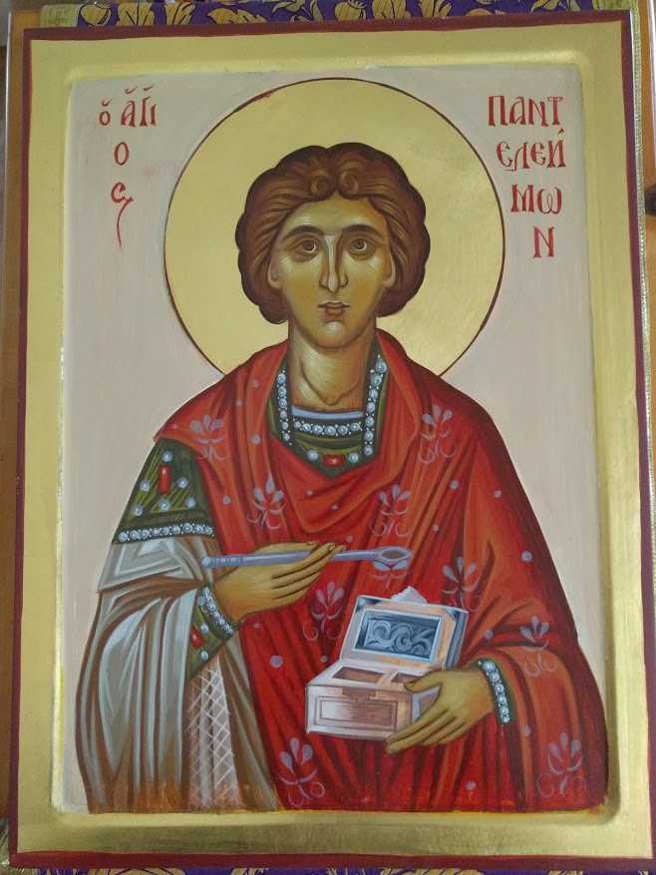
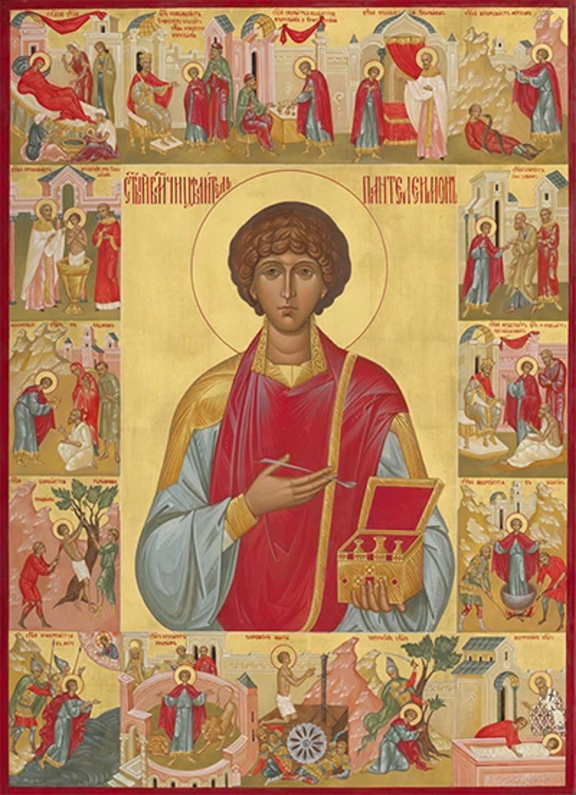
Through the prayers of our Holy Fathers, O Lord Jesus Christ, have mercy on us. Amen.

Troparion (Tone 3) O holy passion-bearer and healer Panteleimon, / entreat the merciful God, that He grant our souls // remission of transgressions.
Kontakion (Tone 5) Emulating the Merciful One, / and receiving from Him the grace of healing, / O passionbearer and martyr of Christ God, / by thy supplications heal thou our spiritual infirmities, / ever driving away the temptations of the foe // from them that faithfully cry out: Save us, O Lord!

----------

O Lord Jesus Christ, grant mercy, life, peace, health, salvation, visitation, pardon, and prosperity for the servants of God,
(Names),
and everyone.
O Physician of souls and bodies, with compunction and contrite hearts we fall down before Thee, and groaning we cry unto Thee: Heal the sicknesses, heal the passions of the souls and bodies of Thy servants,
(Names),
and everyone in need, and pardon them, for Thou art kind-hearted, all transgressions, voluntary and involuntary, and quickly raise them up from their bed of sickness, I pray Thee, hearken and have mercy.

Hearken unto us, O God our Savior, Thou hope of all the ends of the earth and of them that be far off at sea; and be merciful, be merciful, O Master, regarding our sins, and have mercy on us; for a merciful God art Thou, and the Lover of mankind, and unto Thee do we send up glory: to the Father, and to the Son, and to the Holy Spirit, now and ever, and unto the ages of ages. Amen.
Then pick one of the following prayers:

PRAYER TO ST. PANTELEIMON
Great favorite of Christ, most merciful passion-bearer and physician Panteleimon!
Have compassion on me, thy sinful servant, and hearken unto my groaning and my cries; move thou to pity Christ our God, the supreme Physician of our souls and bodies, that He may grant healing of my affliction unto me who am oppressed thereby.
Accept this unworthy supplication from me who am far more sinful than all other men. Visit me with the visitation of grace.
Disdain not the wounds of my sins, but anoint them with the oil of thy mercy, and heal me; that, healthy in soul and body, I may be able, through the grace of God, to pass the remaining days of my life in repentance and the pleasing of God, and may be vouchsafed a good end to my life.
Yea, O favorite of God! entreat Christ God, that by thine intercession He may grant health to my body and salvation to my soul. Amen.
PRAYER TO ST. PANTELEIMON
From "Polny Sbornik Molitv", pp. 214-215: Prayer 3.
Holy Great-Martyr and Healer Panteleimon, thou imitator of God's mercy! Look down in thy loving kindness and hearken unto us, sinners, who offer heartfelt prayers before thy holy icon. Ask for us from the Lord God, before Whom the Angels stand in heaven, remission of our sins and transgressions.
Heal the ills of body and soul of the servants of God whom we here commemorate, who are here present, and of all Orthodox Christians who seek thy help. For behold, we, who because of our sins are possessed by bitter ills and have no help or consolation, yet flee to thee for refuge, since thou hast been given Grace to pray for us and to heal every ill and every disease.
Grant, therefore, to all of us, by thy holy prayers, health and strength of soul and body, a good growth in the Faith and in devotion, and all that is needful unto this temporal life and unto our salvation: So that, having been granted great and rich mercy through thee, we may glorify thee and Him that bestoweth all good things, our God Who is wondrous in His Saints, the Father, and the Son, and the Holy Spirit. Amen.

And then the following prayers:
Prayer of St Silouan of Mount Athos: I pray Thee, O merciful Lord, for all the peoples of the world, that they may come to know Thee by the Holy Spirit.
Protect me, O Lord, from the praise and slander of men. (Evergertinos, Second Book, Hypothesis II , pg 31)

O Lord, let Thy priests be clothed with righteousness; Let them always remember the greatness of their calling; Let them not be entangled in the snares of the world and the devil; Let them be saved from the cares of the world, the delight in riches, and the desire for other things entering into their hearts. (A Prayer for Priests St John of Kronstadt)
Lord Jesus Christ, have mercy on everyone. Amen

The "Prayer of Agreement" is a pious custom among Orthodox Christians. People agree to say a prayer every day, and sometimes agree on the time to say the prayer. I have basically a "prayer of agreement" with the Hermitage of the Holy Cross. They are great venerators of St Panteleimon, and pray a moleben to him after morning service every day. St Panteleimon recently (in 2015) inserted himself into my life, and I have a vigil lamp burning by his icon in my home and pray basically the same moleben they pray, with a few personal editions. I invite anyone who wishes to pray this modified moleben every day. I would appreciate prayers for my sinful self and family. Contact me (mailto:seraphim@orthodox.net) if you agree to say these prayers every day (at least Mon-Sat), and if you ask for the names of my family. I will add your family to my commemorations. Priest Seraphim Holland.
This document: http://www.orthodox.net/services/panteleimon-07-27-prayer-of-agreement-and-readers-moleben-large.doc
This document: http://www.orthodox.net/services/panteleimon-07-27-prayer-of-agreement-and-readers-moleben-large.pdf
http://www.orthodox.net/services/panteleimon-07-27-prayer-of-agreement-and-readers-moleben.doc
http://www.orthodox.net/services/panteleimon-07-27-prayer-of-agreement-and-readers-moleben.pdf

Adapted from the Moleben served every day at the Hermitage of the Holy Cross, Wayne West Virginia and other prayers.
http://www.orthodox.net/services/panteleimon-07-27-moleben-card.doc ; http://www.orthodox.net/services/panteleimon-07-27-moleben.doc

