Thanksgiving Prayers after Holy Communion
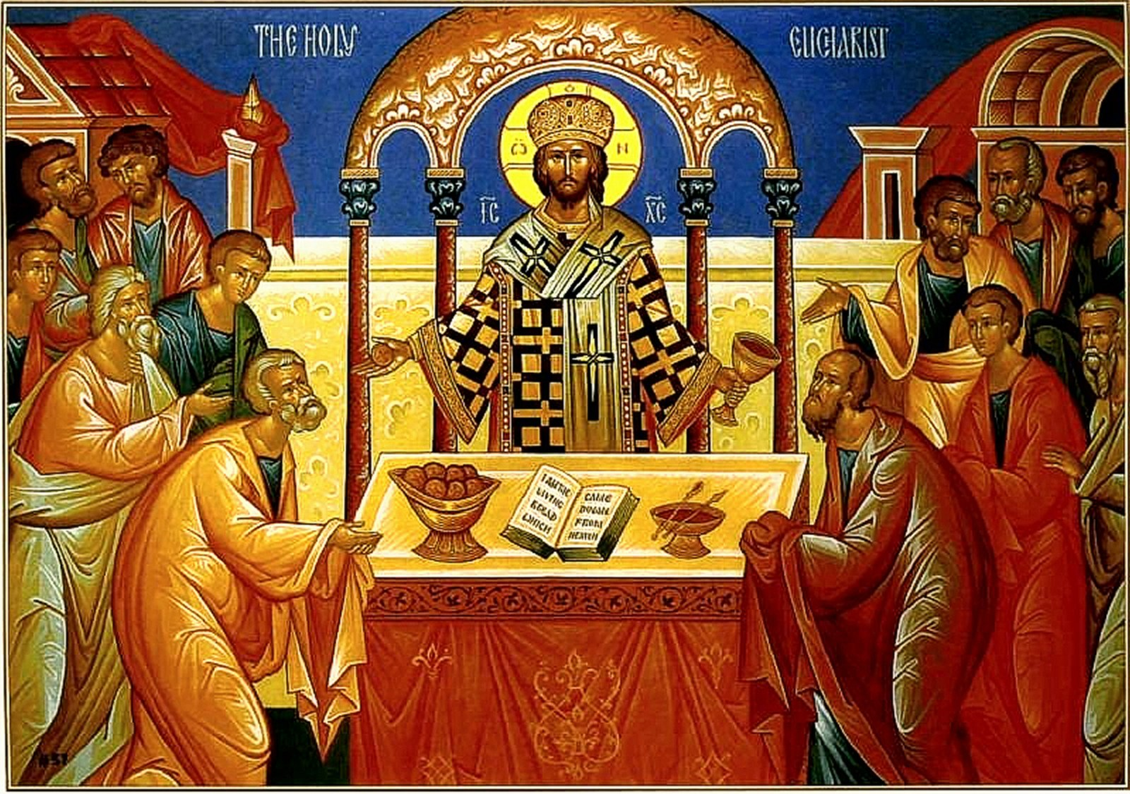

A message to all who will receive it, from Priest Seraphim
The Christian who partakes of the Holy Mysteries must believe in his heart that he is obligated to give thanks to the Lord. This should be an internal feeling. We all struggle with having this internal feeling of thanksgiving. Until we have this feeling perfectly in our heart, we should force ourselves to do things that we know are good for ourselves.
These Thanksgiving prayers should be heard or said by any Christian who communes. They should not be out having coffee or taking a break on the deck or doing anything else. They should not be talking or visiting with others when prayers being said. They should be attentive, to the best of their abilities. This is a learned skill. Like any skill, it takes practice and effort.
It is pretty much impossible to get people to stop talking when they want to talk (such as when everyone is coming forward to venerate the cross after the end of liturgy), so in our parish we are doing the Thanksgiving Prayers *before* the Divine Liturgy ends, when everyone should be still present and paying attention. This is our way of trying to help everyone work on the skill of attentiveness and thanksgiving.
Because we are doing them in the Liturgy and not during the kissing of the cross at the end of the liturgy, we are shortening them somewhat by just saying the prayers and not the troparia.
I humbly ask and require that anyone who plans on taking communion without listening to or saying the Thanksgiving prayers should not take communion in our church. The only exceptions are for those who, for good reason, feel that they have duties to serve the church that will make it impossible for them to listen to the prayers. Everyone must make this decision based with their own conscience and upon consultation with the pastor.
In Christ and with pastoral love, your unworthy Rector, Priest Seraphim, St. Nicholas Orthodox Church, McKinney Texas. 972 658-5433 seraphim@orthodox.net
http://www.orthodox.net
http://www.orthodox.net/services/thanksgiving-prayers-after-holy-communion.docx
http://www.orthodox.net/services/thanksgiving-prayers-after-holy-communion.pdf

Priest: Glory to Thee O God, Glory to Thee O God, Glory to Thee O God

Reader: I thank Thee, O Lord my God, that Thou hast not rejected me, a sinner, but hast vouchsafed me to be a communicant of Thy holy Things. I thank Thee that Thou hast vouchsafed me, the unworthy, to partake of Thy most pure and heavenly Gifts. But, O Lord, Lover of mankind, Who for our sake didst die and rise again and didst bestow upon us these Thy dread and life-giving Mysteries for the well-being and sanctification of our souls and bodies, grant that these may be even unto me for the healing of both soul and body, for the averting of everything hostile, for the enlightenment of the eyes of my heart, for the peace of the powers of my soul, for faith unashamed, for love unfeigned, for the fullness of wisdom, for the keeping of Thy commandments, for an increase of Thy divine grace, and for the attainment of Thy Kingdom; that being preserved by Them in Thy holiness I may ever remember Thy grace, and no longer live for myself but for Thee our Master and Benefactor. And thus, when I have departed this life in hope of eternal life, may I attain unto everlasting rest, where the sound of them that keep festival is unceasing and the delight is endless of them that behold the ineffable beauty of Thy countenance. For Thou art the true desire and the unutterable gladness of those who love Thee, O Christ our God, and all creation doth hymn Thee unto the ages. Amen.
Of St. Basil the Great, 2:
O Master Christ our God, King of the ages and Creator of all things, I thank Thee for all the good things Thou hast bestowed upon me and for the communion of Thy most pure and life-giving Mysteries. I pray Thee, therefore, O Good One and Lover of mankind: Keep me under Thy protection and in the shadow of Thy wings and grant me, even unto my last breath, to partake worthily, with a pure conscience, of Thy holy Things unto the remission of sins and life eternal. For Thou art the Bread of Life, the Source of Holiness, the Giver of good things, and unto Thee do we send up glory, together with the Father and the Holy Spirit, now and ever, and to the ages of ages. Amen.
Verses of Metaphrastes, 3:
O Thou Who givest me willingly Thy Flesh as food,
Thou Who art fire, that doth consume the unworthy,
Burn me not, O my Creator,
But rather enter Thou into my members,
Into all my joints, my reigns, my heart.
Burn up the thorns of all my sins.
Purify my soul, sanctify my thoughts.
Strengthen my substance together with my bones.
Enlighten my simple five senses.
Nail down the whole of me with Thy fear.
Ever protect, preserve, and keep me
From every soul-corrupting deed and word.
Purify and cleanse and adorn me;
Make me comely, give me understanding and enlighten me.
Make me the dwelling-place of Thy Spirit alone,
And no longer a habitation of sin,
That from me as Thine abode through the entry of Communion
Every evildoer, every passion may flee from me as from fire.
As intercessors I offer unto Thee all the saints,
The Commanders of the Bodiless Hosts,
Thy Forerunner, the wise Apostles,
And Thine undefiled pure Mother,
Whose entreaties do Thou accept, O my compassionate Christ.
And make Thy servant a child of light.
For Thou alone art our sanctification, O Good One,
And the radiance of our souls,
And to Thee as our God and Master,
We all send up glory as is meet, every day.
Another Prayer:
O Lord Jesus Christ our God, may Thy Holy Body, be unto me for life eternal, and Thy Precious Blood for the remission of sins; And may this Eucharist be to me for joy, health, and gladness. And at Thy dread Second Coming, vouchsafe me, a sinner, to stand at the right hand of Thy glory, through the intercessions of Thy most pure Mother and of all Thy Saints.
Another Prayer, To the Most Holy Theotokos:
All-holy Lady, Theotokos, light of my darkened soul, my hope, protection, refuge, consolation, my joy; I thank thee that thou hast vouchsafed me, who am unworthy, to be a partaker of the most pure Body and precious Blood of thy Son. O thou who gavest birth to the true Light, do thou enlighten the spiritual eyes of my heart; thou who didst gavest birth to the Source of Immortality, revive me who am dead in sin; thou who art the loving-compassionately Mother of the merciful God, have mercy on me and grant me compunction and contrition in my heart, and humility in my thoughts, and the recall of my thoughts from their captivity. And vouchsafe me until my last breath to receive without condemnation the sanctification of the most Pure Mysteries for the healing of soul and body; And grant me tears of repentance and confession, with which to hymn and glorify thee all the days of my life; For blessed and glorified art Thou unto the ages. Amen.

At St. Nicholas, when we say the prayers
*before the end of divine liturgy*
we end here.
. If a person is saying these prayers privately, or if they are said *after the end of the liturgy*, they should continue here.
Then:

Now lettest Thou Thy servant depart in peace, O Master, according to Thy word: for mine eyes have seen Thy salvation, which Thou hast prepared before the face of all peoples; a light of revelation for the Gentiles, and the glory of Thy people Israel.
Holy God, Holy Mighty, Holy Immortal: have mercy on us Thrice.
Glory be to the Father, and to the Son, and to the Holy Spirit: now and ever, and unto ages of ages. Amen.
All-holy Trinity, have mercy on us. Lord, cleanse us from our sins. Master, Pardon our iniquities. Holy God, visit and heal our infirmities for thy Name's sake.
Lord, have mercy Thrice.
Glory to the Father, and to the Son, and to the Holy Spirit: now and ever, and unto ages of ages. Amen.
Our Father, who art in the heavens, hallowed be thy Name; thy kingdom come; thy will be done on earth, as it is in heaven. Give us this day our daily bread; and forgive us our debts, as we forgive our debtors; and lead us not into temptation. but deliver us from the Evil One.

Priest: For thine is the kingdom, and the power, and the glory, of the Father, and of the Son, and of the Holy Spirit: now and ever, and unto ages of ages. Amen.

Troparion to St John Chrysostom, Eighth Tone:
Reader: Grace shining forth from thy mouth like a beacon hath illumined the universe, and disclosed to the world treasures of uncovetousness, and shown us the heights of humility; but while instructing us by Thy words, O Father John Chrysostom, intercede with the Word, Christ our God, to save our souls.
Glory...
Kontakion, 6th Tone:
From the heavens hast thou received grace, and by thy lips thou dost teach all to worship the One God in Trinity, O John Chrysostom, all blessed righteous one. Rightly do we acclaim thee, for thou art a teacher revealing things divine.
Both now...
O protection of Christians that cannot be put to shame, O Mediation unto the Creator unfailing: Disdain not the suppliant voices of sinners; but be thou quick, O good one, to help us who in faith cry unto Thee; hasten to intercession and speed thou to make supplication, thou who dost ever protect, O Theotokos, them that honor thee.
Lord, have mercy 12 Times
Priest: Most Holy Theotokos save us!
Reader: More honorable than the Cherubim, and beyond compare more glorious than the Seraphim, thee who without defilement gavest birth to God the Word, the very Theotokos, thee do we magnify.
Priest: Glory to Thee, O Christ, our God and our hope, glory to Thee.
Reader: Glory... Both now... Lord have mercy, Lord have mercy, Lord have mercy: Father bless!
Priest: May Christ our true God (Who rose from the dead), through the intercessions of His most pure Mother; and of all the Saints, have mercy upon us and save us, for He is good and the Lover of mankind.
Reader: Amen.

