Table of Contents
TROPARIA FOR THE DAYS OF THE WEEK 2
Monday- The Bodiless Hosts 2
Tuesday- St. John the Forerunner 2
Wednesday and Friday- The Cross 2
Thursday - The Holy Apostles and St. Nicholas 2
Saturday- All Saints, and the Departed 3
Resurrectional Troparia 4
Favorite Troparia 6
Theotokos - "Surety of Sinners" 6
Holy Prophet Daniel and the Three Children 7
St Daniel of Pereyaslavl 7
Great-Martyr & Healer Panteleimon 8
St. Nicholas the Wonderworker 8
St. Seraphim of Sarov 8
St. Nectarios of Pentopolis 9
St. John of San Francisco 9
Holy Hierarch Jonah of Manchuria 9
Great Martyr James of Persia 10
St. John of Kronstadt 11
Elder Porphyrios of Kavsokalyvia 11
Elder Paisios of Mount Athos 11
Saint Silouan of Mt Athos 11
Father Cosmas of Zaire and Zographou 12
Mary of Egypt 12
Blessed Matrona of Moscow 12
Patriarch Joseph the All-Comely 13
Troparion — Tone 4 18
Troparion — Tone 2 18
Kontakion — Tone 8 18
Kontakion — Tone 2 18

TROPARIA FOR THE DAYS OF THE WEEK

Monday- The Bodiless Hosts Troparion, Fourth Tone:
Supreme Commanders of the heavenly hosts, we unworthy ones implore you that by your supplications ye will encircle us with the shelter of the wings of your immaterial glory, and guard us who fall down before you and fervently cry: Deliver us from dangers since ye are the marshals of the hosts on high

Tuesday- St. John the Forerunner Troparion, Second Tone:
The memory of the righteous is celebrated with hymns of praise, but the Lords testimony is sufficient for thee, O Forerunner; for thou has proved to be even more venerable than the prophets, since thou wast granted to baptize in the running waters Him Whom they proclaimed. wherefore, having contested for the truth, thou didst rejoice to announce the good tidings even to those in Hades: that God hath appeared in the flesh, taking away the sin of the world and granting us great mercy.

Wednesday and Friday- The Cross –
Troparion, First Tone:
Save, O Lord, thy people, and bless Thine inheritance; grant Thou unto Orthodox Christians victory over enemies; and by the power of the Cross do Thou preserve Thy commonwealth.

Thursday - The Holy Apostles and St. Nicholas

Troparion for St. Nicholas, fourth tone:
The truth of things revealed thee to thy flock as a rule of faith,/ an icon of meekness and a teacher of temperance./ Therefore thou hast achieved the heights by humility,/ riches by poverty./ O Father and Hierarch Nicholas,/ intercede with Christ God// that our souls be saved.

Troparion, Third Tone

Saturday- All Saints, and the Departed

All Saints - Troparion, Second Tone:
O Apostles, Martyrs, and Prophets, Hierarchs, Monastics, and Righteous Ones; ye that have accomplished a good labor and kept the Faith, that have boldness before the Savior; O Good Ones, intercede for us, we pray, that our souls be saved.

Resurrectional Troparia

Troparion First Tone. When the stone had been sealed by the Jews, and the soldiers were guarding Thine immaculate Body, Thou didst rise on the third day, O Savior, granting life unto the world. Wherefore, the Hosts of the Heavens cried out to Thee, O Life-giver: Glory to Thy Resurrection, O Christ. Glory to Thy kingdom. Glory to Thy dispensation, O only Lover of mankind.

Troparion Second Tone. When Thou didst descend unto death, O Life Immortal, then didst Thou slay Hades with the lightning of Thy Divinity. And when Thou didst also raise the dead out of the nethermost depths, all the Hosts of Heavens cried out: O Lifegiver, Christ our God, glory be to Thee.

Troparion Third Tone Let the heavens be glad; let earthly things rejoice; for the Lord hath wrought might with His arm. He hath trampled down death by death; the first-born of the dead hath He become. From the belly of Hades hath He delivered us and hath granted to the world great mercy.

Troparion Fourth Tone. Having learned the joyful proclamation of the Resurrection from the angel, and having cast off the ancestral condemnation, the women disciples of the Lord spake to the apostles exultantly: Death is despoiled and Christ God is risen, granting to the world great mercy.

Troparion Fifth Tone. Let us, O faithful, praise and worship the Word Who is co-unorignate with the Father and the Spirit, and Who was born of the Virgin for our salvation; for He was pleased to ascend the Cross in the flesh and to endure death, and to raise the dead by His Glorious Resurrection

Troparion Sixth Tone. Angelic Hosts were above Thy tomb, and they that guarded Thee became as dead. And Mary stood by the grave seeking Thine Immaculate Body. Thou didst despoil Hades and wast not tempted by it. Thou didst meet the Virgin and didst grant us life. O Thou Who didst rise from the dead, O Lord, glory be to Thee.

Troparion Seventh Tone. Thou didst destroy death by Thy Cross, Thou didst open Paradise to the thief. Thou didst change the lamentation of the Myrrh-bearers, and Thou didst command Thine Apostles to proclaim that Thou didst arise, O Christ God, and grantest to the world great mercy.

Troparion Eighth Tone. From on high didst Thou descend, O Compassionate One; to burial of three days hast Thou submitted that Thou mightest free us from our passions. O our Life and Resurrection, O Lord, glory be to Thee.

Favorite Troparia

Theotokos - "Surety of Sinners"
Troparion,Tone IV

As thou becamest the honored dwelling place / of the ineffable Essence of God in manner past recounting and understanding, /and art the surety of sinners, / thou bestowest grace and healings. As Mother of the King of all, entreat thy Son, that we may receive mercy on the day of judgment.

Another troparion, Tone IV
All despondency now doth cease, and the sin of despair vanisheth away; sinners find consolation amid their sorrow; their hearts and are splendidly illumined with heavenly love, for today the Mother of God extendeth to us a saving hand and speaketh from her all-pure image, saying:
"I am surety for sinners before my Son! He hath given them into my hands and will hearken unto me as I continually pray for them!"
Wherefore, O ye people who are heavy laden with many sins, fall down before her icon, crying out with tears:
O helper of the world, surety of sinners: by thy maternal supplications entreat the Deliverer of all, that He cover our sins with the utter forgiveness of God and open unto us the radiant gates of paradise, for thou art the intercession and salvation of the Christian race.

Theotokos – Unexpected Joy
(1/25) - Troparion 4th tone
O thou who didst make glad a great sinner with unexpected joy didst accept his tearful repentance And who dost entreat unexpected mercy from thy Son and God Mercifully receive also my tearful sighing and the sorrowful cry of my heart Still the thoughts, calm thou the disturbance And fill with quiet joy the heart that cries from the depths Rejoice, O unexpected joy of my soul.

Holy Prophet Daniel and the Three Children

Dec 17/30 Troparion Tone 2
Great are the achievements of faith! / In the fountain of flame, as in refreshing water, / the three holy children rejoiced; / and the Prophet Daniel was shown to be a shepherd of lions, as of sheep. // By their prayers, O Christ God, save Thou our souls.
Kontakion of the prophet, in Tone III:
Enlightened by the Spirit, / thy pure heart became the receptacle / of most splendid prophecy: / for thou beheldest far-off things / as though they were present, / and, cast into the pit, didst tame the lions. / Wherefore, we honor thee, // O blessed and glorious Prophet Daniel.

St Daniel of Pereyaslavl
+April 7, 1540. He is also commemorated on December 30 and July 28.

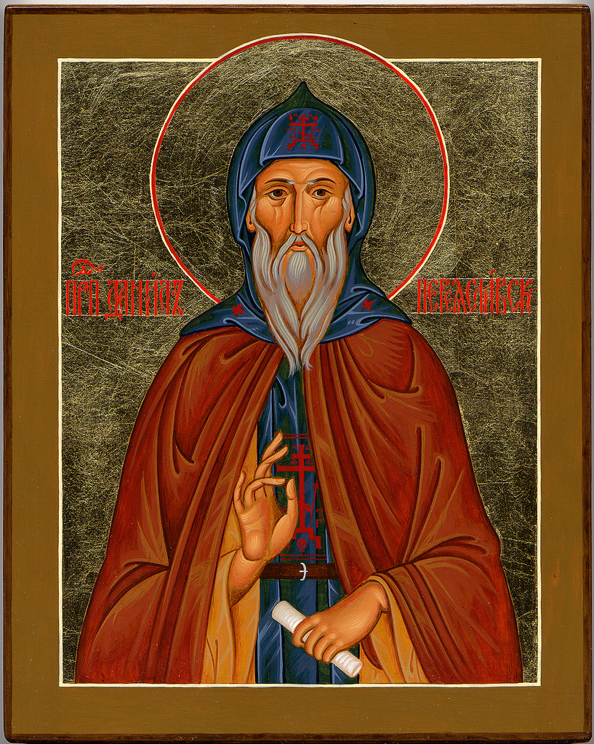

Troparion — Tone 4
The barren wilderness thou didst make fertile with the stream of thy tears; and by thy deep sighing, thou hast given fruit through thy struggles a hundredfold. Accordingly, thou hast become a star for the universe, sparkling with miracles. Therefore, O righteous Father Daniel, intercede with Christ our God to save our souls.

Great-Martyr & Healer Panteleimon

7/27 – 8/9 Troparion (Tone 3) O holy passion-bearer and healer Panteleimon, / entreat the merciful God, that He grant our souls // remission of transgressions.

Kontakion (Tone 5) Emulating the Merciful One, / and receiving from Him the grace of healing, / O passionbearer and martyr of Christ God, / by thy supplications heal thou our spiritual infirmities, / ever driving away the temptations of the foe // from them that faithfully cry out: Save us, O Lord!

St. Nicholas the Wonderworker
(12/6-19) Troparion 4th tone
The truth of things hath revealed thee to thy flock as a rule of faith, * an icon of meekness and a teacher of temperance; * for this cause thou hast achieved the heights by humility, * riches by poverty. * O Father and Hierarch Nicholas, * intercede with Christ our God that our souls be saved.

St. Seraphim of Sarov
(1/2) - Troparion 4th tone
From thy youth thou didst love Christ O blessed one, * and ardently desiring to work for Him Alone, * thou didst struggle in the wilderness in constant prayer and labor, * and having acquired love for Christ with compunction of heart, * thou didst prove to be the beloved favorite of the Mother of God. * Wherefore, we cry to thee, * save us by they prayers, O Seraphim, * our holy father.

St. Nectarios of Pentopolis
(11/9)- Troparion 1st tone The offspring of Selevria, and the guardian of Aegenia, the true friend of virtue, who didst appear in the last years: O Nectarios, we faithful honor thee as a true servant of Christ. For thou pourest forth healings of every kind for those that piously cry out: Glory to Christ who hath glorified thee, Glory to Him that had made thee wondrous, Glory to Him that worketh healings of all kinds through thee.

St. John of San Francisco
(6/19/7/2 Sat closest to July 2nd) - Troparion 5th Tone

Lo, thy care for thy flock during its sojourn / prefigured thy supplications which are ever offered up for the whole world: / Thus do we believe, having come to know thy love, / O holy hierarch and wonderworker John. / Wholly sanctified by the sacred celebration of the all-pure Mysteries, / whereby thou wast thyself ever strengthened, / thou didst hasten unto the suffering, O gladsome healer. / Hasten thou now also to the aid of us // who honor thee with all our hearts.

Holy Hierarch Jonah of Manchuria
(Oct 7) - Troparion 4TH TONE

Thou was a good pastor for the Russian people / who had departed in exodus to live in a foreign land, / guiding them in every way, / but especially with the love of Christ, / in all providing a model of love unfeigned. / Father Jonah, holy hierarch of Christ, // Entreat Him for the salvation of our souls

Great Martyr James of Persia
Troparion Tone 4

James the Martyr and scion of Persia/ drowned the dragon in his blood by his contest:/ he was dismembered for the Faith/ and became the Saviour's trophy-bearer./ He intercedes unceasingly for our souls.
Kontakion Tone 2
Thou didst listen to thy wife and consider the judgment/ O courageous James./ Thou didst spurn the threats and commands of the Persians/ and thy body was pruned like a vine./ We praise thee; O noble Martyr.

St. John of Kronstadt
(10/19) - Troparion 4th tone
O wonderworker living in Christ forever, with love have mercy on them that are in danger; hear thy children who call upon thee with faith; be thou compassionate unto them that hope for aid from thee, O Father John of Kronstadt, our beloved shepherd.

Elder Porphyrios of Kavsokalyvia
(Dec 2) Troparion 1st Tone
The son of Evia, the Elder of All Greeks, * the initiate of Divine Vision and True friend of Christ. * Porphyrios, O faithful, let us praise * who from childhood was filled with divine gifts * the demonized are redeemed and the sick are healed who cry out: * “Glory to Him who gave His might to thee! * Glory to Him who made thee Holy! * Glory to Him, who, through thee, grantest healing to all.

Elder Paisios of Mount Athos
(July 12/25) - 1st tone - The citizen of the desert
The offspring of Farasa, / and the adornment of Athos, / and the imitator and equal in honor / of the venerable ones from ages past; / let us honor Paisios, O faithful, / the vessel full of graces, / who guards from all sorrows, / the faithful crying out: / Glory to Him Who gave thee strength, / Glory to Him Who crowned thee, / Glory to Him Who grants through thee / healings for all.
Saint Silouan of Mt Athos - Troparion, Tone 4
By thy prayers thou didst receive Christ as thy Master on the path of humility; and in thy heart the Holy Spirit witnessed unto thy salvation. For this cause all people called to live in hope are now rejoicing and celebrating thy memory. O holy Father Silouan, pray to Christ to save our souls.
Kontakion, Tone 8
During thy life on earth thou didst serve Christ, following His path and now in Heaven thou dost contemplate Him Whom thou hast loved; dwelling with Him as He promised to His elect, O holy Father Silouan, instruct us in the way that thou hast gone.

St. Gabriel of Georgia
Confessor and Fool for Christ's Sake – Troparion, 4th Tone
As the Master Christ hid His divinity, clothing it in humanity, and, unseen by us, brought into being His ineffable glory, likewise didst thou hide thy glory by means of foolishness, and by the wonder of thy confession wast shown forth as a shepherd of souls; O venerable Father Gabriel, entreat Christ God to have mercy on our souls.

Father Cosmas of Zaire and Zographou

Mary of Egypt
(April 1) Troparion 5th Tone

Enlightened by the grace of the Cross,/ thou wast seen to be a bright light of repentance,/ dispelling the darkness of passions, O all holy one./ thou didst appear as an angel in the flesh/ to holy Zosimas in the wilderness./ Intercede with Christ for us, O Mary our righteous Mother.

Blessed Matrona of Moscow
Troparion (May 2nd/ April 19) 2nd Tone

Let us the faithful today praise blessed eldress Matrona made wise by God; flower of the land of Tula and glorious adornment of the city of Moscow, for whom daylight was unknown but who wast enlightened by the light of Christ and enriched by the gifts of insight and healing: Thou wast a sojourner and wanderer upon earth, but now in the heavenly chambers thou standest before the throne of God and intercedest for our souls.

Patriarch Joseph the All-Comely
(Holy Monday) - Kontakion 8th Tone
Jacob lamented the loss of Joseph, / but his righteous son was seated in a chariot and honored as a king. / For he was not enslaved to the pleasures of Egypt, / but he was glorified by God who sees the hearts of men // and bestows on them a crown incorruptible.

KONTAKIA FOR THE DAYS OF THE WEEK

Monday- The Bodiless Hosts Kontakion, Second Tone:
Supreme Commanders of God and the ministers of the Divine Glory, guides of men and leaders of the angels, ask for what is to our profit and for great mercy, since ye are the Supreme Commanders of the Bodiless Hosts.

Tuesday- St. John the Forerunner Kontakion, Second Tone:
O Prophet of god, and Forerunner of grace, having obtained thy head from the earth as a most sacred rose, we ever receive healings; for again, as of old in the world, thou preachest repentance.

Wednesday and Friday- The Cross Kontakion, Fourth Tone:
O Thou Who wast lifted up willingly on the Cross, bestow Thy mercies upon the new community named after Thee, O Christ God; Gladden with Thy power the Orthodox Christians, granting them victory over enemies; may they have as Thy help the weapon of peace, the invincible trophy.

Thursday- The Holy Apostles and St. Nicholas Troparion, Third Tone

Saturday- All Saints, and the Departed Troparion, Second Tone:
O Apostles, Martyrs, and Prophets, Hierarchs, Monastics, and Righteous Ones; ye that have accomplished a good labor and kept the Faith, that have boldness before the Savior; O Good Ones, intercede for us, we pray, that our souls be saved.
Resurrectional Kontakia
Kontakion First Tone. As God Thou didst arise from the tomb in glory, and Thou didst raise the world together with Thyself. And mortal nature praiseth Thee as God, and death hath vanished. And Adam danceth, O Master, and Eve, now freed from fetters, rejoiceth as she crieth out: Thou art He, O Christ, that grantest unto all resurrection.
Kontakion Second Tone Thou didst arise from the tomb, O omnipotent Savior, and Hades was terrified on beholding the wonder; and the dead arose, and creation at the sight thereof rejoiceth with Thee. And Adam also is joyful, and world, O my Savior, praiseth Thee forever.
Kontakion Third Tone. Thou didst rise today from the tomb, O Merciful One, and didst lead us out of the gates of death. Today Adam danceth and Eve rejoiceth; and together with them both the Prophets and Patriarchs unceasingly praise the divine might of Thine authority.
Kontakion Fourth Tone. My Savior and Redeemer hath, as God, raised up the earthborn from the grave and from their fetters, and He hath broken the gates of Hades, and, Master, hath risen on the third day.
Kontakion Fifth Tone. Unto Hades, O my Savior, didst Thou descend, and having broken its gates as One omnipotent, Thou, as Creator, didst raise up the dead together with Thyself. And Thou didst break the sting of death, and didst deliver Adam from the curse, O Lover of mankind. Wherefore, we all cry unto Thee: Save us, O Lord.
Kontakion Sixth Tone. Having by His life-bestowing hand raised up all the dead out of the dark abysses, Christ God, the Giver of Life, hath bestowed the Resurrection upon the fallen human race; for He is the Savior of all, the Resurrection, and the Life, and the God of all.
Kontakion Seventh Tone. No longer will the dominion of death be able to keep men captive; for Christ hath descended, demolishing and destroying the powers thereof. Hades is bound; the Prophets rejoice with one voice, saying: A Savior hath come for them that have faith. Come forth, ye faithful, for the Resurrection.
Kontakion Eighth Tone. Having arisen from the tomb, Thou didst raise up the dead and didst resurrect Adam. Eve also danceth at Thy Resurrection, and the ends of the world celebrate Thine arising from the dead, O Greatly-merciful One.
Favorite Kontakia

Patriarch Joseph the All-Comely (Holy Monday) - Kontakion 8th Tone
Jacob lamented the loss of Joseph, / but his righteous son was seated in a chariot and honored as a king. / For he was not enslaved to the pleasures of Egypt, / but he was glorified by God who sees the hearts of men // and bestows on them a crown incorruptible.
Great Martyr James of Persia Kontakion Tone 2
Thou didst listen to thy wife and consider the judgment/ O courageous James./ Thou didst spurn the threats and commands of the Persians/ and thy body was pruned like a vine./ We praise thee; O noble Martyr.
St. Gabriel of Georgia, Confessor and Fool for Christ's Sake – Troparion, 4th Tone
Immeasurable is the mercy of God, * by Whose goodness we behold His creation divinized * O venerable father, thou didst confirm in thyself the image of thy Creator * and exalted thy being to the likeness of God, * therefore we glorify thee O Father Gabriel, * for thou art worthy of all praise, * thou wast on earth a trumpet of righteousness, a preacher of love and dove of purity,* and thine all-wondrous humility * hast opened to the world a treasury of wisdom, * and now in heaven art thou, the advocate of God’s mercy and our salvation.

Silouan

Troparion — Tone 4
On the path of humility, / by thy prayers thou received Christ as thy Master. / In your heart the Holy Spirit witnessed to your salvation. / Therefore all people called to live in hope rejoice and celebrate your memory! / Holy Father Silouan, pray to Christ God to save our souls.

Troparion — Tone 2
O all-blessed Father Silouan, / Flaming zealot of the seraphim’s love for the Lord / And fervent imitator of Jeremiah who wept for the people, / Hearing the call of the Mother of the Lord of Hosts, / With wise courage you spewed out the sinful serpent / And withdrew from the snares of the world to the mountain of Athos, / Where in labors and prayer, joined with tears, / In abundance you acquired the grace of the holy Spirit with which our hearts are enflamed. / Being strengthened by you, we cry out with compunction: / My Lord, my Life and the Joy of your saint, / Save the world and us from all cruel things!

Kontakion — Tone 8
During your life on earth you served Christ and followed His path; / now in Heaven you contemplate Him Whom you have loved! / Since you dwell with Him as He promised to His elect, holy Father Silouan, / instruct us now in the path that you have traveled.

Kontakion — Tone 2
O Silouan, beloved of God, / Truly amazing preacher of humility / And radiance warmed by the love for mankind of the Holy Spirit: / The Russian Church rejoices in your labors. / All monks on the Athonite mountain / And all Christian people are rejoicing as well, / Turning themselves towards God with the love of children. / Beseech Him for us, you who have seen God and are equal to the angels, / That burning with your love our souls may be sav

