St Nicholas Orthodox Church, McKinney Texas
Building Project Chronology
Our building project began 12 years ago, when we established a building fund and started looking for a location. For a few years in the '90's, the parish income allowed us to grow the building fund rapidly, and donations to date total approximately $110,000. The total cost of our basic project will be approximately $270,000. We have secured a loan for $160,000 to cover the remaining costs. We will need to raise at least an additional $28,000 to pay for parking, landscaping, irrigation, and other requirements the city has told us must be fulfilled before we obtain an occupancy permit. In time, we plan to have an iconostasis built and icons painted, most likely from local Orthodox Christians.
A building committee, led by a licensed engineer and a registered professional land surveyor, laid out the criteria for a viable land purchase, and we spent many years looking for a good piece of real estate in the Dallas area. In the mid-1990's, we even looked at properties in Arlington and Fort Worth. After a long and difficult search, we decided in the fall of 2006 that the City of McKinney would provide us the best opportunity to find a suitable piece of land within our price range. In April of 2007, we purchased a plot of land in historic downtown McKinney, though we did not yet have the means to build and were undecided about whether this was the best location.
As time went on, it became clearer that building in McKinney is our best option. We will be the only Orthodox church within 15 miles, in a growing and vibrant community. When you look at a map of churches in the area (URL), there is a “hole” in McKinney. We feel that we are helping the DFW community best by locating there.
Once we made up our minds to build a temple on our land, we began to look for a lender, and we had a lot of trouble getting anyone to believe in us. The large national banks did not take us seriously, but we found a friend in a local bank whose vision is to build up the community in which they live and do business. Independent Bank (https://www.independent-bank.com/index.html) has believed in us, and we have a superb working relationship with them. When other banks said no, they found a way to say yes.
This has been a long and difficult journey, and the turning point for us was when we began to really apply ourselves to prayer. It is almost a cliché to say that we should pray about something, and we certainly did, but things really changed after we established a regular weekday liturgy in which we pray for all of our parishioners by name during in the Augmented Ectenia. We did not specifically pray for a new temple or land, but instead, have regularly, each Thursday, served the liturgy and asked God’s mercy for everyone in our flock. This additional weekday liturgy is the most important turning point in our chronology. We have since added a weekly Molieben for the parish, currently served on our land in front of a large wooden cross that we erected.
July 3, 1994. Deacon Seraphim Holland becomes a resident of Texas, on the very day of the glorification of St John Maximovitch. Fr Seraphim had been asked by Bishop Hilarion (now our Metropolitan) to come to Texas to become the pastor of a small mission in Dallas that had been faithfully holding reader’s services. We immediately began holding reader’s vigils on Saturday night, with typica and a meal on Sunday.
March 1995 Fr Seraphim ordained to the priesthood.
1997 Building Fund established. Search for a land or a suitable property begun.
April 2007 Land purchased in McKinney.
St Thomas Sunday, 2007. Outdoor Divine Liturgy on the land, with a picnic afterwards.
January, 2008 The week after Nativity, we began our weekly weekday liturgies. This was made possible because Fr Seraphim no longer was working fulltime. For a long time, we served Tuesday Vespers and Wednesday liturgy, but later changed to Wednesday Vespers and Thursday liturgy (because in Dallas, there are rarely school events on Wednesday evening, because there are a lot of Baptists who have services Wednesday night). The highlight of this liturgy is that we pray by name for everyone in the parish during the Augmented Ectenia.
February 2008 Architect /Designer selected: Tim Bonner and Associates. (http://www.bonnerassoc.net)
Design is based on the "Raising of St. Lazarus", the oldest wooden temple in Russia. Dr McBride, retired professor of Architecture University of Texas at Arlington helped us immensely during this design phase. He is Sub-Deacon at Holy Trinity Greek Orthodox Church.
Builder/Consultant selected” http://www.andersonsargent.com They are one of the first "Green" builders in the area. We decide to build the temple as "green" as possible, to save on maintenance costs.
March 2008 Cross erected on the Sunday of the Cross (3rd Sunday of Great Lent) .
June 2008 Attempts to get a building loan begun. During discussion with Independent Bank, our eventual lender, it became apparent that we needed to account for a more substantial regular income. We instituted our first call for pledges, and the parish responded extremely well, increasing our income by fifty percent, which gave us enough income for the bank to consider us.
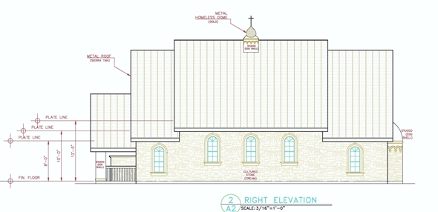
September 2008 Loan approved.and building plans submitted to the city of McKinney for approval.
July 2009 Building permit obtained. July 18 2009 Construction begun.
August 22 / September 4, 2009 Plumbing and Electrical wiring installed and approved.
August 26 / September 8, 2009 Foundation poured.

December 2009 Anticipated date we will be able to use the temple.

