Parish Life at St Nicholas

Our life at Saint Nicholas is very diverese and active, and it all has one purpose. this is the same purpose as the church in general. This is the salvation of the soul. Salvation occurs in an interaction between God and man. this is why we begin the description of our life by talking about the Holy Mysteries.

The Holy Mysteries

The Holy Mysteries are the fountains of divine grace that nourish our spiritual life. Spiritual life is a synergy. Each Orthodox Christian provides his own effort to obey the commandments of the Lord, trusting in Him without reservation. This is like a farmer tending his garden: he tills the soil, pulls out weeds, trims plants and so forth. The Lord, in turn, provides the grace without which no success is possible, just as the farmer's work would be to no avail without seed, sun, rain and wind.

The clergy, as stewards of the divine mysteries, help to teach and encourage the faithful to do their part, so that the seed of divine grace might bear fruit unto eternal life. For this reason, the mysteries are made available to Orthodox Christians who repent of their sins and strive to conform their lives to the teachings of the Holy Church. Those who do not accept the teachings of the Church or who choose not to repent of their sins cannot receive the holy mysteries, since they would be at the same time receiving a precious gift and rejecting the aid that it provides. This would be to their condemnation. Repentance entails struggle against sin, and in the beginning does not involve total victory against sin! We must provide honesty about our sin and effort, and God provides grace. We do not have the ability to conquer our sins, but God does. This is why freedom from sin is not a requirement for participation in the Holy Mysteries, since their primary effect is to help us eradicate sin! the church is a hospital for sinners, and the mysteries are among the greatest treatments ("They that are whole have no need of the physician, but they that are sick: I came not to call the righteous, but sinners to repentance.) Mark2:17)

Baptism and Chrismation
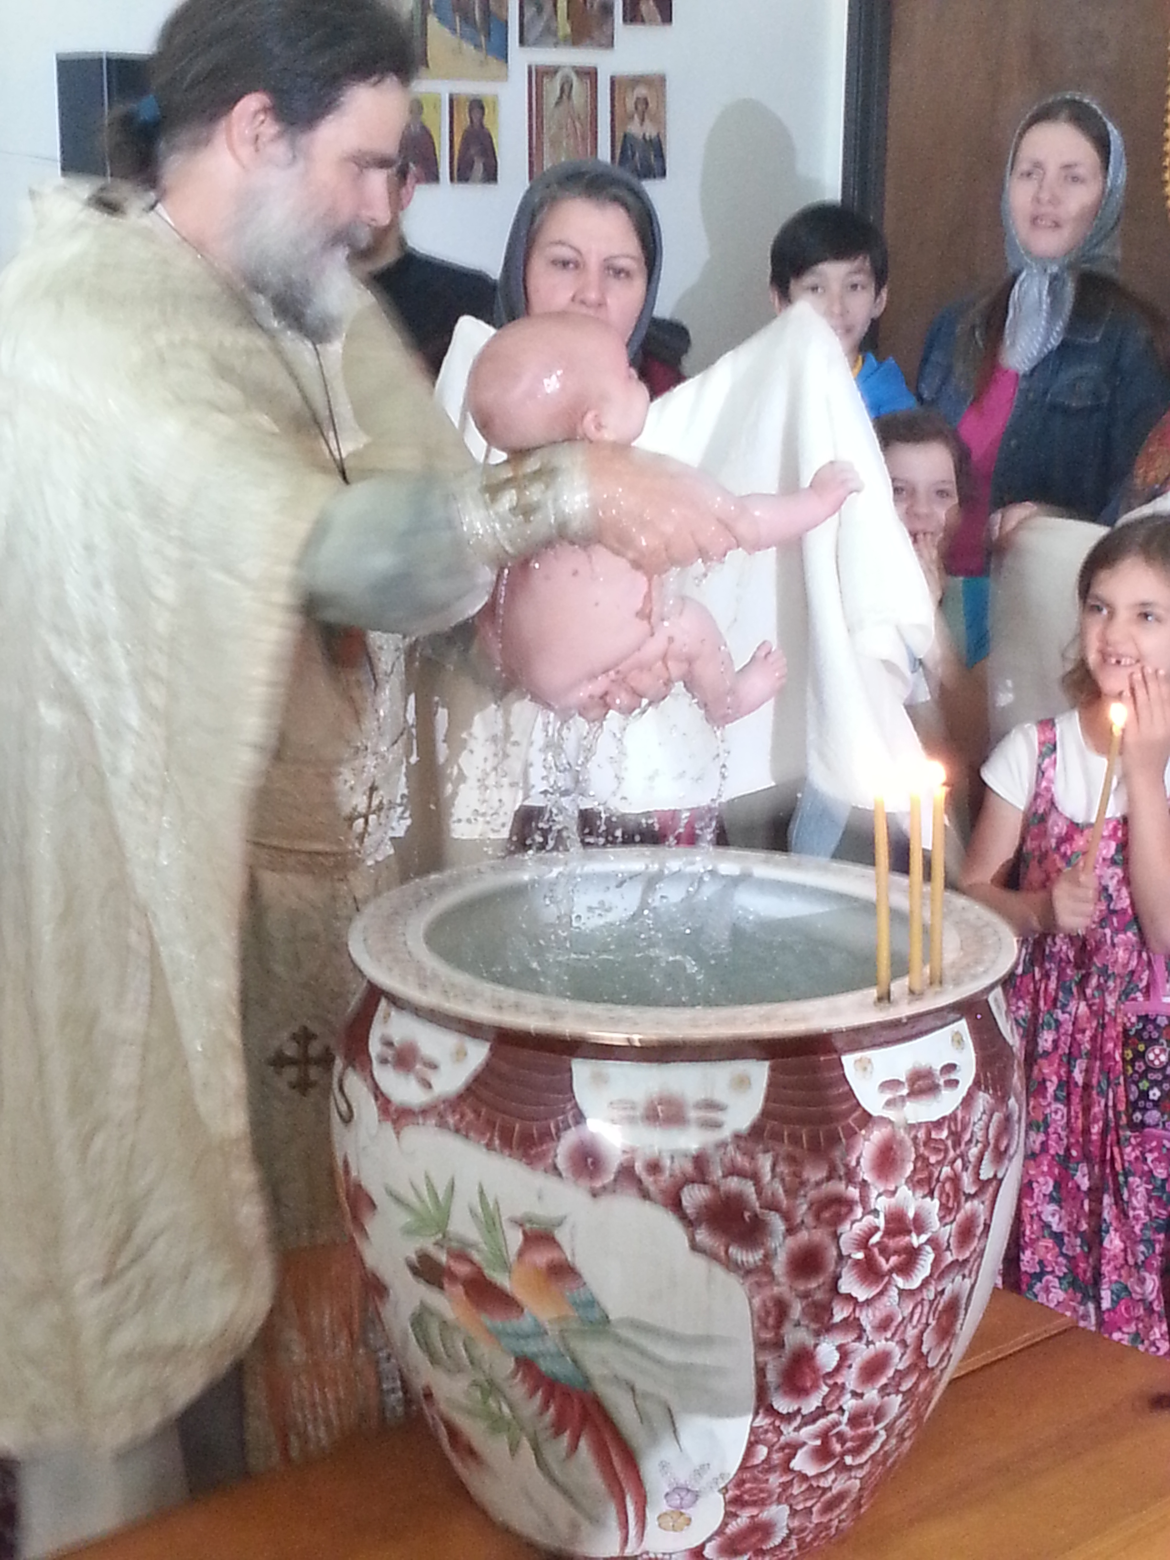
Baptism is the initial mystery, through which a man or woman dies to the old, sinful, fallen self and is reborn in Christ. In baptism, we receive the remission of all our former sins and are united to Christ in the Church. Closely connected to baptism is the mystery of chrismation. In chrismation we receive the seal of the gift of the Holy Spirit, teaching and guiding us on the path of salvation.

Those approaching baptism and chrismation must repent of their former sins and desire to follow Christ. Just as one does not have a child and then neglect it, it makes no sense to be re-born in baptism -- or to have a child baptized -- without a firm intention to care for the newly re-born soul. This care involves struggling to live a moral way of life (this could be called "following the commandments"), personal prayer, the reading of Scriptures, fasting, and attendance at the divine services with the frequent reception of Holy Communion. A person who does not intend to do these things approaches the holy mystery of Baptism hypocritically.

A period of catechesis (instruction) with a priest or catechist is required before baptism. Before a child is baptized, a period of instruction is required for the child’s parents and sponsor.

Communion

“Verily, verily, I say unto you, Except ye eat the flesh of the Son of man, and drink his blood, ye have no life in you. Whoso eateth my flesh, and drinketh my blood, hath eternal life; and I will raise him up at the last day” (John 6:53-54).

Holy Communion is our spiritual food. By partaking of the body and blood of our Lord, God and Saviour Jesus Christ, we are ourselves strengthened in our union with His Body, the Church. We receive remission of our sins and the grace to live a Christian life and inherit life eternal. Those approaching holy communion must repent of their sins and make an effort to follow the commandments of Christ in their lives. A recent confession is usually required.

Confession

Each of us sins daily – indeed, hardly a minute passes without sin in our thoughts. Just as dust and dirt accumulate in our homes, sins accumulate in our souls. Sometimes we sin willingly and at other time we sin out of habit. The more our sins accumulate, the harder it is to see clearly and live in a Christian way.

Just as we have to periodically sweep, vacuum and dust our homes, we must also periodically cleanse our souls. In the Mystery of Confession, we carefully examine our souls, identifying each sin and naming it before God in the presence of the priest. If we truly repent, accept the instruction of the Church and desire to change, then God forgives all of our sins, cleanses our souls and gives us the strength to fight our sinful passions by His grace. The more often we approach Confession, the easier it is to fight our passions and seek the path of God's commandments leading unto salvation.

Marriage

Marriage might be considered the first mystery instituted by God, in the beginning of Creation. “Therefore shall a man leave his father and his mother and shall cleave to his wife, and they two shall be one flesh” (Gen 2:24). Christian marriage, properly understood, is not just a contract between two people, a pledge, or an earthy union. It is a mysterious and wonderful union accomplished by God in the sacrament of crowning. “So then they are no longer two, but one flesh” (Matt 19:6). The unity in marriage is an image of the unity of the Holy Trinity and of the mystical union between Christ and His Church.

A man and woman are joined together in marriage for the purposes of unity, childbearing and chastity. Unity, to approach the unity of the Holy Trinity in self-sacrificial love; childbearing, because love always seeks to give of itself to others (this is why God created the world); chastity, to reign in and properly channel one’s sexual energies.

A period of instruction with a priest or catechist is required before marriage. This process must be begun before a wedding date can be set.

The church does not accept divorce and remarriage except in certain exceptional cases that should be discussed with the priest. “...so then they are no more twain, but one flesh. What therefore God hath joined together, let not man put asunder (Mark 10:9-10).

All sexual activity outside of marriage is a sin because it is destructive to the soul. All homosexual sex is by definition fornication outside of marriage. Sexual sins are among the most difficult to fight and eradicate, especially because the world heartily endorses them. It is important to struggle against sin. God will provide the competence and continence if we provide the effort. Delivery from sexual passions can take many years.

Childbirth

One of God’s greatest gifts is the ability to cooperate with Him in bringing a new person in the world and helping him or her to grow and thrive.

When God grants us the blessing of a child, the Church covers him or her with blessings and prayer. Please call the priest when you give birth, so that he can come and say the “first day” prayers for mother and child and tell you about the remaining prayers and services in preparation for the child’s baptism.

As Christians, we hope that our children will be citizens not only of this world that passes away, but also of the eternal kingdom to come. Parents should therefore ensure that their child receives holy baptism in short order. Before the baptism, a period of instruction is required for the child’s parents and sponsor.

The Church has always recognized than from the point of conception, a child in the womb is a human person with a soul and body. St. John the Baptist first recognized and proclaimed our Lord Jesus Christ when both were still in the womb! (Luke 1:41) Abortion is the murder of a human being. It is destructive not only to a new life, but also to the mother and all who are involved in the abortion in any way. However, no sin will remain destructive to the soul if there is repentance. The Church and its pastors are very aware of this sin and its ripple effects. If you have had or promoted an abortion, please talk to a priest in confidence. There will be no condemnation, only the beginning of healing.

Holy Unction

"Is any sick among you? let him call for the elders of the church; and let them pray over him, anointing him with oil in the name of the Lord: (15) And the prayer of faith shall save the sick, and the Lord shall raise him up; and if he have committed sins, they shall be forgiven him." (James 5:14-15)

Holy Unction is a special anointing with oil, accompanied by prayer, for the healing of sicknesses of soul and body. It is not specifically appointed for those about to die, though it can also be used at that time. If you are seriously ill, please call the priest to discuss whether unction would be advised.
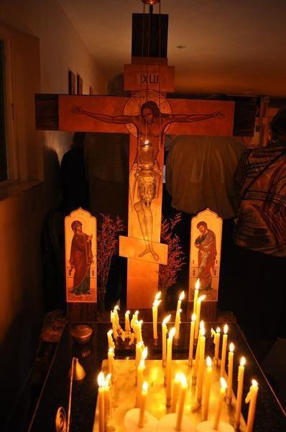
A Blessed Repose

At every service, we pray for “a Christian ending to our lives.” Properly, we speak not of death but of repose, or rest, because this life is only a preparation for life everlasting. We confess in the creed that we “look for the resurrection of the dead and the life of the age to come.” Thus, everything that a Christian does is done with an eye toward the life to come. We pray for more time here on earth because we know we need more time to repent of our sins and to make a beginning in the path of God’s commandments, but as the end of our earthly lives approach, we direct our gaze to the life to come. We call the priest to read the prayers “at the departing of the soul” together with us before our repose, and to pray over our body after we depart.

When a loved one reposes in the Lord, we show our love by covering him or her with prayer. Since it is unthinkable that we would stop loving someone after their death, it is equally unthinkable that we would stop praying for them, since prayer for someone is the deepest and sincerest form of expressing love. It is customary to read the Psalter over the body of the newly-reposed until the time of burial, and to serve memorial services on the 3rd, 9th and 40th days as well as on the anniversary of the repose.

If you or a loved one are approaching the time for departure from this earthly life, please call the priest so that he can pray with and for you and instruct you in how to prepare for this very important part of the Christian life.

Parish Membership

Parishioners may become parish members by filling out a membership declaration. Parish members must live their lives in an Orthodox Christian manner, striving to follow the commandments of the Gospel, regularly attend services in the parish, receive the Holy Mysteries of Confession and Communion, and support the parish with their time, energy and money.

Everybody is welcome to attend services, participate in the life of the community, and receive ministry from the pastor without prejudice, in obedience to our Lord’s command: “Freely you have received; freely give” (Matthew 10:8). Any sacrament in the church is freely offered, and never bought. However, those who do not support the church according to their real abilities (and not sinful false priorities) are sinning, and are not worthy of any leadership position in the church.

Parish Ministries

All parishioners are called to support the parish with their time and talents. There are many opportunities to serve God and one another in our parish. All parish ministries are supervised by the rector (priest), and should be carried out in accordance with his direction and blessing.

Parish Council

The parish council assists the rector (priest) in managing the practical aspects of running the parish: administering the finances, maintaining the building and grounds, etc. the council meets monthly. The council members are elected at the annual parish meeting.

Choir and Readers

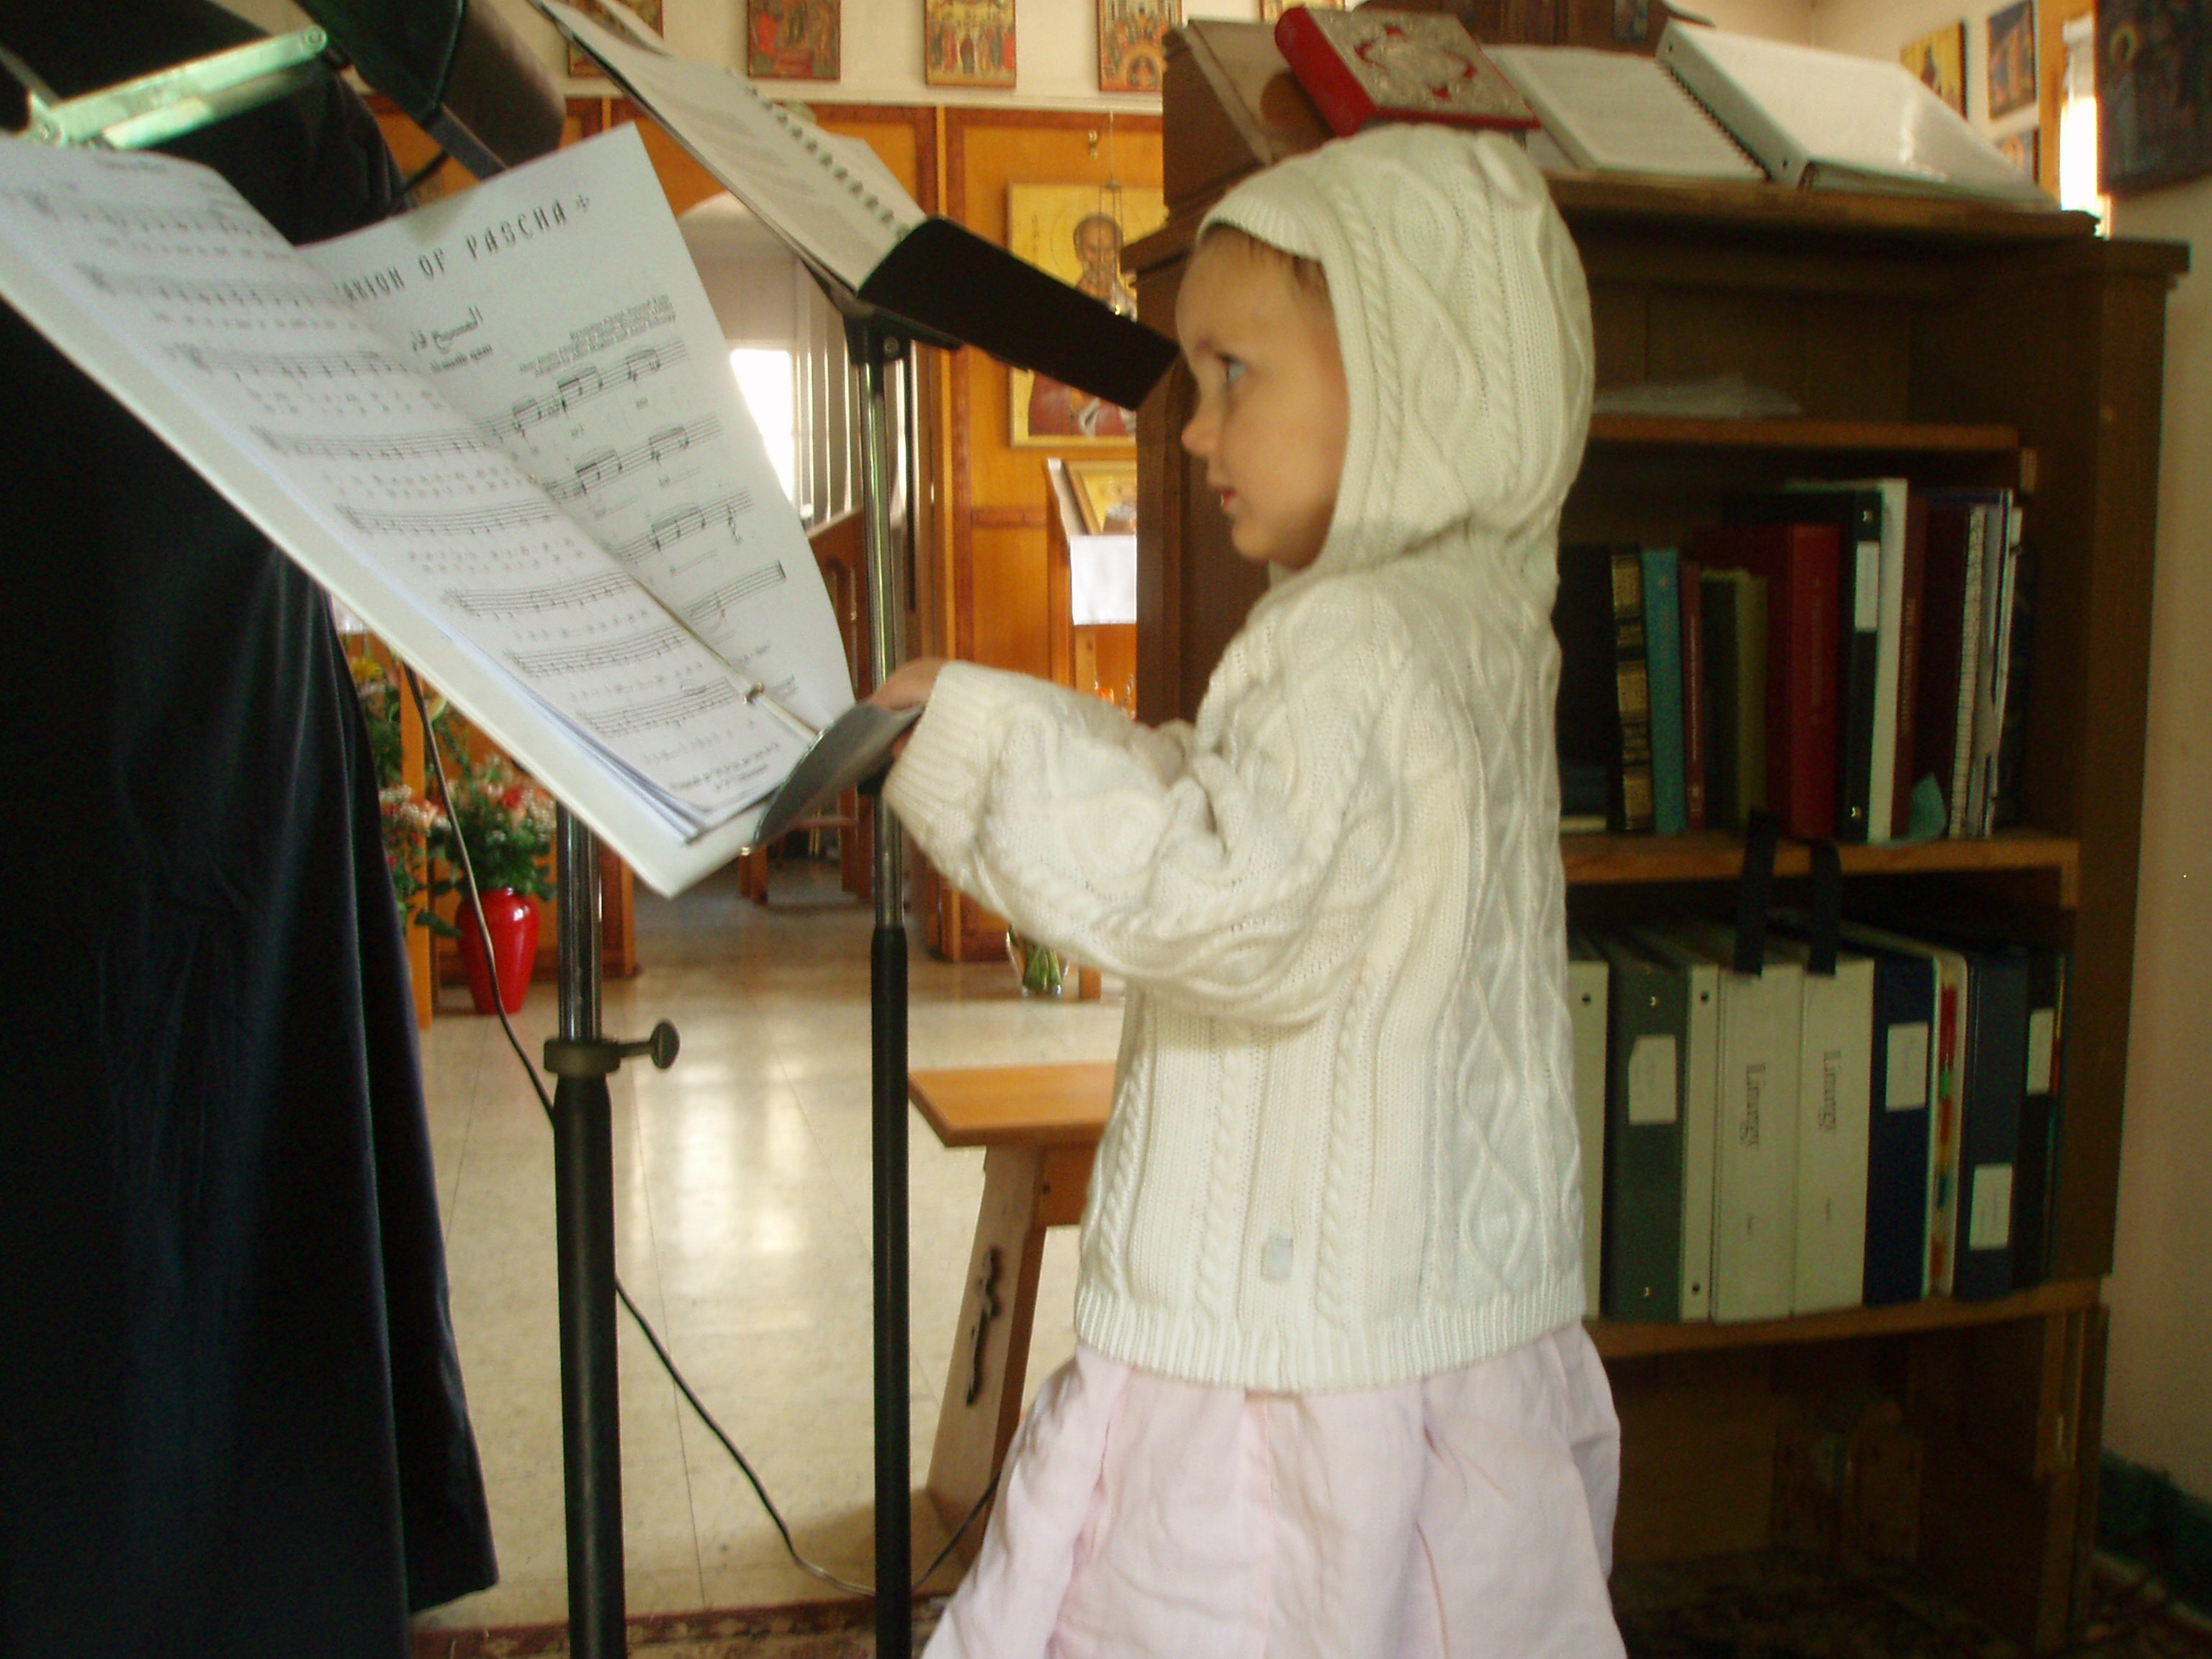
The choir sings the sacred hymns and psalms at the divine services. Readers read the words of the holy scriptures and of the church fathers during the divine services. In these very important ministries, readers and choir members become the voice of the church, expressing the words of the holy fathers and saints clearly and beautifully so that the faithful can be spiritually nourished and grow in the love of God and in the understanding of the truths of the faith.

The readers and the choir serve under the direction of the choir director and the supervision of the rector (priest). If a person does not read or sing well, they should refrain from serving and pray silently instead. We do not read and sing in church because we want to, but because our ministries edifies our brothers and sisters in Christ. “Let all things be done decently and in order” (1 Cor 14:40).

Tonsured readers are obligated to read the Scriptures faithfully and to attend all of the services that they can. A reader who does not do this is an oxymoron.

Altar Servers

Altar servers help with the practical aspects of the priest's service in the holy altar. They prepare and tend the censer, light and carry the lamps, and clean and maintain the sanctuary (altar area). Altar servers serve in direct obedience to the priest.

St. Juliana Sisterhood

The sisterhood is a group of ladies who work, under the leadership of the head sister, to do various necessary works around the parish. The sisterhood spearheads the weekly trapeza (The word is Greek for "table", and in most parishes means a meal (or the place where the meal is served) after any service), the cleaning of the temple and hall, and a number of other important projects.

St. John Brotherhood

The brotherhood is a group of men who work, under the leadership of the Warden, to do various necessary works around the parish. The brotherhood helps to maintain the building and grounds and spearhead other important projects.

