“Prayer and Its Practice”
July 17, 2011 ~ 5:00 – 7:00 p.m.
Speaker, Igumen Gregory Zaiens
Presented by: St. Nicholas Orthodox Church, McKinney, TX
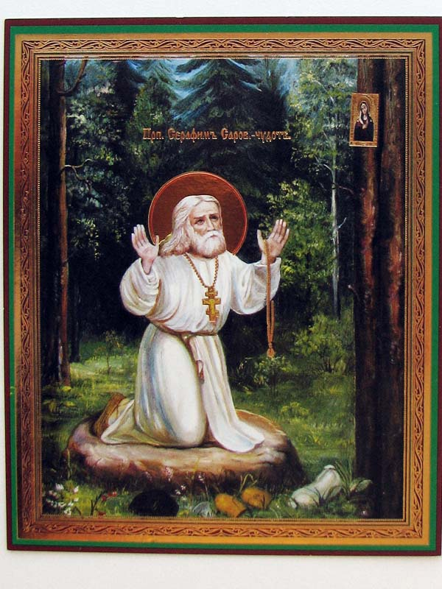
At the Bingham House, 800 S. Chestnut St., McKinney, TX
5:00– 7:00 p.m. Russian Tea
5:30 - 6:30 p.m. Igumen Gregory speaks on Prayer and Its Practice
6:30 – 7:00 p.m. Question and Answer Session
$25 per person, $20 for each additional family member
Proceeds to help our Church build a covered deck since our hall is too small.
Deadline for tickets: July 2, 2011
Here is a rare opportunity to learn first hand about prayer practice in the Orthodox Church from Igumen Gregory Zaiens, Archimandrite of St. Arsenius Hermitage, Decatur, Texas, and published author. Join us at the very lovely Bingham House B&B, directly across from St. Nicholas, in McKinney. After his talk Igumen Gregory has graciously offered to answer questions from the audience.
Complimentary teas, coffees, confections, and other delicacies offered by the ladies of St. Nicholas
Prelude music provided by Gabrielle Bronzich
Childcare provided at St. Nicholas Orthodox Church, directly across from the Bingham House, by the youth of
St. Nicholas and St. Sava – donation appreciated

To book your reservations now, go to http://orthodox.net and pay directly by Paypal, or send your check, made out to St. Nicholas Orthodox Church, to:
Dcn. Nicholas Park, Box 37, McKinney, TX 75070
Please include a note w/your name, number attending, and childcare needed
Questions: Call Elaine King @ 214-556-9486

