The Orthodox Faith, Worship, and Life, Orthodox Catechism: An outline
Index of all articles

This is a commentary, explanation, and amplification of the book “The Orthodox Faith, Worship, and Life, Orthodox Catechism: An outline.” These notes are intended to be watched or read in conjunction with reading chapters in this excellent book. Sometimes, there are things unsaid that a beginner might not understand, so we have attempted to fill in some of the gaps that we have seen in the catechumens we have taught. This book is very deep, and you should read it slowly and look at the references. One of the problems with books, in my opinion, is they give a reference, but then they don't give you the text. Even when the author shows the text, you might want to look at the context.

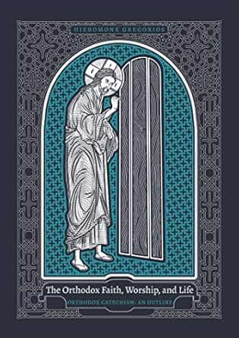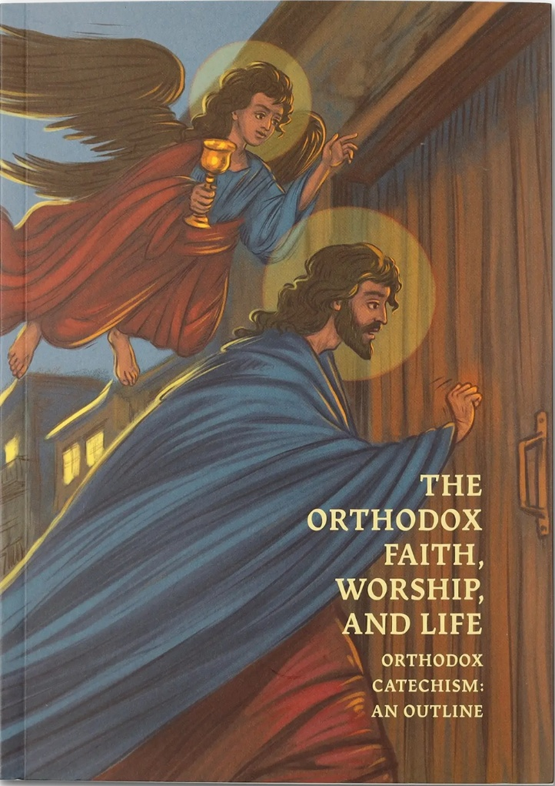
This book has an “Old cover”, Left, and a redesigned cover with a painting of Jesus knocking at a door, with an angel. (right)
You can buy the book here: https://newromepress.com/the-orthodox-faith-worship-and-life

The text files are available at http://www.orthodox.net/catechism

The YouTube files are in the Playlist: https://www.youtube.com/playlist?list=PLEh2brXYUf7k06I4K0dgAJC11A3TlgpFK
A zillion other catechetical offerings are in the Playlist: https://www.youtube.com/playlist?list=PLEh2brXYUf7k06I4K0dgAJC11A3TlgpFKv

Our YouTube channel has sermons, articles, catechesis, commentary, hot takes, etc: http://www.youtube.com/orthodoxnet
This file:
http://www.orthodox.net/catechism/catechism+orthodox-faith-worship-and-life-orthodox-catechism-index.docx
http://www.orthodox.net/catechism/catechism+orthodox-faith-worship-and-life-orthodox-catechism-index.pdf

The Orthodox Faith, Worship, and Life, Orthodox Catechism: An Outline What is Catechism? Pp 002—07
Holy Catechism: What is Catechism? (It is *not* just learning stuff)

VIDEO: https://youtu.be/cCU9si3lVzk
TEXT: http://www.orthodox.net/catechism/catechism+orthodox-faith-worship-and-life-orthodox-catechism-03-07.docx

“The Orthodox Faith, Worship, and Life, Orthodox Catechism: An outline.” 1.1 Pg 08. The Synodikon of the Holy and Ecumenical Seventh Council
The church exclusively has the authority to proclaim dogma

VIDEO: https://youtu.be/I8bhPYsm2Xc
TEXT: (differs slightly from video and audio)
http://www/orthodox.net/catechism/catechism+orthodox-faith-worship-and-life-orthodox-catechism-008.docx
http://www/orthodox.net/catechism/catechism+orthodox-faith-worship-and-life-orthodox-catechism-008.pdf

“The Orthodox Faith, Worship, and Life, Orthodox Catechism” 1.1 Introductory Remarks Pp 10 – 12
About faith.

VIDEO: https://youtu.be/p4a7NJkAaZ4
TEXT: (differs slightly from video and audio)
http://www/.orthodox.net/catechism/catechism+orthodox-faith-worship-and-life-orthodox-catechism-010-012.docx
http://www/.orthodox.net/catechism/catechism+orthodox-faith-worship-and-life-orthodox-catechism-010-012.pdf
Page 11: “No One has seen God”
Page 11: “Faith is man's answer to the Revelation concerning God. " 2 A good primer on how to have increased faith.
Page 11: “Faith is the unshakable belief in the existence of things we hope for.”
Page 12: “Therefore being justified by faith, let us have peace with God through our Lord Jesus Christ…”
Page 11: “Faith is the synergy of men in the ministry of his salvation.”
Page 12: “Faith is the beginning of salvation and life in Christ.”

