"Without a vision the people perish".
November, 2015
St Nicholas Orthodox Church, McKinney TX

[ A little unsolicited advice: read the footnotes. ]

I have many "visions" for our church. I think you need to know more of them, and I invite you to join me, an "old man who dreams dreams". My apologies to my flock, which often experiences what my dear Matushka has experienced all these years. I think a lot about stuff, but rarely say what I am thinking.

I want more grace, more happiness and more healing for everyone. Many in our community are having a hard time. Most of our suffering is invisible to others, but God knows all things. We live in an age of unprecedented (in the history of mankind!) wealth, entertainments, stress, depression, purposelessness, moral confusion and existential angst. The Christian way of life is the only cure.

I want more than "services", and meals, and the usual parish activity. I want healing for everybody our community touches. I want our church to be a place of refuge for the sick, the mentally ill, poor, depressed, confused, homeless, and those who feel the weight of their sin and want to be relieved of their burden.

We already do all these things, but we are small. Our resources -- people, space, funds -- are limited.

I am very proud of our little community. There are larger ones out there, and many are colder too. We are warm, but we must remember that in the Christian life there is no limit to how warm we can become. The world is cold. The only place it that can give it warmth is the church. We must be warm, and spread this warmth. Look at the incident from the Desert Fathers, below, to see the kind of warmth I am talking about.

Abba Lot went to see Abba Joseph and said to him, “Abba as far as I can I say my little office, I fast a little, I pray and meditate, I live in peace and as far as I can, I purify my thoughts. What else can I do?” Then the old man stood up and stretched his hands towards heaven. His fingers became like ten lamps of fire and he said to him, “If you will, you can become all flame.”
- From the Desert Fathers

We are collaborators with our Lord Jesus Christ, Who said: "I am come to send fire on the earth; and what will I, if it be already kindled?"

We have the spirit and "phronema to increase our outreach to the world.

We need physical things for our "cup of water" to become a large harbor for souls, and spiritual things too.

We have made great progress in increasing our spiritual things. I count among them, first of all, that we celebrate a weekday liturgy and Moleben every week, and pray aloud for everyone in our community, and many more besides, in these services. Our weekday liturgy and the weekly Moleben is the reason we built our temple in McKinney and have built a Christian community which easily welcomes the homeless, the poor, and the stranger

It would be good if we someday have the spiritual and physical resources add another liturgy each week. Perhaps we will have a second priest, and be able to celebrate "40 day liturgies" and a full liturgical cycle daily. We could celebrate a Slavonic liturgy every week. There is no limit to how much we can pray, if we have the will to pray.

I am fully aware that most in our community cannot attend the weekday liturgy, and some are not even aware of it or even care about it, but it benefits all of us. This is how a Christian community helps all within it. Not everyone is super "spiritual" and comes to church weekly or even monthly, but the prayers of a community benefit everyone. Our weekday liturgy is a hallmark of our community, as much as our free trapeza after Liturgy, and our carefully conducted services.

Other spiritual things are our robust teaching and catechizing of the flock, from the little ones on up. We have quality instruction, and I am especially pleased to see the children excited about it. I am sad to see that some adults in our flock do not value our classes. They must be convinced! This convincing does not come from nagging them to stay a little later on Sunday to benefit from our classes; it will happen as we as a community become sweeter, because of our prayer and the following of the Gospel. This is an area where we can should continually get better, and offer more. This will happen, as spiritual things and physical things increase. Our ongoing education -- for children and adults -- is almost as important as the services.

Our "physical things" include, first of all, more people to catch our vision, and do more things. We need more readers, more who can sing especially on weekdays, more who will teach, more who will clean, more who will cook, more who will participate in or organize outreaches to the community, more who will pray for our community. We need more of our flock to firmly commit their financial resources to something worth supporting - the only way of life that leads to eternal life.

We are too small, in people and in resources. We need a little more dedicated people to reach "critical mass". We need a place to put those people. Our dining hall is way too small. We have no classrooms for our classes. Our church is too small. We cannot afford to adorn the church with an iconostasis and iconography. All these things are important, and if we live the Gospel, these physical things will help us to bear spiritual fruit.

Some more of this "old man's" dreams include homeschooling for our children. Our politically correct climate will get more oppressive. I am convinced that our children need more from us. For those who wish to homeschool I want to have a coop where they can receive good education, and learn the "weightier things" -- justice and mercy and morality. Even if children are in public or private school, we could have a robust Saturday program for them. We could do this is we wanted to. We could do this if there were more children, more teachers, more space.

We must increase our outreach to the community - feeding those who are hungry, those who feel left behind by the world, children left behind by the educational system. All this takes more time, and more money and more people.

The Dallas Metroplex is a large place. There should be a hundred Orthodox churches! My vision includes missionary outreach, and the planting of mission parishes in the area, or even in Texas or Oklahoma or wherever God leads. To do this, we need to train up clergy, and have the wherewithal to support a mission parish until it is self-sustaining. None of this is possible for us right now, but is can be possible in the future.

Our God is infinitely creative. He created the universe out of nothing. We have no idea what He will do with our community. There are things that we will do, people that we will touch, that we have not imagined yet. Ours is a story that is not yet fully written.

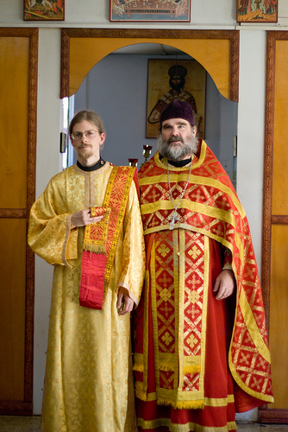
If you are not a priest or a deacon, or sing in the choir, what is your part in this vision? You must, of your own free will choose to have a part. Nobody will force you, but if your heart understands the Christian life, you will force yourself. You will support our family -- your family -- with your prayers, your time, your money. You will understand that everyone on the parish is significant. God sees all things and remembers everything. He values anything done in His name with good will.

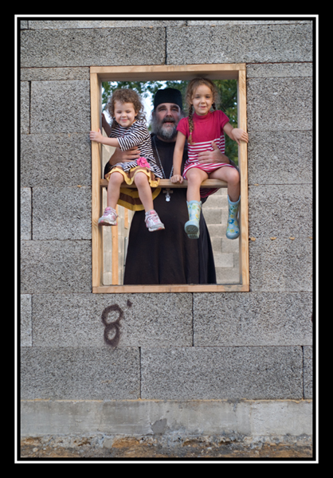
We are at an important point in our parish history. We have it within our power to determine our future. We started with a little mission, in a run down building in Dallas that has long since been destroyed (a football and baseball field stands where we worshipped for many years). We saved a little, and after many years built our temple in McKinney. We have grown to the point where it is too small, without enough dining area or classrooms for our youth. Being too small is a good problem to have -- if our hearts are big, and not small.

What's it going to be? Where do we go from here? What "cup of water" will you offer to your parish family? This is your choice, and it has eternal consequences. Make your voice, and your presence, and your prayers be heard.

unworthy Priest Seraphim

.

Proverbs 29:18 "Where there is no vision, the people perish: but he that keepeth the law, happy is he."
Joel 2:28 "And it shall come to pass afterward, that I will pour out of my Spirit upon all flesh; and your sons and your daughters shall prophesy, and your old men shall dream dreams, and your young men shall see visions." To put this in modern parlance, the Holy Spirit makes us think "outside the box"!
Luke 12:49
'Phronema" -An almost untranslatable Greek word, that means basically, a true Christian way of thinking and living - the Orthodox "mind", which is the mind of Christ, and effects everything we do, say, think and value.
"For whosoever shall give you a cup of water to drink in my name, because ye belong to Christ, verily I say unto you, he shall not lose his reward." Mark 9:41 Everything we do , if it is done with good will and love -- MATTERS. No true Christian believes that anything he does because of love is insignificant or will not bear fruit.
"Moleben" - A Russian word that is from the word "molitva" - prayer, and means a prayer service. In Russian usage, this service is like an abbreviated Matins service, and may include a "Canon" or an "Akathist". In the Greek usage, this same service is called a "Paraklesis" (Service of supplication) and often includes a beautiful supplicatory canon, sung to a beautiful melody. We do both.
This is a good and pious custom, where a person gives a donation of their choosing, and asked the church to serve Divine Liturgy 40 days in a row, and pray for their departed loved one, or sometimes for another intention. This is commonly done in Monasteries, but we have been asked to do this many times, and we do not have the resources to do this - BUT WE COULD DEVELOP THEM.
Our services are in English, but especially at Sunday liturgy, we repeat some things in Slavonic (always an Epistle, Gospel, the creed, the "Our Father", and usually dome of the troparia), because we have many Russian Orthodox who have grown up with prayers in Slavonic. Slavonic is the liturgical language of the Russian Orthodox church. I have no plans to serve in Slavonic in the Sunday liturgy, but a Slavonic liturgy during the week, if there is a need, would be a wonderful offering of prayer to God, and would edify many of our faithful.

