Useless Questions

Prayer for others is like oxygen

A Simple Prayer Rule

Read the Prologue (online) everyday!

A Simple prayer rule, complete text

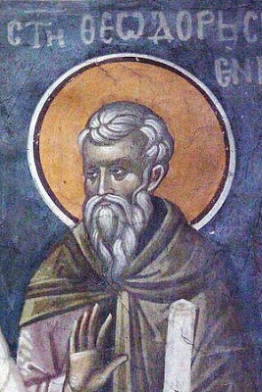
When Theodore the Sanctified was in Panopolis with St. Pachomius, his spiritual father, a philosopher came to him and offered to debate with him about the Faith. The philosopher then posed these three questions to Theodore: "Who was not born, but died?" "Who was born and did not die?" "Who died and did not decay?" To these questions, St. Theodore replied: "Adam was not born and died. Enoch was born and did not die. Lot's wife died and did not decay."
And the saint added this advice to the philosopher: "Heed our sound advice; depart from these useless questions and scholastic syllogisms; draw near to Christ Whom we are serving and you will receive forgiveness of sins." The philosopher became mute from such a pointed answer and being ashamed, he departed. From this, the enormous difference is clearly seen between a pagan philosopher and a Christian saint. The one [the philosopher] loses himself in abstractions, in cleverly twisted words, in logical provocations and in thoughtful sport while the other [the saint] directed his whole mind on the Living God and on the salvation of his soul. The one is abstract and dead, while the other is practical and alive.
From the Prologue for today: May 16 (5/29 on the civil calendar). (http://98.131.104.126/prolog/May16.htm)
Christian life is very practical. If you do not pray, and struggle to love God and neighbor, and follow all the commandments with humility and effort, it does not matter how much philosophy you know. Let us poor ones apply St Theodore’s words to our own lives. Much in our daily life is not essential. Much is intellectually arrogant and lazy. It is not so important that we have a clever argument on Facebook or some other social media, and this is definitely corrosive to our souls if we do not pray and read the scriptures with attention and humility.

Prayer for others is like oxygen

A Simple Prayer Rule
Applying St Theodore’s words to something very practical, essential and hard – praying for others.
In my personal and pastoral experience, praying for those on my commemoration list is the most important thing that I do, and it is warfare. Thank God, I am writing these words after I have finished my morning rule. There is no substitute for effort in the Christian life. Knowing stuff and learning stuff and being able to talk about stuff is not “effort”, but forcing ourselves to pray, and to read the scriptures, and to humble ourselves – this is salvific Christian effort.
Try this, if you do not have a consistent prayer rule, or do a lot of reading of “spiritual” things on unspiritual mediums, and engage in many intellectual arguments about Christianity.
Make a list of all significant people in your life. These would be those you love, and those you struggle to love, or even, perhaps (God forgive us our sins!), do not love. They include your family, friends, pastor, those you have conflicts with, those who have hurt you in the past (and when you think of them, your heart does not feel at peace), those who have asked you to pray for them, and those who have “crossed your path” and touched your heart in some way. Consider prayer for these people to be as necessary as oxygen, as food and water.
Pray for these people, at your BEST time of the day. For most people, this is the morning, unless, of course, you are getting up 15 minutes only before you need to leave for work.
Here is a simple rule*:
The Trisagion prayers, then “Lord Have mercy”12x, then “Glory… Both now…, “O Come let us worship…”, the morning troparia, the 50th Psalm, the Symbol of Faith. This is all from the morning prayers, which are in the Jordanville prayer book, and any complete prayer book. If you say these prayers often, you will memorize them, and this will greatly assist your prayer. Then, for each person, make the sign of the cross, while making a low bow*, and say: “Lord Jesus Christ, have mercy on (N)”. It is even better to make a prostration* for each person, or at least for certain people. You are free to change things up, but try to do “less” consistently before you try to do “more”.
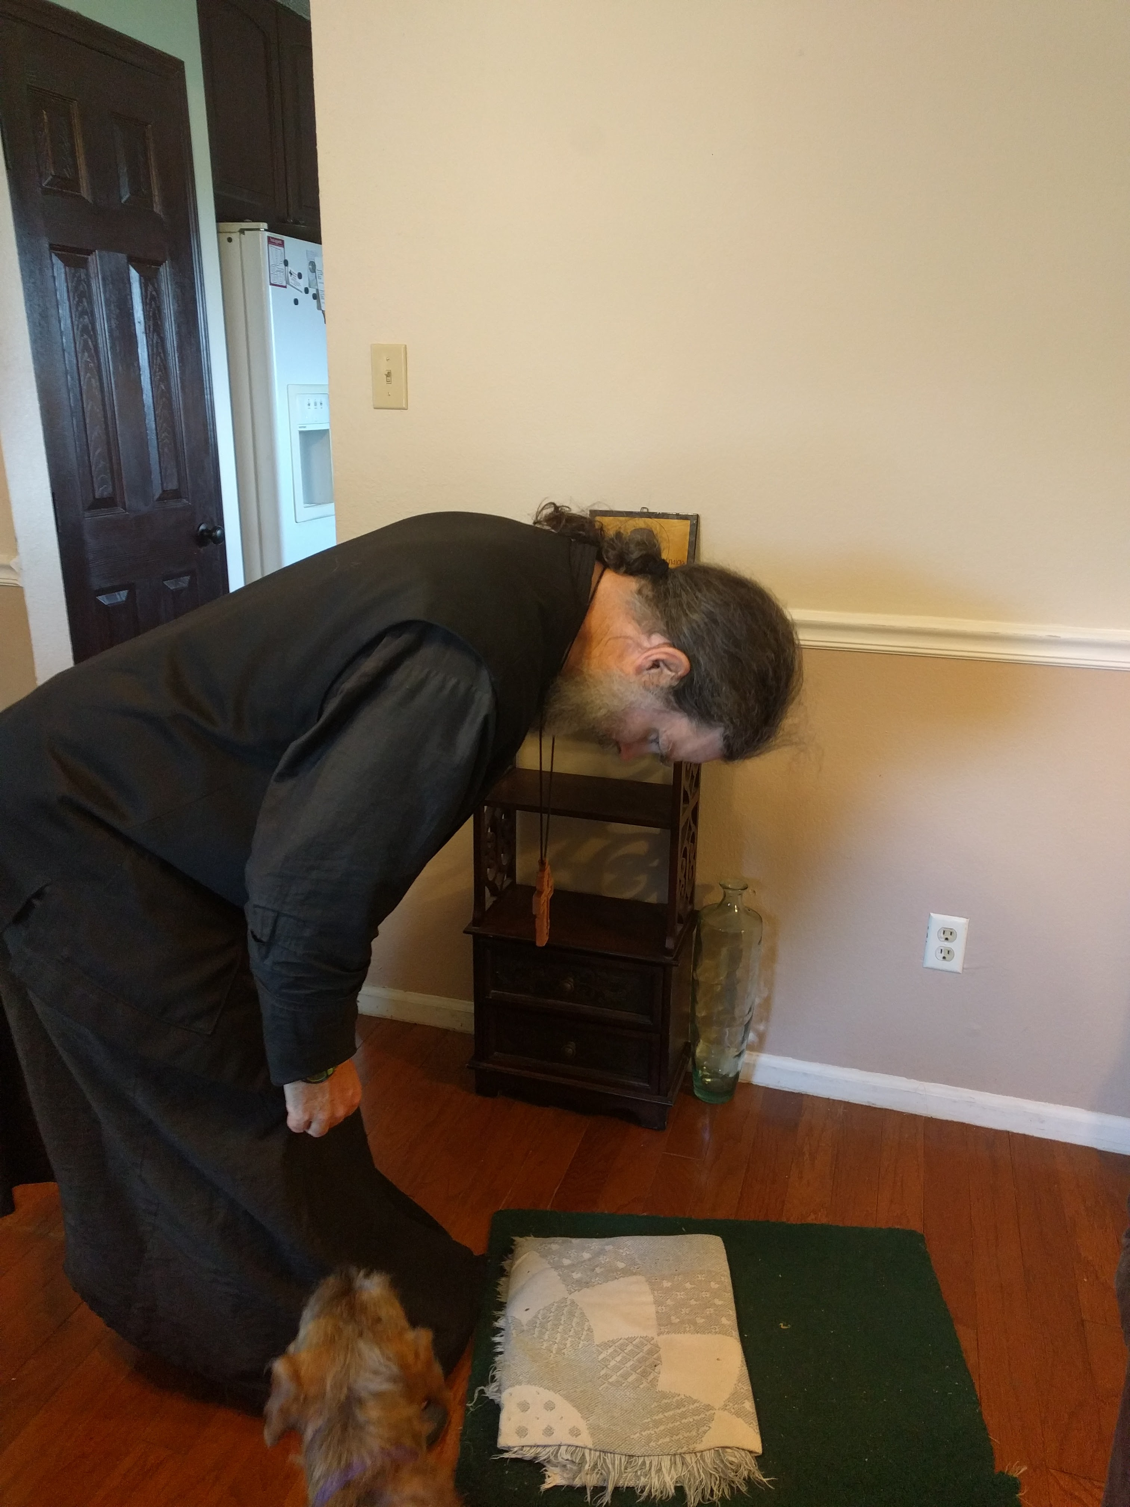
* A low bow, or “poklon”. Make the sign of the cross, and as you are finishing the cross, bend at the waist, and at your knees a little, and bow your upper body and head in such a way that your right hand touches or is near to your right knee. Praying with your mind, and body is very beneficial, and increases compunction and attention.

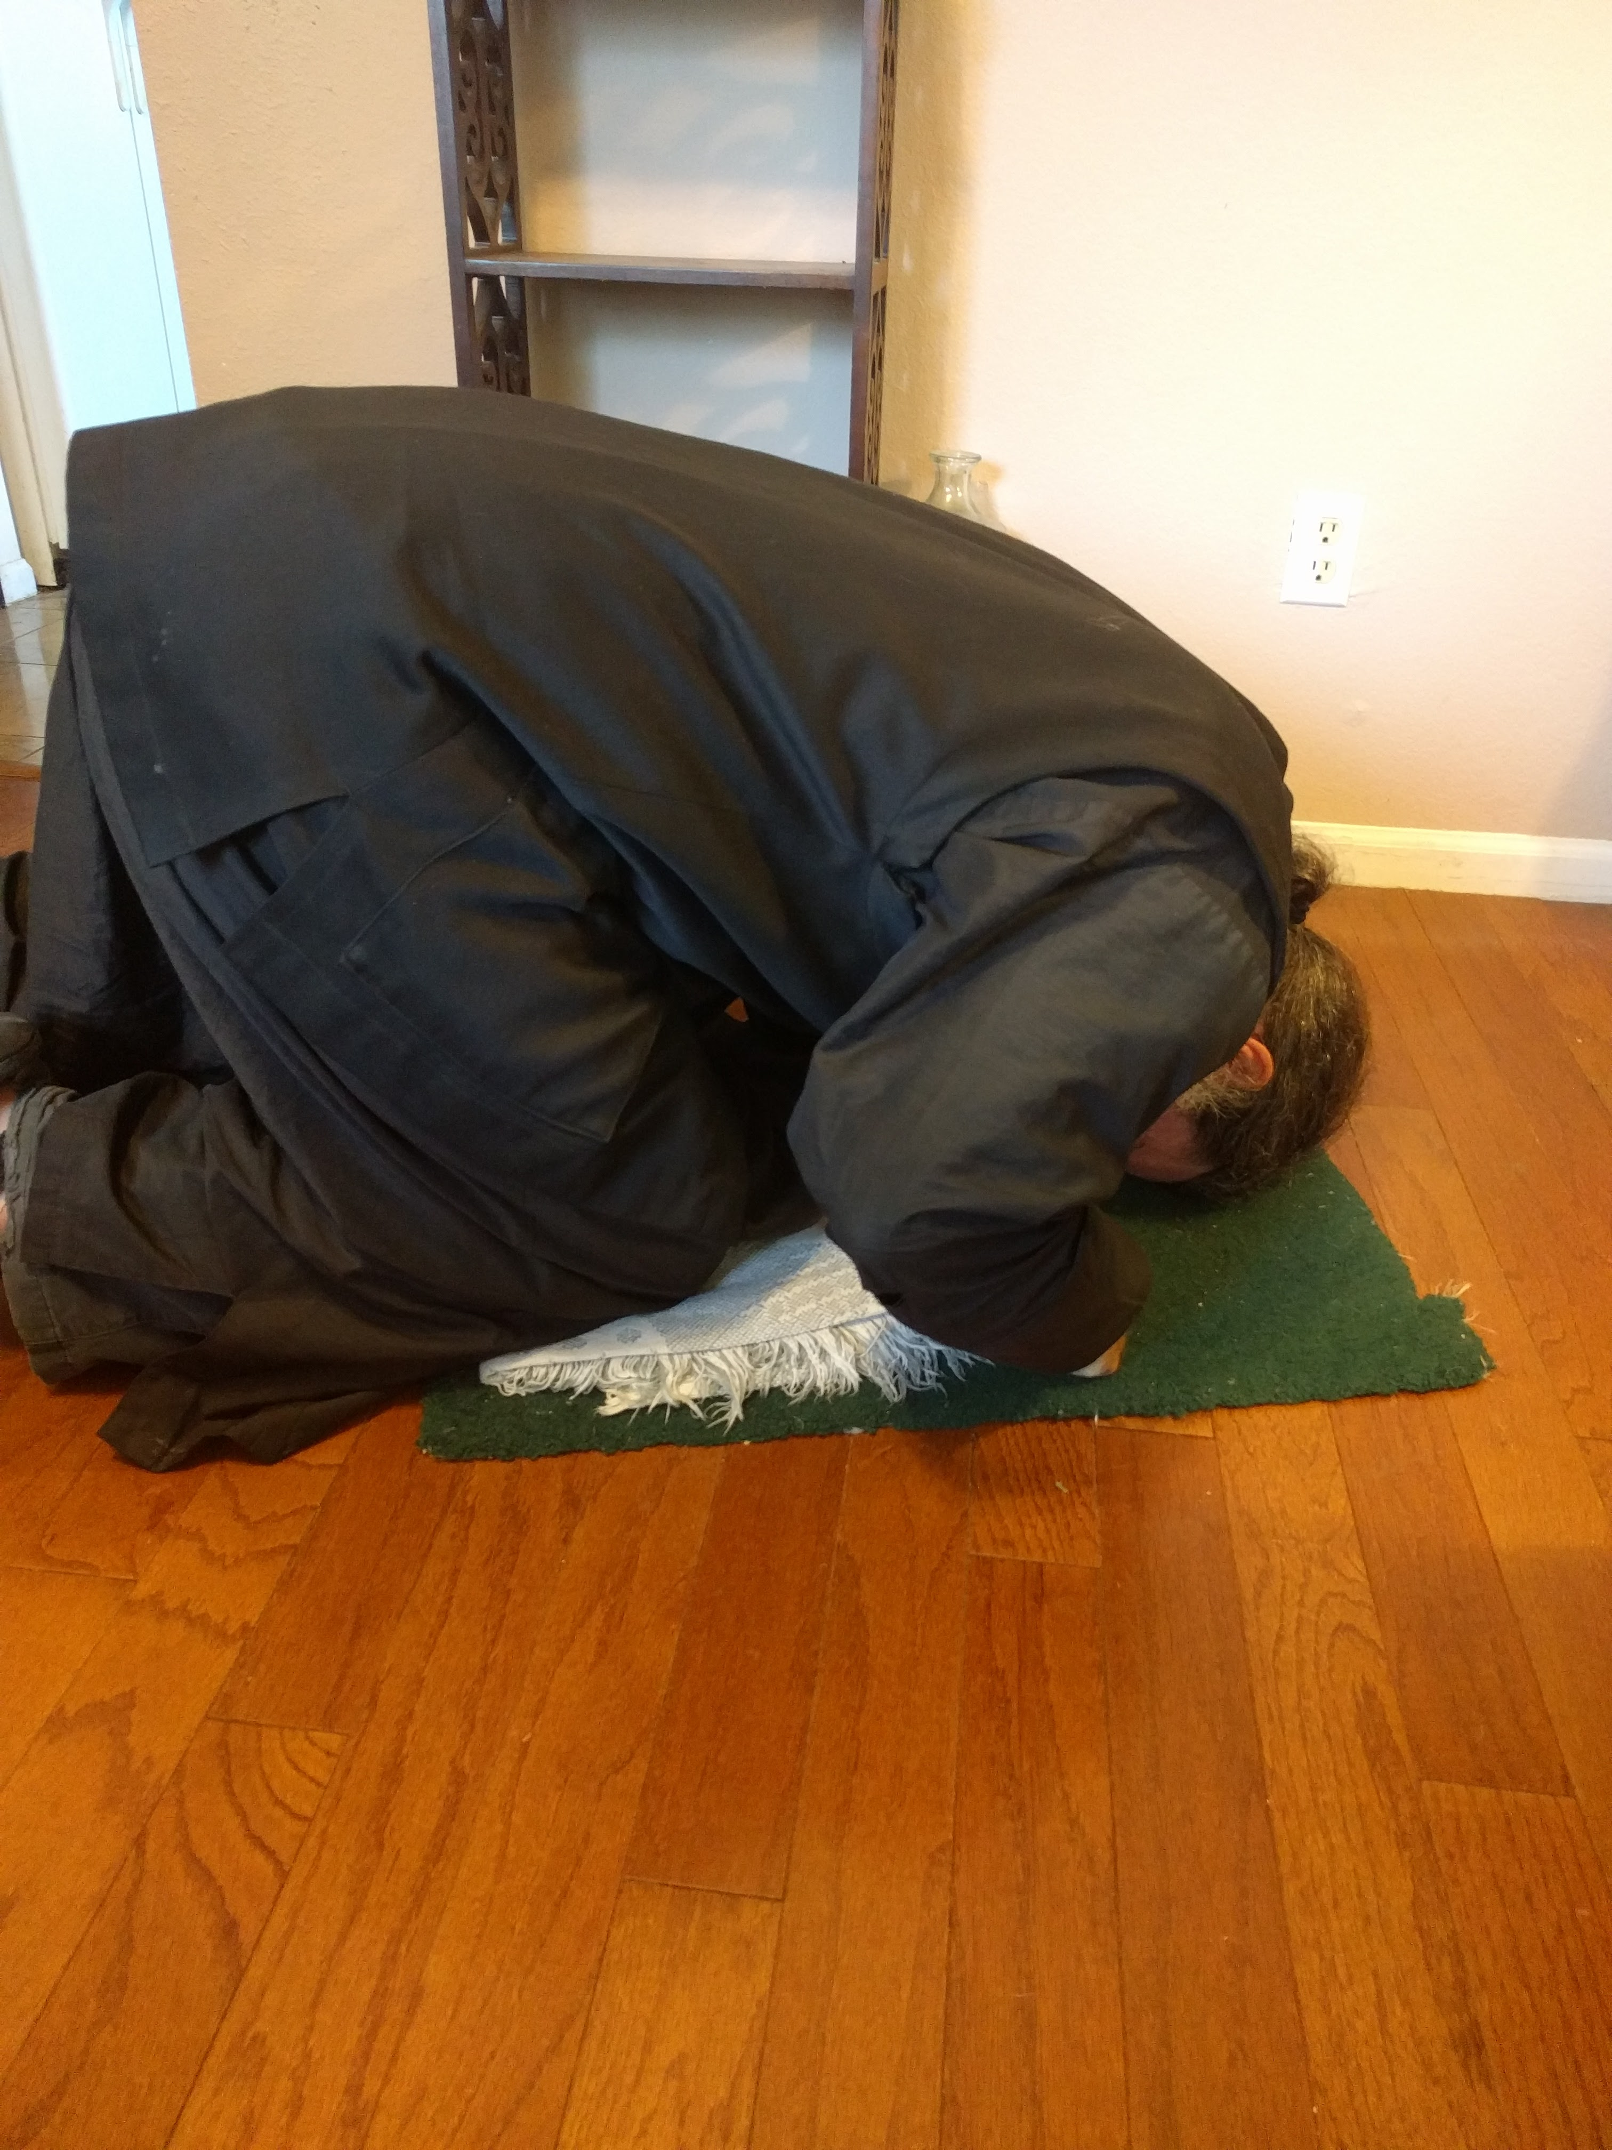
* A “Prostration”. Make the sign of the cross, and as you are finishing the cross, get on your knees, and bring your face close to the ground, then stand back up. The hands should be relatively close to the knees.
Both of these (low bow, prostration) are demonstrated here:
https://youtu.be/r4FaqRa1KFE

Read the Prologue (online) everyday!
It is good to sanctify your “smart” phone by reading this essential literature (the Prologue) every day.
Go to: http://www.rocor.org.au/?page_id=925 or go here: http://98.131.104.126/prolog/my.html and select the date you want (according to the church calendar – you gotta be able to subtract 13 days from today’s date on Joe’s Garage Calendar, which can be a challenge before coffee in the morning)
Or, go here: http://98.131.104.126/prolog/my.html All links have the same text, with slightly different presentation.
I keep the previous day’s entry open, and adjust the url manually. This way I do not need to do any arithmetic:
Today is: http://98.131.104.126/prolog/May16.htm Tomorrow is: http://98.131.104.126/prolog/May17.htm

A Simple prayer rule, complete text
From the Morning prayers:
The Trisagion prayers:
Glory to Thee, our God, glory to Thee.
O Heavenly King, Comforter, Spirit of Truth, Who art everywhere present and fillest all things, Treasury of good things and Giver of life: Come and dwell in us, and cleanse us of all impurity, and save, our souls, O Good One.
Holy God, Holy Mighty, Holy Immortal, have mercy on us. (Thrice)
Glory to the Father, and to the Son, and to the Holy Spirit, both now and ever, and unto the unto the ages of ages. Amen.
O Most Holy Trinity, have mercy on us. O Lord, blot out our sins. O Master, pardon our iniquities. O Holy One, visit and heal our infirmities for Thy name's sake.
Lord have mercy. (Thrice)
Glory to the Father and to the Son and to the holy Spirit, both now and ever, and unto the ages of ages. Amen.
Our Father, Who art in the Heavens, hallowed by Thy Name. Thy Kingdom come, Thy will be done, on earth as it is in Heaven. Give us this day our daily bread. And forgive us our debts, as we forgive our debtors. And lead us not into temptation, but deliver us from the evil one.
A layman then says: “Through the prayers of our Holy Fathers, O Lord Jesus Christ, have mercy on us. Amen”
Morning Troparia: (TONE 1)
Having risen from sleep, we fall down before Thee, O Good One, and the angelical hymn we cry aloud to Thee, O Mighty One: Holy, holy, holy art Thou, O God; through the Theotokos have mercy on us.
Glory to the Father, and to the Son, and to the Holy Spirit.
From bed and sleep hast Thou raised me up, O Lord, enlighten my mind and heart, and open my lips that I may hymn Thee, O Holy Trinity: Holy, holy, holy art Thou, O God; through the Theotokos, have mercy on us.
Now and ever and to the ages of ages. Amen.
Suddenly the Judge shall come, and the deeds of each will be laid bare; but with fear do we cry at midnight: Holy, holy, holy art Thou, O God; through the Theotokos, have mercy on us.
Lord have mercy. (12 times)
O come, let us worship God our King.
O come let us worship and fall down before Christ our King and our God.
O come, let us worship and fall down before Him, Christ Himself, our King and our God.
And three "reverences" (low bows, described above))
PSALM 50
Have mercy on me, O God, according to Thy great mercy; and according to the multitude of Thy compassions blot out my transgression. Wash me thoroughly from mine iniquity, and cleanse me from my sin.
For I know mine iniquity, and my sin is ever before me. Against Thee only have I sinned and done this evil before Thee, that Thou mightest be justified in Thy words, and prevail when Thou art judged.
For behold, I was conceived in iniquities, and in sins did my mother bear me. For behold, Thou hast loved truth; the hidden and secret things of Thy wisdom hast Thou made manifest unto me.
Thou shalt sprinkle me with hyssop, and I shall be made clean; Thou shalt wash me, and I shall be made whiter than snow.
Thou shalt make me to hear joy and gladness; the bones that be humbled, they shall rejoice.
Turn Thy face away from my sins, and blot out all mine iniquities.
Create in me a clean heart, O God, and renew a right spirit within me.
Cast me not away from Thy presence, and take not Thy Holy Spirit from me.
Restore unto me the joy of Thy salvation, and with Thy governing Spirit establish me.
I shall teach transgressors Thy ways, and the ungodly shall turn back unto Thee.
Deliver me from bloodguiltiness. O God, Thou God of my salvation; my tongue shall rejoice in Thy righteousness.
O Lord, Thou shalt open my lips, and my mouth shall declare Thy praise.
For if Thou hadst desired sacrifice, I had given it; with wholeburnt offerings Thou shalt not be pleased.
A sacrifice unto God is a broken spirit; a heart that is broken and humbled God will not despise.
Do good, O Lord, in Thy good pleasure unto Sion, and let the walls of Jerusalem be builded.
Then shalt Thou be pleased with a sacrifice of righteousness, with oblation and wholeburnt offerings.
Then shall they offer bullocks upon Thine altar.
The Symbol of Faith:
I believe in one God, the Father Almighty, Maker of heaven and earth, and of all things visible and invisible.
And in one Lord Jesus Christ, the Son of God, the Only-begotten, begotten of the Father before all ages. Light of Light; true God of true God, begotten, not made; of one essence with the Father by Whom all things were made;
Who for us men, and for our salvation, came down from the heavens, and was incarnate of the Holy Spirit and the Virgin Mary, and became man;
And was crucified for us under Pontius Pilate, and suffered, and was buried;
And arose again on the third day according to the Scriptures; And ascended into the heavens, and sitteth at the right hand of the Father.
And shall come again, with glory, to judge both the living and the dead; Whose kingdom shall have no end.
And in the Holy Spirit, the Lord, the Giver of Life; Who proceedeth from the Father; Who with the Father and the Son together is worshipped and glorified; Who spake by the prophets.
In One, Holy, Catholic, and Apostolic Church.
I confess one baptism for the remission of sins.
I look for the resurrection of the dead, And the life of the age to come. Amen.
Then, for each person in your dyptichs (list of people you want to pray for):
make the sign of the cross, while making a low bow*, and say: “Lord Jesus Christ, have mercy on (N)”. It is even better to make a prostration* for each person, or at least for certain people.

