Letter to a prisoner

The most important verse in the Bible. Our purpose in life.

Old Testament traditions and church traditions.

What is sin?
http://www.orthodox.et/prison-ministry/prison-ministry-letters_2019+our-purpose-ot-church-traditions-what-is-sin.pdf
http://www.orthodox.et/prison-ministry/prison-ministry-letters_2019+our-purpose-ot-church-traditions-what-is-sin.doc

From: Priest Seraphim Holland PO 37, McKinney, TX 75070 to: … Date: Oct 10, 2019 ns
Dear …:
Try as I might, I am always behind on letters. I also cannot seem to see many people in …. This week, I saw only one person, and the previous week nobody because your count was all messed up. This is kind of demoralizing. I am responding to a letter that I don’t think I responded to yet, that is dated 08-27-19. I already sent a general letter that you should’ve gotten last week. I am very disappointed that I didn’t get to see you and … especially this week, as I was going to talk about the Creed. Were still going to do that. Try to memorize it.
I am going to give you a hint that will help you if you want me to write more often. Since my secretary gets disorganized and confused, he often just grabs the latest letter and writes a response to it. Therefore, the more letters you write, the more likely I’m going to write back, even that day.
I think I must’ve asked you to talk about Genesis Chapter 1 because you wrote about it. The big point of Genesis Chapter 1 is not the creation of the stars, the moon, the earth, all animals, the waters etc. The most important part of Genesis, and in fact the most important part of the entire Scriptures, is near the end of Genesis chapter 1, when God created man. He said, that is God said, referring to Himself in the plural since He is a plurality of persons, “let US make man in our own image and after our likeness (GEN 1:26a).
It is upon this verse that all the rest of Scripture lies. God made man in His own image to obtain His likeness. God showed man his purpose by creating him in His image. That means that we are the highest of all creation. The entirety of all of creation, the entire universe with all its planets and stars and animals, and even in the uncreated world, angels, is not worth the dignity of one man. We can deduce why we were created, and how we are to live and our purpose from this verse.
After creating man, God told him to subdue the earth.
“And God blessed them, saying, Increase and multiply, and fill the earth and subdue it, and have dominion over the fish of the seas and flying creatures of heaven, and all the cattle and all the earth, and all the reptiles that creep on the earth.” Genesis 1:28 Brenton
Many people misunderstand this command and think that it gives man the right to do what he wishes to the earth, but the most important meaning of this command is very spiritual. Because man is made in the image of God, he should have control over all of his soul’s faculties, since God is perfect control over all of His faculties. That is, he should have dominion over them, like a king has dominion over all of his subjects. That would mean that all of our desires are harmonious with the will of God, and that all of our abilities allow us to accomplish every godly desire.
You asked the question, “Why did God create?” There is a simple answer, of one syllable. He created because of love. God loves, and God is love. God created man to love him and to give him with the only gift that is significant in the universe – Himself. That is why he made man in His own image. We see in the animal world that animals that are created in the image of their parents are able to do the things their parents do. Lions are strong, birds can fly, and human beings can know God because they were created by God to be like God. The Scripture even says in the Psalms that “ye are gods”. It does not mean that we are divine, but that we have been created to know the divine and to become like the divine.
You ask another question: “was it for us or Him?”. God created us to know Him. God needs nothing, but He chooses to love us and give us of Himself. So, I suppose the proper answer to that question is that He created us for our benefit.
Everything we do in life must be because we were made in the image of God to obtain His likeness. Anything that we do that does not assist us in attaining His likeness is sin. Anything we do that helps us obtain His likeness is virtue. This is a different understanding of sin than the West understands. The West thinks of sin is an affront to God, something that makes Him angry and offends him. God is not offended by anything.
Sin is that which brings us further from God. We see the first example of sin in Adam and Eve. Prior to their sin, they walked with God in the garden. After their sin they were afraid of him and spoke to him with fear and confusion. The dialogue of Adam and Eve with God after their fall also shows that their understanding became clouded, and they made excuses for themselves. This is what sin does. It makes us afraid, and it clouds our understanding. I have a favorite saying, that I tell people often: “sin makes you stupid”. God wants us to understand Him and to know Him and to be united with Him. Sin obstructs that process. It is not an affront to God, but it is an impediment to our knowing Him.
I also asked you to talk about John chapter 3. In the dialogue with Nicodemus, Jesus talks of being born again. This is baptism, in which we are reborn by water and the Spirit. You asked a question by doing a formula: “so belief in Christ is not equal to being born again?”. Belief in Christ includes being born again, and living as a person who believes in Christ. Our salvation is not a static event, neither of baptism nor an intellectual assertion about God, as so many of the Protestants believe. Baptism is the beginning of our life, just as being born is the beginning of our life in the world. A baby might be born of genius parents, but if he is not educated and talked to and read to, he will never develop, and will never become a genius.
You also said that we are born condemned. That is more of a Western idea. We are not born condemned, but we are born weak, and inclined to sin. The infant eventually shows this when he becomes older. No child, when he is born is guilty before God. That idea is a heresy called “Original Sin”, which the Latins believe. They believe that the sin of Adam was transmitted to every man and his guilt was transmitted to every man. Adam’s weakness and inclination to sin was transmitted to every man, but we are guilty or innocent depending on how we behave.
I think you quoted the struggle for virtue by saying: “asceticism is basically forcing the darkness in you into the light”. Yes indeed! Asceticism is not just physical things; it is everything. It is where we force ourselves to pray, to forgive, to be humble, to fast, to love. We force ourselves to do the things that we should do naturally, but we have not yet reached that point. In the next life, our freedom will be that we will be able always to freely choose good and always be able to do it. Jesus spoke of this condition, the final condition of the soul, when we have perfect freedom, to always perfectly follow God’s will because we desire nothing else: “If the Son therefore shall make you free, ye shall be free indeed. ” (John 8:36 KJV)

“ In this age now, sometimes we don’t want to choose good, and sometimes we want to do good and don’t have the strength to do it. The Christian life entails the strengthening of man’s will by God’s grace and man’s effort, which is cooperating with God’s grace. This is not possible unless the grace of God acts from within. This grace will not act until we are baptized. That is why baptism is so important. Of course, the grace of God acts on all men, but on those who are unbaptized are acted on by grace from without, to bring them to baptism. After baptism the grace of God acts from within. This is one of the reasons why the Eucharist is so primary to our faith. We partake of the body of Christ and bring Him within our bodies to enlighten us from within.
You answered my typical question that I ask everyone about purpose in life in the following way: “To help as many people as I can… My purpose is to look after orphans, that is what my goal is. I want to start a self-sufficient ranch/children’s home”.
Your goal is a laudable one, and may God help you to reach it! It is not your purpose. It will be fulfilled if God desires it as you are fulfilling your purpose. Your purpose is defined by our Lord’s prayer in the garden of Gethsemane, on Holy Thursday, just before he was arrested. He said that: “This is eternal life, that they may know Thee, the only true God and Jesus Christ whom Thou hast sent.” (John 17:3) Your purpose, and my purpose, and the purpose of every man made in the image of God is to know God. Of course, we cannot know someone without becoming like them. So, the Christian life is the process of becoming like God. It is the process of putting off our sins and having dominion over our soul’s faculties so that they would be harmoniously united to God. All of this happens by grace, with our effort.
You also said: “my purpose is to learn and grow spiritually and do my best to be the best man I can be.” Again, that is a very laudable goal, and indeed you will grow spiritually and do your best and be the best man you can be as you fulfill your purpose. God did not make you to serve Him. He made you to know Him. You cannot know Him without serving Him, but your purpose is not to serve Him. Your purpose is to know Him.
You also told me that you don’t: “want prison to be my legacy.” May it be blessed. May God help you in all things, to be the person that you were born to be.
You also said: “Sometimes I feel the Christian church tries to focus too much on evolving spiritually through asceticism and leans too much on tradition… God gave the Israelites the Torah; they formulated their traditions from that. The church is done the same thing.”
I think you have it wrong my friend. The entire purpose of the Christian church is so that man can fulfill his purpose. The church is the body of Christ, and in Christ we fulfill our purpose. The reason for traditions is because they protect us. Individual people can depend on traditions like a sort of superstition, but the church does not. The entire purpose of our life is to have union with God, and it is indeed also the entire purpose of the church. It is a great temptation to look upon the activities of man and ascribe them to the church. The church is the body of Christ and is perfect. Men are imperfect and do imperfect things. Without asceticism, we cannot be saved. Asceticism is not a goal in and in and of itself. Asceticism is when we care so much about the things of God that we don’t allow anything to get in our way, whether it be our sins, our comfort, the foods we eat, or anything else.
Your letter talks a lot about the Old Testament laws and how they apply to us. I’m too tired to talk about it too much now. If we accept that the church is the body of Christ and guided by the Holy Spirit, whatever the church says and practices must be correct. For now, we’ll go with that, and if you have any questions, we will talk about them. You did ask why are we not celebrating the feast of Tabernacles. The Old Testament was a shadow of what was to come. We don’t celebrate the Passover anymore, because Christ is our Passover. We don’t celebrate the Jewish feast of Pentecost, because we are able to fulfill the law and to become like Christ because of the Christian Pentecost. There are many things in the law that were temporary. The moral things are not temporary, but some of the new laws and other things were temporary. It will take too long to write this in a letter and I’m already at page 4.
You said in your letter that “the Emperor moved the capital to Constantinople and the Empire eventually split, so did the church.” A man created Empire did split into two, but it is impossible for the church to split. The church is typified by the seamless robe of Christ, and cannot be anything but one. We do not say that the church split with the great schism. We say that the Romans and later their children, Luther and the rest, left the church. The unity of the church is always intact.
You also said in your letter: “if we worship in spirit and truth the spirit should teach us and lead us to truth. What is truth?” In your ensuing discussion you said: “truth is based in reason, it’s reasonable to believe that Orthodoxy is the original version of the Romanized Christianity and is privy to information and reasonings that the rest of Christendom is not.”
What is truth? Pilate asked this question, but he was not really interested in the answer, so Christ did not tell him. Truth is God, or perhaps it would be better just to quote our Lord Jesus Christ: “I am the way, the truth, and the life: no man cometh unto the Father, but by me.“ (John 14:6) His answer shows the truth found in is our relationship with God. All truth comes from God. All truth is understood in the human soul by experiencing God. This is not by apprehension because man has reason. God is not apprehended by our reason. He is only understood when the soul is prepared to know Him, and God reveals into itself to us as he wishes the way in which he wishes. The understanding of how man knows God is fundamentally different in the West versus the East. We can know God only by God revealing Himself to us as we are able to understand Him. We become able to understand Him by the combination of our weak struggles and His great grace, as we live a Christian life in the church. It is actually redundant to say that we “live a Christian life in the church”, as it is impossible to live a Christian life outside of the church. Whatever people do outside of the church, may God bless them and help them. But we who are Christians must live in a certain way.
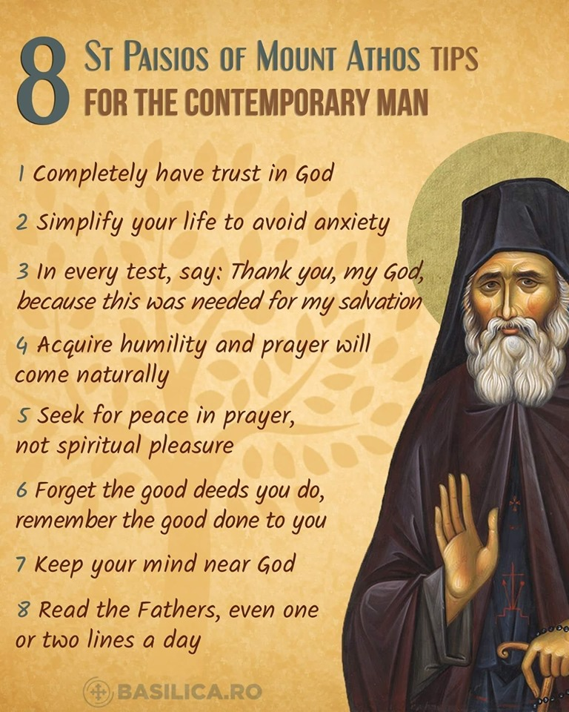
You also said in your letter: “I have one thing to reason over, ‘the Bible’, it’s full of clues and it is God inspired, beyond that I have no other influence.” I have a treat for you. The Bible came from the church. Therefore, the church will teach you about the Bible. You do not need to rely on your reason. In fact, in the beginning, your reason just gets in the way. Obedience precedes understanding. This is where our asceticism is especially useful. It is good to just do what we are told. You’re told to fast, so you fast. You’re told to forgive, so you forgive. You are told to go to confession, so you go to confession. You’re told to come to the services and to pray, and so you pray. You read prayers from the prayer book, so that you can learn how to pray properly. There is much freedom and our way of life. It appears to be not free to a Protestant, but that’s because he does not understand it. I hope that you will begin to understand it and see what I mean.
Okay, I think I’ve come to the end of your letter. I’m sure there many more things we can talk about in the future, but I must stop at some point, since I have other letters to write. May God bless you and help you in all things.
When your heart is disturbed in spirit by any passion, and you are deprived of peace, and are filled with agitation, and words of displeasure and animosity to your neighbor fall from your tongue, do not linger in this condition, so destructive to you, but immediately bend your knees and confess your sin before the Holy Spirit...
Righteous John, Wonderworker of Kronstadt
My Life in Christ p.146
A man told us the following miraculous event, which happened after Elder had fallen asleep [Father Eumenios Saridakis (1931-1999)].
As soon as we heard that my bride was expecting a baby, and although it was 10:30 pm Saturday night, we decided to go for a walk, even as far as the outside door of Father Eumenio's cell. As we approached, we saw light beneath the door and, as we went to knock, a girl, full of joy, opened up and said:
"Oh, he is waiting for you and sent me to open for you. I never come in such hours, and especially on Saturday, because it is dark and deserted."
When we got in, the same girl turns around and asks us:
"What is the problem?"
"Well my wife is pregnant and we came to pray that everything goes well."
"You know," said the girl, addressing my wife, who cried out in tears "you'll have a problem, but our Elder will help you and everything will go well."
After we venerated his stole and his bed, we left. When we got out, my wife kept crying — she had never met Father Eumenios in person — and I asked her why these sobs. She answered me:
"Because when we went in, he was sitting on the couch and, when I sat next to him, he told me, "You're going to have a boy, everything's going to be okay."
The pregnancy was going on, but, at some point, doctors told my wife that the fetus was hydrocephalus and suggested that they take it because months had passed and the problem, mental and kinetic, would exist in the newborn and would continue throughout his life and her own life would be destroyed. Note that we already had a healthy eighteen year old daughter. But she refused, because she had faith in Father Eumenios and what he had said that night.
She signed papers with the doctors on her decision to keep the hydrocephalus fetus and months passed. We were all in a state of anxiety and distress, with only the serenity that the conversation with the Elder gave her.
Indeed, when she went for the established ultrasound in the seventh month, a miracle happened! The fetus was normal with no trace of hydrocephalus. Not all doctors could believe it and they were talking about a miracle.
To this day, the child is in great health and is named Eumenius, for the sake of our Elder, to whom we owe his existence.
Miracle of St. John Maximovic (a saint of our times)
Once, at the beginning of the summer holidays, Valya was unwell. The girl's condition quickly deteriorated, the fever did not subside. When Valya, because of a severe sore throat, refused not only to eat, but also to drink, the parents sounded the alarm. The hospital was overcrowded, there were no free beds, and the doctor, providing them with medicine, sent them home. The night turned out to be difficult for the whole family: the girl lost consciousness, then came to herself again, it became difficult for her not only to swallow, but also to breathe.
In the morning, mother, tired, with sunken eyes, went to her daughter and said in a deliberately cheerful voice:
- Valya, Vladyka is here, he came to visit you! The patient's eyelids were heavy, as if filled with lead, and she opened her eyes with difficulty. At that moment, Vladyka approached her bed and, blessing, affectionately said: “I came to tell you a joke.”
And Vladyka John began to tell some funny story that Valya did not understand and did not even hear clearly. She lay in silence, and she was so bad, and Vladyka, meanwhile, began to laugh at his own story. The faces of Valya's parents appeared in the doorway. They looked at the bishop with bewilderment, but he seemed not to notice them.
“You didn’t like this joke, well, I'll tell you another one!”
And Vladyka told her a few jokes in a row, accompanying each with a loud laugh. None of them seemed funny to the sick girl, and the grimace of suffering never left her pale face. Valya hardly looked into the doorway: her father was no longer just perplexed, he was angry. But Vladyka paid no attention to Valya’s parents and continued:
“I’m sure the next joke will make you laugh.” Here, listen. Once, a bishop, just like me, had a cell mate and a subdeacon. They fought, and then went to the bishop to explain the situation. The bishop asks the sub-deacon: “How did he hit you?” And the sub-deacon answers: “Not in a nice way, but with a candlestick!”
Then Vladyka laughed so fervently that the sick girl could not stand it and laughed with him. Parents looked at them with round eyes in amazement, and this made Valya laugh even harder. While the girl was laughing, something in her throat burst open. As she learned later, she had a severe form of diphtheria and when she was laughing, it burst, which prevented her from swallowing and breathing.
Vladyka immediately broke off laughter and told his parents:
“Clean everything up, make sure that Valya rinses your mouth and throat. Now she will be fine."
After that, he blessed the girl and left. Valya noticed that Vladyka looked terribly tired, as if it wasn’t he who was laughing so cheerfully now. When she rinsed her mouth and throat, she felt instant relief and fell asleep. Her sleep was calm and light, the fever was asleep.
In the afternoon, an alarmed doctor came and carefully asked Valya's mother if the patient was alive. And the mother answered even cheerfully:
"Not only alive, but also healthy. Her temperature is normal and she is sleeping peacefully.
The doctor could not believe her words. After seeing the girl, he said only:
"This is a miracle. This is nothing but a miracle."

