Priest Seraphim Holland, PO 37, McKinney TX 75070; General Letter 1 11/12-25 SAINT JOHN THE MERCIFUL, PATRIARCH OF ALEXANDRIA (+ 612).

Dear brothers and sister (for the first time in 23 years, someone has contacted me about a woman in prison, so it may be that my prison ministry expands when all of the hoopla regarding travel to Africa ends):
This is a general letter, that is basically being sent by someone else for me. I would like to be able to write a personal response to all of you on your letters, but I have basically hit a wall. I think you know about that wall. That wall is not so much a physical wall, and is not related to our physical exhaustion; it is when things are too complicated or too hard or too bleak or too something. I also have duties as a member of the Board of Directors of Orthodox Africa, and as such will be traveling to Uganda in December, and Kenya in January into February. The Ugandan trip is December 4-20, and the Kenya trip is, I believe January 21 through February 21. I’m also going to a family reunion over Thanksgiving, in Florida. Marina’s parents are there. Immediately after that trip I leave for Uganda. After returning from Uganda, a few days later I will go to a youth conference in Cincinnati. It is called the St. Herman’s youth conference, and it is always wonderful. In Africa, I will be visiting some old friends, and go to youth conference, and also evaluating a new mission, and evaluating old missions. I hope that I will get my mojo back regarding prison ministry. The travel sometimes is hard, but it’s not the reason that I’m tired. The reason for exhaustion is always thoughts. There’s been some setbacks, and if I were a saint, although we do is pray and continue to have clear thoughts. But since I’m not a saint, I guess I need a little bit of recovery time, and these trips in Africa hopefully will provide that.
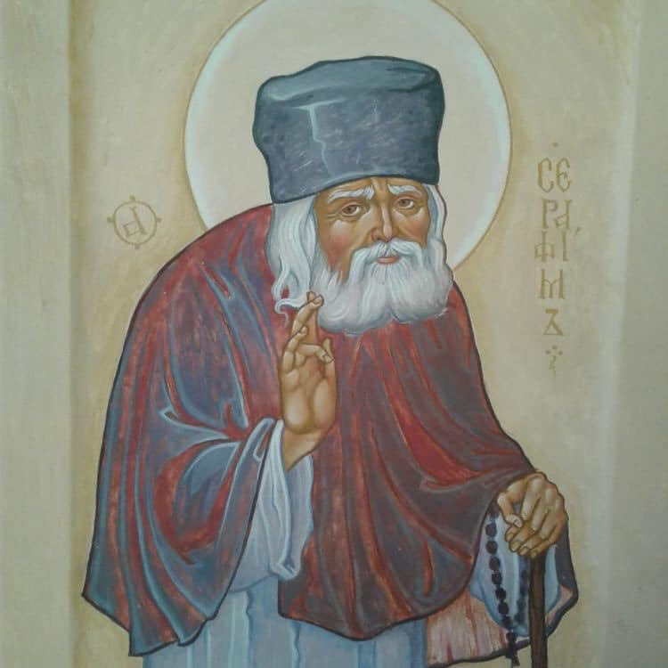
A lot of you been very kind and told me personally or in a letter that my attention toward you makes a real difference in your life. I appreciate that very much. The fact is, that with or without anybody saying anything, everything we do matters. Why is it that our thoughts tell us otherwise? All of you are connected to me through prayer. That is because I pray for each one of you every day. My prayers are poor, but they are consistent. Since no one is worthy, I tell myself that even though my prayers are not worthy because of the kind of man that I am, God sees my intent and your need, and answers those prayers. I think of myself as the prostitute praying. Some of you know that story. It is from a wonderful book about an encounter with St. Seraphim of Sarov, my patron saint. I will include it here.
"You may judge how great the power of prayer is even in a sinful person, when it is offered whole-heartedly, by the following example from Holy Tradition. When at the request of a desperate mother who had been deprived by death of her only son, a harlot whom she chanced to meet, still unclean from her last sin, and who was touched by the mother's deep sorrow, cried to the Lord: 'Not for the sake of a wretched sinner like me, but for the sake of the tears of a mother grieving for her son and firmly trusting in Thy loving kindness and Thy almighty power, Christ God, raise up her son, O Lord!' And the Lord raised him up. - St Seraphim of Sarov
I’m sorry that this letter might seem to be impersonal. I’m still wrestling with a big pile of letters, and not enough time in the day to do everything. I thought I would tell you about my day a little bit, because I try to do the important things. Letter writing and visiting in prisons and visiting in Africa, and serving services – all those things are important. But they are not the most important things. The most important thing in my day as a general thing. It is that I would live and act as a Christian.
In line with that primary directive that my heart tells me is that I must pray. I usually pray from the Psalter at least two or three fees was a day, and I have course commemorate a long list of people. This is most critical. I have made also a 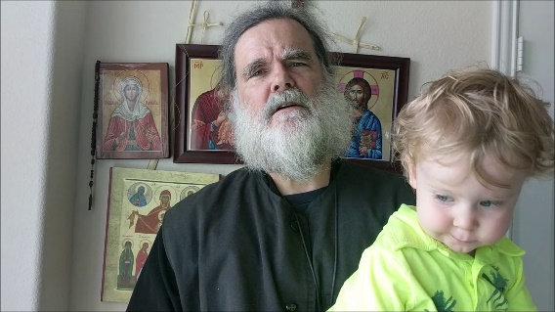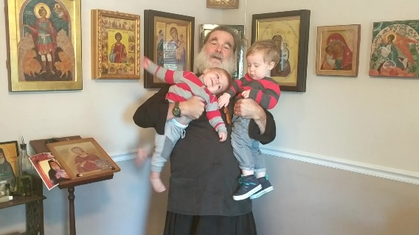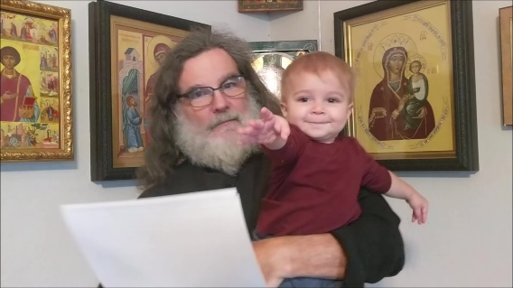
Monster man (Noah), Both, Axe-man (Owen Daniel). From stills of Monster and axe-man movies, when I talk about some spiritual thing while holding them.
commitment to my two youngest grandsons, and I take care of each once a week. I do this for me and for them. When Daniel died, I felt a certain sadness that to some extent is never going away. But those of you who know me know that I don’t believe that we should just be sad and sit around. Grief, and its sister, regrets and energy in our life. Energy either creates or destroys. So I choose to take that energy, try to create. I try to pour myself into the lives of my grandsons. Of course I love all of my grandchildren, but the dynamic is different with them because they go to school, or they are older, or they are in a big family that does not have need of anyone to take care of them on a given day. So, I’m taking advantage of that dynamic, and taking care of my monster man and my ax man.
Recently, we commemorated St. John the Dwarf, an Egyptian monk. His sayings are beautiful. So, I will just end this letter by including his sayings. Read them carefully, and read them again and again. Write me a letter about your favorite ones. I will read all the letters when I get back home. I may even respond to each one individually,
John the Dwarf: from The Sayings of the Desert Fathers
John the Dwarf, son of poor parents in Tese, was born about 339. The second story here clearly belongs to his youth at home before he became a monk, while he was living with his family. At the age of eighteen he went to Seeds and was trained by Abba Ammoes for twelve years. One of the most vivid characters in the desert, he attracted many disciples and in order to preserve his own solitude he dug himself a cave underground. He was ordained priest, and the number of his sayings, recorded and pre- served, points to his importance among his disciples. After 407 he went to Suez and the Mountain of Anthony.
1. It was said of Abba John the Dwarf that he withdrew and lived in the desert at Scetis with an old man of Thebes. His Abba, taking a piece of dry wood, planted it and said to him, 'Water it every day with a bottle of water, until it bears fruit.' Now the water was so far away that he had to leave in the evening and return the following morning. At the end of three years the wood came to life and bore fruit. Then the old man took some of the fruit and carried it to the church saying to the brethren, 'Take and eat the fruit of obedience.'
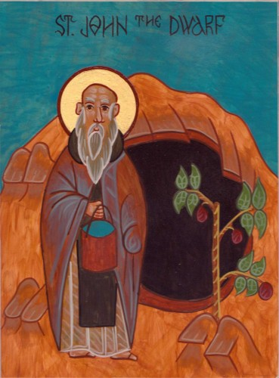
2. It was said of Abba John the Dwarf, that one day he said to his elder brother, 'I should like to be free of all care, like the angels, who do not work, but ceaselessly offer worship to God.' So, he took off his cloak and went away into the desert. After a week he came back to his brother. When he knocked on the door, he heard his brother say, before he opened it 'Who are you?' He said, 'I am John, your brother.' But he replied, 'John has become an angel, and hence- forth he is no longer among men.' Then the other begged him saying, 'It is I.' However, his brother did not let him in, but left him there in distress until morning. Then, opening the door, he said to him, 'You are a man and you must once again work in order to eat.' Then John made a prostration before him, saying, 'Forgive me.'
3. Abba John the Dwarf said, 'If a king wanted to take possession of his enemy's city, he would begin by cutting off the water and the food and so his enemies, dying of hunger, would submit to him. It is the same with the passions of the flesh: if a man goes about fasting and hungry the enemies of his soul grow weak.'
4. He also said, 'He who gorges himself and talks with a boy has already in his thought committed fornication with him.'
5. He also said, 'Going up the road again towards Scetis with some ropes, I saw the camel driver talking and he made me angry; so, leaving my goods, I took to flight.'
6. On another occasion in summertime, he heard a brother talking angrily to his neighbor, saying, Ah! you too?' So, leaving the harvest, he took to flight.
7. Some old men were entertaining themselves at Scetis by having a meal together; amongst them was Abba John. A venerable priest got up to offer drink, but nobody accepted any from him, except John the Dwarf. They were surprised and said to him, 'How is it that you, the youngest, dared to let yourself be served by the priest?' Then he said to them, 'When I get up to offer drink, I am glad when everyone accepts it, since I am receiving my reward; that is the reason, then, that I accepted it, so that he also might gain his reward and not be grieved by seeing that no-one would accept anything from him.' When they heard this, they were all filled with wonder and edification at his discretion.
8. One day when he was sitting in front of the church, the brethren were consulting him about their thoughts. One of the old men who saw it became a prey to jealousy and said to him, 'John, your vessel is full of poison.' Abba John said to him, 'That is very true, abba; and you have said that when you only see the outside, but if you were able to see the inside, too, what would you say then?'
9. The brethren used to tell how the brethren were sitting one day at an agape and one brother at table began to laugh. When he saw that, Abba John began to weep, saying, 'What does this brother have in his heart, that he should laugh, when he ought to weep, because he is eating at an agape?
10. Some brethren came one day to test him to see whether he would let his thoughts get dissipated and speak of the things of this world. They said to him, 'We give thanks to God that this year there has been much rain and the palm trees have been able to drink, and their shoots have grown, and the brethren have found manual work.' Abba John said to them, 'So it is when the Holy Spirit descends into the hearts of men; they are renewed and they put forth leaves in the fear of God.'
11. It was said of him that one day he was weaving rope for two baskets, but he made it into one without noticing, until it had reached the wall, because his spirit was occupied in contemplation.
12. Abba John said, 'I am like a man sitting under a great tree, who sees wild beasts and snakes coming against him in great numbers. When he cannot withstand them any longer, he runs to climb the tree and is saved. It is just the same with me; I sit in my cell and I am aware of evil thoughts coming against me, and when I have no more strength against them, I take refuge in God by prayer and I am saved from the enemy.'
13. Abba Poemen said of Abba John the Dwarf that he had prayed God to take his passions away from him so that he might become free from care. He went and told an old man this: 'I find myself in peace, without an enemy,' he said. The old man said to him, 'Go, beseech God to stir up warfare so that you may regain the affliction and humility that you used to have, for it is by warfare that the soul makes progress.' So, he besought God and when warfare came, he no longer prayed that it might be taken away, but said, 'Lord, give me strength for the fight.'
14. Abba John said, 'Here is what one of the old men in ecstasy said: "Three monks were standing at the edge of the sea, and a voice came to them from the other side saying, 'Take wings of fire and come here to me.' The first two did so and reached the other shore, but the third remained, crying and weeping exceedingly. But later wings were given to him also, not of fire, but weak and without strength, so that with great difficulty he reached the other shore, sometimes under water, sometimes above it. So, it is with the present generation; if they are given wings they are not of fire, but wings that are weak and without power." '
15. A brother questioned Abba John saying, 'How is it that my soul, bruised with wounds, does not blush to speak against my neighbor?' The old man told him a parable relating to slander, 'There was a poor man who had a wife. He saw another very beautiful woman and he took her. They were both quite naked. A feast was being held somewhere near and both women begged him to take them with him. Taking both of them, he put them into a barrel and put them aboard a ship and so they reached the place. When it became hot, the people lay down to rest. One of the women looked out of the barrel and seeing no-one, went to a pile of rubbish and joining old rags together, made herself a girdle and then walked about confidently. The other, sitting inside the barrel, naked, said, "Look at that courtesan who is not ashamed to walk about naked." Grieved at this, her husband said to her, "This is truly wonderful! She at least hides her nakedness, but, as for you, you are completely naked; are you not ashamed to say that?" So, it is when one speaks against one's neighbor.'
16. The old man also said this to a certain brother about the soul which wishes to be converted, 'There was in a city a courtesan who had many lovers. One of the governors approached her, saying, "Promise me you will be good, and I will marry you." She promised this and he took her and brought her to his house. Her lovers, seeking her again, said to one another, "That lord has taken her with him to his house, so if we go to his house and he learns of it, he will condemn us. But let us go to the back, and whistle to her. Then, when she recognizes the sound of the whistle, she will come down to us; as for us, we shall be unassailable." When she heard the whistle, the woman stopped her ears and withdrew to the inner chamber and shut the doors.' The old man said that this courtesan is our soul, that her lovers are the passions and other men; that the lord is Christ; that the inner chamber is the eternal dwelling; those who whistle are the evil demons, but the soul always takes refuge in the Lord.
17. One day when Abba John was going up to Scetis with some other brothers, their guide lost his way for it was night-time. So, the brothers said to Abba John, 'What shall we do, abba, in order not to die wandering about, for the brother has lost the way?' The old man said to them, 'If we speak to him, he will be filled with grief and shame. But look here, I will pretend to be ill and say I cannot walk anymore; then we can stay here till the dawn.' This he did. The others said, 'We will not go on either, but we will stay with you.' They sat there until the dawn, and in this way, they did not upset the brother.
18. There was an old man at Scetis, very austere of body, but not very clear in his thoughts. He went to see Abba John to ask him about forgetfulness. Having received a word from him, he returned to his cell and forgot what Abba John had said to him. He went off again to ask him and having heard the same word from him he returned with it. As he got near his cell, he forgot it again. This he did many times; he went there, but while he was returning, he was overcome by forgetfulness. Later, meeting the old man he said to him, 'Do you know, abba, that I have forgotten again what you said to me? But I did not want to overburden you, so I did not come back.' Abba John said to him, 'Go and light a lamp.' He lit it. He said to htm, 'Bring some more lamps, and light them from the first.' He did so. Then Abba John said to the old man, 'Has that lamp suffered any loss from the fact that other lamps have been lit from it?' He said, 'No.' The old man continued, 'So it is with John; even if the whole of Scetis came to see me, they would not separate me from the love of Christ. Consequently, whenever you want to, come to me without hesitation.' So, thanks to the endurance of these two men, God took forgetfulness away from the old man. Such was the work of the monks of Scetis; they inspire fervor in those who are in the conflict and do violence to themselves to win others to do good.
19. A brother questioned Abba John, saying, 'What ought I to do? A brother often comes to fetch me for work, and since I am ill and weak, I get tired out working; what should I do, in order to keep the commandment?' The old man answered him saying, 'Caleb said to Joshua, the son of Nun: "I was forty years old when Moses, the servant of the Lord, sent me with you into the desert in this land; and now I am eighty-five years of age; as then, so now I can still take part in the battle and withdraw from it." (cf. Jos. 14.7-11) In the same way you, too, if you are strong enough to go out and to come in, go to work; but if you cannot do it, sit down in your cell and weep for your sins and when they find you filled with compunction, they will not compel you to go out.'
20. Abba John said, 'Who sold Joseph?' A brother replied saying, 'It was his brethren.' The old man said to him, 'No, it was his humility which sold him, because he could have said, "I am their brother" and have objected, but, because he kept silence, he sold himself by his humility. It is also his humility which set him up as chief in Egypt.'
21. Abba John said, 'We have put the light burden on one side, that is to say, self-accusation, and we have loaded ourselves with a heavy one, that is to say, self-justification.'
22. He also said, 'Humility and the fear of God are above all virtues.'
23. The same abba was sitting in church one day and he gave a sigh, unaware that there was someone behind him. When he noticed it, he lay prostrate before him, saying, 'Forgive me, abba, for I have not yet made a beginning.'
24. The same abba said to his disciple, 'Let us honor one only, and everyone will honor us; for if we despise one, that is God, everyone will despise us, and we will be lost.'
25. It was said of Abba John that when he went to church at Scetis, he heard some brethren arguing, so he returned to his cell. He went around it three times and then went in. Some brethren who had seen him, wondered why he had done this, and they went to ask him. He said to them, 'My ears were full of that argument, so I circled round in order to purify them, and thus I entered my cell with my mind at rest.'
26. One day a brother came to Abba John's cell. It was late and he was in a hurry to leave. While they were speaking of the virtues, dawn came without their noticing it. Abba John came out with him to see him off and they went on talking until the sixth hour. Then he made him go in again and after they had eaten, he sent him away.
27. Abba John gave this advice, 'Watching means to sit in the cell and be always mindful of God. This is what is meant by, "I was on the watch and God came to me." ' (Matt. 25, 36)
28. He also said, 'Who is as strong as the lion? And yet, because of his greed he falls into the net, and all his strength is brought low.'
29. He also said that the Fathers of Scetis ate bread and salt and said, we do not regard bread and salt as indispensable.' So, they were strong for the work of God.
30. One day a brother came to Abba John to take away some baskets. He came out and said to him, 'What do you want, brother?' He said, 'Baskets, abba.' Going inside to bring them to him, he forgot them, and sat down to weave. Again, the brother knocked. When Abba John came out, the brother said, 'Bring me the baskets, abba.' The old man went in once more and sat down to weave. Once more the brother knocked and, coming out, Abba John said, 'What do you want, brother?' He replied, 'The baskets, abba.' Then, taking him by the hand, Abba John led him inside, saying, 'If you want the baskets, take them and go away, because really, I have no time for such things.'
31. A camel-driver came one day to pick up some goods and take them elsewhere. Going inside to bring him what he had woven, Abba John forgot about it because his spirit was fixed in God. So once more the camel-driver disturbed him by knocking on the door and once more Abba John went in and forgot. The camel-driver knocked a third time and Abba John went in saying, 'Weaving - camel; weaving - camel.' He said this so that he would not forget again.
32. The same abba was very fervent. Now someone who came to see him praised his work, and he remained silent, for he was weaving a rope. Once again, the visitor began to speak and once again, he kept silence. The third time he said to the visitor, 'Since you came here, you have driven away God from me.'
33. An old man came to Abba John's cell and found him asleep, with an angel standing above him, fanning him. Seeing this, he withdrew. When Abba John got up, he said to his disciple, 'Did anyone come in while I was asleep?' He said, 'Yes, an old man.' Then Abba John knew that this old man was his equal, and that he had seen the angel.
34. Abba John said, 'I think it best that a man should have a little bit of all the virtues. Therefore, get up early every day and acquire the beginning of every virtue and every commandment of God. Use great patience, with fear and long-suffering, in the love of God, with all the fervor of your soul and body. Exercise great humility, bear with interior distress; be vigilant and pray often with reverence and groaning, with purity of speech and control of your eyes. When you are despised do not get angry; be at peace, and do not render evil for evil. Do not pay attention to the faults of others, and do not try to compare yourself with others, knowing you are less than every created thing. Renounce everything material and that which is of the flesh. Live by the cross, in warfare, in poverty of spirit, in voluntary spiritual asceticism, in fasting, penitence and tears, in discernment, in purity of soul, taking hold of that which is good. Do your work in peace. Persevere in keeping vigil, in hunger and thirst, in cold and nakedness, and in sufferings. Shut yourself in a tomb as though you were already dead, so that at all times you will think death is near.'
35. It was said of the same Abba John that when he returned from the harvest or when he had been with some of the old men, he gave himself to prayer, meditation and psalmody until his thoughts were re-established in their previous order.
36. One of the Fathers said of him, 'Who is this John, who by his humility has all Scetis hanging from his little finger?'
37. One of the Fathers asked Abba John the Dwarf, 'What is a monk?' He said, 'He is toil. The monk toils at all he does. That is what a monk is.'
38. Abba John the Dwarf said, 'There was a spiritual old man who lived a secluded life. He was held in high estimation in the city and enjoyed a great reputation. He was told that a certain old man, at the point of death, was calling for him, to embrace him before he fell asleep. He thought to himself, if I go by day, men will run after me, giving me great honor, and I shall not be at peace in all that. So, I will go in the evening in the darkness and I shall escape everyone's notice. But lo, two angels were sent by God with lamps to give him light. Then the whole city came out to see his glory. The more he wished to flee from the glory, the more he was glorified. In this was accomplished that which is written: "He who humbles himself will be exalted." ' (Luke 14.11)
39. Abba John the Dwarf said, A house is not built by beginning at the top and working down. You must begin with the foundations in order to reach the top.' They said to him, 'What does this saying mean?' He said, 'The foundation is our neighbour, whom we must win, and that is the place to begin. For all the commandments of Christ depend on this one.'
40. What follows was said about Abba John. The parents of a young girl died, and she was left an orphan; she was called Paesia. She decided to make her house a hospice, for the use of the Fathers of Scetis. So for a long time she gave hospitality and served the Fathers. But in the course of time, her resources were exhausted and she began to be in want.
Some wicked men came to see her and turned her aside from her aim. She began to live an evil life, to the point of becoming a prostitute. The Fathers, learning this, were deeply grieved, and calling Abba John the Dwarf said to him, 'We have learnt that this sister is living an evil life. While she could, she gave us charity, so now it is our turn to offer her charity and to go to her assistance. Go to see her then, and according to the wisdom which God has given you, put things right for her.'
So Abba John went to her, and said to the old doorkeeper, 'Tell your mistress I am here.' But she sent him away saying, 'From the beginning you have eaten her goods, and see how poor she is now.' Abba John said to her, 'Tell her, I have something which will be very helpful to her.' The doorkeeper's children, mocking him, said to him, 'What have you to give her, that makes you want to meet her?' He replied, 'How do you know what I am going to give her?' The old woman went up and spoke to her mistress about him. Paesia said to her, 'These monks are always going about in the region of the Red Sea and finding pearls.' Then she got ready and said to the doorkeeper, 'Please bring him to me.'
As he was coming up, she prepared for him and lay down on the bed. Abba John entered and sat down beside her. Looking into her eyes, he said to her, 'What have you got against Jesus that you behave like this?' When she heard this she became completely rigid. Then Abba John bent his head and began to weep copiously. She asked him, Abba, why are you crying?' He raised his head, then lowered it again, weeping, and said to her, 'I see Satan playing in your face, how should I not weep?' Hearing this, she said to him, Abba, is it possible to repent?' He replied 'Yes.' She said, 'Take me wherever you wish.' 'Let us go,' he said and she got up to go with him. Abba John noticed that she did not make any arrangements with regard to her house; he said nothing, but he was surprised.
When they reached the desert, the evening drew on. He, making a little pillow with the sand, and marking it with the sign of the cross, said to her, 'Sleep here.' Then, a little further on, he did the same for himself, said his prayers, and lay down. Waking in the middle of the night, he saw a shining path reaching from heaven to her, and he saw the angels of God bearing away her soul. So he got up and went to touch her feet. When he saw that she was dead he threw himself face downwards on the ground, praying to God. He heard this: 'One single hour of repentance has brought her more than the penitence of many who persevere without showing such fervour in repentance.'
41. The old man said that there were three philosophers who were friends. The first died and left his son to the care of one of the others. When he grew up he had intercourse with the wife of his guardian, who found them out and turned the boy out of doors. Although the young man came and asked his guardian to forgive him he would not receive him, but said, 'Go and work for three years as a ferryman and I will forgive you.' After three years the young man came to him again, and this time he said, 'You still have not done penance; go and work for three more years, and give away all you earn, bearing all insults.' So he did this, and then his guardian said to him, 'Now go to Athens and learn philosophy.' There was an old man who sat at the philosophers' gate and he used to insult everyone who entered it. When he insulted this young man, the boy began to laugh, and the old man said, 'Why are you laughing, when I have insulted you?' He told him, 'Would you not expect me to laugh? For three years I have paid to be insulted and now I am insulted free of charge. That is why I laughed.' Abba John said, 'The gate of the Lord is like that, and we Fathers go through many insults in order to enter joyfully into the city of God.'
42. Abba John said to his brother, 'Even if we are entirely despised in the eyes of men, let us rejoice that we are honoured in the sight of God.'
43. Abba Poemen said that Abba John said that the saints are like a group of trees, each bearing different fruit, but watered from the same source. The practices of one saint differ from those of another, but it is the same Spirit that works in all of them.
44. Abba John said, 'If a man has in his soul the tools of God, he will be able to stay in his cell, even if he has none of the tools of this world. If a man has the tools of this world, but lacks those of God, he can still use those tools to stay in the cell. But if a man has neither the tools of God nor of this world, it is absolutely impossible for him to stay in his cell.'
45. The old man also said, 'You know that the first blow the devil gave to Job was through his possessions; and he saw that he had not grieved him nor separated him from God. With the second blow, he touched his flesh, but the brave athlete did not sin by any word that came out of his mouth in that either. In fact, he had within his heart that which is of God, and he drew on that source unceasingly.'
46. One day Abba John was sitting down in Scetis, and the brethren came to him to ask him about their thoughts. One of the elders said, 'John, you are like a courtesan who shows her beauty to increase the number of her lovers.' Abba John kissed him and said, 'You are quite right, Father.' One of his disciples said to him, 'Do you not mind that in your heart?' But he said, 'No, I am the same inside as I am outside.'
47. They said that when he was given his wages for all the work he had done in the harvest, he took it to Scetis, saying, 'My widows and my orphans are in Scetis.'
REFLECTION
After a long separation from his companion Paisius, John the Dwarf visited him. Each asked the other what virtue he had attained in the time they were apart. Paisius said: "The sun has never seen me eat." John the Dwarf said: "And it has never seen me angry."
Instructing the brethren in Scetis, John used this story of a repentant human soul: "In one town there lived a beautiful woman, a harlot who had many lovers. A certain prince told her that he would take her as his wife if she promised that she would live honorably and faithfully in marriage. She promised this and the prince took her to his court and married her. However, her former lovers decided to turn her back to her former ways, and reclaim her for themselves. They dared not face the prince, so they went around the back of the palace and began to whistle. The woman heard the whistling, recognized it, and quickly stopped her ears. She hid in an inner chamber of the palace and locked the door behind her. Thus, she was delivered from new temptations." St. John explained this story in the following manner: "The harlot is the soul; her lovers are the passions; the prince is Christ; the inner chamber is the heavenly habitation; and the lovers who whistle and entice are the demons. If the soul would constantly turn from its passions and flee to God, then the passions and the demons would be frightened and flee from it."

