A Prayer for Priests

St John of Kronstadt
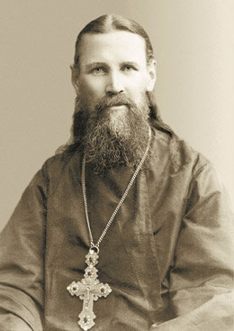
O Lord, let Thy priests be clothed with righteousness;
Let them always remember the greatness of their calling;
Let them not be entangled in the snares of the world and the devil;
Let them be saved from the cares of the world,
the delight in riches,
and the desire for other things entering into their hearts.

St. John of Kronstadt

Pray this prayer for your priest (whether you like him or not, trust him or not, respect him or not), and your spiritual father, and any other priest you care about (and especially the ones you do not care about!) Either one at a time, or all at once, modify the prayer to refer to them by name....
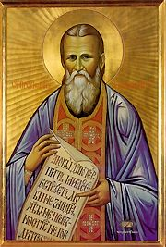
O Lord, let Thy priest (NAME(s)) be clothed with righteousness;
Let (him (them)) always remember the greatness of (his (their)) calling;
Let (him (them)) not be entangled in the snares of the world and the devil;
Let (him (them)) be saved from the cares of the world, the delight in riches, and the desire for other things entering into (his (their)) heart(s).

This prayer is available as shown also in PDF and Word formats:
http://www.orthodox.net/trebnic/of-john-of-kronstadt-for-priests.doc
http://www.orthodox.net/trebnic/of-john-of-kronstadt-for-priests.pdf
http://www.orthodox.net/trebnic/of-john-of-kronstadt-for-priests.html

And also in a card format. Print the prayer and separate into 4 "cards"
http://www.orthodox.net/trebnic/of-john-of-kronstadt-for-priests-card.doc
http://www.orthodox.net/trebnic/of-john-of-kronstadt-for-priests-card.pdf

I have modified the prayer and pray it as follows:
O Lord, let Thy unworthy servant Seraphim and
Thy priests_________ be clothed with righteousness;
Let them always remember the greatness of their calling;
Let them not be entangled in the snares of the world and the devil;
Let them be saved from the cares of the world, the delight in riches,
cowardice, equivocation, duplicity, undue regret, despondency, anger, coldness, exhaustion, judgment of others, cynicism, negativity, laziness, forgetfulness regarding prayer, indifference, unawareness, lack of empathy, aloofness, manipulation, heresy, being too opinionated
and the desire for other things entering into their hearts.

St. John of Kronstadt (italics not in original prayer)

Thank you to Fr John Cassian for finding this prayer and commenting before it, saying words that ring true for every priest. I am following his request, and have entered into a "prayer of agreement" with him. I invite you to also pray for him, and me. Above are two pictures of saints. Below is the a picture of the unworthy priest I am asking you to pray for:

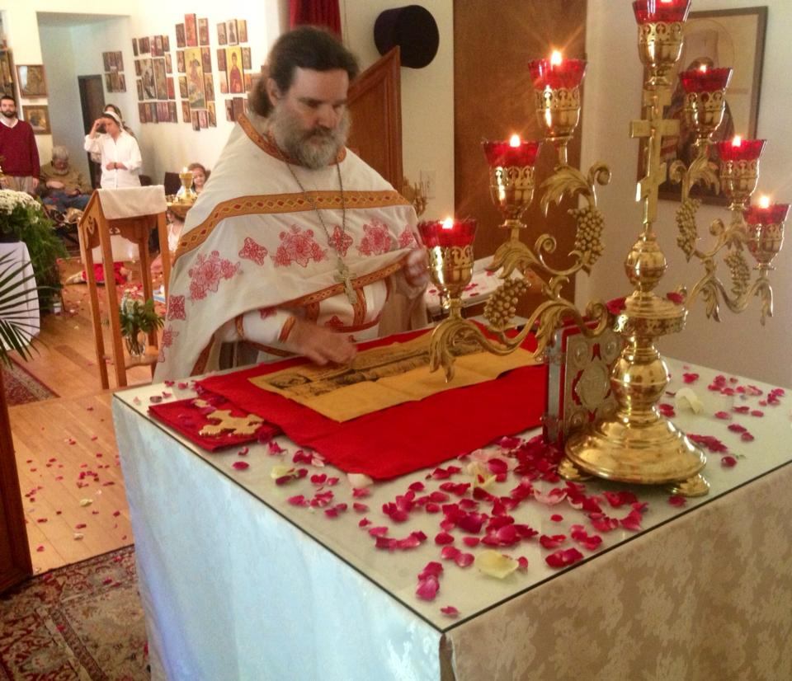

Almost Pascha! Holy Saturday Liturgy. Priest Seraphim Holland

Priest Seraphim Holland 2016

This and other Orthodox materials are available in from:
St. Nicholas Orthodox Church, McKinney, Texas

- Mailing Address: Box 37, McKinney, TX 75070
- Rectory Phone: 972/658-5433
- Email: seraphim@orthodox.net
- Web Page: http://www.orthodox.net

Archive of commentaries: http://www.orthodox.net/scripture
Archive of homilies: http://www.orthodox.net/sermons

To receive regular mailings of sermons, and scriptural and services commentary and other things throughout the church year, read our blog “Redeeming the Time” (http://www.orthodox.net/redeemingthetime). You may also subscribe to the RSS Feed or receive its postings by email.

Our parish Email list (http://groups.google.com/group/saint-nicholas-orthodox-church) also has all the latest postings from our website and blog; everyone is welcome to join.

All rights reserved. Please use this material in any edifying reason. We ask that you contact St. Nicholas if you wish to distribute it in any way. We grant permission to post this text, if completely intact only, including this paragraph and the URL of the text, to any electronic mailing list, church bulletin, web page or blog.

