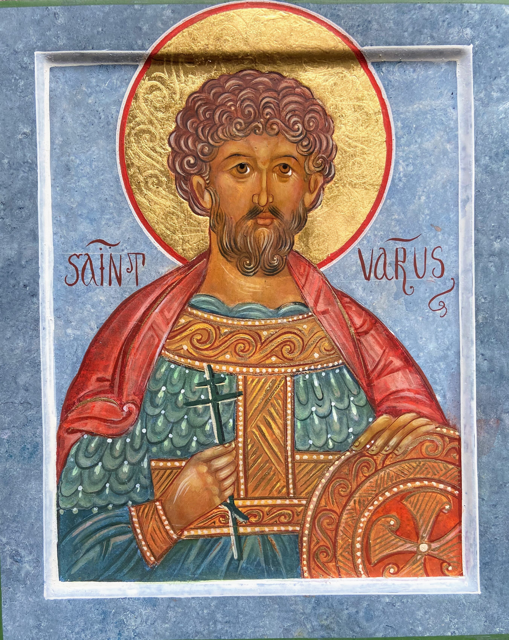
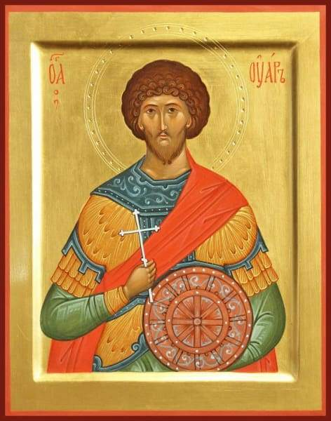

Concerning the prayer of St. Varus,

and prayer for the reposed who are not Orthodox

The Holy Martyr Varus is commemorated on October 19. The Life recounts how, after his martyrdom, his relics were taken by Cleopatra & placed in a church. There she continually prayed for his intercessions, and especially for her dead relatives who were not Orthodox Christians. When her son died suddenly, she challenged the saint why he had let this happen after all her efforts for the saint.
The Saint appeared to her in a glorious vision with her son and said: “I make entreaty for you at all times unto God. I have prayed first of all for your relatives, with whom you buried me, that their sins be remitted them, and now I have enrolled your son in the army of the King of Heaven. Did you not beseech me here at my grave that I ask God to grant you and your son whatever is in accordance with His will and is to your benefit? Therefore, I have prayed unto the good God, and in His ineffable kindness He has deigned to number your son among the host of Heaven.”
Our tradition is that St. Varus shows that it is pleasing to God to pray for our reposed non-orthodox relatives, and indeed for anyone who died outside of the church. We do not attempt to discern the condition of such people in the next life. God knows all things. We only know that God is love, and because we are made in His image, we should love, and those who love will remember those whom they have loved in this life even if they pass into the next life. As to whether we pray for them, since we love them, we do not concern ourselves with whether they are Orthodox Christians or not.
We must always pray for those who died outside of the Church, especially those of our own family. We do not commemorate them at the Liturgy, but certainly we should pray for them during our prayers at home.
Just think how many nominal Christians do not pray for the departed or just simply forget to do so. How terrible if a reposed soul was simply forgotten about & no one prayed for him! If prayer is an aspect of our love for others then the prayer of the Faithful must be a source of great consolation for those reposed who would otherwise be completely forgotten.
A last thought is that although it is 'private prayer', since we are still members of the Church, this prayer is still the prayer of the Church, even though expressed in a different manner from the Liturgy. Thus, it is still a powerful prayer for the reposed.

Prayer to Martyr Varus

O Holy, wondrous Martyr Varus, who, burning with zeal for the Heavenly King, didst confess Him before thy torturers and didst greatly suffer for Him!
Now the Church doth venerate thee, as one glorified with the glory of heaven by Christ the Lord, Who granted thee the abundant grace to approach Him boldly.
And now, standing before Him together with the Angels, rejoicing on high, beholding the Most Holy Trinity clearly, and enjoying the Uncreated Light, remember the suffering of our relatives (and those we remember, and those we hold in our hearts) who have died outside the Faith, and accept our pleas, and as thou didst intercede for the unbelieving ancestors of Cleopatra and didst free them from eternal suffering,
remember those who have died unbaptized or have been buried in an ungodly manner, or died suddenly, or by their own hand, or unjustly,
N.N.

(Continuation of Prayer to Martyr Varus)

…. and pray earnestly that they may be delivered from eternal darkness, that we may all, with one mouth and one heart, praise the Most Merciful Creator unto the ages of ages. Amen.

Troparion of St Varus the Martyr tone 5
Thou didst follow in the steps of the martyrs/ and contend for the glory of Christ./ Thou wast tied to a beam and restored by the Tree of Life,/ and thine intercessions gladden our souls.
Kontakion, in Tone IV
Following Christ, O martyr Varus, and draining His cup, thou wast crowned with the wreath of martyrdom and joinest chorus with the angels. Pray thou without ceasing for our souls.

----------------------------------------------------------------------------------------------------------------------------------------------

Sessional hymn, in Tone V—

Pray thou for the whole world, O great-martyr, and cease not to ask mercy for all sinners who have in divers ways grievously offended the Master and continue to offend him, who by mortal works have utterly done themselves to death and acquired nought, since they have wrought evil.
And intercede also, O passion-bearer, for our departed kinfolk, NN., beginning as is possible; and cease not to pray and fall down before the Lord Who hath mercy on all, that He forgive and have mercy on those who sit in darkness and are embittered with exceeding great bitterness.

----------------------------------------------------------------------------------------------------------------------------------------------

Glory…:
Another sessional hymn, in Tone III—

O great Varus, dweller in everlasting joy and namesake of heavenly rest: With boldness thou darest to remember before the Lord the redeeming qualities of our forebears; for even though we cannot place thee in their graves, yet do we beseech thee to add thy prayers to our earnest supplications that they be granted pity. Wherefore, fall down and pray, for the Master will not reject thine intercession, but, inclined by His infinite goodness, will send deliverance and great mercy upon those who are embittered with exceeding great bitterness.

----------------------------------------------------------------------------------------------------------------------------------------------

Now & ever…:
Theotokion, in the same tone—

O all-radiant Lady, who art hymned above all and art continually magnified by the heavenly hosts, Mother of the King of all: Since thy glory and greatness are increased where and when He desireth, when thou helpest sinners and coverest the whole world with thy supplications,
O Mistress, increase the majesty of thy sublimity, and by thy fervent supplications deliver from grievous torments our unbelieving and unbaptized kinfolk and NN., who are commemorated with them; and grant them deliverance and great mercy.

Ikos:

Be thou mindful of our words, O splendid denizen of heaven, glorious Varus, great-martyr of Christ, namesake of everlasting rest, who by thy great sufferings didst obtain an impassable and splendid resting-place, far from inescapable imprisonment, unceasing retribution and want:
Haste thou by thy God-pleasing supplications to deliver His compunctionate servants NN., for whose sake we entreat thee, standing before thee and crying out with earnestness: Fulfill our petitions, O holy one, and beseech Christ God unceasingly in behalf of our souls.

Exapostilarion—

O Lord and Master, may what Thou didst when Thou forgavest the ancestors of Cleopatra be right even today: Hearken unto the supplication of Varus, Thy great-martyr who intercedeth for us, the greatly sinful. Deliver from torments NN., who are remembered to Thee with pity. Make haste and speed, O Compassionate One, in that Thou art merciful, to have mercy on them, for Thou canst do whatsoever Thou desirest.

----------------------------------------------------------------------------------------------------------------------------------------------
Glory…, Now & ever…: Theotokion—

Haste thou, O Mistress, to hearken to our supplication, which we offer unto thee in thy church; and do thou, O Theotokos, incline to mercy thy Son and Master, that He have mercy and release from his just anger our deceased ancestors and our other kinfolk, NN.
Wherefore, haste thou. O greatly merciful one, to deliver them; for thou art merciful, who desirest mercy for all.

The Life of the Holy Martyr Varus and the Seven Christian Teachers Who Were with Him, and the Commemoration of the Blessed Cleopatra and Her Son John
Oct. 19/Nov. 1

During the reign of the impious Maximian, the Emperor of the Romans, there lived in Egypt a brave soldier named Varus, who secretly served the King of Heaven. Out of fear he hid his faith in the true God for a time, but later, he revealed it before both heaven and earth and became a spectacle before angels and men.
At that time Maximian raised up a persecution against the Christians and issued a decree in every province of his empire commanding that those Christians who would not sacrifice to the gods be put to death. When this ordinance was published in the land of Egypt, the blood of Christians was shed mercilessly; all who worshipped the Creator and not things created were subjected to various torments.
Varus, a secret Christian, visited by night the faithful who were held in prison for their confession of Christ, bribing the guards with gold to permit him to enter the cells in which they were held. He bound up the wounds of the holy martyrs and washed their blood, gave them to eat, kissed their stripes, and prayed them to beseech Christ to have mercy on him.
It happened that there were seven teachers of the Christians, desert- dwellers, that were brought before the Prince of Egypt. When the Prince questioned them, he found them to be firm in the faith. Having subjected them to flogging, he had them cast bound into prison. When Varus learned of this, he hastened by night to the dungeon where the saints were being held. After he had given much gold to the guards, he was permitted to visit the saints. Varus loosed their hands and removed their feet from the stocks that held them and then placed food before them. He besought them to eat, for they had remained hungry for eight days since they had been left in prison with no food.
He fell at their feet and kissed them, and he praised them for their sufferings, saying, "Blessed are you, O good and faithful servants of the Lord! You shall enter into the joy of your Lord, for you have resisted unto blood (Heb. 12:4). Blessed are you, O good strugglers; the right hand of the Most High has woven crowns for you in Heaven. You have run with patience the race that is set before you (Heb. 12:1), and I know for certain that tomorrow your sufferings shall come to an end. Blessed are you, O passion-bearers of Christ; the Kingdom of Heaven is open unto you, for you suffer with Christ, Who suffered for our sake, as the Apostle says, If so be that we suffer with him, we shall also be glorified with him (Rom. 8:17).
I beseech you, O holy servants of God, pray for me to Christ that He have mercy upon me, for it is my desire to suffer for Him, but I have not the strength to do so. I fear the cruel torments I see you have undergone." The saints replied, "Beloved, no one who is fearful can attain perfection, nor can he who does not sow reap. Likewise, a man who is unwilling to suffer receives no crown. Remember the words written in the Gospel: Whosoever shall deny Me before men, him will I deny before My Father which is in Heaven (Matt. 10:33). If you fear passing torments, you shall not escape those which are eternal. If you fear to confess Christ on earth, you shall not be sated with the vision of His countenance in Heaven. Therefore, come, O brother, and tread with us the path of martyrdom, which leads to the Master Who looks down upon our struggles. Suffer together with us, for you will not soon find again a company like ours. When he heard these things, Varus' heart was set afire with love for God, and he wished to endure torment for Jesus Christ. He passed the entire night at prayer with the holy martyrs and hearkened unto their teaching gladly.
When the morning was come, the Prince's servants came to the prison to bring the holy martyrs before the tribunal. As they entered the dungeon, they saw Varus seated with the prisoners, hearing their words with compunction of heart. They were astonished, and they asked, "What is your business here, Varus? Have you lost your mind, giving heed to the myths of which these wicked men tell? Have you no fear that someone will speak of this to the Prince or one of the nobles? You shall lose both your military rank and your life!" Varus replied, "He who tells the Prince of me is my benefactor. Know that if you choose to make accusation against me, I am ready to die for Christ with the other Christians here."
The servants were thus put to silence. They took six of the martyrs from the prison, but the seventh they left, for he had weakened so from his wounds that he died and departed unto the Lord, leaving his place to be filled by Varus, who was to complete his suffering. The saints were led bound before the Prince, who sat proudly upon his tribunal and sought to compel them to sacrifice to the idols. When they would not consent, they were stripped and beaten mercilessly upon the wounds they had already received. Thus, were wounds added to their wounds and stripes to their stripes, but they endured their suffering as though it were nothing and said only, "We are Christians."
Then the Prince asked, "Were there not seven of these men? Now there are but six. Where is the seventh?" At that very moment Saint Varus entered and said, "I am the seventh. He of whom you spoke has already finished his course and gone to Christ, leaving me to complete his sufferings. I am prepared to render to you whatever he owed you. I wish to take his place among these noble martyrs who suffer for Christ, for I am a Christian." When the Prince heard this, he asked his attendants, "Who is this man?" They replied, "It is the soldier Varus, the commander of the band of Tyanis." The Prince was perplexed and said to Varus, "What demon has led you to surrender yourself to perdition? Why do you choose to forsake your military rank and the honors that await you and bring evil upon yourself?"
The blessed Varus answered, "I prefer the Bread which is come down from heaven and the chalice of the divine and most precious blood of my Lord to your honors and esteem. I count nothing more dear than my Christ: not your regard, my rank, great honors, nor yet life itself. To suffer for Christ I count as the greatest honor and to lose all things for His sake as gain."
The Prince then cast his angry glance upon the six holy martyrs and said, "This is your work, you impious deceivers! It is you who have beguiled this soldier of the Emperor, depriving him of his senses by your sorcery! I swear to you by my great gods that I shall put you to death even before I do the same to him and thus revenge the dishonor you have shown our gods. You are unworthy to remain among the living, for you blaspheme the gods and lead others into wicked error."
The saints replied, "We have not beguiled Varus but have rather delivered him from deception. We have not caused him to lose his mind but have restored him to his senses. God has vouchsafed him strength and boldness for the struggle, that together with us he might prevail over your feeble might and that of your gods. In but a short time you shall behold his soldierly courage, for we have enrolled him in the host of the angels. Is it your boast that you shall destroy us? Know that it is our desire to lay down our lives for the Lord of all."
The Prince said, "I will immediately have you cut in pieces if you do not fall down and worship the gods of Egypt!" The saints answered, “The gods that have not made the heavens and the earth, even they shall perish” (Jer. 10:11). Wishing to move the Prince to yet greater anger, the blessed Varus said, "The fool shall speak foolish things, says the Prophet Isaiah. Lo, our bodies lie stretched out before you. Do with them as you would."
Greatly angered, the Prince commanded that Varus be suspended from a tree, that he might put him to torture. To the six saints he said, "We shall see who will prevail over whom: you over us as you suffer torment or we over you as we inflict our tortures. Of a truth I say to you that if you by your patience prevail over me, I will renounce my gods and believe in your Christ."
The saints replied, "Try your strength against one of us, and if you can overcome him, you may hope to prevail over the others." As they began to torment Varus, he said to the holy martyrs, "O holy passion-bearers! Bless me, who am your servant, that I may share your lot. Entreat the Master Christ for me that He grant me patience, for He knows that our flesh is infirm. The spirit indeed is willing, it is written, but the flesh is weak (Matt. 26:41)."
The saints lifted up their eyes unto Heaven and prayed fervently for Varus as the servants began to beat his whole body with rods and staves.
As the saint was being beaten, the Prince said, "Now tell us, Varus, what profit your Christ brings you."
Varus bravely replied, "More than you receive from your gods." The saints cried out to Varus, "Take courage, Varus, and may your heart be strengthened, for Christ invisibly stands before you and strengthens you!"
Answered Varus, "Truly, I perceive the help of my Christ, for these torments seem as nothing to me."
Then they scraped his sides with iron claws, after which he was hung upside-down from the tree. They tore the skin from his back, cut his flesh with razors, and thrashed him with switches until he burst open and his bowels fell to the ground. When the holy martyrs saw his inward parts fall out, they wept.
The persecutor beheld the martyrs weeping, and he cried out with a great voice, "Lo, you are defeated! You have been brought low, and you weep from fear of torment! What more is necessary for you to acknowledge that Christ cannot deliver you out of our hands and for you to forsake Him and worship our gods?"
The saints answered, "You are a beast and not a man! We are not defeated but shall yet prevail by the power of Jesus, Who strengthens us. We do not weep because we fear torment but out of natural love for our brother, whom you wish to slay in a beastly manner. In spirit we rejoice for him, for a crown has already been prepared for the noble sufferer."
The Prince then commanded that they be led back to prison. As Varus saw the saints being returned to the dungeon, he cried out to them from the tree from which he was suspended and was being tortured, saying, "My teachers! Pray for me one last time unto Christ, for I am about to depart from my body. I thank you for you have made me to inherit life eternal."
Saint Varus endured torture for five hours and then in suffering surrendered his honorable and holy soul into the hands of the Lord. Thinking that he was yet alive, the torturers continued to beat and torment his corpse. When they saw that he was already dead, they were amazed, and in accordance with the persecutor's command, they cast him out of the city in the place where the carcasses of beasts were left to be devoured by dogs.
There was a widow living in that city named Cleopatra, who was born in Palestine. Her husband, an officer, had died in Egypt, and she had a son named John, who was still a little boy. When Saint Varus was tortured, she looked on from afar upon his sufferings, sighing and beating her breast, for she was a Christian. When the martyr's corpse was cast out of the city, she arose by night, took certain of her servants, and went to remove the long-suffering body of Saint Varus. She brought it to her home, where she dug a grave for it in her room.
The next morning, the Prince had the other martyrs brought forth from the prison, and after he had tortured them for a long time, they were beheaded. They were also cast out of the city without burial, but their corpses were taken by night and committed to the earth by secret Christians. Every day Cleopatra censed and lit candles before the grave of Saint Varus, whom she regarded as her great intercessor and mediator before God.
When, after some years, the persecution died down, she began to consider how she might return to the land of her birth, and she wondered how it would be possible for her to take with her the relics of Saint Varus. She decided to send a gift to the Prince, which was taken to him by a messenger, who said to him on her behalf, "My husband was an officer and died here in the Emperor's service. He has still not received final burial, for it is not seemly that an officer and man of rank be buried in a foreign land. I, who am a widow and a stranger in this country, wish to return to my homeland to live with my kindred. Therefore, my lord, permit me to take the remains of my beloved husband to the land of my birth, that I may give them a fitting burial together with my forebears, for I wish to remain with my spouse even after I die."
The woman sent this message that the Christians might not think that it was the relics of the holy martyr she was removing from the city, for she was afraid that they would prevent her from taking that sacred treasure. The Prince accepted her gift and granted her request, but she took the remains of Saint Varus rather than those of her husband. Like a vine she brought them out of Egypt (cf. Ps. 79:8) into Palestine to her village of Edras, which was near Tabor, and she buried them there with her fathers. Every day she went to his grave, censed it, and lit candles there. When the other Christians who lived there saw this, they began to go with her to where the saint lay. They brought with them their sick, who received healing at Saint Varus' grave through his prayers.
Soon all the Christians in the parts that lay roundabout learned of Saint Varus, and they began to come with faith to his tomb. When Cleopatra saw how the Christians gathered to pray at the grave of the saint, she determined to build a church dedicated to him. Soon its erection was begun.
By that time her son had reached manhood, and Cleopatra desired that he receive a position in the imperial army. Through the intercession of certain mediators, she requested that her son be commissioned an officer, and her entreaty was granted. Her son received from the Emperor his appointment to the army and the emblems of his rank while the church was being constructed, but Cleopatra said, "My son shall not begin to serve the Emperor in the army until the house of God is completed. It is my intention that he be here to help transfer the saint's relics to the church. After this is done, he may depart to serve the Emperor."
When the church was completed, Cleopatra summoned bishops, priests, and monks, removed the precious relics of the holy martyr from their grave, and had them placed on a very costly bier. She laid her son's military belt and uniform upon the relics, that they might be sanctified by the saint's remains. She prayed to Saint Varus fervently that he be her son's protector, and all the bishops and priests present bestowed their blessing upon the young man. A multitude of Christian people without number had gathered there as well, and accompanied by them, Cleopatra and her son carried the bier and the relics to the church. The church was consecrated, and the remains of the saint were placed beneath the altar. Then the Divine Liturgy was served.
Cleopatra fell down before the relics of Saint Varus and prayed thus: "I beseech thee, O passion-bearer of Christ: Ask God for that which is profitable for me and for mine only son. I do not dare ask for anything more than what the Lord Himself wisheth, for He knoweth what is needful for us. May His good and perfect will be done in us!"
After the service was completed, a great banquet was set before those present at which Cleopatra and her son served the guests. Cleopatra instructed her son to eat nothing until the evening, when the meal was finished and only then to partake of that which remained. As the youth was serving, he suddenly took ill, and he went to lie down upon his bed. When all the guests had arisen from the meal, Cleopatra called for her son, that he might share with her what food remained. But John was unable even to reply, for he was burning with a great fever. When Cleopatra saw how ill her son was, she said, "As the Lord lives, I will not put food into my mouth until I learn what is to become of my child!" She sat down beside him and sought to cool the fire of his fever; but her own womb burned still more than did his body, and her heart ached for her only son.
At midnight the youth died, leaving his mother to weep inconsolably. As she lamented bitterly, she hastened to the Church of Saint Varus, and she fell down before his sepulcher and cried out, "O servant of God! Is this how thou hast rewarded me for the great labors I endured on thy behalf? Is this the succor which thou providest me, who forsook my husband on thine account and have placed my hope in thee? Thou hast permitted mine only son to die; thou hast deprived me of mine only consolation and hast taken from me the light of mine eyes! Who shall now feed me in mine old age? Who shall close mine eyes when I die? Who shall commit my body to the grave? It had been better for me to die than to behold my beloved son perish in his youth like a flower before its time. Either give me back my son as once Elisha returned the son of the Shunamite woman (cf. IV Kings, ch. 4) or take me hence without delay, for I can endure this bitter sorrow no longer."
Cleopatra remained weeping by the grave of the saint and then fell asleep for a short while from weariness and grief. As she slept, she beheld Saint Varus in a dream. He held her son by the hand, and they both shone like the sun. Their vesture was whiter than snow, and they were girded with golden belts; upon their heads were crowns of unspeakable beauty. Seeing this, the blessed Cleopatra fell down before them, but Saint Varus lifted her up and said, "O woman, why do you cry unto me? Do you imagine that I have forgotten the good works you did on my behalf in Egypt and along the way to this place? Do you suppose that I felt nothing when you removed my body from amid the carcasses of beasts, placing it in a coffin? Have I not always hearkened to your prayers? I make entreaty for you at all times unto God. I have prayed first of all for your relatives, with whom you buried me, that their sins be remitted them, and now I have enrolled your son in the army of the King of Heaven. Did you not beseech me here at my grave that I ask God to grant you and your son whatever is in accordance with His will and is to your benefit? Therefore, I have prayed unto the good God, and in His ineffable kindness He has deigned to number your son among the host of Heaven. Lo, you see that your son now stands near the Lord's throne. If you wish, take him and send him to serve a mortal and earthly king since you do not desire that he should serve the heavenly and eternal King."
The youth, who sat beside Varus and embraced him, exclaimed, "No, my lord! Pay no heed to my mother, neither permit me to be returned to the world, which is full of falsehood and every iniquity, and from which you delivered me when you came to me. Do not deprive me, O father, of a portion with the saints and a dwelling place among them." Then the youth turned to his mother and said, "Why do you lament for me thus, mother? I have been enrolled in the host of Christ the King and have been permitted to stand before Him with the angels. Why do you now ask that I be removed from the kingdom and brought to abasement?" When the blessed Cleopatra saw that her son's appearance was like that of an angel, she said, "Take me with you that we may be together." Saint Varus said, "In this place you are with us. Go in peace, and after a time, when the Lord commands, we shall come and take you. After saying this, the saint became invisible. When Cleopatra awoke, her heart was filled with ineffable happiness and joy, and she related her dream to the priests. They buried her son beside the sepulcher of Saint Varus, and Cleopatra wept no more but rather rejoiced in the Lord. Later she distributed her possessions among the needy and renounced the world. She lived beside the Church of Saint Varus, serving God in prayer and fasting by day and night. Every Sunday as she prayed Saint Varus appeared to her in great glory with her son. After she had lived in this God-pleasing manner for seven years, the blessed Cleopatra reposed. Her body was placed in the Church of Saint Varus near her son John, and her holy soul took up its abode in the heavens, together with Saint Varus and John. There it now stands in the presence of God, to Whom be glory unto the ages of ages. Amen.

From Orthodox Life Vol. 44 No. 5 [October 1994]
Translated by Father Thomas Maretta From the Slavonic Menologion of St. Demetrius of Rostov
St. Varus is celebrated Oct. 19/Nov. 1 along with seven monk martyrs in Egypt, [307], Blessed Cleopatra [327], and her son, John

This:http://www.orthodox.net/trebnic/to-martyr-varus-for-the-reposed-outside-the-church.doc
http://www.orthodox.net/trebnic/to-martyr-varus-for-the-reposed-outside-the-church.pdf

You may choose to print this document, which is a booklet. Print it double-sided, flipping the page on the short side, and use a saddle stapler to secure the pages.
http://www.orthodox.net/trebnic/to-martyr-varus-for-the-reposed-outside-the-church-booklet.pdf

Life: http://codexjustinianus.blogspot.com/2010/10/he-holy-martyr-varus-and-seven-teachers.html http://www.johnsanidopoulos.com/2015/10/saint-varus-martyr-and-blessed-cleopatra.html

All of these prayers are also in the document: “Daniel’s list”: http://www.orthodox.net/daniel/dyptichs-daniels-list.html, http://www.orthodox.net/daniel/dyptichs-daniels-list.doc & http://www.orthodox.net/daniel/dyptichs-daniels-list.pdf (the most up to date will always be doc and pdf)

