VARIOUS PRAYERS 2
Short Intercessory Prayers 3
Prayer of St Silouan of Mount Athos: 3
For those who bear hatred or enmity against me 3
To pray for someone more diligently 3
Prayer in The Way of the Pilgrim, for others 3
A small prayer 3
The Jesus Prayer 4
Intercessory Prayers of Divine Liturgy 5
The Prayer of the First Antiphon – modified 5
The Prayer of the Second Antiphon 5
The Prayer of the Third Antiphon (modified) 5
Long Intercessory Prayers 6
Prayer for all the peoples of the world, according to the model of St Silouan of Mount Athos. 6
Prayer of Elder Paisios for the Whole World 12
A Prayer for One's Enemies - by St Nicolai of Zica 14
A prayer of St Peter of Damaskos 16
Lenten prayer of Nersess the Gracious 19
Intercessory Prayers for Priests 23
A Prayer for Priests - St Gregory Palamas 23
A Prayer for priests by St John of Kronstadt 23
Prayers for the Sick 24
A Prayer for the Ailing 24
Troparion for the ailing, 4th Tone 24
Prayers for the Reposed 24
O God of Spirits 24
Prayer for every departed person 25
Daily Prayers 27
O Divine Light! 27
A Morning Prayer by St. Paisios the Great 27
Prayer of Elder Gabriel 28
Prayer of St. Philaret, Metropolitan of Moscow 29
Daily Prayer of Hieroschemamonk Parthenios 29
Morning Prayer of St Jerome 31
Prayer For The Granting Of Prayer 32
Prayer of Holy Martyr Boniface Dec 19/ Jan 1 33
The Prayer of the Optina Elders 33
Prayer of Patriarch Pavle of Serbia 34
Prayers to the Holy Spirit 35
Prayer to the Holy Spirit by St Maximos the Greek 36
Prayers of Thanksgiving 38
Prayer of Thanksgiving by St Basil The Great 38
Prayer of Thanksgiving, attributed to St John Chrysostom 39
From the Hours 40
Prayer of the Hours 40
Prayer of the 1st Hour 40
Prayer of St. Mardarius (3rd hour) 40
Prayer of Basil the Great at the 6th Hour 41
Various Prayers 42
From the Evergertinos 42
From Exodus 42
Psalm 17 42
Prayer For The Gift Of The Jesus Prayer 42
Prayer against scattered thoughts 43

http://www.orthodox.net/trebnic/various-prayers-for-an-orthodox-christian.doc
http://www.orthodox.net/trebnic/various-prayers-for-an-orthodox-christian.pdf
http://www.orthodox.net/trebnic/various-prayers-for-an-orthodox-christian-booklet.pdf

VARIOUS PRAYERS

Short Intercessory Prayers

Prayer of St Silouan of Mount Athos:

I pray Thee, O merciful Lord, for all the peoples of the world, that they may come to know Thee by the Holy Spirit.

For those who bear hatred or enmity against me

O Lord grant mercy unto them that bear hatred or enmity against me, and also unto them that revile or slander me: That none of them may at all suffer any evil, whether in the present or in the age to come, on account of me, who am impure. But cleanse them all in Thy mercy, and protect them by Thy grace, O Thou who art good. (Old Believer Prayer Book, pg. 312)

To pray for someone more diligently
Save, O Lord, and have mercy on Thy servant(s) ________, [bow]
Deliver him (her, them) from every tribulation, wrath and need [bow],
From every sickness of soul and body, [bow]
Forgive him (her, them) every transgression, voluntary and involuntary, [bow]
Teach them to pray and to live with purpose. [bow]
And do whatever is profitable for our souls. [bow]. From the Old Believer Prayer Book, with line 5 added

Prayer in The Way of the Pilgrim, for others

Merciful Lord, may Thy will be done; Thou desirest that all men come to the truth and be saved, have mercy and save Thy servant N. Receive this petition from me as a cry of love which Thou hast commanded.

A small prayer

O Lord Jesus Christ, have mercy on all who are bent over
and help them to rise up.

The Jesus Prayer

An excellent way to pray for someone is to pray a short prayer for them, such as the ones above, then say the Jesus prayer for the person, for a set number of times. One may say "Lord Jesus Christ, have mercy on N", or, more inclusively, "on us".

Intercessory Prayers of Divine Liturgy

The Prayer of the First Antiphon – modified

O Lord our God, Whose dominion is indescribable, and Whose glory is incomprehensible, Whose mercy is infinite, and Whose love for mankind is ineffable: Do thou thyself, O Master, according to Thy tender compassion, look upon us, and upon our holy temple, and deal with us, and them that pray with us, and them that have asked my unworthy self to pray for them, and all of my flock, here and everywhere, and them that love us and them that hate us, and them that love Thee and them that hate Thee, and them that have left us, and them that are suffering and cannot stand up straight, and them that are being persecuted, according to Thine abundant mercies and compassions.

The Prayer of the Second Antiphon

O Lord our God, save Thy people and bless Thine inheritance, preserve the fullness of Thy Church, sanctify them that love the beauty of Thy house; do Thou glorify Them by Thy divine power, and forsake not us that hope in Thee.

The Prayer of the Third Antiphon (modified)

O Thou who hast bestowed upon us these common and concordant prayers, and Who hast promised that when two or three are agreed in Thy name, Thou wouldst grant their requests:
Thine unworthy servant, who calls upon the holy intercessions of the great martyr and healer Panteleimon, and of my luminous patron, Father Seraphim, begs of Thee
Do Thou Thyself now fulfill the requests of all of us to our profit, granting us in this present age the knowledge of Thy truth, and in that to come, life everlasting. (modifications in italics)

Long Intercessory Prayers

Prayer for all the peoples of the world, according to the model of St Silouan of Mount Athos.

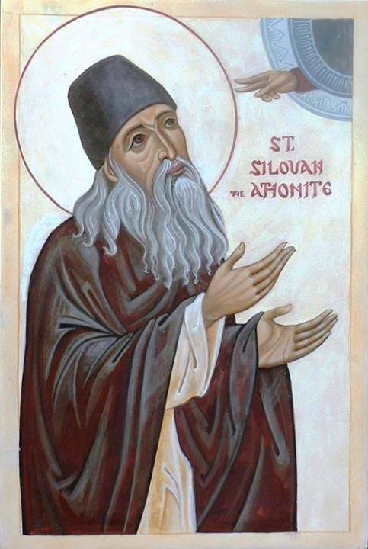
I pray Thee, O Merciful Lord, for all the peoples of the world, that they may come to know Thee by the Holy Spirit.
I pray Thee, O Merciful Lord, that Thou wouldst relieve the suffering of the hungry, and that they may come to know Thee by the Holy Spirit.
I pray Thee, O Merciful Lord, that Thou wouldst bring to repentance those who can alleviate the suffering of the hungry, but do nothing, or even actively increase their suffering, and that they may come to know Thee by the Holy Spirit.
I pray Thee, O Merciful Lord, that Thou wouldst relieve the sickness and suffering of those who are ill, especially those who suffer because of civil war, oppression, neglect and poverty, and that they may come to know Thee by the Holy Spirit.
I pray Thee, O Merciful Lord, that Thou wouldst comfort and make safe those who are suffering from war, and killing, and civil unrest, and that they may come to know Thee by the Holy Spirit.
I pray Thee, O Merciful Lord, that Thou wouldst comfort and guard from anger, bitterness and despair those who have lost loved ones because of the inhumanity of men. Help them to not return hatred for hatred or murder for murder, and grant that they may come to know Thee by the Holy Spirit.
I pray Thee, O Merciful Lord, that Thou wouldst enlighten and bring to repentance those who kill and rape and plunder from their fellow man, and that they may come to know Thee by the Holy Spirit.
I pray Thee, O Merciful Lord, that Thou wouldst comfort and protect women, children and men who are trafficked as slaves, and that they may come to know Thee by the Holy Spirit.
I pray Thee, O Merciful Lord, that Thou wouldst comfort and protect women, children and men who are abused physically, sexually, verbally and emotionally, and that they may come to know Thee by the Holy Spirit.
I pray Thee, O Merciful Lord, that Thou would bring to sobriety, peacefulness and love those who are angry and nursing grudges, and planning retribution for wrongs they have suffered, and that they may come to know Thee by the Holy Spirit.
I pray Thee, O Merciful Lord, that Thou wouldst enlighten those who hate Christianity and the church because of personal experiences, and prejudices, and that they may come to know Thee by the Holy Spirit.
I pray Thee, O Merciful Lord, that Thou wouldst make steadfast those who are suffering persecution, deprivation, slander and danger because of their true belief in Thee, and that they may come to know Thee by the Holy Spirit.
I pray Thee, O Merciful Lord, that Thou wouldst comfort, protect and bring to repentance those who are incarcerated, and that they may come to know Thee by the Holy Spirit.
I pray Thee, O Merciful Lord, that Thou wouldst comfort and guard from evil thoughts and actions those who are suffering unjustly for something they did not do, and that they may come to know Thee by the Holy Spirit.
I pray Thee, O Merciful Lord, that Thou wouldst comfort and give purpose and joy to those who are in despair or feel no purpose in their lives or are contemplating suicide, and that they may come to know Thee by the Holy Spirit.
I pray Thee, O Merciful Lord, that Thou wouldst bring to full sobriety, and mental clarity those who suffer from mental illness and those who are possessed or oppressed by demons, and that they may come to know Thee by the Holy Spirit.
I pray Thee, O Merciful Lord, that Thou wouldst enlighten and bring to repentance those who kill and torture and dominate others in the name of a false God, and that they may come to know Thee by the Holy Spirit.
I pray Thee, O Merciful Lord, That Thou wouldst enlighten and bring to repentance those who kill and profit from and promote the killing of babies in the womb, and children, and the elderly and the feeble, and that they may come to know Thee by the Holy Spirit.
I pray Thee, O Merciful Lord, that Thou wouldst comfort and enlighten and bring to repentance and fill with true joy and purpose those who are contemplating killing their unborn child, and those who have killed their children, and that they may come to know Thee by the Holy Spirit.
I pray Thee, O Merciful Lord, that Thou wouldst help those who have committed a great sin, and have great sorrow, to know Thy forgiveness and to grow in hope, and love, and joy, and that they may come to know Thee by the Holy Spirit.
I pray Thee, O Merciful Lord, that Thou wouldst bring to repentance those who are advocating for or attempting to impose abortion upon anyone, and that they may come to know Thee by the Holy Spirit.
I pray Thee, O Merciful Lord, that Thou wouldst bring to repentance and true belief and moral purity politicians who promote and subsidize all immorality, the killing of the unborn and feeble and disenfranchisement or the subjugation of the poor, and that they may come to know Thee by the Holy Spirit.
I pray Thee, O Merciful Lord, that Thou wouldst bring to repentance and true belief and moral purity those who teach indecent things because of greed, or ignorance or any other hidden sin, and that they may come to know Thee by the Holy Spirit.
I pray Thee, O Merciful Lord, that Thou wouldst help those who know what is right and are afraid to speak the truth, especially the clergy, and that they may come to know Thee by the Holy Spirit.
I pray Thee, O Merciful Lord, that Thou would enlighten and bring true belief, and purpose those who do not believe in Thee, or oppose Thee, and that they may come to know Thee by the Holy Spirit.
I pray Thee O Merciful Lord, that thou wouldst increase peace in families, and mutual love between all, and that they may come to know Thee by the Holy Spirit.
I pray Thee, O Merciful Lord, that Thou wouldst teach spouses to put aside any divisions and grow to perfection in Thee through loving each other, with peace, mutual comfort, and tranquility, and that they may come to know Thee by the Holy Spirit.
I pray Thee, O Merciful Lord, that Thou wouldst help spouses to keep their marriage bed undefiled, never with lust or selfishness or perverse practices, and always increasing their love for Thee, and that they may come to know Thee by the Holy Spirit.
I pray Thee, O Merciful Lord, that Thou wouldst guard children from the pernicious effects of our unbelieving society and that they would grow in their faith unto the stature of a perfect man, and that they may come to know Thee by the Holy Spirit.
I pray Thee, O Merciful Lord, that Thou wouldst help Fathers and Mothers to do the one thing needful for their children, and with patience and wisdom raise them in the fear of Thee and piety and remember to pray for them with tears every day, and that they may come to know Thee by the Holy Spirit.
I pray Thee, O Merciful Lord, that Thou wouldst teach siblings to love each other as their neighbor and not have petty squabbles and disputes, and that they may come to know Thee by the Holy Spirit.
I pray Thee, O Merciful Lord, that Thou wouldst prosper the church and not let any one of our children, loved ones and friends be lost to unbelief, lukewarmness or depravity, and that they may come to know Thee by the Holy Spirit.
I pray Thee, O Merciful Lord, that Thou wouldst bring to repentance and purity those who fornicate and do impure sexual things or have heretical beliefs concerning them, and that they may come to know Thee by the Holy Spirit.
I pray Thee, O Merciful Lord, that Thou wouldst break the bondage of those who are addicted to pornography and all uncleanness, and that they may come to know Thee by the Holy Spirit.
I pray Thee, O Merciful Lord, that Thou wouldst bring to wholeness and purity those who are engaged in the homosexual lifestyle and give strength to those who have any kind of illicit sexual attractions to live in purity and holiness, and that they may come to know Thee by the Holy Spirit.
I pray Thee, O Merciful Lord, that Thou wouldst give courage and steadfastness to those Who have true belief in Thee, whose lives, families and property are at great risk because of the spectre of militant Islam, atheistic governments, or any totalitarian system that hates true Christianity, and that they may come to know Thee by the Holy Spirit.
I pray Thee, O Merciful Lord, that Thou wouldst comfort and give true joy to those who are in despair because of drug addiction, and that they may come to know Thee by the Holy Spirit.
I pray Thee, O Merciful Lord, that Thou wouldst help those who do not live according to purpose to learn their purpose, and that they may come to know Thee by the Holy Spirit.
I pray Thee, O Merciful Lord, that Thou wouldst enlighten and bring to repentance and true faith those who proclaim heresies, and that they may come to know Thee by the Holy Spirit.
I pray Thee, O Merciful Lord, that Thou wouldst help all peoples to have the remembrance of death and to have their treasure in heaven, not among the things of the world which are passing away, and that they may come to know Thee by the Holy Spirit
I pray Thee, O Merciful Lord, that Thou wouldst bring to repentance and Christian action those of us who do very little to help our suffering brethren, and that they may come to know Thee by the Holy Spirit.
I pray Thee, O Merciful Lord, that Thou wouldst forgive me my terrible sins, and not let any one of them cause my brother to stumble. And if I have caused anyone to stumble because of my sins, I beseech Thee - forgive! And give me a path to rectify my wrongs, and grant that we all may come to know Thee by the Holy Spirit.
I pray Thee, O Merciful Lord, that Thou wouldst help me to love my enemies, that we all may come to know Thee by the Holy Spirit.
I pray Thee, O Merciful Lord, that Thou wouldst open my heart to the sufferings of others, that we all may come to know Thee by the Holy Spirit.
I pray Thee, O Merciful Lord, that Thou wouldst help me to judge rightly regarding my brothers, but never to disdain them because of their sins, and that we all may come to know Thee by the Holy Spirit.
I pray Thee, O Merciful Lord, that Thou wouldst season my foolish words with salt, that we all may come to know Thee by the Holy Spirit.
I pray Thee, O Merciful Lord, that Thou wouldst teach me to pray with attention and love, that those I pray for may come to know Thee by the Holy Spirit.
I pray Thee, O Merciful Lord, for all the peoples of the world, that they may come to know Thee by the Holy Spirit.
Amen.

Prayer of Elder Paisios for the Whole World

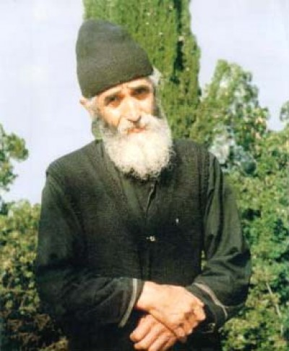

Our Lord Jesus Christ:
Do not abandon Thy servants who live far away from the Church. May Thy love convict them and bring them back to Thee.
Lord have mercy on Thy servants who are suffering from cancer.
Lord have mercy on Thy servants who suffer either from small or serious ailments.
Lord have mercy on Thy servants who suffer from physical infirmities.
Lord have mercy on Thy servants who suffer from spiritual infirmities.
Lord have mercy on our leaders and inspire them to govern with Christian love.
Lord have mercy on children who come from troubled homes.
Lord have mercy on troubled families and those who have been divorced.
Lord have mercy on all the orphans of the world, on all those who are suffering pain and injustices since losing their spouses.
Lord have mercy on all those in jail, on all anarchists, on all drug abusers, on all murderers, on all abusers of people, and on all thieves. Enlighten these people and help them to straighten out their lives.
Lord have mercy on all those who have been forced to emigrate.
Lord have mercy on all those who travel on the seas, on land, in the air, and protect them.
Lord have mercy on our Church, the bishops, the priests and the faithful of the Church.
Lord have mercy on all the monastic communities, male and female, the elders and eldresses and all the brotherhoods of Mt. Athos.
Lord have mercy on Thy servants who find themselves in the midst of war.
Lord have mercy on Thy servants who are being pursued in the mountains and on the plains.
Lord have mercy on Thy servants who are being hunted like birds of prey.
Lord have mercy on Thy servants who were forced to abandon their homes and their jobs and feel afflicted.
Lord have mercy on the poor, the homeless and the exiled.
Lord have mercy on the nations of the world. Keep them in Thy embrace and envelope them with Thy holy protection. Keep them safe from every evil and war.
Keep our beloved homelands in Thy protective embrace day and night. Embrace her with Thy holy protection defending her from all evil and war.
Lord have mercy on those who have been abandoned and have suffered injustice. Have mercy on families that are going through trying times. Pour Thy abundant love upon them.
Lord have mercy on Thy servants who suffer from spiritual and bodily problems of all kinds.
Lord have mercy on those who are despairing. Help them and grant them peace.
Lord have mercy on those that have requested that we pray for them.
Lord grant eternal rest to all those who have passed on to eternal life throughout the ages.
This prayer was given to a convent which had asked the Elder for a prayer rule that could be used by the nuns in their evening vigils. This directive was given to the nuns during the final years of his life. It would be correct to add intentions as your heart directs, and to say this prayer as part of your daily rule.

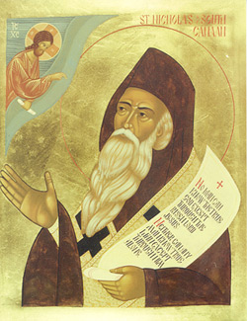
A Prayer for One's Enemies - by St Nicolai of Zica
Bless my enemies, O Lord. Even I bless them and do not curse them.
Enemies have driven me into Thy embrace more than friends have.
Friends have bound me to earth, enemies have loosed me from earth and have demolished all my aspirations in the world.
Enemies have made me a stranger in worldly realms and an extraneous inhabitant of the world.
Just as a hunted animal finds safer shelter than an unhunted animal does, so have I, persecuted by enemies, found the safest sanctuary, having ensconced myself beneath Thy tabernacle, where neither friends nor enemies can slay my soul.
Bless my enemies, O Lord. Even I bless them and do not curse them.
They, rather than I, have confessed my sins before the world.
They have punished me, whenever I have hesitated to punish myself.
They have tormented me, whenever I have tried to flee torments.
They have scolded me, whenever I have flattered myself They have spat upon me, whenever I have filled myself with arrogance.
Bless my enemies, O Lord. Even I bless them and do not curse them.
Whenever I have made myself wise, they have called me foolish.
Whenever I have made myself mighty, they have mocked me as though I were a dwarf.
Whenever I have wanted to lead people, they have shoved me into the background.
Whenever I have rushed to enrich myself, they have prevented me with an iron hand.
Whenever I thought that I would sleep peacefully, they have wakened me from sleep.
Whenever I have tried to build a home for a long and tranquil life, they have demolished it and driven me out.
Truly, enemies have cut me loose from the world and have stretched out my hands to the hem of Thy garment.
Bless my enemies, O Lord. Even I bless them and do not curse them.
Bless them and multiply them; multiply them and make them even more bitterly against me:
So, that my fleeing to Thee may have no return;
So, that all hope in men may be scattered like cobwebs;
So, that absolute serenity may begin to reign in my soul;
So, that my heart may become the grave of my two evil twins: arrogance and anger;
So, that I might amass all my treasure in heaven;
Ah, so that I may for once be freed from self-deception, which has entangled me in the dreadful web of illusory life.
Enemies have taught me to know what hardly anyone knows, that a person has no enemies in the world except himself.
One hates his enemies only when he fails to realize that they are not enemies, but cruel friends.
It is truly difficult for me to say who has done me more good and who has done me more evil in the world: friends or enemies.
Therefore bless, O Lord, both my friends and my enemies.
A slave curses enemies, for he does not understand. But a son blesses them, for he understands.
For a son knows that his enemies cannot touch his life. Therefore, he freely steps among them and prays to God for them.
Bless my enemies, O Lord. Even I bless them and do not curse them. Amen.

A prayer of St Peter of Damaskos
St Peter of Damaskos Book1. A Treasury of Divine Knowledge. The Third Stage of Contemplation
St Peter introduces the prayer: "Then, conscious that Thy look is upon me, with all my soul I will cry out and say:"
0 most merciful Lord, I thank Thee, I glorify Thee, I hymn Thee, I venerate Thee, for unworthy though I am, Thou hast found me worthy in this hour to give thanks to Thee and to be mindful of the wonders and blessings - numberless and unfathomable, visible and invisible, known and unknown - that Thy grace has bestowed and still bestows on our souls and bodies.
I confess Thy gifts; I do not hide Thy blessings; I proclaim Thy mercies; I acknowledge Thee, 0 Lord my God, with all my heart, and glorify Thy name for ever. ‘For great is Thy mercy towards me’ (Ps. 85:13), and inexpressible is Thy forbearance and long-suffering over my many sins and iniquities, over the heinous and godless things that I have done, and still do, and will do in the future.
From these Thy grace has saved me, whether they were committed consciously or unconsciously, in word, in action, or in thought. Thou knowest them all, 0 Lord, Searcher of hearts, from my birth until my death; and, abject that I am, I dare to confess them before Thee.
‘I have sinned, I have transgressed, I have acted godlessly’ (cf. Dan. 9:5), ‘I have done evil in Thy sight’ (Ps. 50:4), and I am not worthy to gaze upon the height of heaven.
Yet, finding courage in Thy inexpressible compassion, in Thy goodness and tender mercy that excel our understanding, I fall before Thee and entreat Thee, Lord: ‘Have mercy upon me, 0 Lord, for I am weak’ (Ps. 6:2), and forgive me my many crimes. Do not allow me to sin again or to stray from Thy straight path, or to injure or offend anyone, but check in me every iniquity, every evil habit, every mindless impulse of soul and body, of anger and desire; and teach me to act according to Thy will.
Have mercy on
my brethren and fathers,
on all monks and priests everywhere,
on my parents, my brothers and sisters, my relatives,
on those who have served us and those who serve us now,
on those who pray for us and who have asked us to pray for them,
on those who hate us and those who love us,
on those whom I have injured or offended,
on those who have injured or offended me or who will do so in the future,
and on all who trust in Thee.
Forgive us every sin whether deliberate or unintentional.
Protect our lives and our departure out of this world from
impure spirits,
from every temptation,
from all sin and malice,
from presumption and despair,
from lack of faith,
from folly,
from self-inflation and cowardice,
from delusion and unruliness,
from the wiles and snares of the devil.
In Thy compassion grant us what is good for our souls in this age and in the age to be.
Give rest to our fathers and brethren who have departed this life before us, and through the prayers of them all have mercy on my unhappy self in my depravity.
See how feeble I am in all things:
rectify my conduct,
direct my life and death into the paths of peace,
fashion me into what Thou wilt and as Thou wilt,
whether I want it or not.
Grant only that I shall not fail to find myself at Thy right hand on the day of judgment, Lord Jesus Christ my God, even though I am the least of all Thy servants to be saved.
Give peace to Thy world, and in ways best known to Thee have mercy on all men.
Count me worthy to partake of Thy pure body and Thy precious blood,
for the remission of sins,
for communion in the Holy Spirit,
as a foretaste of eternal life in Thee with Thine elect,
through the intercessions of Thy most pure Mother,
of the angels and the celestial powers
and of all Thy saints;
for Thou art blessed through all the ages. Amen.
Most holy Lady, Mother of God, all celestial powers, holy angels and archangels, and all saints, intercede for me a sinner.
God our Master, Father almighty, Lord Jesus Christ, the Only-begotten Son, and Holy Spirit, one Godhead, one Power, have mercy on me a sinner.
AMEN
St Peter continues with instruction about praying the Psalter:
After praying in this way, you should immediately address your own thoughts and say three times: ‘0 come, let us worship and fall down before God our King.’ Then you should begin the psalms, reciting the Trisagion after each subsection of the Psalter, and enclosing your intellect within the words you are saying. After the Trisagion say ‘Lord, have mercy’ forty times; and then make a prostration and say once within yourself, ‘I have sinned, Lord, forgive me’. On standing, you should stretch out your arms and say once, ‘God, be merciful to me a sinner’. After praying in this way, you should say once more, ‘0 come, let us worship...’ three times, and then another sub-section of the Psalter in the same way.
Pages 117-119 Excerpted from https://ia802708.us.archive.org/32/items/Philokalia-TheCompleteText/Philokalia-Complete-Text.pdf. Endnotes by Priest Seraphim Holland

Lenten prayer of Nersess the Gracious

I confess with faith and adore, Father, Son, and Holy Spirit, uncreated and immortal essence, creator of angels, of humans, and of all that exists. Have mercy upon Thy creatures and upon me, a great sinner.
I confess with faith and adore thee, O light indivisible, consubstantial Holy Trinity and one Godhead, creator of light and dispeller of darkness. Dispel from my soul the darkness of sin and ignorance, and at this hour enlighten my mind, that I may pray to Thee according to Thy will, and receive from Thee the fulfillment of my supplications. Have mercy upon Thy creatures and upon me, a great sinner.
Heavenly Father, true God, who sent Thy Beloved Son to seek the wandering sheep, I have sinned against heaven and before Thee; receive me like the prodigal son, and clothe me with the garment of innocence, of which I was deprived by sin. Have mercy upon Thy creatures and upon me, a great sinner.
Son of God, true God, who descended from the bosom of the Father, and took flesh of the holy virgin Mary for our salvation, who was crucified and buried, and rose from the dead, and ascended to the Father, I have sinned against heaven and before Thee; remember me like the robber, when thou comest into Thy kingdom. Have mercy upon Thy creatures and upon me, a great sinner.
Spirit of God, true God, who descended into the Jordan and into the upper chamber, and who enlightened me by baptism in the holy font, I have sinned against heaven and before Thee; cleanse me with Thy divine fire as thou didst purify the holy apostles with fiery tongues. Have mercy upon Thy creatures and upon me, a great sinner.
Uncreated essence, I have sinned against Thee in mind, soul and body; do not remember my former sins for the sake of Thy holy name. Have mercy upon Thy creatures and upon me, a great sinner.
Beholder of all, I have sinned against Thee, in thought, word and deed; erase the record of my offences, and write my name in the book of life. Have mercy upon Thy creatures and upon me, a great sinner.
Searcher of secrets, I have sinned against Thee willingly and unwillingly, knowingly and unknowingly, grant me -- a great sinner -- forgiveness, for since I was born of the holy font until this day I have sinned before Thee, by my senses, and by all the members of my body. Have mercy upon Thy creatures and upon me, a great sinner.
All provident Lord, place Thy holy fear as a guard before my eyes so they may not look lustfully; before my ears so that they may not delight in hearing evil words; before my mouth so that it may not speak any falsehoods; before my heart so that it may not think evil; before my hands so that they may not do injustice; before my feet, that they may not walk in the paths of injustice; but so direct them, that they may always be according to all Thy commandments. Have mercy upon Thy creatures and upon me, a great sinner.
Christ, who art the living fire, inflame my soul with the fire of Thy love, which thou didst send forth upon the earth, that it may burn the stains of my soul, sanctify my conscience, purge the sins of my body, and kindle in my heart the light of Thy knowledge. Have mercy upon Thy creatures and upon me, a great sinner.
Jesus, Wisdom of the Father, grant me wisdom, that I may always think, speak, and do that which is good in Thy sight; save me from evil thoughts, words and deeds. Have mercy upon Thy creatures and upon me, a great sinner.
Lord, Who wills that which is good, and art the director of the will, let me not follow the inclinations of my heart, but lead me to live always according to Thy good will. Have mercy upon Thy creatures and upon me, a great sinner.
Heavenly King, grant me Thy kingdom, which thou hast promised to Thy beloved; strengthen my heart to hate sin, and to love Thee alone, and to do Thy will. Have mercy upon Thy creatures and upon me, a great sinner.
Protector of Thy creatures, by the sign of Thy cross keep my soul and body from the allurements of sin, from the temptations of the devil and unjust people, and from all perils of soul and body. Have mercy upon Thy creatures and upon me, a great sinner.
Christ, the guardian of all, let Thy right hand guard and shelter me by day and by night, while at home and while away, while sleeping and while awake, that I may never fall. Have mercy upon Thy creatures and upon me, a great sinner.
My God, who opens Thy hand and fills all things living with Thy bounty, to thee I commit my soul; do care for me and provide for the needs of my body and soul forever. Have mercy upon Thy creatures and upon me, a great sinner.
Thou who didst bring back the wanderers, turn me from my evil ways to good ones and imprint upon my soul the recollection of the dreadful day of death, the fear of hell and the love of Thy kingdom that I may repent of my sins and do righteousness. Have mercy upon Thy creatures and upon me, a great sinner.
Fountain of immortality, make the tears of repentance flow from my heart, like those of the adulteress, that I may wash away the sins of my soul before I depart from this world. Have mercy upon Thy creatures and upon me, a great sinner.
Bestower of mercy, grant that I may come to Thee with true faith, with good works and by the communion of Thy holy body and blood. Have mercy upon Thy creatures and upon me, a great sinner.
Beneficent Lord, commit me to a good angel, that I may deliver up my spirit in peace; convey it undisturbed by the malice of evil spirits that are under the heavens. Have mercy upon Thy creatures and upon me, a great sinner.
Christ, true light, make my soul worthy to behold with joy the light of Thy glory, in that day when thou callest me and to rest in the hope of good things in the mansions of the just until the day of Thy glorious coming. Have mercy upon Thy creatures and upon me, a great sinner.
Righteous judge, when thou comest in the glory of the Father to judge the living and the dead, enter not into judgement with Thy servant, but deliver me from the eternal fire, and make me worthy to hear the blissful call of the just to Thy heavenly kingdom. Have mercy upon Thy creatures and upon me, a great sinner.
All-merciful Lord, have mercy upon all Thy faithful, on those who are mine and on those who are strangers; on those whom I know and on those whom I know not; on the living and on the dead; and forgive all my enemies, and those who hate me, the trespasses that they have committed against me; turn them from the malice which they bear towards me, that they may be worthy of Thy mercy. Have mercy upon Thy creatures and upon me, a great sinner.
Glorified Lord, accept the supplications of Thy servant, and graciously fulfill my petitions, through the intercession of the holy mother of God, John the Baptist, the first martyr St. Stephen, St. Gregory our illuminator, the holy apostles, prophets, divines, martyrs, patriarchs, hermits, virgins and all Thy saints in heaven and on earth. And unto thee, O indivisible Holy Trinity, be glory and worship forever and ever. Amen.

Intercessory Prayers for Priests

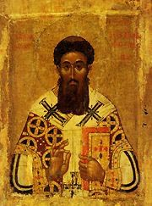
A Prayer for Priests - St Gregory Palamas
O Lord Jesus Christ, Enkindle the hearts of all Thy priests with the fire of zealous love for Thee, that they may ever seek Thy glory,
Give them strength that they may labor unceasingly in Thine earthly vineyard for the salvation of our souls and the glory of Thine All-Honorable and Majestic Name of the Father, and of the Son, and of the Holy Spirit, now and ever, and unto ages of ages. Amen.

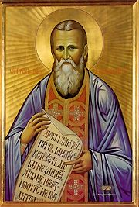
A Prayer for priests by St John of Kronstadt
O Lord, let Thy unworthy servant Seraphim and
Thy priests_________ be clothed with righteousness;
Let them always remember the greatness of their calling;
Let them not be entangled in the snares of the world and the devil;
Let them be saved from the cares of the world, the delight in riches,
cowardice, equivocation, duplicity, undue regret, despondency, anger, coldness, exhaustion, judgment of others, cynicism, negativity, laziness, forgetfulness regarding prayer, indifference, unawareness, lack of empathy, aloofness, manipulation, heresy, being too opinionated
and the desire for other things entering into their hearts. (italics not in original prayer)

Prayers for the Sick

A Prayer for the Ailing
O Master Almighty, O Holy King, Who chastenest and destroyest not, Who strengthenest the falling, and settest aright the fallen, Who correctest the bodily afflictions of mankind: We pray Thee, O our God, visit Thine infirm servant N. with Thy mercy, pardon him (her) every sin, voluntary and involuntary.
Yea, O Lord, send down Thy healing power from heaven, touch his (her) body, quench the fever, subdue passion and every subtle infirmity. Be the healer of Thy servant N. raise him (her) from his (her) couch of sickness, and from his (her) bed of suffering healed and whole; grant him (her) to be well-pleasing unto Thy Church and doing Thy will. For Thine it is to show mercy and to save us, O our God, and unto Thee do we send up glory: to the Father, and to the Son, and to the Holy Spirit, now and ever, and unto the ages of ages.

Troparion for the ailing, 4th Tone
O Christ, Who alone art quick to help, show from on high a speedy visitation to Thy suffering servant(s), and deliver him (her)(them) from illness and bitter pain, and raise him (her)(them) up to praise and glorify Thee unceasingly, through the intercessions of the Theotokos, O only Lover of mankind.
Glory to the Father, and to the Son, and to the Holy Spirit, both now and ever and unto the ages of ages. Amen.
As once, O Savior, Thou didst raise up Peter's mother-in-law, and the paralyzed man who was carried on his bed, so also now, O Compassionate One, visit and heal Thy suffering servant(s), lying on the bed of sickness, and wounded with a mortal wound, for Thou alone didst bear the infirmities, pains and diseases of our race, and Thou canst do all things, for Thou art plenteous in mercy.

Prayers for the Reposed

O God of Spirits
O God of spirits and of all flesh, Who hast trampled down death, and overthrown the devil, and given life to Thy world: Do Thou, Thyself, O Lord give rest to the soul(s) of Thy departed servant(s) _____,
in a place of light, a place of green pasture, a place of repose, whence all sickness, sorrow and sighing are fled away. Pardon every sin committed by him (her, them), in word, deed or thought, in that Thou art a good God, the Lover of mankind; For there is no man that liveth and sinneth not, for Thou alone art without sin, Thy righteousness is an everlasting righteousness, and Thy Word is Truth.
For Thou art the Resurrection, and the Life, and the repose of Thy departed servant(s) _____,
O Christ our God, and to Thee we send up glory, together with Thine unoriginate Father, and Thy most holy and good and life-creating Spirit, now and ever, and to the ages of ages

Prayer for every departed person

Remember, O Lord our God, Thy servant, our brother/sister, N., who has reposed in the Faith and hope of life eternal, and in that Thou art good and the Lover of mankind, Who remittest sins and blottest out iniquities, do Thou loose, remit and pardon all his/her sins, voluntary and involuntary.
Deliver him/her from eternal torment and the fire of Gehenna, and grant unto him/her the communion and delight of Thine eternal good things prepared for them that love Thee.
For though he/she hath sinned, yet hath he/she not forsaken Thee, and he/she undoubtedly believed in the Father and the Son and the Holy Spirit; and even until his/her last breath did he/she confess Thee in Orthodox fashion: God glorified in Trinity, Unity in Trinity and Trinity in Unity.
Wherefore, be Thou merciful unto him/her and reckon his/her faith in Thee, rather than his/her deeds, and in that Thou art compassionate, grant him/her rest with Thy saints; for there is no man that liveth and doth not sin.
But Thou alone art wholly without sin, and Thy truth is forever; and Thou alone art the God of mercies, and compassion, and love for mankind, and unto Thee do we ascribe glory, to the Father, and to the Son and to the Holy Spirit, now and ever, and unto ages of ages. Amen.

In the back of the "Boston" Psalter. http://www.synaxis.info/psalter/5_english/b_reading/kath_prayers.html

Daily Prayers

O Divine Light!
O Love, Who hands Himself over to suffering for us!
Enlighten the eyes of our souls, that we might see the ruination caused by the desires of our sinful hearts!
Breathe a holy fear into us, that we might tremble at sin if it merely draws near to our soul.
Strengthen our will with grace-filled power for the fight against impiety.
On the Passion of Our Lord Jesus Christ, By St. Philaret (Gumilevsky) of Chernigov, St. Herman of Alaska Brotherhood. Homily 1, pg 32

A Morning Prayer by St. Paisios the Great

O Lord Jesus Christ my God, give me a good, sinless, and spotless day.
O Lord, forsake me not.
O Lord, do not stand afar off from me
O Lord, stretch out to me a helping hand.
O Lord, support me with the fear of Thee.
O Lord, plant this fear and the love for Thee in my heart.
O Lord, teach me to do Thy will.
O Lord, grant mourning and humility to my heart.
O Lord, give me unceasing tears, compunction, and remembrance of death.
O Lord, free me from every temptation of soul and body.
O Lord, expel from me every unclean thought, and every shameful and improper imagination.
O Lord, wipe out of me the negligence, the indolence, the sorrow, the forgetfulness, the insensitivity, the hardness, and the captivity of my mind.
O Lord, have mercy on me, as Thou knowest and as Thou dost wish, and forgive all my transgressions.
And grant that my pitiful soul may depart from my wretched body in quietude, in good repentance, in unhesitating confession, and in pure and spotless faith.
Amen. St. Paisios the Great, 4th century

Prayer of Elder Gabriel
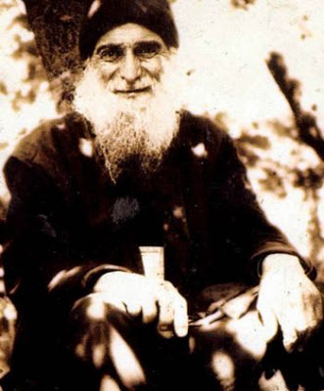
O Lord, I entreat Thee, hear us from Heaven, look with favor upon us, grant us Thy mercy, let us depart in peace, that we may walk in Thy way, fulfill Thy commandments, and renounce sin.
Teach us, O Lord, to pray before Thee and to keep Thy holy law, so that our hearts would become devoted to Thee, and grant that we all would live according to Thy holy law.

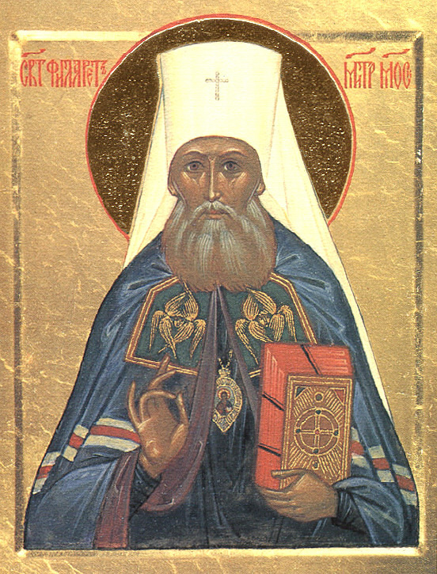
Prayer of St. Philaret, Metropolitan of Moscow
My Lord, I know not what I ought to ask of Thee.
Thou and Thou alone knowest my needs.
Thou lovest me more than I am able to love Thee.
O Father, grant unto me, Thy servant, all which I cannot ask.
For a cross I dare not ask, nor for consolation; I dare only to stand in Thy presence.
My heart is open to Thee. Thou seest my needs of which I myself am unaware.
Behold and lift me up!
In Thy presence I stand, awed and silenced by Thy will and Thy judgments, into which my mind cannot penetrate.
To Thee I offer myself as a sacrifice. No other desire is mine but to fulfill Thy will.
Teach me how to pray. Do Thyself pray within me. Amen.

Daily Prayer of Hieroschemamonk Parthenios
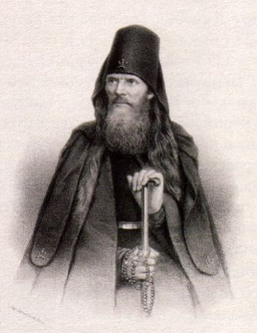
Lord Jesus Christ, Son of God, do not permit vanity, self-love, sensuality, carelessness, anger to rule over me and steal me from Thy love, O my Lord and Creator, all my hope!
Do not leave me without a portion of the blessed eternity. Grant also that I may follow Thy Holy example, that I may submit to the authorities placed over me.
Grant me the clean soul, the simplicity of heart; which makes us worthy of Thy love.
To Thee, my God, I lift up my soul and heart; do not allow Thy creation to perish, but free me from the single and greatest enemy ... sin.
Grant, Lord, that I may endure anxiety and sorrows of the soul with the same patience as the joy with which I receive satisfaction of heart.
If Thou desirest, Lord, Thou canst cleanse me and sanctify me. Here I commit myself to Thy mercy... begging Thee to destroy within me all that is offensive to Thee, and to unite me to the assembly of Thy chosen.
Lord, take from me: idleness of spirit, which destroys time; vanity of thoughts, which hinders Thy presence and distracts my attention to prayer.
If, while in prayer, I turn away from Thee in my thoughts, help me; so that this distraction may not be willful, and that - averting my mind - I may not avert my heart from Thee.
I confess to Thee, my Lord God, all the sins of my wickedness committed before Thee, now and in the past. Forgive me for them, for the sake of Thy Holy Name, and save my soul, which thou hast redeemed with Thy precious Blood.
I entrust myself to Thy mercy. I submit to Thy will. Do with me according to Thy mercy and not according to my evil and wickedness.
Teach me Lord, to dispose my deeds so that they will serve in glorifying Thy Holy Name.
Take pity, O Lord, on all Christians. Hear the desires of all who cry out to Thee, and deliver them from evil.
Save Thy servants [ insert names ] .
Send them comfort, consolation in sorrows, and Thy holy mercy. Lord, I especially pray for those who have in anyway insulted, abused and grieved me. Do not punish them for the sake of me, a sinner; but pour Thy mercy upon them.
Lord, I pray to Thee especially for all those whom I, a sinner, insulted or tempted in word, deed, thought, knowingly and unknowingly.
Lord God, forgive us our sins and mutual offenses. Dispel from our hearts, O Lord, all indignation, suspicion, anger, remembrance of evil, quarrels, and all that might hinder and lessen brotherly love.
Be merciful Lord, to those who have entrusted me, an unworthy sinner, to pray for them.
Be merciful Lord, to all who ask Thy help. Lord, make this day a day of Thy mercy; give to each according to their petition.
Be the Shepherd of the lost, the Guide of Light of unbelievers, the Teacher of the unwise, the Father of orphans, the Helper of the oppressed, the Healer of the sick, the Comforter of the dying, and lead us all to the desired end... to Thee, our refuge and blessed repose. Amen.

Morning Prayer of St Jerome

Lord Jesus Christ, as I rise in the morning, be attentive unto me and govern mine actions and my words and my thoughts, that I may pass the whole day within Thy will. Grant me Thy fear, O Lord, compunction of heart, lowliness of mind, a pure conscience, that I may scorn the world, ponder heaven, hate sins, and love righteousness. Take from my heart the cares of the world. Wrench from me, O Lord, the appetite for gluttony, the desire for fornication, the love of money, the plague of irritability, the sadness of this world, listlessness, empty joy, worldly pride. Plant in me, O Lord, the virtues: an abstaining body's self-containment, chastity, humility, and unfeigned brotherly love. Guard my mouth, Lord, that I may not speak vanities, nor tell worldly tales nor detract others in their absence, that I may not curse my parents, that I may not answer cursing with cursing, but rather with blessing. O Lord, let Thy praise be continually in my mouth. Guard mine eyes, Christ, that they may not see what is evil to lust after it, nor the delicacies of this world nor the goods of my neighbor, but let me say in the spirit of David, "Mine eyes are ever toward the Lord, for He it is that will draw my feet out of the snare", and again, "Unto Thee have I lifted up mine eyes, unto Thee that dwellest in heaven". Guard mine ears lest they listen to slander and lies or idle talk, but let them be opened every day to listen to the word of God, who heareth and reigneth unto ages of ages. Amen.
Psalm references: Ps 24:16, Ps 122:1. This prayer: http://www.orthodox.net/trebnic/of-jerome-a-morning-prayer.doc, http://www.orthodox.net/trebnic/of-jerome-a-morning-prayer.pdf

Prayer For The Granting Of Prayer
O All-merciful Lord!
Grant me the divine gift of holy prayer, flowing from the depth of my heart.
Gather together the dispersed thoughts of my mind, that it may always strive towards its Creator and Savior.
Destroy the burning arrows of the evil one, which tear me away from Thee.
Quench the flame of the passionate thoughts that devour me during prayer.
Cover me with the grace of Thy Most-holy Spirit, that to the very end of my sinful life I may love Thee alone with all my heart, all my soul and mind,
and all my strength, and in the hour when my soul takes leave of my mortal body, O Sweetest Jesus, take into Thy hands my spirit when Thou comest into Thy Kingdom. Amen.
From the spiritual diary of St. John of Kronstadt, "My Life in Christ"

Prayer of Holy Martyr Boniface Dec 19/ Jan 1
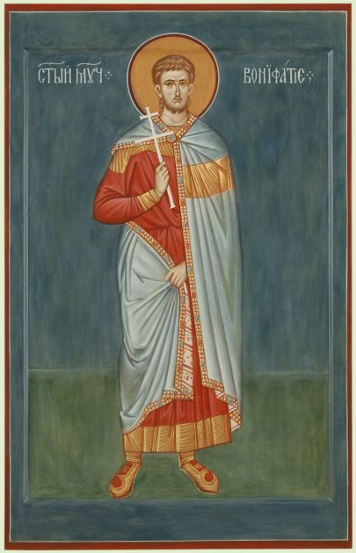
O Lord God, may Thy mercy go before me!
Be my Helper and let not mine enemy close to me the path to heaven, on account of my senseless sins.
Accept my spirit in peace, and number me with those whose blood hath been shed for Thy sake and who have kept the faith.
Deliver from pagan error the people which Thou hast gained by Thy blood, O Christ, for blessed art Thou Who abidest unto the ages
Troparion Tone 4
Thou didst fervently follow after the Martyrs/ and confess Christ before unbelievers, O Boniface./ Thou didst give thy body to modest Aglais/ as imperishable treasure:/ healings and mercy flow from it for the world.
Kontakion Tone 4
Thou didst offer thyself as a blameless sacrifice,/ O wise crown-bearer,/ to One Who is about to be born of a Virgin for thy sake, O Boniface.

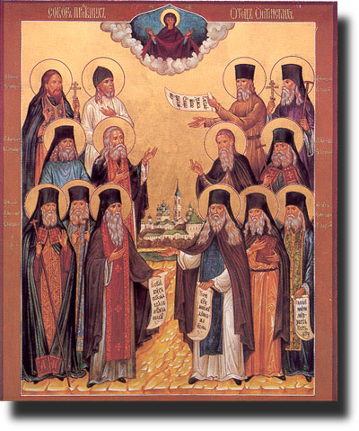
The Prayer of the Optina Elders

Grant unto me, O Lord, that with peace of mind I may face all that this new day is to bring.
Grant unto me to dedicate myself completely to Thy Holy Will.
For every hour of this day, instruct and support me in all things.
Whatsoever tidings I may receive during the day, do Thou teach me to accept tranquilly, in the firm conviction that all eventualities fulfill Thy Holy Will.
Govern Thou my thoughts and feelings in all I do and say. When things unforeseen occur , let me not forget that all cometh down from Thee.
Teach me to behave sincerely and rationally toward every member of my family, that I may bring confusion and sorrow to none.
Bestow upon me, my Lord, strength to endure the fatigue of the day, and to bear my part in all its passing events.
Guide Thou my will and teach me to pray, to believe, to hope, to suffer, to forgive, and to love.
Amen.

Prayer of Patriarch Pavle of Serbia

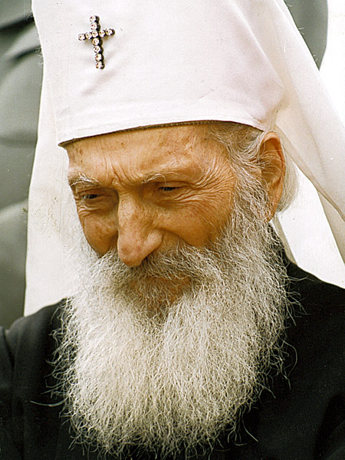
Lord, glory to Thee! Lord, help! Lord, bless! Glory to Thee! For glory begins belongs to Thee alone, to Thy greatness alone, to Thy wisdom, Thy justice, but above all to Thy endless goodness, our Father! On account of it, we put our hope also in thy help without which we know not and cannot begin anything good; we also put our hope in Thy blessings without which all our effort and work will be nothing more than building a house upon the sand, which will be destroyed as soon as the first rain descends, and the rivers flood, and the winds start blowing.
(“Patriarch Pavle of Serbia, Life according to the Gospel”, p 11, from the first hierarchal sermon, 1957)
http://www.orthodox.net/trebnic/of-patriarch-pavle-for-help.doc

Prayers to the Holy Spirit

Save Thy servant from misfortunes, O good Comforter, for the unclean demons greatly and constantly assail me with vile thoughts and illusions.

Kontakion, in Tone II: Spec. Mel.: “Seeking the highest…”— In hymns let us reverently praise and magnify the Life of all, the ever-flowing Well-spring of divine gifts, the most Holy Spirit, as of one essence with the Father and equally eternal with the Son; and with faith let us worship Him as God.
Another verse: I worship Thee, O Master, Comforter and God. Have mercy and save those who worship Thee, confessing Thee to be God!

With Thy divine grace, O Paraclete, enlighten my soul, which hath been darkened by the passions, and drive away from it the deep darkness of ignorance.

Having armed himself against me in every way with the abominable goads of youth, the vile one hath thereby defiled my soul and my whole life. O all-good Paraclete, heal me with the fruits of repentance!

In mind have I fallen into grievous perils, and I am wholly beset by perplexity, and am falling into divers misfortunes; and like a boat upon the waves of the sea am I bestormed. O all-good Comforter, quickly rescue me from this grievous battering, I pray Thee!

Kontakion, in Tone II— Having sinned more than the harlot and Esau, I flee to Thy compassions: Turn not Thy grace away from me, O all-holy Paraclete!

It is truly meet to magnify with glorifications and to glorify with fear Thee, the most Good and most Holy One, the Preserver of our life, the Great and Awesome One, Who with the Father and the Son dost reign as God over all things visible and the invisible, the Spirit of God Who proceedest from the Father alone.

Glory…: With divine hymns we all hymn Thee as God: the Father, the Son and the divine Spirit, the tripartite Might, the single Kingship and Dominion.

Now & ever…: O Mistress, Mother of the Deliverer, accept the supplications of thine unprofitable servants, and thereby grant deliverance of sins and the acceptable correction of a God-pleasing life.

Prayer to the Holy Spirit by St Maximos the Greek

O Master, all-good Paraclete, Who art One of the Holy and worshipful, consubstantial and indivisible Trinity, accept this poor entreaty which Thou hast allowed to be offered unto Thee by a man sinful and condemned; and forgive me mine offenses, voluntary and involuntary.
Cleanse me of my hidden [sins], and take pity on Thy servant [in the face the sins] of others.
Extend Thy favor to me, the sinful and unworthy, visit the infirmity of my soul with Thy grace, and heal its broken state.
Have mercy on me, O Master, Paraclete and God! Have mercy on me, sanctify my soul and body, enlighten my mind and reason, and cleanse the conscience of my soul from all defilement.
And from impure thoughts, from the plottings of the wicked and the intentions of the bad, from all vainglory, pride and self-aggrandizement, from arrogance and audacity, from satanic insolence, and from all pharisaical hypocrisy and mine every evil habit, do Thou utterly deliver me for the sake of the glory of Thy name.
And grant me sincere repentance, contrition and humility of heart, meekness and serenity, and all Christian reverence, understanding and spiritual skill, with all nobility, thankfulness and perfect patience.
Yea, O God, for the sake of the glory of Thy name hearken unto me, the sinful one who prayeth to Thee, and vouchsafe that for the remainder of my wretched life I may sincerely repent of mine iniquities with all humbleness of mind, chastity and true temperance, having put away all doubt, double-mindedness and insensitivity; and fully preserve me in a pious and Orthodox confession of the Christian Faith, O Master, that I may be vouchsafed all the days of my life to hymn thee without doubting, to bless and glorify Thee, and to say: O holy God, unoriginate Father!
O holy Mighty One, His Son Who is equally without beginning! O holy Immortal One, Holy Spirit Who proceedest from the Father and abidest and restest in the Son!
O most Holy Trinity, glory be to Thee! Glory to Thee, O Holy Trinity, Who art consubstantial, life-creating and indivisible! Glory to Thee for all things!
Glory to thee, O Mother of God, refuge of the faithful, deliverance for those beset by evils, and divine consolation of my soul! O thou who art full of the grace of God, my most wretched soul, which that been wounded by the arrows of the enemy, do I entrust to thine almighty intercession; and protect and save it unharmed by the wiles of the demons, that I may cry out to thee: Rejoice, O unwedded Bride!

http://www.orthodox.net/services/canon-of-st-maximos-to-the-divine-paraclete.doc
http://www.orthodox.net/services/canon-of-st-maximos-to-the-divine-paraclete.pdf

Prayers of Thanksgiving

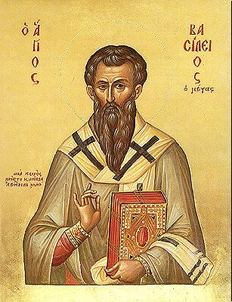
Prayer of Thanksgiving by St Basil The Great

O Existing One, Master Lord, God, almighty and adorable Father: It is truly meet and right and befitting the majesty of Thy holiness that we should praise Thee, hymn Thee, bless Thee, worship Thee, give thanks unto Thee and glorify Thee, the only truly existing God, and offer unto Thee with contrite heart and spirit of humility this our rational worship; for Thou art He that hath graciously bestowed upon us the knowledge of Thy truth.
And who is sufficient to speak of Thy mighty acts, to make all Thy praises to be heard, or to tell of all Thy wonders at every season?
O Master of all, Lord of heaven and earth, and of all creation both visible and invisible, Who sittest upon the throne of glory and beholdest the depths, Who art unoriginate, invisible, immutable, the Father of our Lord:
The great God and Savior Jesus Christ, our Hope, Who is the Image of Thy goodness, the Seal of equal type, in Himself showing forth Thee, the Father, the living Word, the true God, the Wisdom before all ages, the Life, Sanctification, Power, the true Light, through Whom the Holy Spirit was manifested:
The Spirit of truth, the Gift of adoption, the Pledge of the inheritance to come, the First-fruits of eternal good things, the life-giving Power, the Fountain of sanctification, by Whom enabled every rational and intelligent creature doth serve Thee and ascribe to Thee perpetual praise, for all things are Thy servants.
Filled thus with great awe at Thine immeasurable mercies and love, do Thou receive the unfeigned praise and thanksgiving of our unworthy hearts for all that Thou hast provided for us in this world and the next, and enable us to walk before Thee in holiness and purity all the days of our life in fitting gratitude for Thy loving-kindness to us;
For blessed art Thou O Holy Father together with Thy Son, our Lord Jesus Christ to Whom, with Thee and the Holy Spirit, be all honor and glory and worship, now and every and unto ages of ages.

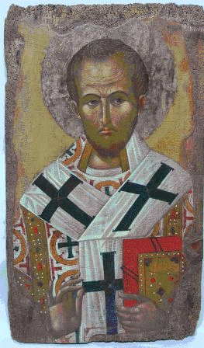
Prayer of Thanksgiving, attributed to St John Chrysostom
What praise, of what hymn, or what thanksgiving, or what recompense shall we offer unto Thee, the Only God, Who lovest mankind?
For when we were condemned to destruction and immersed in our sins, Thou didst bestow freedom upon us, and hast given us the immortal and heavenly nourishment of the Body and Blood of Thy Christ.
Therefore we pray Thee: Deliver us from judgment, together with Thy servants who minister unto Thee.
Keep us and them in honor and holy living; and those who pray with us, and who have been partakers of Thy Mystical Table, preserve free of condemnation unto their last breath.
May it be unto them a sanctification of soul and body, unto the keeping of Thy Commandments; and thus may we be granted to attain Thy Heavenly Kingdom, together with all who have been well-pleasing unto Thee from all ages:
Through the prayers and intercessions of our holy, all-pure, most blessed and glorious Lady, the Birthgiver of God and Ever-Virgin Mary, of Saint N. whose memory we keep, and of all Thy Saints, now and ever, and unto ages of ages. Amen.

From the Hours

Prayer of the Hours
THOU WHO AT ALL TIMES AND AT EVERY HOUR, in heaven and on earth, art worshipped and glorified, O Christ God, Who art long suffering, plenteous in mercy, most compassionate, Who lovest the righteous and hast mercy on sinners, Who callest all to salvation through the promise of good things to come: Receive, O Lord, or prayers at this hour, and guide our life toward Thy commandments. Sanctify our souls, make chaste our bodies, correct our thoughts, purify our intentions, and deliver us from every sorrow, evil and pain. Compass us about with Thy holy angels, that guarded and guided by their array, we may attain to the unity of the faith and the knowledge of Thine un-approachable glory; for blessed art Thou unto the ages of ages. Amen.

Prayer of the 1st Hour
O CHRIST THE TRUE LIGHT, Who enlightenest and sanctifiest every man that cometh into the world; Let the light of Thy countenance be signed upon us, that in it we may see the unapproachable Light, and guide our steps in the doing of Thy commandments, through the intercessions of Thy most pure Mother, and of all Thy saints. Amen.

Prayer of St. Mardarius (3rd hour)
O SOVEREIGN GOD, the Father Almighty, O Lord, the Only-begotten Son, Jesus Christ, and Thou O Holy Spirit, one Godhead, one Power: have mercy on me a sinner, and by the judgements which Thou knowest, save me, Thine unworthy servant; for blessed art Thou unto the ages of ages. Amen.

Prayer of Basil the Great at the 6th Hour

O GOD AND LORD OF HOSTS, and Maker of all creation, Who by the tender compassion of Thy mercy which transcendeth comprehension, didst send down Thine Only-begotten Son, our Lord Jesus Christ, for the salvation of our race, and by His precious Cross didst tear asunder the handwriting of our sins, and thereby didst triumph over the principalities and powers of darkness: Do Thou Thyself, O Master, Lover of mankind, accept also from us sinners these prayers of thanksgiving and entreaty, and deliver us from every destructive and dark transgression, and from all enemies, both visible and invisible, that seek to do us evil. Nail down our flesh with the fear of Thee, and incline not our hearts unto words or thoughts of evil, but pierce our souls with longing for Thee, and being guided by Thy light as we behold Thee, the Unapproachable and Everlasting Light, we may send up increasing praise and thanksgiving unto Thee, the Un-originate Father, with Thine Only-begotten Son, and Thine All-Holy and Good and Life-creating Spirit, now and ever, and unto the ages of ages. Amen.
Prayer of Basil the Great at the 9th Hour
O MASTER, LORD JESUS CHRIST, OUR GOD, Who art long-suffering in the face of our transgressions, and Who hast brought us even unto this hour, wherein Thou didst hang upon the life-creating Tree, and didst make a way into Paradise for the wise thief, and by death didst destroy death: Be gracious unto us sinners and Thine unworthy servants; for we have sinned and committed iniquity, and are not worthy to lift our eyes and behold the height of heaven, for we have abandoned the way of Thy righteousness, and have walked in the desires of our hearts. But we beseech Thy boundless goodness: Spare us, O Lord, according to the multitude of Thy mercy and save us for Thy holy name's sake; for our days were consumed in vanity. Rescue us from the hand of the adversary, and forgive us our sins, and mortify our carnal mind; that, putting aside the old man, we may be clad with the new, and live for Thee, our Master and Benefactor; and that thus by following in Thy commandments, we may attain to rest everlasting, wherein is the dwelling place of all them that rejoice. For Thou art indeed the true joy and gladness of them that love Thee, O Christ our God, and unto Thee we send up glory, with Thine un-originate Father, and Thy most holy, and good, and life-creating Spirit, now and ever, and unto the ages of ages. Amen.

Various Prayers

From the Evergertinos

Protect me, O Lord, from the praise and slander of men. Evergertinos, Second Book, Hypothesis II , pg 31

From Exodus

Now therefore, I pray thee, if I have found grace in Thy sight, shew me now Thy way, that I may know thee, that I may find grace in Thy sight: and consider that this nation is Thy people. (Exo 33:13 KJV)

Psalm 17
And the Lord will recompense me according to my righteousness, and according to the purity of my hands will He recompense me. [21] For I have kept the ways of the Lord, and I have not acted impiously toward my God. [22] For all his judgements are before me, and His statutes departed not from me. [23] And I shall be blameless with Him, and I shall keep myself from mine iniquity. [24] And the Lord will reward me according to my righteousness, and according to the purity of my hands before His eyes. [25] With the holy man wilt Thou be holy, and with the innocent man wilt Thou be innocent. [26] And with the elect man wilt Thou be elect, and with the perverse wilt Thou be perverse. [27] For Thou wilt save a humble people, and Thou wilt humble the eyes of the arrogant. [28] For Thou wilt light my lamp, O Lord my God, Thou wilt enlighten my darkness.

Prayer For The Gift Of The Jesus Prayer
Lord Jesus Christ, Son of God!
Angels and men bow down before Thy Name. The powers of hell tremble before it.
Thy Name is the sure weapon which drives away all adversaries.
Thy Name scorches sins and passions.
Thy Name gives strength in ascetic labors, gathers our scattered mind into one, and enriches us with virtues in the fulfillment of Thy commandments.
Thy name works miracles and unites us with Thee, grants us peace and joy in the Holy Spirit, and the Heavenly Kingdom is possible in the future life.
Therefore I, thine unworthy slave, pray to Thee: drive from us our spiritual ignorance, enlighten us with the knowledge of Divine Truth, and teach us to ceaselessly repeat this prayer undistracted, in humility, attentively, with a feeling of repentant contrition, with our mind and heart, [ according to our vows of monasticism].
"Lord Jesus Christ, Son of God, have mercy on me a sinner. "
Thou hast said, O Lord, with Thy most pure lips: "Whatsoever ye shall ask in My name, that will I do." (Jn 14:13). (Compiled by the Elders of Optina Monastery)

Prayer against scattered thoughts
Gather my scattered mind, O Lord, and my iced over heart, purify, like unto Peter, granting me repentance, like unto the publican sighing, and like unto the adulteress' tears, so that with the great voice I may call to Thee, O God, save me, for Thou alone art good and the Lover of mankind
Translated from the Russian by Deacon Viatcheslav Davidenko of St Mary of Egypt Parish, Norcross GA . Used with permission.

This document was compiled by Priest Seraphim Holland. Please contact him concerning corrections seraphim@orthodox.net It is at http://www.orthodox.net/trebnic/various-prayers-for-an-orthodox-christian.doc http://www.orthodox.net/trebnic/various-prayers-for-an-orthodox-christian.pdf It is designed to be printed as a booklet, with software like “Clickbook”. All these prayers and many others are at http://www.orthodox.net/trebnic/. If this booklet is useful to you, I ask that you would pray daily for my sinful self and my family (children in italics): - Priest Seraphim & Marina (Holland) - Deacon Nicholas & Genevieve, Anna, Emelia, Sophia, Lucy, Nina, Gregory, Alexandra (Park) - Timothy & Christina, Nadezda, Matthew, Vivian (McFadden) - Timothy & Elizabeth, not orthodox:Kai Lyn (Holland) - Matthias & Natalie (King) - +DANIEL (my son, drowned at age 20, 06/11/2017 – http://www.orthodox.net/daniel If you agree to pray for +Daniel, I will put you on “Daniel’s list” - http://www.orthodox.net/daniel/dyptichs-daniels-list.html St Nicholas Orthodox Church, McKinney, TX 708 S Chestnut, McKinney TX 75069 http://www.orthodox.net There are sermons, catechesis, prayers, articles, videos, and more on our website.
These prayers are inset and in blue because that is the way I type-set them in a Divine Liturgy booklet I use. This might seem random to you, but it makes sense to me.
This is St Silouan's original prayer, quoted in Archimandrite Zacharias, “The Enlargement of the Heart”. All other prayers are according to his model, and written by someone who is not a saint.
Similar to an ectenia at the end of Compline
From a prayer at the end of the Third Hour
Nersess the Gracious (1100-1173) is revered by the Armenian Orthodox Church as a saint. This prayer was taken from a post on a monachos.net discussion list: 01-03-2007, 07:46 PM (http://www.monachos.net/forum/showthread.php?t=3588&). It may also be found at http://www.1stholistic.com/Spl_prayers/A2004/prayer_lenten-prayers-nursess.htm This is an extremely edifying and richly dogmatic prayer, suitable for all Orthodox Christians. The publication of this prayer does not constitute any acknowledgment or denial of the sanctity of Nersess the Gracious.

