Chapter 1 exercises

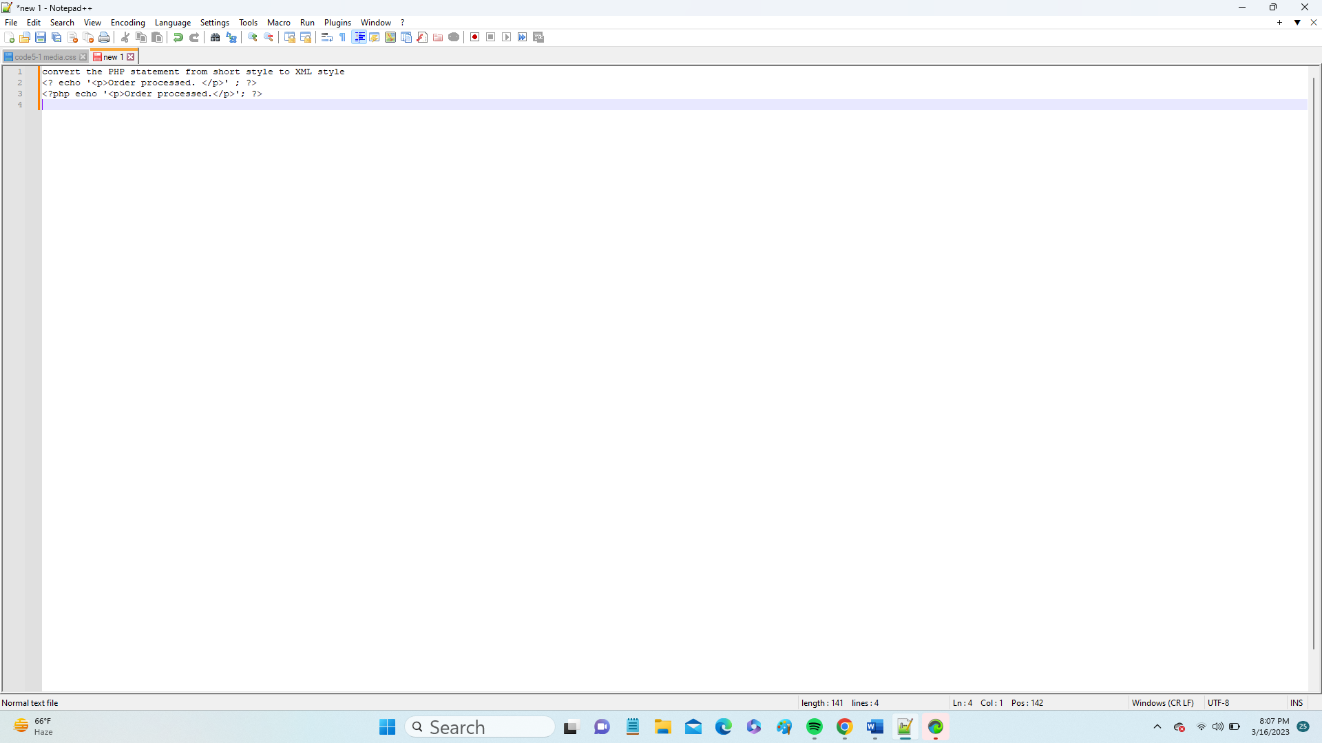

1. Write a single line PHP comment that says “Hello World”

///Hello world

1. Graphical user interface, text, application, Word, email

   Description automatically generated

Write a statement that accesses the contents of the field quantity in an array variable named $_POST

Echo the string $hello world in such a way that the $hello variable's contents are interpolated into the output.

1. Echo “$hello world”
2. Assign the literal value 0.00 to the variable named $totalamount

<?php

$totalamount=0.00

Chapter 2

You need to open the file orders.txt for writing. Modify the following code, specifically the two placeholders, to accomplish your goal.

$fp = ___("$document_root/../orders/orders.txt", '___');

1. $fp = ___("$document_root/../orders/orders.txt", '___');

$fp=open("$document_root/.../orders/orders.txt",'w'

1. Use the PHP fwrite function to write the string stored in $outputstring to the file pointed to by $fp.

1. Use PHP to close the file $fp programmatically.

4. You need to use a PHP while loop to read from a file until the end of the file is reached. Modify the following code to accomplish your goal.

5. Use PHP to echo the size of the file orders.txt that's present in your current working directory.

Chapter 2

You need to open the file orders.txt for writing. Modify the following code, specifically the two placeholders, to accomplish your goal.

$fp = ___("$document_root/../orders/orders.txt", '___');

2. Use the PHP fwrite function to write the string stored in $outputstring to the file pointed to by $fp.

1. Use PHP to close the file $fp programmatically.

4. You need to use a PHP while loop to read from a file until the end of the file is reached. Modify the following code to accomplish your goal.

while (!___($fp))

5. Use PHP to echo the size of the file orders.txt that's present in your current working directory.

Chapter 3