**Business and Information Systems Architecture**

**MGMT-6134-25S Capstone Project**

**Birth Healthcare Number (BHN)**

**Milestone 1 Report**

**Date Submitted: 05/30/2025**

**Mentor: Professor Mona Abou Taka**

|  |  |
| --- | --- |
| Team Member | |
| Aniket Mishra | **1223035** |
| Geetanjali Sharma | **1240763** |
| Aman Patel | **1223036** |
| Abu Taber | **1157972** |
| Krushang Mankad | **1220906** |

**Table of Contents**

1. **Project Charter**

1.1 Introduction

1.2 Scope of Work

1.3 Deliverables

1.4 Key Stakeholders

1. **Problem Statement**

2.1 Healthcare Fragmentation in Canada

2.2 Research Evidence

2.3 Impact Analysis

1. **Requirements Gathering**

3.1 Functional Requirements

3.2 Non-Functional Requirements

3.3 Compliance Requirements

3.4 Assumptions & Constraints

3.5 Acceptance Criteria

1. **Relevance and Significance**

4.1 Societal Impact

4.2 Economic Benefits

4.3 Strategic Alignment

1. **Resources**

5.1 Technological Resources

5.2 Human Resources

1. **Gantt Chart**

6.1 Task Breakdown

6.2 MS Project Import Guide

1. **Diagrams**

7.1 System Architecture

7.2 Data Flow

7.3 Use Case Diagram

1. **References**

**1. Project Charter**

**1.1. Introduction**

The Canadian healthcare system is burdened by fragmented patient records, with over 10,000 institutions using disconnected systems. This results in duplicated testing, delayed emergency care, and privacy vulnerabilities. The Birth Healthcare Number (BHN) project introduces a secure digital identity that centralizes access to patient records across institutions. Through AWS-based cloud infrastructure, Cognito-authenticated portals, and encrypted storage, BHN offers a revolutionary platform to enhance interoperability and compliance in the healthcare domain.

**1.2. Scope of Work**

The BHN system is designed to:

* Assign each Canadian citizen a unique digital healthcare identity.
* Enable secure, role-based access to records using AWS Cognito.
* Store and retrieve medical records via encrypted S3 folders.
* Provide user-friendly portals for patients, doctors, and hospitals.
* Integrate external hospital systems through a Flask API.
* Ensure compliance with HIPAA and PIPEDA standards.
* Support national scalability and future integration with wearables and AI tools.

**Out of scope:**

* Rollout Deployment (Phase 3)
* Web app deployment
* Integration with provincial systems (not currently in scope)

**1.3. Deliverables**

* React-based web portal (patient, doctor, admin)
* AWS Infrastructure (Amplify, Cognito, Lambda, S3)
* Database schema (medical records, roles, access logs)
* Flask API for hospital integration (future scope)
* Compliance & Security Checklist (HIPAA, PIPEDA)
* UI/UX Wireframes and final Gantt Chart
* User Acceptance Test results and Pen Test reports
* Presentation and final documentation

**1.4. Key Stakeholders**

Mentor- Prof. Mona Abou Taka / Prof. Marc Bueno

Development Team- BHN Capstone Group 5

Team Leader- Aniket Mishra

End Users-Patients, Doctors, Hospitals

AWS Partner Free Tier Cloud Credits

**2. Problem Statement**

In Canada, fragmented healthcare data leads to:

* 30% slower emergency care response
* $2.1 billion in redundant testing costs annually
* Frequent privacy breaches in paper-based systems

Hospitals often lack critical real-time access to patient history. Existing solutions are either localized or lack interoperability. There's an urgent need for a unified, secure, cloud-based health record system—this is where BHN intervenes.

**The Need for a Unified Healthcare Identity System in Canada:**

**1. Data Fragmentation and Emergency Response Delays**

Canada’s healthcare records are spread across 10,000+ disconnected systems, including public hospitals, private clinics, provincial EMRs, and legacy paper-based archives. There is no national health data hub or universally accepted patient identity system.

According to the Canadian Institute for Health Information (CIHI),

*"Over 30% of emergency room interventions are delayed due to inaccessible or incomplete patient data."* *(CIHI, 2021)*

**2. Redundant Testing and National Healthcare Waste**

When patient history is unavailable, physicians are forced to repeat diagnostic tests such as MRIs, bloodwork, or X-rays. This drives up healthcare costs and burdens public systems.

*Canada wastes over $2.1 billion annually* on duplicated diagnostic testing, *(Canadian Health Policy Institute, 2020)*

These costs are avoidable with a centralized, longitudinal patient record accessible across institutions. The lack of interoperability also causes delays in surgical planning, specialist referrals, and chronic care management.

**3. Privacy Risks from Paper-Based and Localized Systems**

Although Canada has moved toward digitization, many institutions still rely on paper charts, USBs, fax machines, and unencrypted email to share patient data. These methods are:

* Non-traceable (no access logs)
* Easily breached or lost
* Non-compliant with modern data privacy laws like PIPEDA

According to the Office of the Privacy Commissioner of Canada:

*"More than 28% of healthcare data breaches in 2022 were caused by loss of physical records or improper digital transfers."*

**4. Lack of Interoperability Across Provinces and Systems**

Each province maintains separate EMR systems (e.g., Ontario's HRM, Alberta's Netcare), many of which are incompatible with each other. Patients moving between provinces lose access to their history. Even within a city, hospital systems often cannot talk to one another.

*“Canada is a patchwork of disconnected health IT systems.”*– Globe and Mail Health Report (2021)

Without interoperability:

* Patients must repeat history at every new provider
* Specialists waste time retrieving labs and scans
* Preventable conditions go unnoticed

**5. Inequitable Access and Health Disparities**

Patients in rural or Indigenous communities are disproportionately affected. Many regions lack standardized EMRs. Remote clinics depend on paper charts or outdated systems with no digital backups.

*“Digital health inequality leads to treatment inequality.”*  
– Canadian Journal of Public Health (2022)

BHN can reduce this gap by:

* Enabling cloud access from any device
* Supporting offline caching for remote clinics
* Standardizing role-based access for all healthcare providers

**6. Compliance Gaps in Existing Systems**

While hospitals aim to be PIPEDA-compliant, many legacy systems:

* Lack audit logs
* Do not support patient consent workflows
* Store data in unencrypted or non-Canadian servers

*“Only 37% of healthcare providers in Canada meet full HIPAA/PIPEDA security benchmarks.”*  
– NIST Cybersecurity Healthcare Study, 2022

Without a unified platform built from the ground up for compliance, these risks will only grow as digital healthcare expands**.**

**Why BHN is the Solution**

The Birth Healthcare Number (BHN) provides a unique, lifelong digital identity that:

* Links to a fully encrypted AWS-hosted portfolio
* Allows secure, real-time access to medical history
* Supports role-based access control via AWS Cognito
* Enables interoperability across provinces and providers
* Ensures auditability, compliance, and data sovereignty

BHN is not a replacement for provincial EMRs—it is a unifying layer that ensures access, accountability, and accuracy across Canada’s decentralized systems

**3. Requirements Gathering**

**3.1 Functional Requirements**

|  |  |  |
| --- | --- | --- |
| ID | Requirement | Priority |
| FR1 | Login via BHN with OTP for patients | High |
| FR2 | Doctors can view/write medical records | High |
| FR3 | Encrypted file uploads (lab reports, scans) | High |
| FR4 | Emergency dashboard with fast record access | High |
| FR5 | Hospital API for data sync | Medium |

**3.2 Non-Functional Requirements**

* Encryption: AES-256 for data at rest and in transit.
* Latency: Records must be retrieved in under 2 seconds.
* Uptime: ≥ 99.9% using AWS CloudFront and Lambda.
* Compliance: HIPAA and PIPEDA-compliant infrastructure.
* Accessibility: WCAG 2.1 Level AA.

**3.3 Assumptions, Constraints, and Acceptance Criteria**

**Assumptions as of Milestone 1:**

* All users have basic digital literacy.
* Hospitals have internet access and systems capable of API integration.

Constraints:

* Limited to AWS Free Tier and educational licenses.
* Project duration is 12 weeks.
* Fixed development team roles.

Acceptance Criteria:

* Emergency BHN fetch time ≤ 2 seconds
* Unauthorized access logs 403 errors
* PIPEDA data consent flow verified
* Encryption keys rotate successfully (CloudTrail log confirmed)

**4. Relevance and Significance**

This project holds national significance:

* Aligns with Canada Health Infoway and Pan-Canadian Health Data Strategy
* Enables cross-institutional collaboration in real time
* Reduces medical redundancy and enhances patient safety
* Future-proof: designed to scale with AI analytics

Industry Innovation:

Combines government-grade compliance (HIPAA, PIPEDA) with cloud-native scalability.

**5. Resources**

**5.1 Technological Resources**

Frontend: React.js, AWS Amplify

Backend: AWS Lambda, Node.js, Python

Database: S3 (encrypted), KMS, DynamoDB, SQL

Authentication: AWS Cognito

API: Python Flask on EC2, Node.js API

Infrastructure: CloudFront, Route 53

Testing : Jest, Mocha, OWASP ZAP

Project Management: MS Project, GitHub, Figma

**5.2 Human Resources**

|  |  |  |
| --- | --- | --- |
| **ROLE** | **NAME** | **RESPONSIBILITY SUMMARY** |
| Application Manager | Aniket Mishra | React Frontend, AWS Integration, Lambda APIs |
| Security and Solution Architect | Abu Taber | Cognito, S3 Setup, Encryption, Deployment |
| DB Developer | Krushang Mankad | Schema Design, API Conn., EC2 Setup |
| QA & Tester | Aman Patel | UAT Scripts, Pen Testing, Compliance Testing |
| Project Manager | Geetanjali Sharma | Documentation, Gantt Chart, PPT, Milestones |

**6. Gantt Chart**

The BHN project was initiated on May 20, 2025, and will conclude on August 7, 2025(Tentative). Below is a summary of the schedule with dependencies and resource assignments:

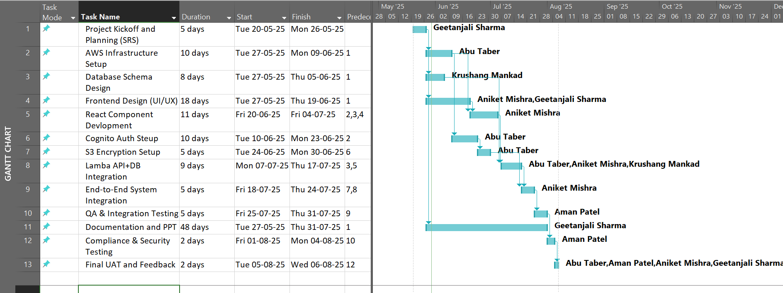

1. **Diagrams**

7.1 System Architecture

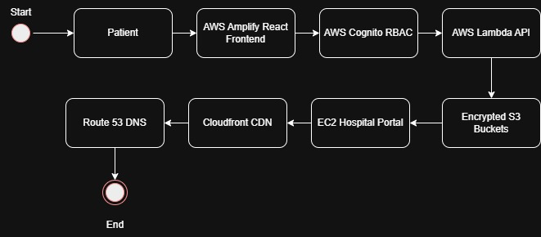

*Figure 1: System Architecture Design*

* 1. Data Flow

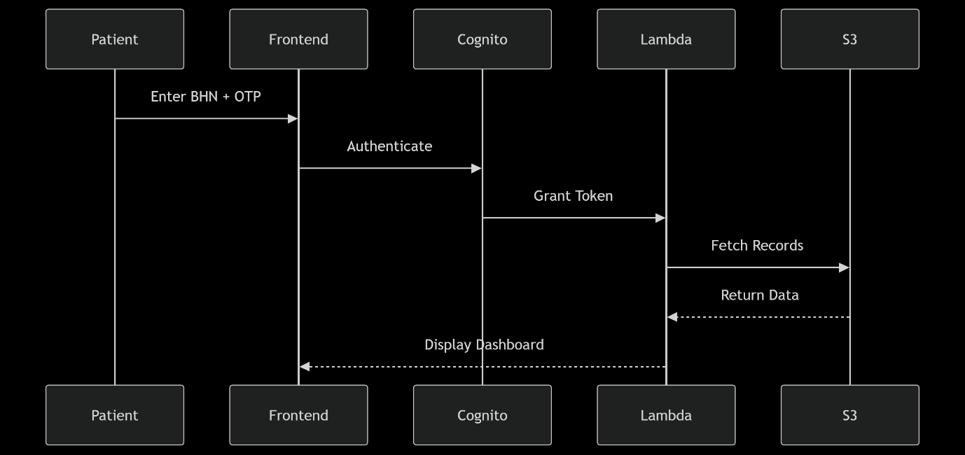

*Figure 2: Data Flow Diagram*

1. **Sources and References**

•Canadian Institute for Health Information (CIHI). (2021). Emergency Room Wait Times & Health Data Fragmentation.

•Canadian Health Policy Institute. (2020). Costs of Redundant Testing in Public Health Systems.

• Office of the Privacy Commissioner of Canada. (2023). Annual Health Privacy Breach Report.

•Globe and Mail. (2021). Patchwork Nation: The State of Health IT in Canada.

•Canadian Journal of Public Health. (2022). Digital Health Equity and Rural Care Gaps.

•NIST Healthcare Cybersecurity Framework. (2022). Canada HIPAA & PIPEDA Alignment Review.