Matlab homework 1

B11901003方嘉麟

(a)

1.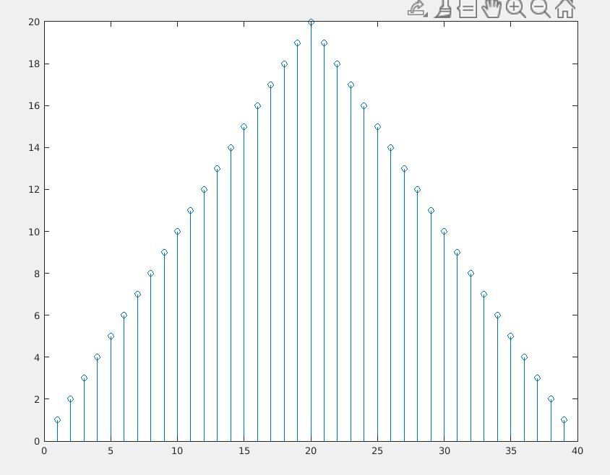2.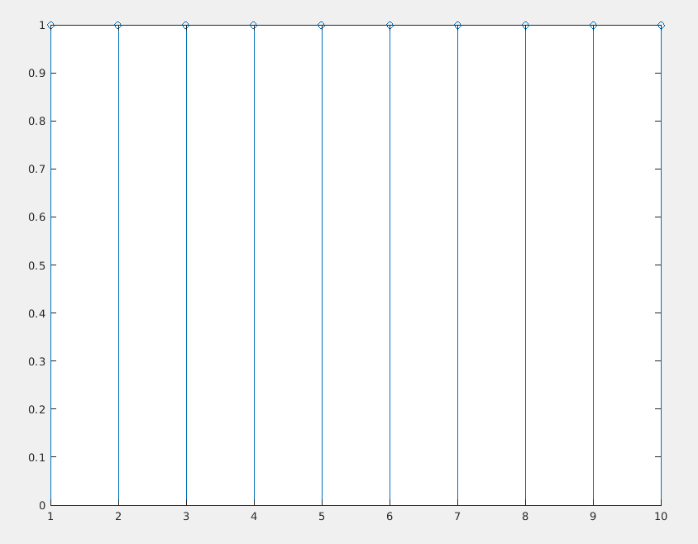

(b)

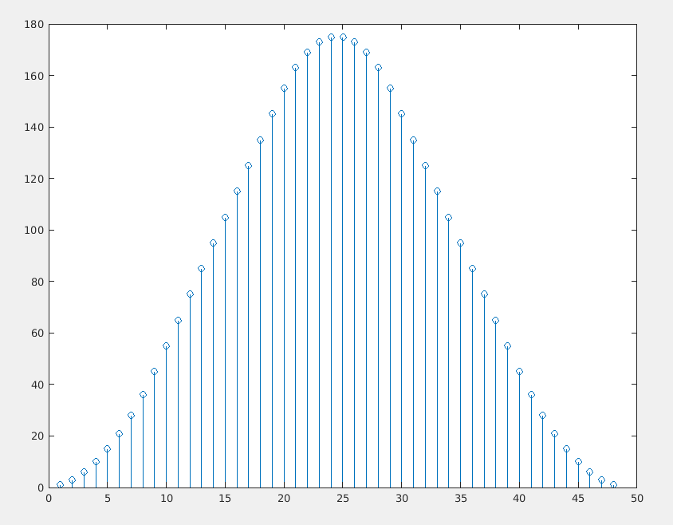

(c)



The answer is the same as using “conv” directly.

Because what the matrix did is summing the x1[i] \* x2[j] and store in y[i+j].

(d)

1.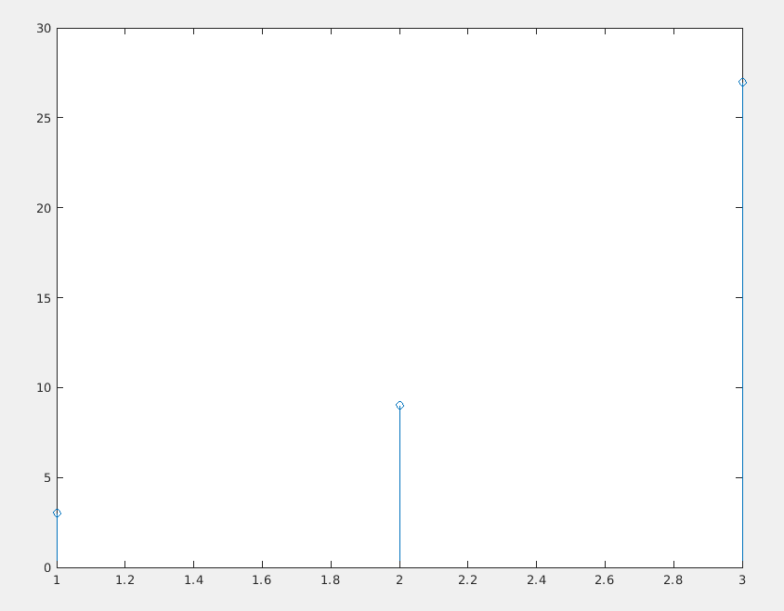2.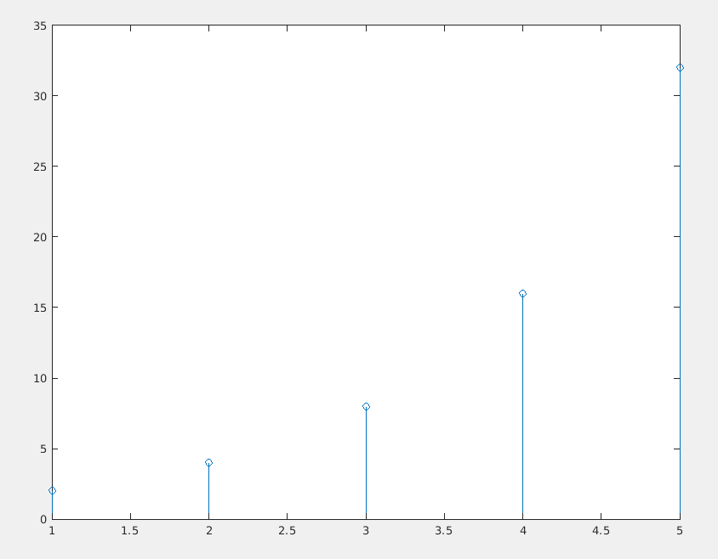

3.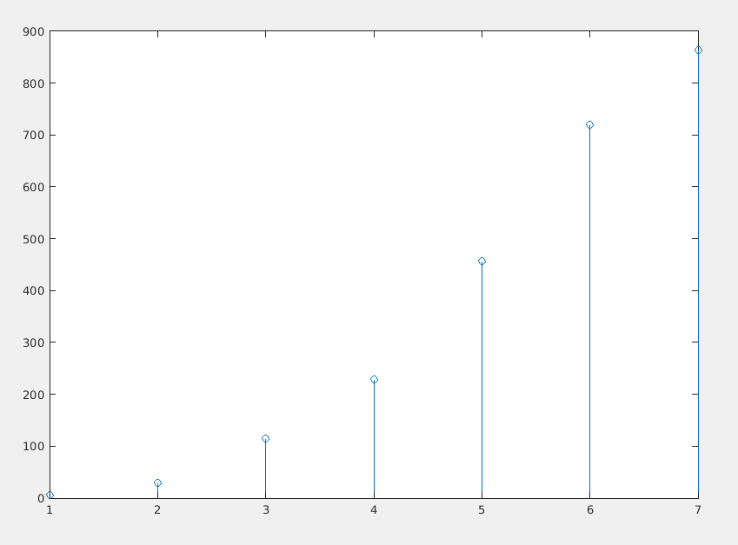4.

3 and 4 are the same.

Because the matrix summed the x1[i] \* x2[j] and store in y[i+j]. i.e. what the matrix did is just convoluting x1 and x2.