Matlab homework 4

B11901003方嘉麟

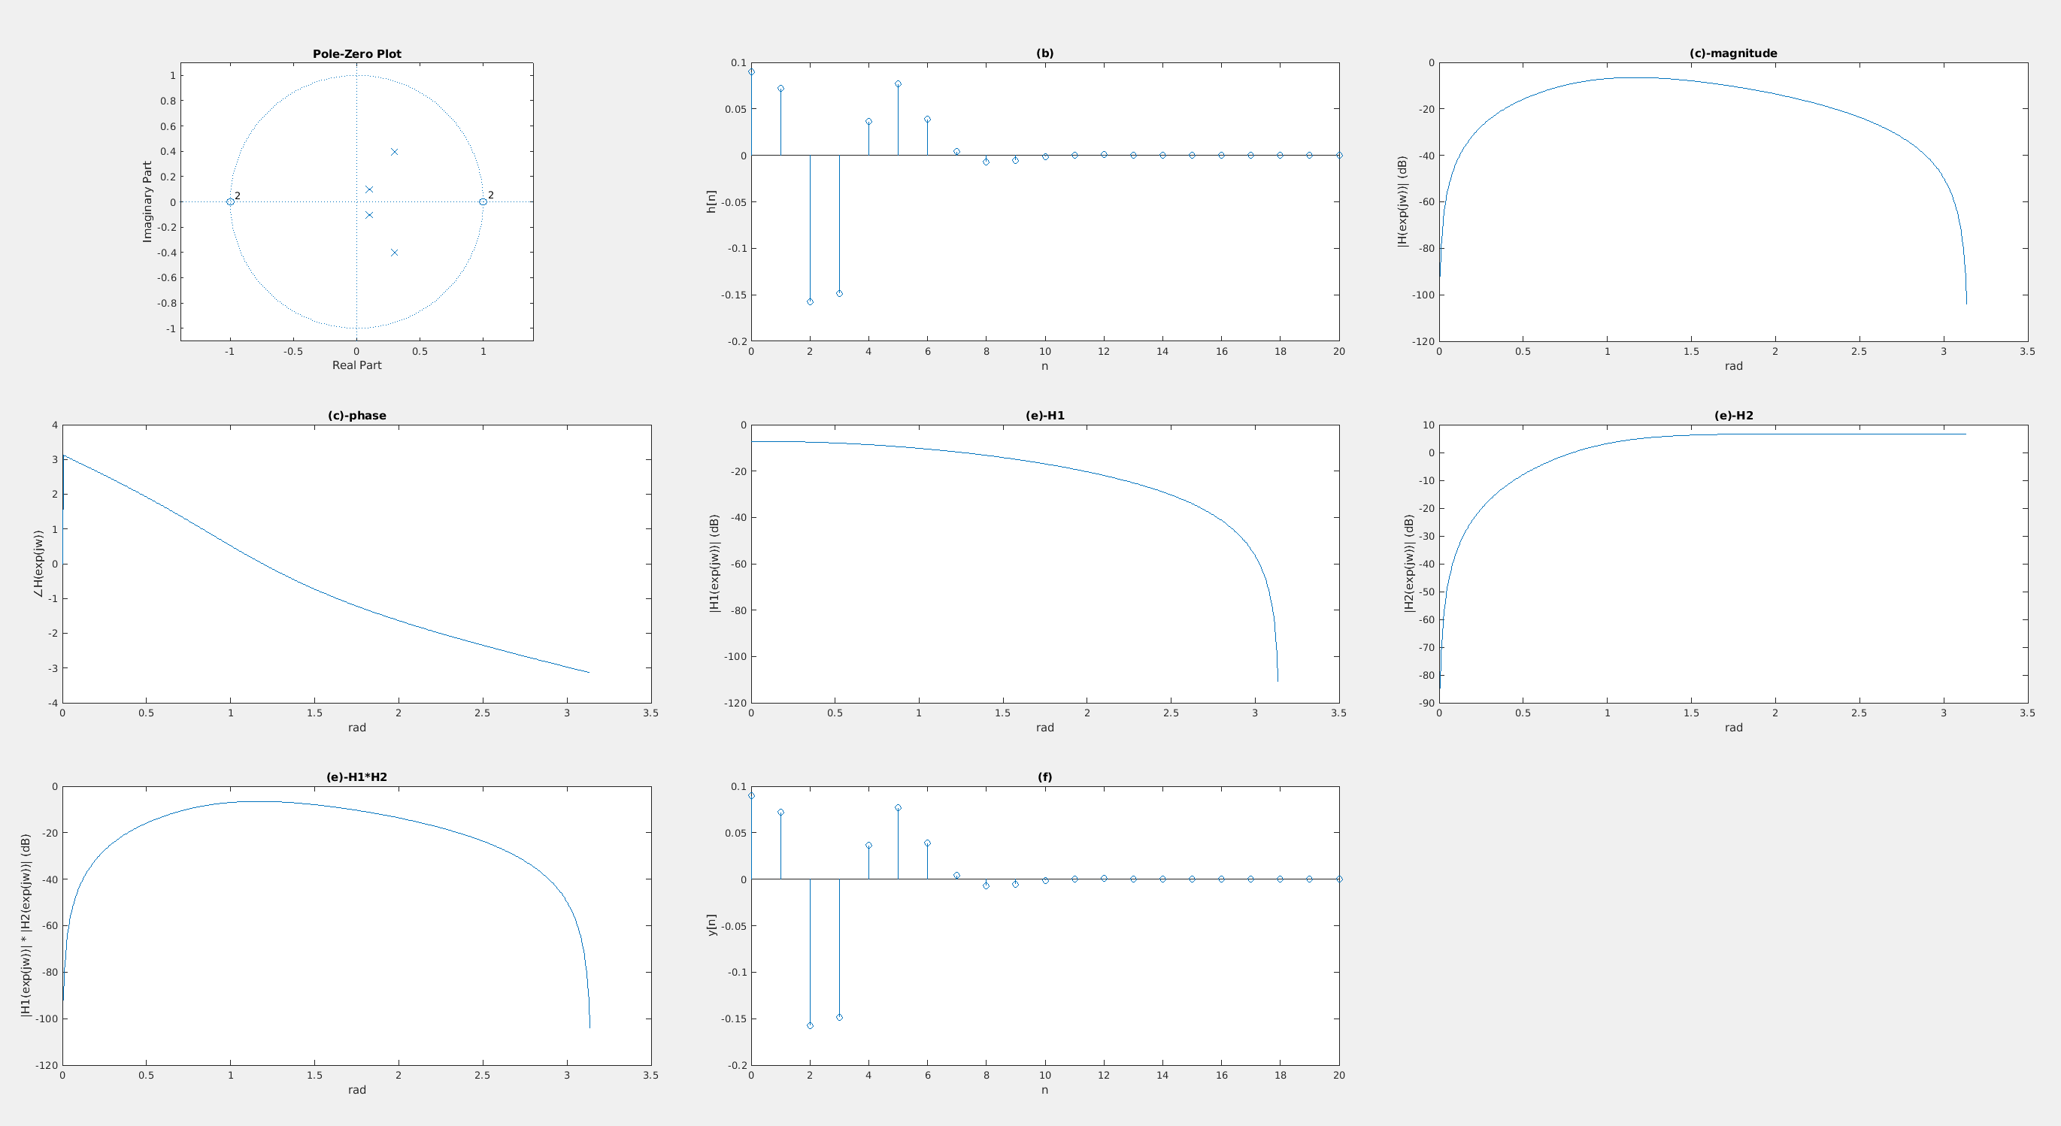

(a) $\left|z\right|>\frac{1}{2}$ (because of causality)

(d) $H\left(z\right)= \frac{0.09+0.18z^{-1}+0.09z^{-2}}{1-0.2z^{-1}+0.02z^{-2}}×\frac{1-2z^{-1}+z^{-2}}{1-0.6z^{-1}+0.25z^{-2}}$

(e) I check this by Matlab in line 76 (all(abs(h1) .\* abs(h2) - abs(h) < 1e-12)), and the result is true, so the results of (c)-magnitude and (e)-H1\*H2 are almost the same.

(f) I check this by Matlab in line 86 (all(y - hb < 1e-12)), and the result is true, so the results of (b) and (f) are almost the same.