The arm used in this report was #10.

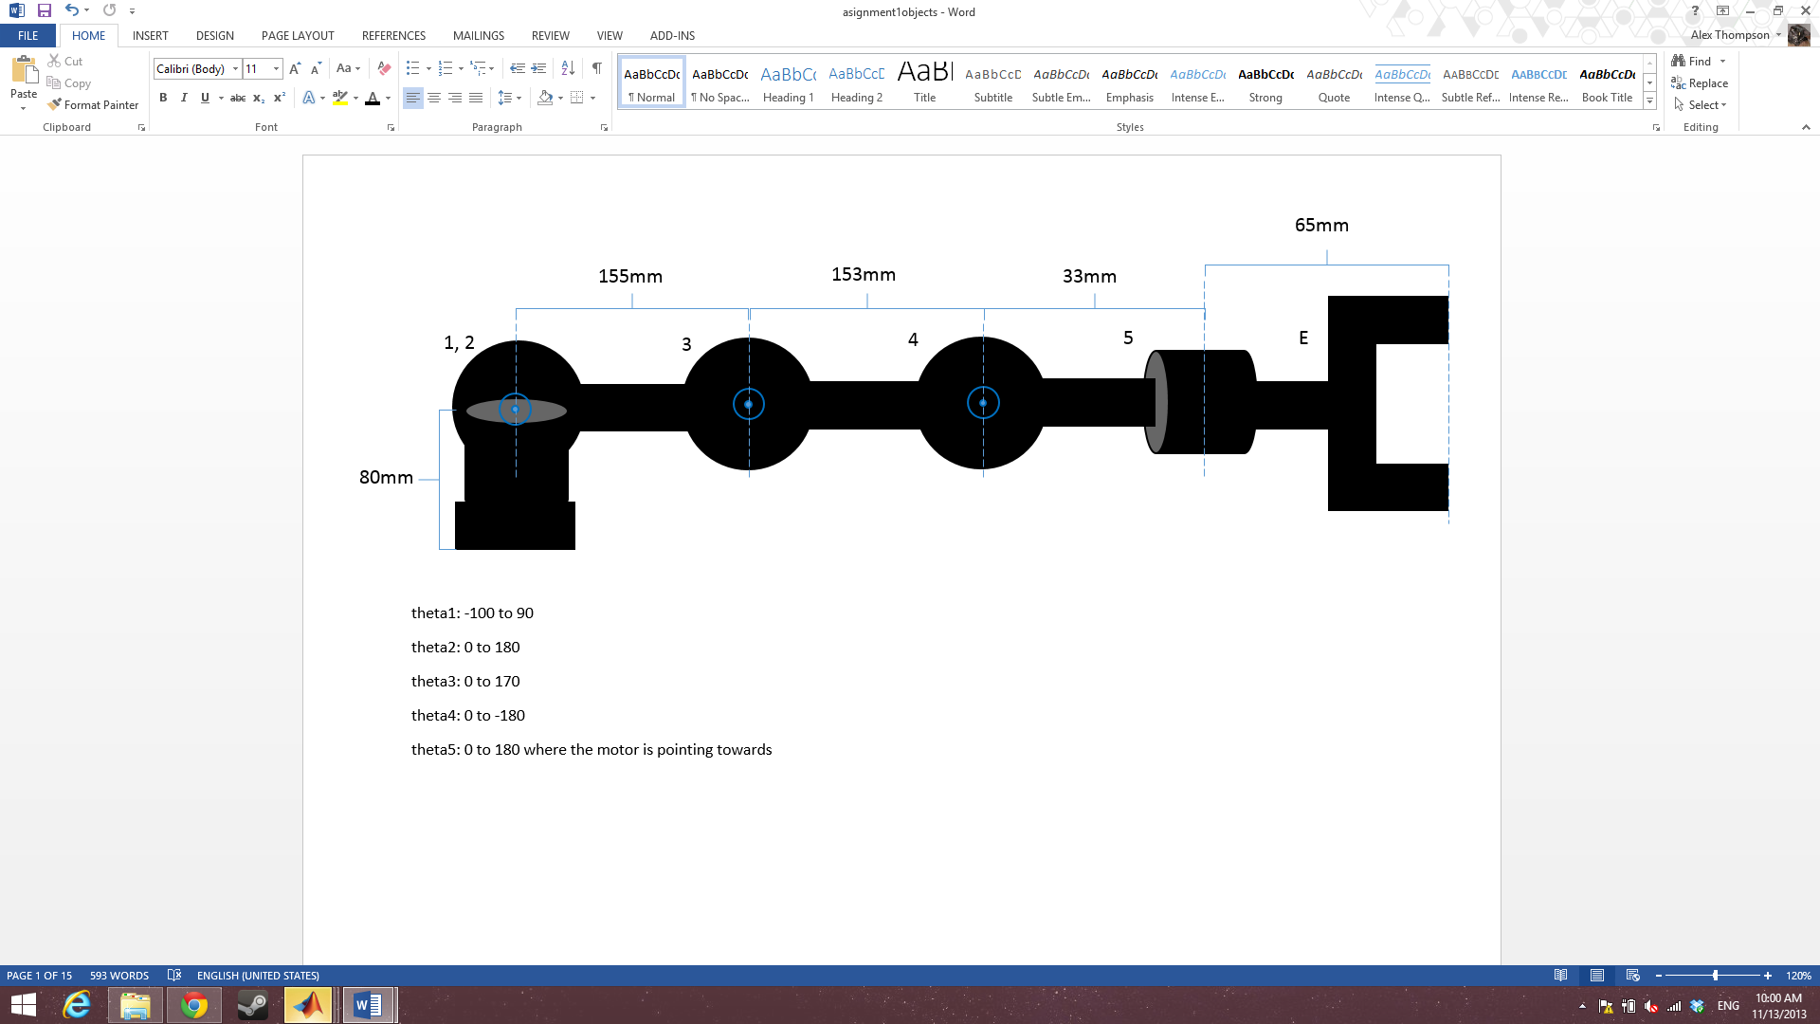

|  |  |
| --- | --- |
| **part** | **length** |
| base to shoulder | 85mm |
| shoulder to elbow | 93mm |
| elbow to wrist | 108mm |
| wrist to rotator | 33mm |
| rotator to beginning of end effector claw | 37mm |
| rotator to end of end effector claw | 65mm |

|  |  |
| --- | --- |
| joint | **rotation limitations** |
|  | -105 to 100 |
|  | 0 to 140 |
|  | 0 to -160 |
|  | -110 to 70 |
|  | -100 to 100 |

servo min: 500

servo max: 2500