# The *las* and *rhl* Quorum Sensing Systems in *Pseudomonas aeruginosa* Form a Multi-Signal Reciprocal Network Which Can Tune Reactivity to Variations in Physical and Social Environments

## Supporting Information

### Structured Literature Search

The PubMed database of the US National Institutes of Health was queried on 20 July 2021 using the query [PubMed Search ("review"[Title/Abstract] OR "review"[Publication Type]) AND "quorum sensing"[Title] AND "pseudomonas aeruginosa"[Title/Abstract]](https://pubmed.ncbi.nlm.nih.gov/?term=%28%22review%22%5BTitle%2FAbstract%5D+OR+%22review%22%5BPublication+Type%5D%29+AND+%22quorum+sensing%22%5BTitle%5D+AND+%22pseudomonas+aeruginosa%22%5BTitle%2FAbstract%5D&sort=), resulting in 76 results with publication dates from 1996 to 2021. Papers that incluced a daigram of the gene transcription networks for the *las* and *rhl* quorum sensing systems were further analyzed to show the interactions present on those diagrams. Tables S.1 and S.2 show the results. Of the papers analyzed, all show the *las* system positively activating the *rhl* system, and none show the *rhl* system postively activating the *las* system.

| Paper | PMID | →*lasI* | →*lasR* | →*rhlI* | →*rhlR* | →elastase |
| --- | --- | --- | --- | --- | --- | --- |
| (García-Reyes, Soberón-Chávez, and Cocotl-Yanez 2020) | [31794380](https://pubmed.ncbi.nlm.nih.gov/31794380/) | ● | ○ | ● | ● | ● |
| (Rutherford and Bassler 2012) | [23125205](https://pubmed.ncbi.nlm.nih.gov/23125205/) | ● | ○ | ● | ● |  |
| (Proctor, McCarron, and Ternan 2020) | [31971503](https://pubmed.ncbi.nlm.nih.gov/31971503/) | ● | ○ | ○ | ● |  |
| (Jakobsen et al. 2013) | [23841636](https://pubmed.ncbi.nlm.nih.gov/23841636/) | ● | ○ | ● | ● |  |
| (Soukarieh et al. 2018) | [29999316](https://pubmed.ncbi.nlm.nih.gov/29999316/) | ● | ● | ● | ● |  |
| (Tateda 2005) | [15926474](https://pubmed.ncbi.nlm.nih.gov/15926474/) | ● | ○ | ● | ○ | ● |
| (Williams et al. 2007) | [19249239](https://pubmed.ncbi.nlm.nih.gov/19249239/) | ○ | ○ | ● | ● |  |
| (Heurlier, Dénervaud, and Haas 2006) | [16503417](https://pubmed.ncbi.nlm.nih.gov/16503417/) | ● | ○ | ● | ○ |  |
| (Le Berre et al. 2006) | [16631332](https://pubmed.ncbi.nlm.nih.gov/16631332/) | ○ | ○ | ● | ● |  |
| (Juhas, Eberl, and Tümmler 2005) | [15816912](https://pubmed.ncbi.nlm.nih.gov/15816912/) | ● | ● | ● | ● | ● |
| (Donabedian 2003) | [12799145](https://pubmed.ncbi.nlm.nih.gov/12799145/) | ● | ○ | ● | ● | ● |
| (Reuter, Steinbach, and Helms 2016) | [26819549](https://pubmed.ncbi.nlm.nih.gov/26819549/) | ● | ○ | ○ | ● | ● |
| (Yong and Zhong 2013) | [22767136](https://pubmed.ncbi.nlm.nih.gov/22767136/) | ● | ○ | ● | ● | ● |
| (Welsh and Blackwell 2016) | [27268906](https://pubmed.ncbi.nlm.nih.gov/27268906/) |  |  | ● | ● | ● |
| (De Sordi and Mühlschlegel 2009) | [19845041](https://pubmed.ncbi.nlm.nih.gov/19845041/) | ● | ○ | ● | ○ |  |
| (Winzer and Williams 2001) | [11437336](https://pubmed.ncbi.nlm.nih.gov/11437336/) | ● | ○ | ○ | ● | ● |
| (Schuster et al. 2013) | [23682605](https://pubmed.ncbi.nlm.nih.gov/23682605/) | ● | ○ | ● | ● |  |
| (Papaioannou, Utari, and Quax 2013) | [24065108](https://pubmed.ncbi.nlm.nih.gov/24065108/) | ● | ● | ○ | ● | ● |
| (Roy, Adams, and Bentley 2011) | [22112397](https://pubmed.ncbi.nlm.nih.gov/22112397/) | ● | ○ | ● | ● |  |

**Table S.1.** Activation of QS genes by LasR/3‑oxo‑C12‑HSL in review of published literature. Solid dots indicate positive activation in the paper’s diagram of gene transcription, while hollow dots indicate that the diagram shows no effect. No diagrams indicated repression. Note that some papers made no attempt to indicate particular interactions; several, for example, concentrated strictly on the QS genes themselves and did not show the effect on downstream genes such as those for elastase.

| Paper | PMID | →*lasI* | →*lasR* | →*rhlI* | →*rhlR* | →elastase |
| --- | --- | --- | --- | --- | --- | --- |
| (García-Reyes, Soberón-Chávez, and Cocotl-Yanez 2020) | [31794380](https://pubmed.ncbi.nlm.nih.gov/31794380/) | ○ | ○ | ○ | ○ | ● |
| (Rutherford and Bassler 2012) | [23125205](https://pubmed.ncbi.nlm.nih.gov/23125205/) | ○ | ○ | ● | ○ |  |
| (Proctor, McCarron, and Ternan 2020) | [31971503](https://pubmed.ncbi.nlm.nih.gov/31971503/) | ○ | ○ | ● | ○ |  |
| (Jakobsen et al. 2013) | [23841636](https://pubmed.ncbi.nlm.nih.gov/23841636/) | ○ | ○ | ● | ○ |  |
| (Soukarieh et al. 2018) | [29999316](https://pubmed.ncbi.nlm.nih.gov/29999316/) | ○ | ○ | ○ | ○ |  |
| (Tateda 2005) | [15926474](https://pubmed.ncbi.nlm.nih.gov/15926474/) | ○ | ○ | ● | ○ | ● |
| (Williams et al. 2007) | [19249239](https://pubmed.ncbi.nlm.nih.gov/19249239/) | ○ | ○ | ○ | ○ |  |
| (Heurlier, Dénervaud, and Haas 2006) | [16503417](https://pubmed.ncbi.nlm.nih.gov/16503417/) | ○ | ○ | ● | ○ |  |
| (Le Berre et al. 2006) | [16631332](https://pubmed.ncbi.nlm.nih.gov/16631332/) | ○ | ○ | ○ | ○ |  |
| (Juhas, Eberl, and Tümmler 2005) | [15816912](https://pubmed.ncbi.nlm.nih.gov/15816912/) | ○ | ○ | ● | ● | ● |
| (Donabedian 2003) | [12799145](https://pubmed.ncbi.nlm.nih.gov/12799145/) | ○ | ○ | ○ | ○ | ● |
| (Reuter, Steinbach, and Helms 2016) | [26819549](https://pubmed.ncbi.nlm.nih.gov/26819549/) | ○ | ○ | ○ | ○ | ● |
| (Yong and Zhong 2013) | [22767136](https://pubmed.ncbi.nlm.nih.gov/22767136/) | ○ | ○ | ● | ○ | ● |
| (Welsh and Blackwell 2016) | [27268906](https://pubmed.ncbi.nlm.nih.gov/27268906/) | ○ | ○ |  |  | ○ |
| (De Sordi and Mühlschlegel 2009) | [19845041](https://pubmed.ncbi.nlm.nih.gov/19845041/) | ○ | ○ | ● | ○ |  |
| (Winzer and Williams 2001) | [11437336](https://pubmed.ncbi.nlm.nih.gov/11437336/) | ○ | ○ | ● | ○ | ● |
| (Schuster et al. 2013) | [23682605](https://pubmed.ncbi.nlm.nih.gov/23682605/) | ○ | ○ | ● | ○ |  |
| (Papaioannou, Utari, and Quax 2013) | [24065108](https://pubmed.ncbi.nlm.nih.gov/24065108/) | ○ | ○ | ● | ○ | ● |
| (Roy, Adams, and Bentley 2011) | [22112397](https://pubmed.ncbi.nlm.nih.gov/22112397/) | ○ | ○ | ○ | ○ |  |

**Table S.2.** Activation of QS genes by RhlR/C4‑HSL in review of published literature. Same notation as previous table.

### Data Analysis

Gene expression data for *lasI,* *rhlI,* and *lasB* was collected every hour for a 24-hour period. Observations used for analysis were limited to a two-hour window that contained the peak expression level for each gene. Figures S.1, S.2, and S.3 show the full time course of expression levels and highlight the intervals used for analysis. Those windows were 8–10 hours, 3–5 hours, and 4–6 hours for *lasI,* *rhlI,* and *lasB,* respectively.

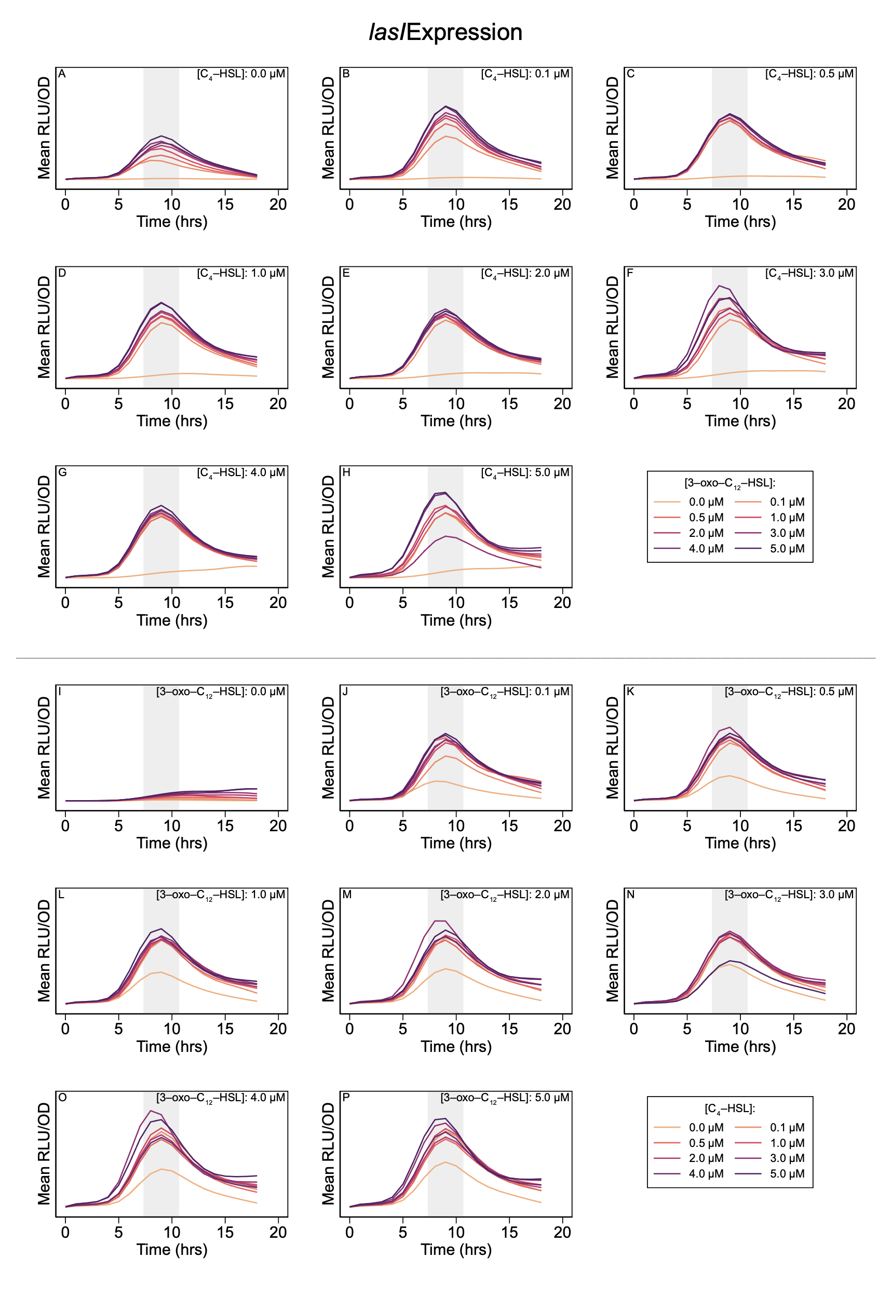

**Figure S.1. Expression level of lasI over time course of experiment.** Shaded regions highlight peak expression and indicate two-hour period used in analysis.

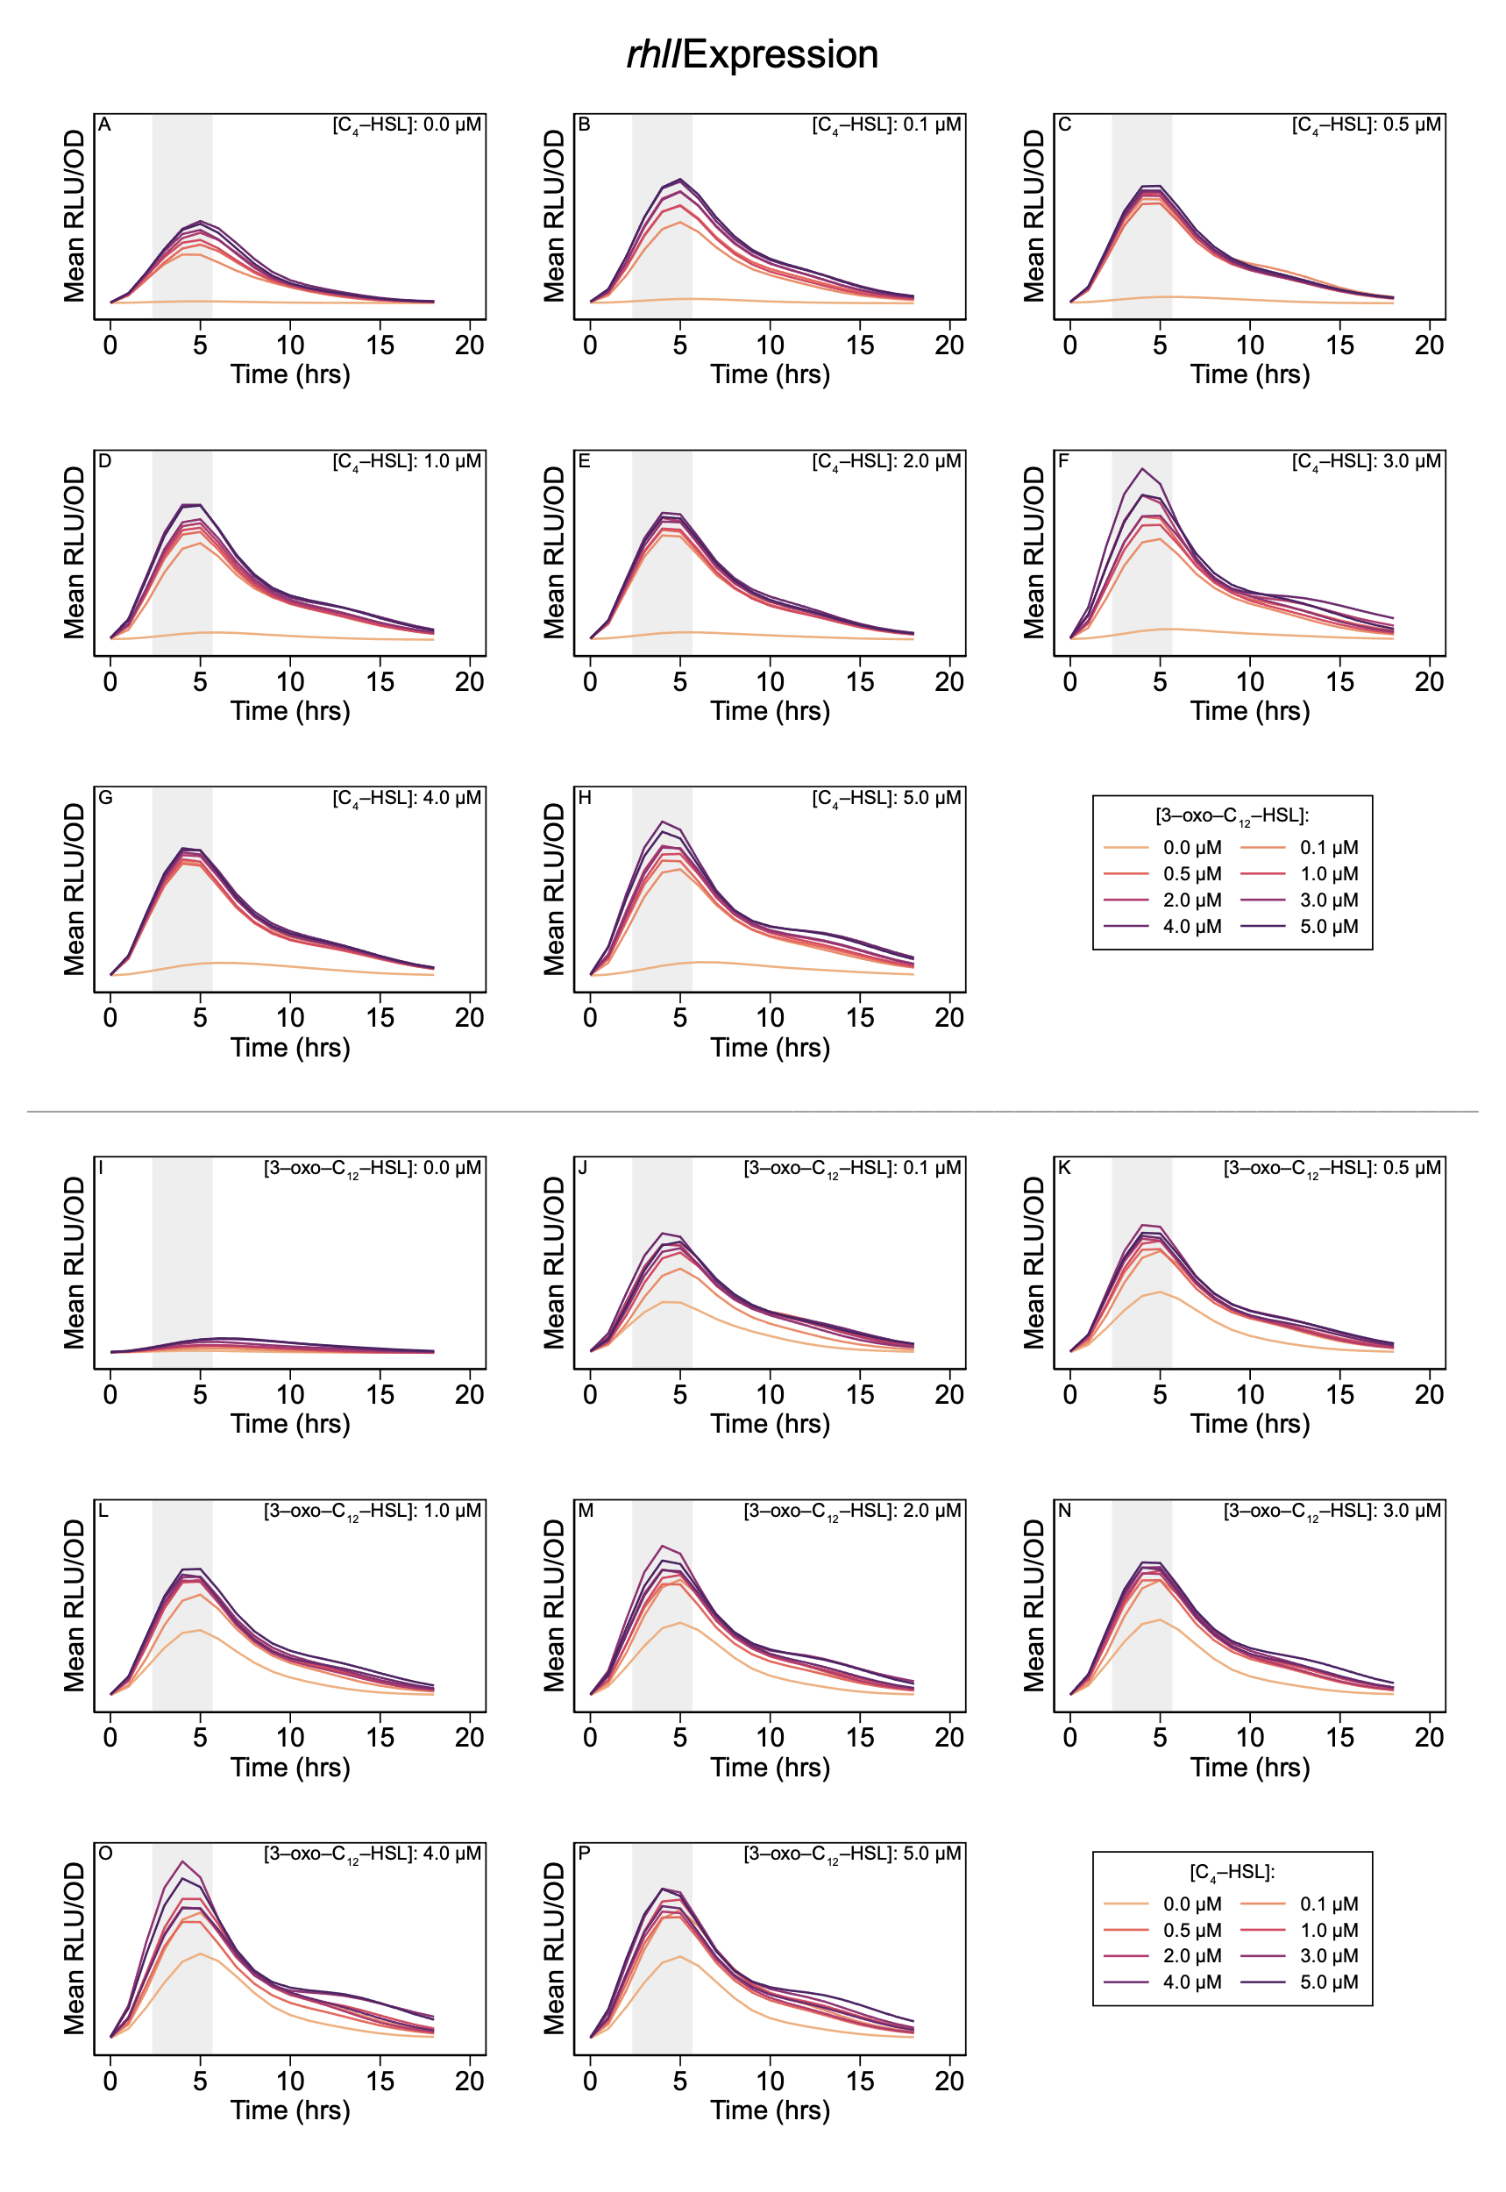

**Figure S.2. Expression level of rhlI over time course of experiment.** Shaded regions highlight peak expression and indicate two-hour period used in analysis.

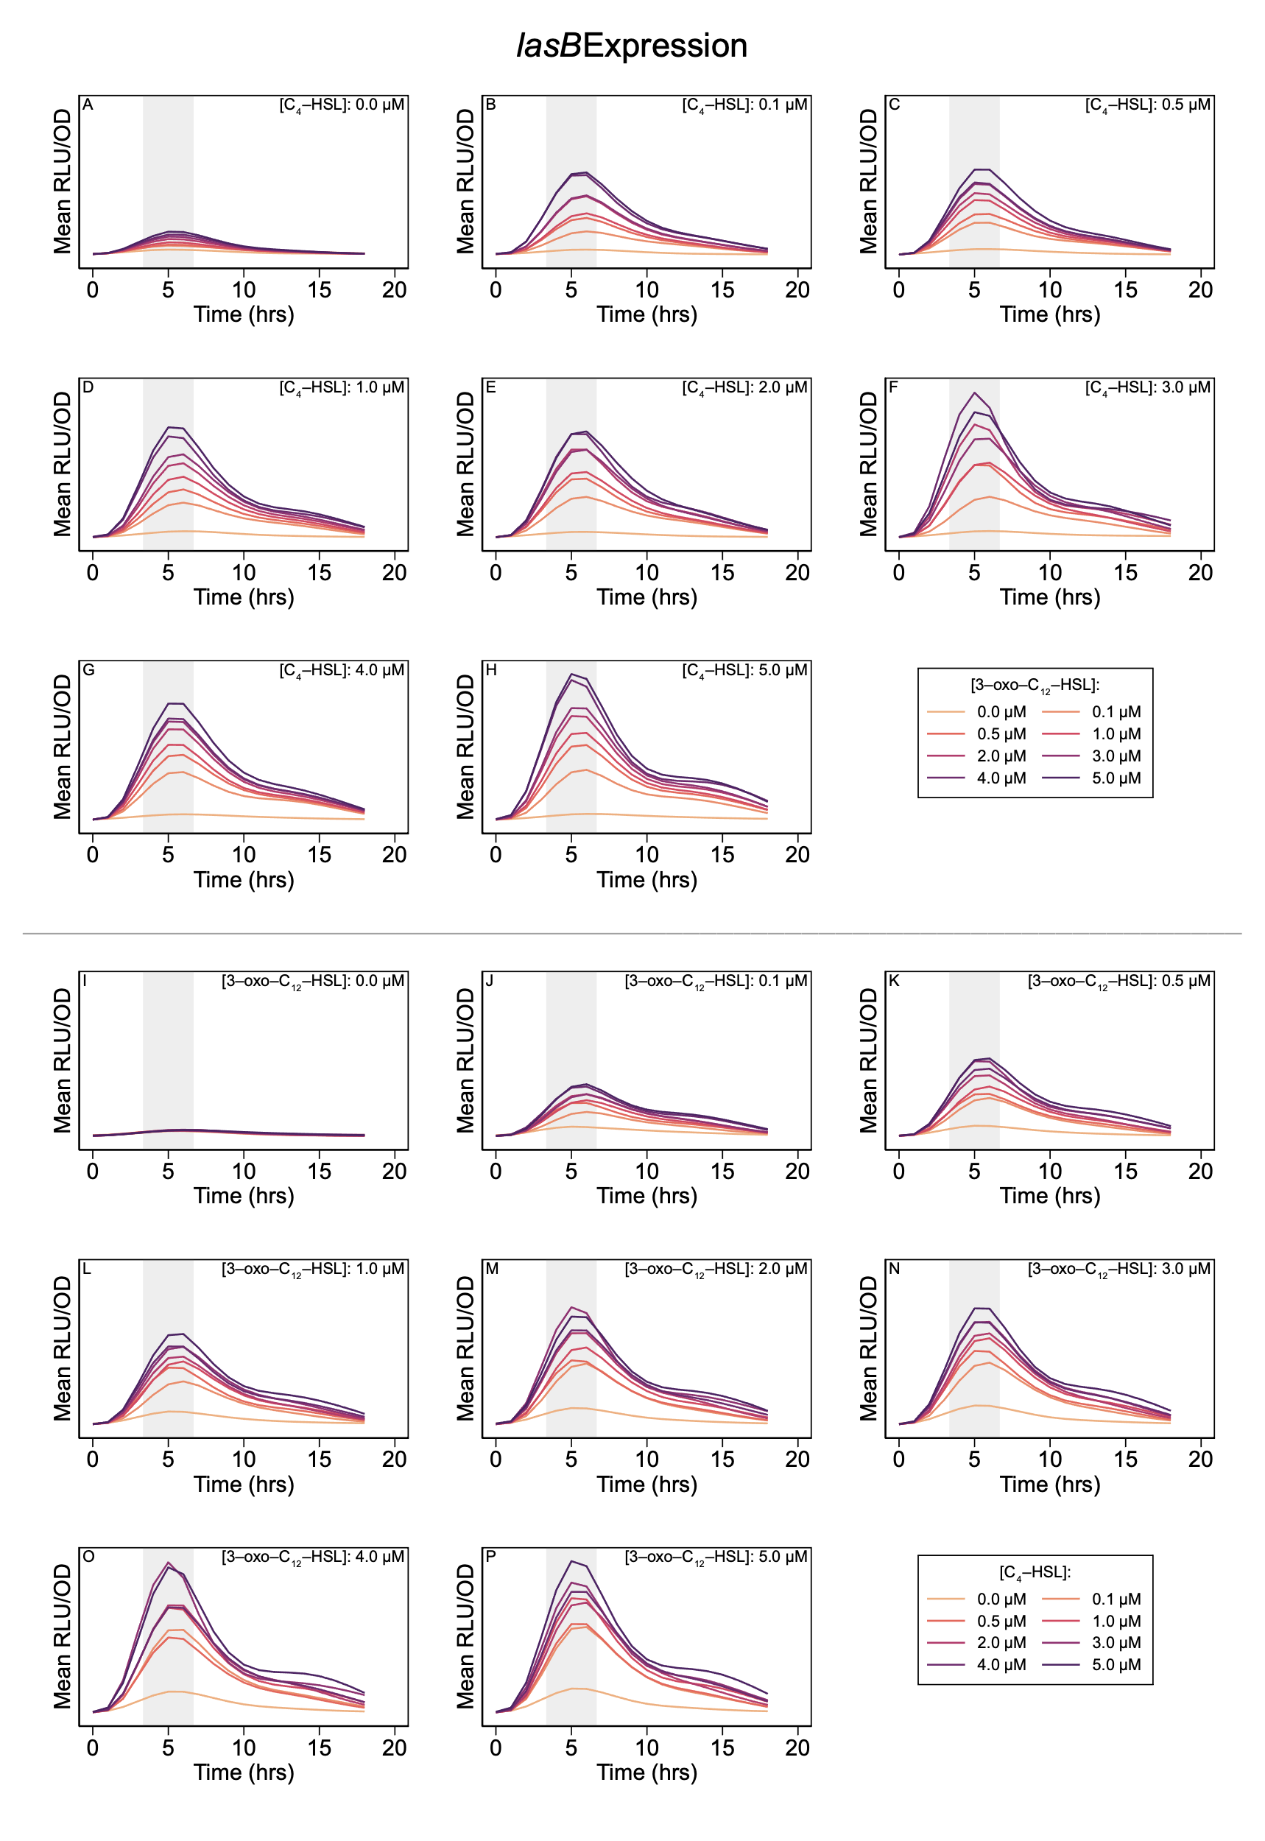

**Figure S.3. Expression level of lasB over time course of experiment.** Shaded regions highlight peak expression and indicate two-hour period used in analysis.

## References

De Sordi, L, and FA Mühlschlegel. 2009. “Quorum Sensing and Fungal-Bacterial Interactions in *Candida Albicans:* A Communicative Network Regulating Microbial Coexistence and Virulence.” *FEMS Yeast Res* 9 (7): 990–99.

Donabedian, H. 2003. “Quorum Sensing and Its Relevance to Infectious Diseases.” *J Infect* 46 (4): 207–14.

García-Reyes, S, G Soberón-Chávez, and M Cocotl-Yanez. 2020. “The Third Quorum-Sensing System of *Pseudomonas Aeruginosa:* Pseudomonas Quinolone Signal and the Enigmatic PqsE Protein.” *J Med Microbiol* 69 (1): 25–34.

Heurlier, K, V Dénervaud, and D Haas. 2006. “Impact of Quorum Sensing on Fitness of *Pseudomonas Aeruginosa.*” *Int J Med Microbiol* 296 (2-3): 93–102.

Jakobsen, TH, T Bjarnsholt, PØ Jensen, M Givskov, and N Høiby. 2013. “Targeting Quorum Sensing in *Pseudomonas Aeruginosa* Biofilms: Current and Emerging Inhibitors.” *Future Microbiol* 8 (7): 901–21.

Juhas, M, L Eberl, and B Tümmler. 2005. “Quorum Sensing: The Power of Cooperation in the World of *Pseudomonas.*” *Environ Microbiol* 7 (4): 459–71.

Le Berre, R, K Faure, S Nguyen, M Pierre, F Ader, and B Guery. 2006. “[Quorum Sensing: A New Clinical Target for *Pseudomonas Aeruginosa*?].” *Med Mal Infect* 36 (7): 349–57.

Papaioannou, E, PD Utari, and WJ Quax. 2013. “Choosing an Appropriate Infection Model to Study Quorum Sensing Inhibition in *Pseudomonas* Infections.” *Int J Mol Sci* 14 (9): 19309–40.

Proctor, CR, PA McCarron, and NG Ternan. 2020. “Furanone Quorum-Sensing Inhibitors with Potential as Novel Therapeutics Against *Pseudomonas Aeruginosa.*” *J Med Microbiol* 69 (2): 195–206.

Reuter, K, A Steinbach, and V Helms. 2016. “Interfering with Bacterial Quorum Sensing.” *Perspect Medicin Chem* 8: 1–15.

Roy, V, BL Adams, and WE Bentley. 2011. “Developing Next Generation Antimicrobials by Intercepting AI-2 Mediated Quorum Sensing.” *Enzyme Microb Technol* 49 (2): 113–23.

Rutherford, ST, and BL Bassler. 2012. “Bacterial Quorum Sensing: Its Role in Virulence and Possibilities for Its Control.” *Cold Spring Harb Perspect Med* 2 (11): a012427.

Schuster, M, DJ Sexton, SP Diggle, and EP Greenberg. 2013. “Acyl-Homoserine Lactone Quorum Sensing: From Evolution to Application.” *Annu Rev Microbiol* 67: 43–63.

Soukarieh, F, P Williams, MJ Stocks, and M Cámara. 2018. “*Pseudomonas Aeruginosa* Quorum Sensing Systems as Drug Discovery Targets: Current Position and Future Perspectives.” *J Med Chem* 61 (23): 10385–402.

Tateda, K. 2005. “[*Pseudomonas Aeruginosa* Infection and the Quorum-Sensing Mechanism].” *Nihon Naika Gakkai Zasshi* 94 (5): 999–1004.

Welsh, MA, and HE Blackwell. 2016. “Chemical Probes of Quorum Sensing: From Compound Development to Biological Discovery.” *FEMS Microbiol Rev* 40 (5): 774–94.

Williams, P, K Winzer, WC Chan, and M Cámara. 2007. “Look Who’s Talking: Communication and Quorum Sensing in the Bacterial World.” *Philos Trans R Soc Lond B Biol Sci* 362 (1483): 1119–34.

Winzer, K, and P Williams. 2001. “Quorum Sensing and the Regulation of Virulence Gene Expression in Pathogenic Bacteria.” *Int J Med Microbiol* 291 (2): 131–43.

Yong, YC, and JJ Zhong. 2013. “Impacts of Quorum Sensing on Microbial Metabolism and Human Health.” *Adv Biochem Eng Biotechnol* 131: 25–61.