- CustomerApiApplication.java:
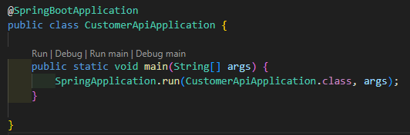
  - Bootstraps Spring Boot application.
  - Scans components, entities, repositories and starts embedded server.
  - Delegates runtime lifecycle to Spring context.
- CustomerServiceImpl.java:
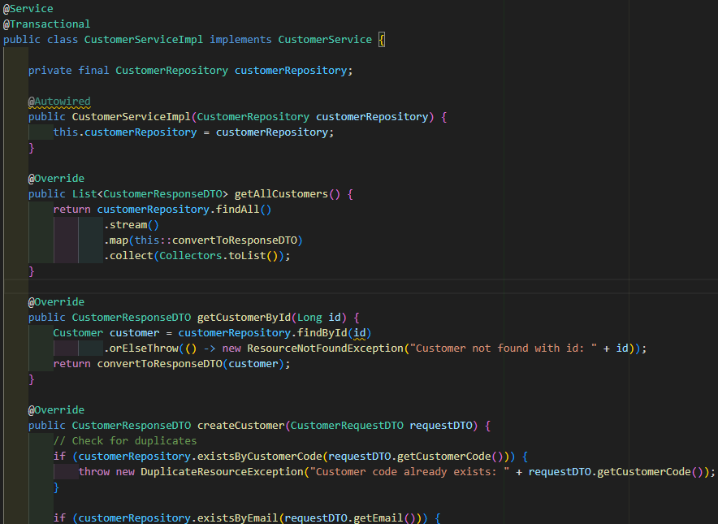
  - Implements CustomerService and contains business logic for CRUD, search, filtering, pagination and sorting.
  - Validates duplicates (customerCode, email) and throws domain exceptions.
  - Converts between DTOs and Customer entity for persistence and responses.
  - Uses repository for DB operations and applies transactional boundaries.
  - Implements partial update logic with uniqueness checks.
- CustomerService.java (interface):
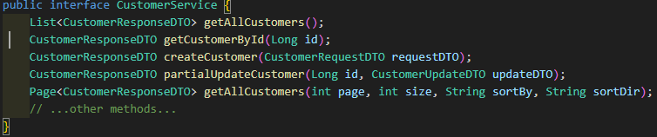
  - Declares service API: list, get, create, update, partial update, delete, search, filtering and pagination.
  - Serves as contract for service implementations.
- CustomerRepository.java:
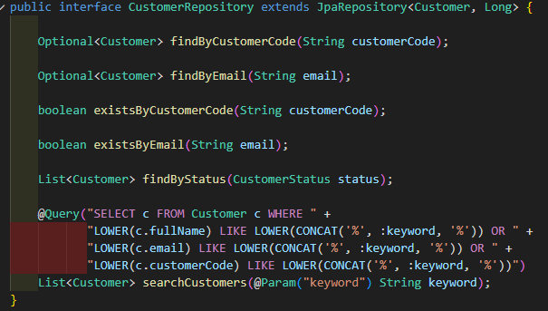
  - Extends JpaRepository to provide CRUD and pageable DB access for Customer.
  - Declares finder methods (by code, email, status) and existence checks.
  - Provides a JPQL @Query searchCustomers for keyword searching across fields.
- ResourceNotFoundException.java:
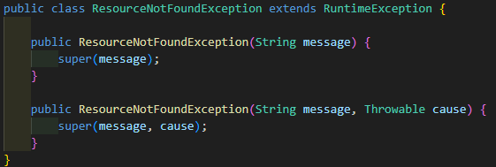
  - Custom RuntimeException used when a requested resource is missing (maps to 404 in handlers).
- DuplicateResourceException.java:
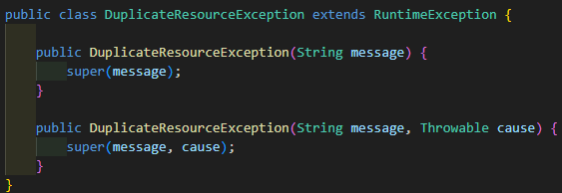
  - Custom RuntimeException thrown when a unique constraint would be violated (maps to 409 in handlers).
- GlobalExceptionHandler.java:
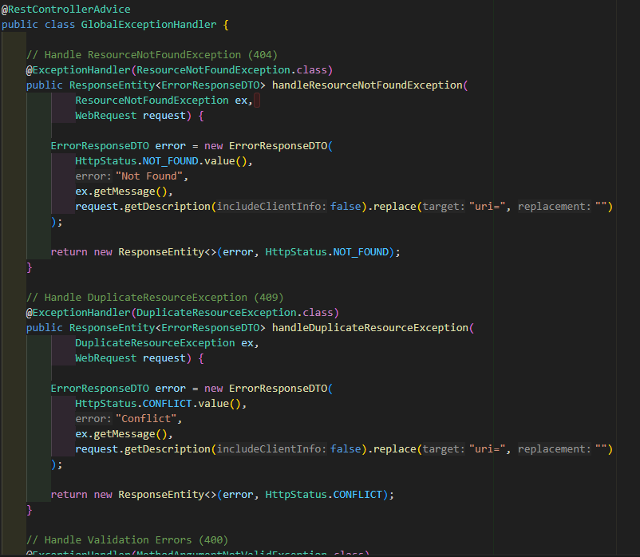
  - Catches domain and framework exceptions across controllers (@RestControllerAdvice).
  - Maps exceptions to ErrorResponseDTO with appropriate HTTP status: 404, 409, 400 and 500.
  - Aggregates validation field errors into details for 400 responses.
- CustomerStatus.java (enum):
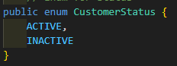
  - Defines allowed customer states: ACTIVE and INACTIVE.
  - Used by entity, repository and service filtering/validation.
- Customer.java (entity):
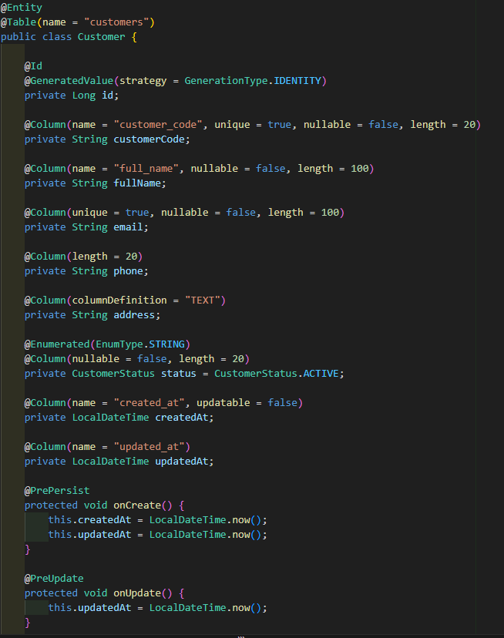
  - JPA entity mapping customers table with fields (id, code, name, email, phone, address, status, timestamps).
  - Enforces unique/nullable constraints at column level.
  - Maintains createdAt/updatedAt via @PrePersist/@PreUpdate lifecycle callbacks.
- ErrorResponseDTO.java:
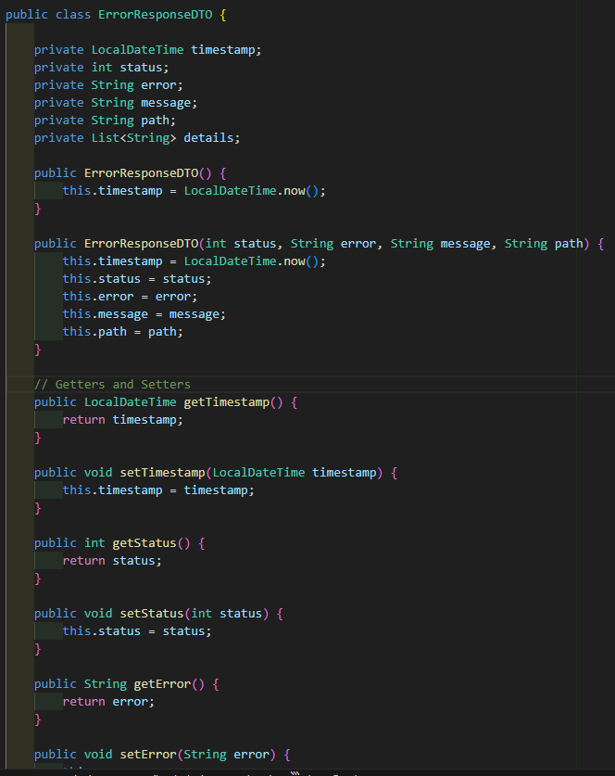
  - DTO used by GlobalExceptionHandler to return structured error responses.
  - Contains timestamp, status, error, message, path and optional details list.
- CustomerUpdateDTO.java:
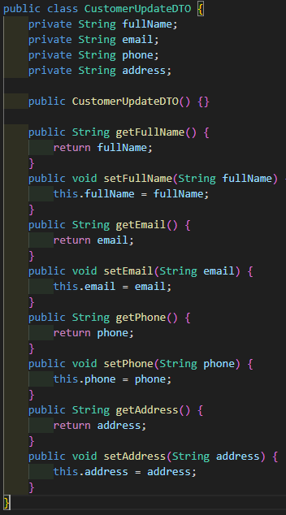
  - Lightweight DTO for PATCH partial updates; fields are optional.
  - Passed to service.partialUpdateCustomer to update only supplied fields.
- CustomerResponseDTO.java:
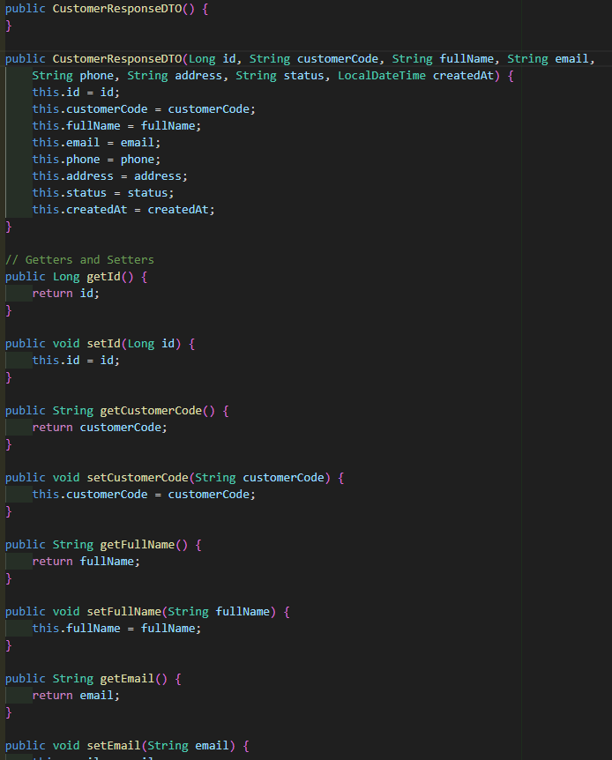
  - DTO returned to clients for read operations.
  - Exposes id, customerCode, fullName, email, phone, address, status and createdAt.
- CustomerRequestDTO.java:
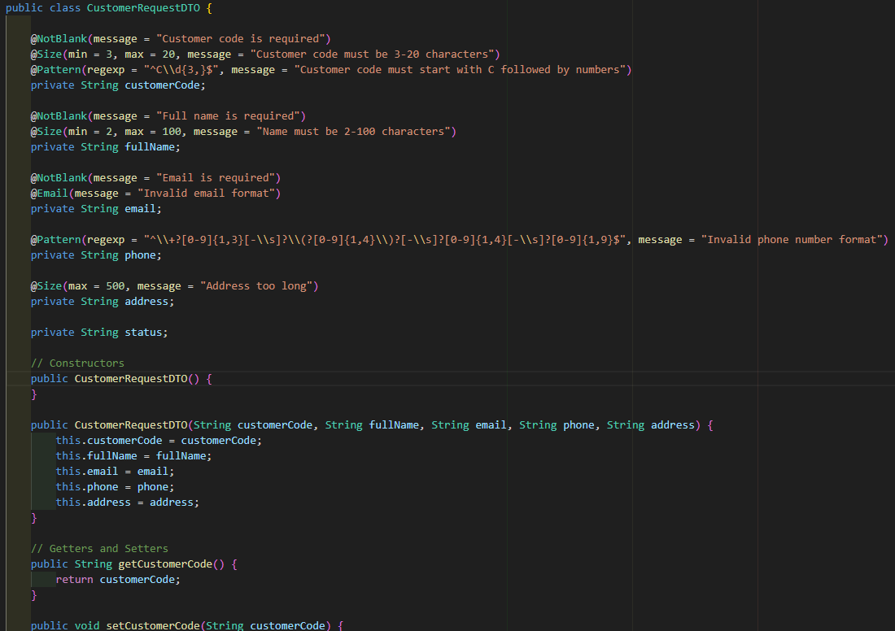
  - DTO used for create (and full update) requests with validation annotations (@NotBlank, @Email, @Pattern, @Size).
  - Carries customerCode, fullName, email, phone, address and optional status.
- CustomerRestController.java:
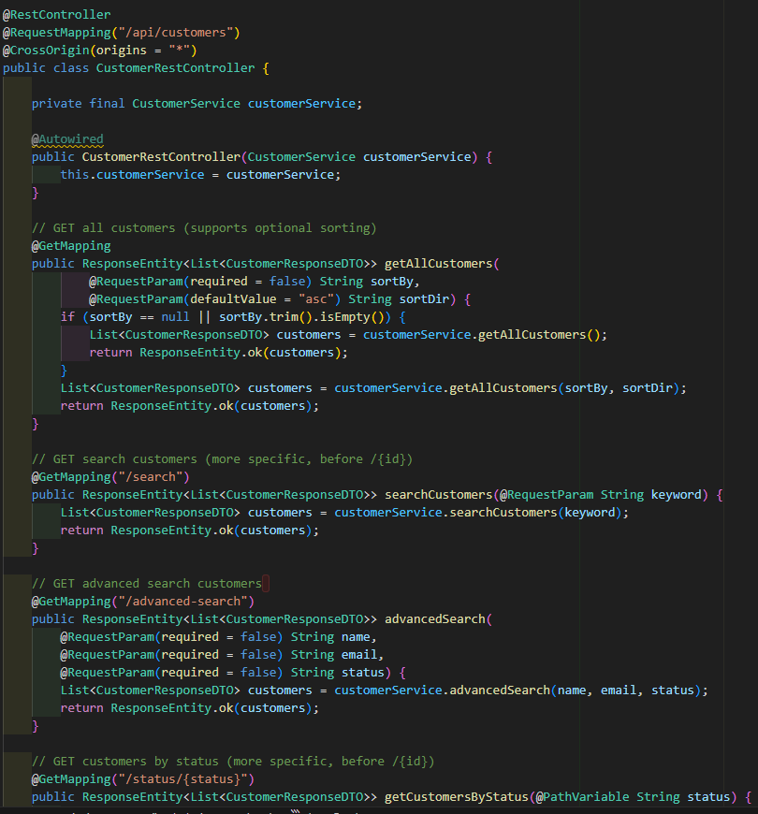
  - Exposes REST endpoints under /api/customers for list/search/filter/page/get/create/update/patch/delete.
  - Validates incoming DTOs (@Valid), delegates to CustomerService, and returns appropriate ResponseEntity payloads and statuses.
  - Orders specific routes (search/status/page) before the generic /{id} path to avoid routing conflicts.

