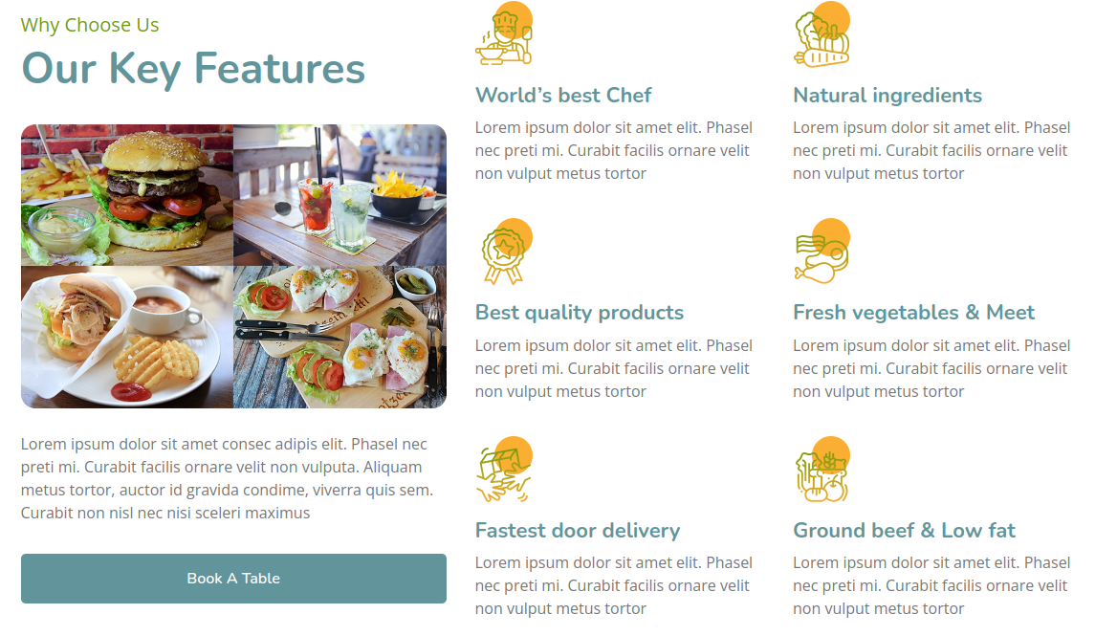
<!-- Feature Start -->
<div class="feature">
<div class="container">
<div class="row">
<div class="col-lg-5">
<div class="section-header">
<p>Why Choose Us</p>
<h2>Our Key Features</h2>
</div>
<div class="feature-text">
<div class="feature-img">
<div class="row">
<div class="col-6">
<img src="img/feature-1.jpg" alt="Image">
</div>
<div class="col-6">
<img src="img/feature-2.jpg" alt="Image">
</div>
<div class="col-6">
<img src="img/feature-3.jpg" alt="Image">
</div>
<div class="col-6">
<img src="img/feature-4.jpg" alt="Image">
</div>
</div>
</div>
<p>
Lorem ipsum dolor sit amet consec adipis elit. Phasel nec preti mi. Curabit facilis ornare velit non vulputa. Aliquam metus tortor, auctor id gravida condime, viverra quis sem. Curabit non nisl nec nisi sceleri maximus
</p>
<a class="btn custom-btn" href="">Book A Table</a>
</div>
</div>
<div class="col-lg-7">
<div class="row">
<div class="col-sm-6">
<div class="feature-item">
<i class="flaticon-cooking"></i>
<h3>World’s best Chef</h3>
<p>
Lorem ipsum dolor sit amet elit. Phasel nec preti mi. Curabit facilis ornare velit non vulput metus tortor
</p>
</div>
</div>
<div class="col-sm-6">
<div class="feature-item">
<i class="flaticon-vegetable"></i>
<h3>Natural ingredients</h3>
<p>
Lorem ipsum dolor sit amet elit. Phasel nec preti mi. Curabit facilis ornare velit non vulput metus tortor
</p>
</div>
</div>
</div>
<div class="row">
<div class="col-sm-6">
<div class="feature-item">
<i class="flaticon-medal"></i>
<h3>Best quality products</h3>
<p>
Lorem ipsum dolor sit amet elit. Phasel nec preti mi. Curabit facilis ornare velit non vulput metus tortor
</p>
</div>
</div>
<div class="col-sm-6">
<div class="feature-item">
<i class="flaticon-meat"></i>
<h3>Fresh vegetables & Meet</h3>
<p>
Lorem ipsum dolor sit amet elit. Phasel nec preti mi. Curabit facilis ornare velit non vulput metus tortor
</p>
</div>
</div>
</div>
<div class="row">
<div class="col-sm-6">
<div class="feature-item">
<i class="flaticon-courier"></i>
<h3>Fastest door delivery</h3>
<p>
Lorem ipsum dolor sit amet elit. Phasel nec preti mi. Curabit facilis ornare velit non vulput metus tortor
</p>
</div>
</div>
<div class="col-sm-6">
<div class="feature-item">
<i class="flaticon-fruits-and-vegetables"></i>
<h3>Ground beef & Low fat</h3>
<p>
Lorem ipsum dolor sit amet elit. Phasel nec preti mi. Curabit facilis ornare velit non vulput metus tortor
</p>
</div>
</div>
</div>
</div>
</div>
</div>
</div>
<!-- Feature End -->

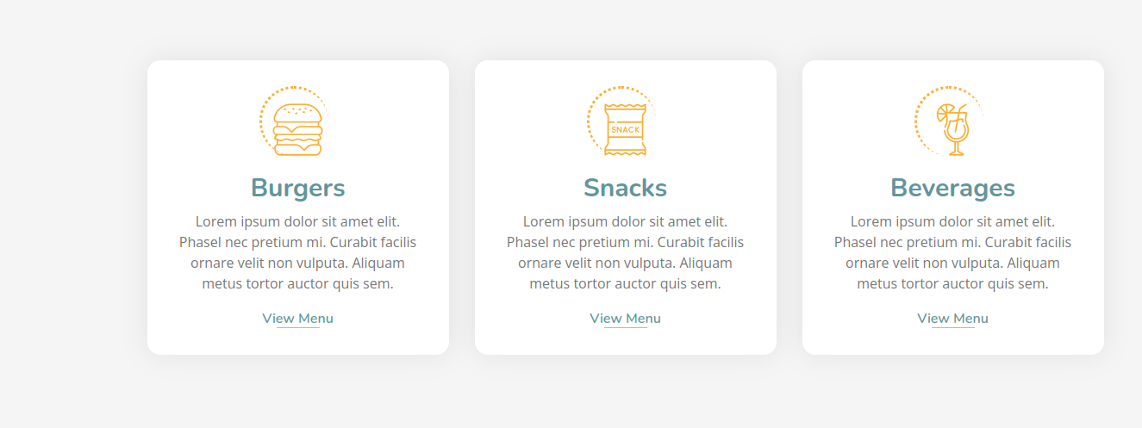

<!-- Food Start -->
<div class="food">
<div class="container">
<div class="row align-items-center">
<div class="col-md-4">
<div class="food-item">
<i class="flaticon-burger"></i>
<h2>Burgers</h2>
<p>
Lorem ipsum dolor sit amet elit. Phasel nec pretium mi. Curabit facilis ornare velit non vulputa. Aliquam metus tortor auctor quis sem.
</p>
<a href="">View Menu</a>
</div>
</div>
<div class="col-md-4">
<div class="food-item">
<i class="flaticon-snack"></i>
<h2>Snacks</h2>
<p>
Lorem ipsum dolor sit amet elit. Phasel nec pretium mi. Curabit facilis ornare velit non vulputa. Aliquam metus tortor auctor quis sem.
</p>
<a href="">View Menu</a>
</div>
</div>
<div class="col-md-4">
<div class="food-item">
<i class="flaticon-cocktail"></i>
<h2>Beverages</h2>
<p>
Lorem ipsum dolor sit amet elit. Phasel nec pretium mi. Curabit facilis ornare velit non vulputa. Aliquam metus tortor auctor quis sem.
</p>
<a href="">View Menu</a>
</div>
</div>
</div>
</div>
</div>
<!-- Food End -->

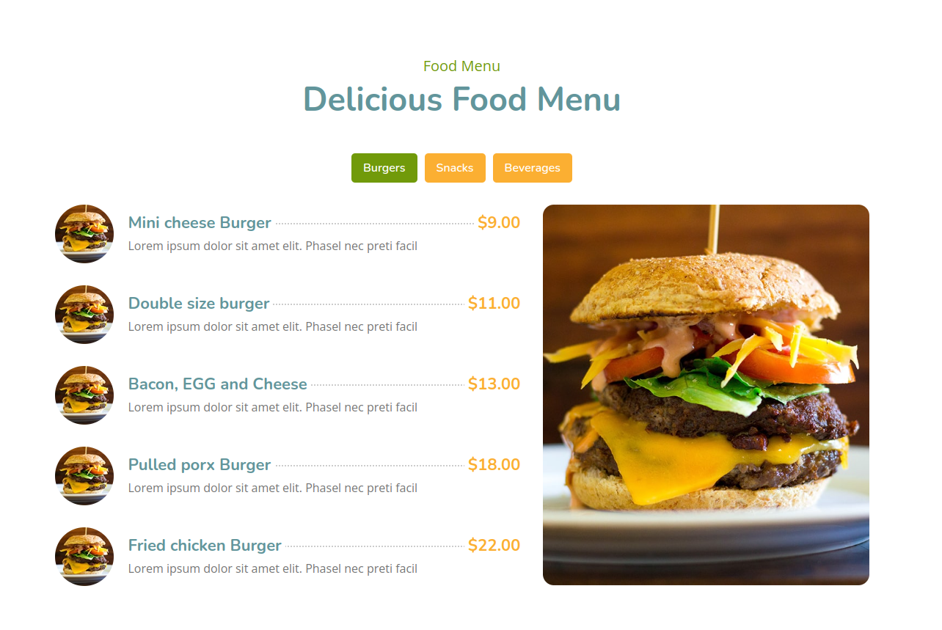

<!-- Menu Start -->
<div class="menu">
<div class="container">
<div class="section-header text-center">
<p>Food Menu</p>
<h2>Delicious Food Menu</h2>
</div>
<div class="menu-tab">
<ul class="nav nav-pills justify-content-center">
<li class="nav-item">
<a class="nav-link active" data-toggle="pill" href="#burgers">Burgers</a>
</li>
<li class="nav-item">
<a class="nav-link" data-toggle="pill" href="#snacks">Snacks</a>
</li>
<li class="nav-item">
<a class="nav-link" data-toggle="pill" href="#beverages">Beverages</a>
</li>
</ul>
<div class="tab-content">
<div id="burgers" class="container tab-pane active">
<div class="row">
<div class="col-lg-7 col-md-12">
<div class="menu-item">
<div class="menu-img">
<img src="img/menu-burger.jpg" alt="Image">
</div>
<div class="menu-text">
<h3><span>Mini cheese Burger</span> <strong>$9.00</strong></h3>
<p>Lorem ipsum dolor sit amet elit. Phasel nec preti facil</p>
</div>
</div>
<div class="menu-item">
<div class="menu-img">
<img src="img/menu-burger.jpg" alt="Image">
</div>
<div class="menu-text">
<h3><span>Double size burger</span> <strong>$11.00</strong></h3>
<p>Lorem ipsum dolor sit amet elit. Phasel nec preti facil</p>
</div>
</div>
<div class="menu-item">
<div class="menu-img">
<img src="img/menu-burger.jpg" alt="Image">
</div>
<div class="menu-text">
<h3><span>Bacon, EGG and Cheese</span> <strong>$13.00</strong></h3>
<p>Lorem ipsum dolor sit amet elit. Phasel nec preti facil</p>
</div>
</div>
<div class="menu-item">
<div class="menu-img">
<img src="img/menu-burger.jpg" alt="Image">
</div>
<div class="menu-text">
<h3><span>Pulled porx Burger</span> <strong>$18.00</strong></h3>
<p>Lorem ipsum dolor sit amet elit. Phasel nec preti facil</p>
</div>
</div>
<div class="menu-item">
<div class="menu-img">
<img src="img/menu-burger.jpg" alt="Image">
</div>
<div class="menu-text">
<h3><span>Fried chicken Burger</span> <strong>$22.00</strong></h3>
<p>Lorem ipsum dolor sit amet elit. Phasel nec preti facil</p>
</div>
</div>
</div>
<div class="col-lg-5 d-none d-lg-block">
<img src="img/menu-burger-img.jpg" alt="Image">
</div>
</div>
</div>
<div id="snacks" class="container tab-pane fade">
<div class="row">
<div class="col-lg-7 col-md-12">
<div class="menu-item">
<div class="menu-img">
<img src="img/menu-snack.jpg" alt="Image">
</div>
<div class="menu-text">
<h3><span>Corn Tikki - Spicy fried Aloo</span> <strong>$15.00</strong></h3>
<p>Lorem ipsum dolor sit amet elit. Phasel nec preti facil</p>
</div>
</div>
<div class="menu-item">
<div class="menu-img">
<img src="img/menu-snack.jpg" alt="Image">
</div>
<div class="menu-text">
<h3><span>Bread besan Toast</span> <strong>$35.00</strong></h3>
<p>Lorem ipsum dolor sit amet elit. Phasel nec preti facil</p>
</div>
</div>
<div class="menu-item">
<div class="menu-img">
<img src="img/menu-snack.jpg" alt="Image">
</div>
<div class="menu-text">
<h3><span>Healthy soya nugget snacks</span> <strong>$20.00</strong></h3>
<p>Lorem ipsum dolor sit amet elit. Phasel nec preti facil</p>
</div>
</div>
<div class="menu-item">
<div class="menu-img">
<img src="img/menu-snack.jpg" alt="Image">
</div>
<div class="menu-text">
<h3><span>Tandoori Soya Chunks</span> <strong>$30.00</strong></h3>
<p>Lorem ipsum dolor sit amet elit. Phasel nec preti facil</p>
</div>
</div>
</div>
<div class="col-lg-5 d-none d-lg-block">
<img src="img/menu-snack-img.jpg" alt="Image">
</div>
</div>
</div>
<div id="beverages" class="container tab-pane fade">
<div class="row">
<div class="col-lg-7 col-md-12">
<div class="menu-item">
<div class="menu-img">
<img src="img/menu-beverage.jpg" alt="Image">
</div>
<div class="menu-text">
<h3><span>Single Cup Brew</span> <strong>$7.00</strong></h3>
<p>Lorem ipsum dolor sit amet elit. Phasel nec preti facil</p>
</div>
</div>
<div class="menu-item">
<div class="menu-img">
<img src="img/menu-beverage.jpg" alt="Image">
</div>
<div class="menu-text">
<h3><span>Caffe Americano</span> <strong>$9.00</strong></h3>
<p>Lorem ipsum dolor sit amet elit. Phasel nec preti facil</p>
</div>
</div>
<div class="menu-item">
<div class="menu-img">
<img src="img/menu-beverage.jpg" alt="Image">
</div>
<div class="menu-text">
<h3><span>Caramel Macchiato</span> <strong>$15.00</strong></h3>
<p>Lorem ipsum dolor sit amet elit. Phasel nec preti facil</p>
</div>
</div>
<div class="menu-item">
<div class="menu-img">
<img src="img/menu-beverage.jpg" alt="Image">
</div>
<div class="menu-text">
<h3><span>Standard black coffee</span> <strong>$8.00</strong></h3>
<p>Lorem ipsum dolor sit amet elit. Phasel nec preti facil</p>
</div>
</div>
<div class="menu-item">
<div class="menu-img">
<img src="img/menu-beverage.jpg" alt="Image">
</div>
<div class="menu-text">
<h3><span>Standard black coffee</span> <strong>$12.00</strong></h3>
<p>Lorem ipsum dolor sit amet elit. Phasel nec preti facil</p>
</div>
</div>
</div>
<div class="col-lg-5 d-none d-lg-block">
<img src="img/menu-beverage-img.jpg" alt="Image">
</div>
</div>
</div>
</div>
</div>
</div>
</div>
<!-- Menu End -->

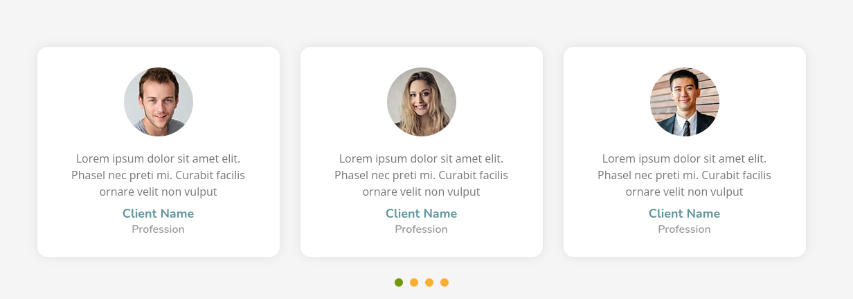

<!-- Testimonial Start -->
<div class="testimonial">
<div class="container">
<div class="owl-carousel testimonials-carousel">
<div class="testimonial-item">
<div class="testimonial-img">
<img src="img/testimonial-1.jpg" alt="Image">
</div>
<p>
Lorem ipsum dolor sit amet elit. Phasel nec preti mi. Curabit facilis ornare velit non vulput
</p>
<h2>Client Name</h2>
<h3>Profession</h3>
</div>
<div class="testimonial-item">
<div class="testimonial-img">
<img src="img/testimonial-2.jpg" alt="Image">
</div>
<p>
Lorem ipsum dolor sit amet elit. Phasel nec preti mi. Curabit facilis ornare velit non vulput
</p>
<h2>Client Name</h2>
<h3>Profession</h3>
</div>
<div class="testimonial-item">
<div class="testimonial-img">
<img src="img/testimonial-3.jpg" alt="Image">
</div>
<p>
Lorem ipsum dolor sit amet elit. Phasel nec preti mi. Curabit facilis ornare velit non vulput
</p>
<h2>Client Name</h2>
<h3>Profession</h3>
</div>
<div class="testimonial-item">
<div class="testimonial-img">
<img src="img/testimonial-4.jpg" alt="Image">
</div>
<p>
Lorem ipsum dolor sit amet elit. Phasel nec preti mi. Curabit facilis ornare velit non vulput
</p>
<h2>Client Name</h2>
<h3>Profession</h3>
</div>
</div>
</div>
</div>
<!-- Testimonial End -->

------------------- CSS --------------------------------
.testimonial {
position: relative;
width: 100%;
padding: 90px 0;
margin: 45px 0;
background: rgba(0, 0, 0, .04);
}

.portrait_home {
position: relative;
width: 100%;
padding: 90px 0;
margin: 45px 0;
position: relative;
width: calc(100% + 30px);
margin: 0 -15px;
}

.testimonial .testimonials-carousel {
position: relative;
width: calc(100% + 30px);
margin: 0 -15px;
}

.testimonial .testimonial-item {
position: relative;
margin: 15px;
padding: 30px;
display: flex;
align-items: center;
justify-content: center;
flex-direction: column;
background: #ffffff;
border-radius: 15px;
box-shadow: 0 0 15px rgba(0, 0, 0, .08);
transition: .3s;
overflow: hidden;
}

.testimonial .testimonial-item:hover {
box-shadow: none;
}

.testimonial .testimonial-img {
position: relative;
width: 100px;
border-radius: 100px;
margin-bottom: 20px;
overflow: hidden;
}

.testimonial .testimonial-img img {
width: 100%;
border-radius: 100px;
}

.testimonial .testimonial-item p {
text-align: center;
margin-bottom: 10px;
}

.testimonial .testimonial-item h2 {
position: relative;
font-size: 18px;
font-weight: 700;
margin-bottom: 2px;
}

.testimonial .testimonial-item h3 {
color: #999999;
font-size: 16px;
font-weight: 600;
margin: 0;
}

.testimonial .owl-dots {
margin-top: 10px;
text-align: center;
}

.testimonial .owl-dot {
display: inline-block;
margin: 0 5px;
width: 12px;
height: 12px;
border-radius: 50%;
background: #fbaf32;
}

.testimonial .owl-dot.active {
background: #719a0a;
}

