Thyroid Cancer Risk Analysis
Gabriela Bermudez, Joseph Healt, and Daylin Hernandez
IST-718 Big Data Analytics, Spring 2025

Introduction
Thyroid cancer has seen a significant increase in incidence rates over the past few decades. According to the American Cancer Society (2022), the incidence rate of thyroid cancer has nearly tripled in the United States since the 1970s, with papillary thyroid carcinoma being the most commonly diagnosed subtype. Globally, thyroid cancer trends vary, with higher prevalence in countries with increased medical surveillance and iodine fortification programs (Morris et al., 2016). Advances in diagnostic techniques, particularly ultrasonography and fine-needle aspiration biopsy, have contributed to the rising detection rates (Davies & Welch, 2014). However, debates persist regarding whether this increase is solely due to improved detection or if environmental and genetic factors are contributing to higher occurrences.
Thyroid function tests are crucial in assessing thyroid health and potential cancer risks. Thyroid-Stimulating Hormone (TSH) is a pituitary hormone that regulates thyroid function, and abnormal levels can indicate thyroid dysfunction. Triiodothyronine (T3) and Thyroxine (T4) are the primary thyroid hormones responsible for regulating metabolism, making their imbalances significant indicators of various thyroid disorders. Nodule size is also a key factor in thyroid cancer evaluation, as larger nodules (specifically those greater than 1 cm) often require further assessment for malignancy (Haugen et al., 2016). Understanding these markers is essential in determining thyroid cancer risk and guiding clinical decision-making.
Objective
The objective of this project is to analyze factors contributing to thyroid cancer risk using a dataset containing demographic, medical history, and thyroid function test results. By identifying key predictors, this study aims to build a predictive model for assessing an individual’s risk level for thyroid cancer.
Data Set Description
The original dataset contained 212,691 rows and 17 columns of medical records from multiple countries, providing a comprehensive set of demographic details, medical history, and thyroid function test results. During our initial data exploration, we identified that regional differences could significantly impact our findings. Consequently, we decided to focus solely on data from the United States to improve the relevance and applicability of our analysis. This filtered subset includes 10,558 records and 17 features.
Sample Predictors:
- Demographic Information: Age, Gender, Ethnicity
- Medical & Lifestyle Factors: Family History, Radiation Exposure, Iodine Deficiency, Smoking, Obesity, Diabetes
- Thyroid Function Levels: TSH Level, T3 Level, T4 Level, Nodule Size
- Target Variables: Thyroid Cancer Risk (Low, Medium, High), Diagnosis (Benign/Malignant)

Dataset Link: Thyroid Cancer Risk Prediction Dataset
Data Exploration:
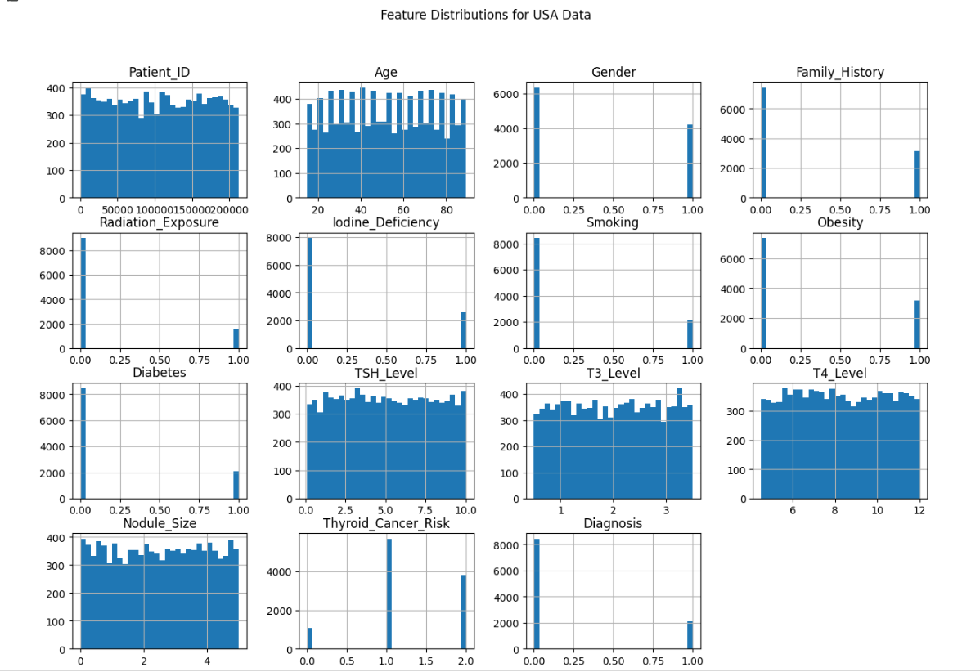
To better understand the characteristics of the dataset after narrowing our focus to the United States data, an exploration using visual methods to identify patterns and key features was conducted. Histograms of key features such as TSH, T3, and T4 levels showed distinct distribution patterns. TSH levels exhibited a wide range with several high-value outliers, suggesting potential cases of severe thyroid dysfunction. Nodule size also showed variability, with larger nodules appearing more frequently in higher-risk cases.
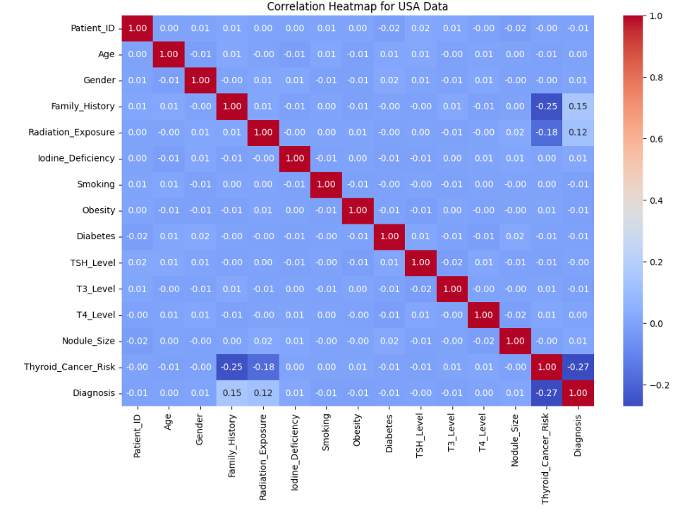
In addition to feature distributions, a correlation heatmap highlighted key relationships between TSH, T3, and T4 levels, which served to reinforce their interconnection in thyroid hormone regulation. These strong correlations emphasize their predictive value in identifying thyroid cancer risk.
The exploration also revealed key findings that could influence future modeling. First, a class imbalance was found where there are fewer malignant cases compared to benign ones, which pose a potential challenge for model performance. Second, the distinct patterns in TSH levels and Nodule Size confirmed their role as critical predictors in assessing thyroid cancer risk.
This exploration phase guided our feature selection and data preparation strategies by informing decisions on handling outliers, addressing class imbalance, and improving model performance.
Interesting and Surprising Results:
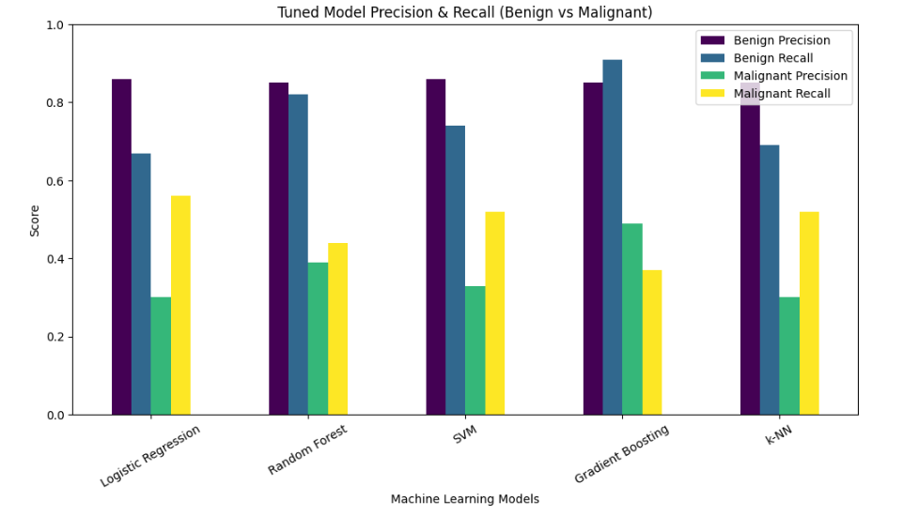

Several unexpected insights emerged during the model evaluation process, which revealed key strengths, weaknesses, and unexpected patterns in the data. One of the most important findings was the significant improvement in the Gradient Boosting model's performance after tuning. Initially the Gradient Boosting model showed moderate performance, however after tuning, the accuracy (0.7973) was the highest among all models. This improvement highlights Gradient Boosting's ability to successfully capture complex feature interactions and patterns within the data.
In contrast, Random Forest, which initially performed well with an accuracy of 0.7831, experienced a drop in accuracy after tuning (0.7476). This unexpected result suggests that the tuning process may have led to overfitting, which reduced the model’s ability to generalize to unseen data. This finding highlights that tuning does not always guarantee better results — in some cases tuning may over-adjust parameters which can negatively impact performance.
Another surprising outcome was the consistently low precision for malignant cases across all models, even after tuning. Despite improvements in recall for some models (especially SVM and k-NN), precision for malignant cases remained problematic. This pattern suggests that the models struggled to establish clear decision boundaries for identifying malignant cases, which pose a risk of false positives in real-world applications.
Logistic Regression, while stable, has demonstrated minimal improvement after tuning, with accuracy increasing only by 0.002. This limited improvement suggests that the model's linearity may have limited its ability to capture complex data relationships.

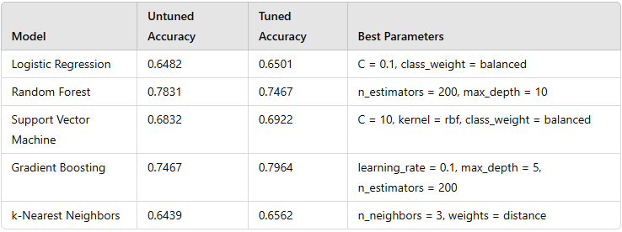
Interestingly, SVM performed better than anticipated in terms of malignant case recall. Despite being outperformed in overall accuracy by Gradient Boosting and Random Forest, SVM managed to achieve stronger recall for malignant cases, highlighting its strength in handling boundary-based data. However, this improvement in recall came at the cost of lower precision.
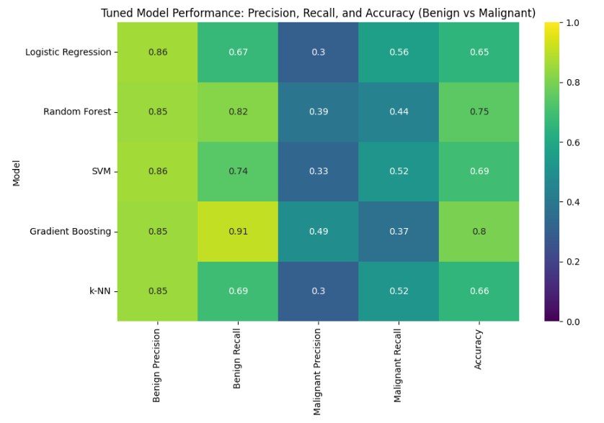
An unexpected finding also emerged from the feature importance analysis. While traditional thyroid cancer risk factors such as TSH Level and Nodule Size were expected to be dominant predictors, the PCA-transformed features (PC1, PC2, and PC3) appeared as the most influential features in the Random Forest and Gradient Boosting models.
Lastly, the impact of the class imbalance was evident throughout the analysis. Despite incorporating techniques like class weighting during model tuning, the improvements to recall for malignant cases remained low.

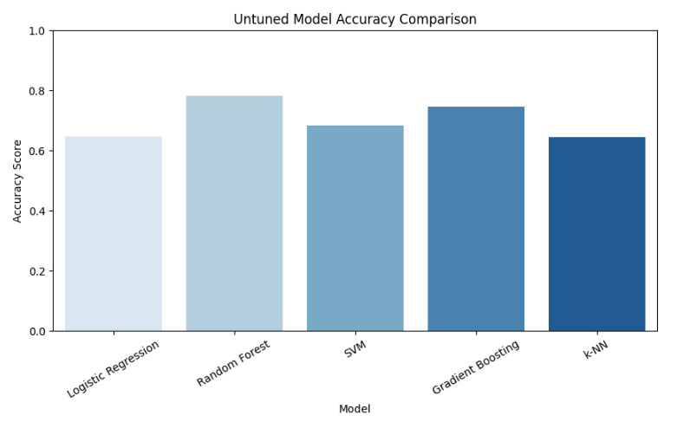
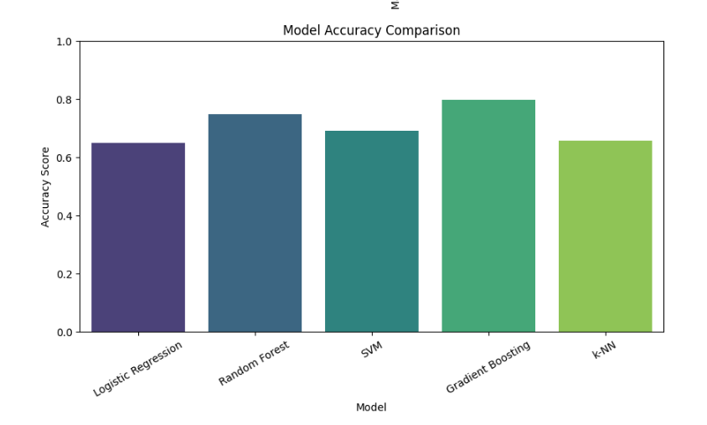
In summary, the strong performance of the tuned Gradient Boosting model highlights its effectiveness in handling complex medical data, while the unexpected decline in Random Forest’s accuracy post-tuning shows the risks of overfitting. The consistently low precision for malignant cases highlights the need for enhanced strategies to improve model reliability and reduce false positives.
Summary of Methods Used
Data Preprocessing
Principal Component Analysis (PCA) was applied to reduce dimensionality and improve model efficiency. Additionally, Synthetic Minority Oversampling Technique (SMOTE) was applied to address class imbalance in benign and malignant cases. Interaction terms were created to capture complex feature relationships.
Machine Learning Models
The following models were built, evaluated, and tuned:
- Logistic Regression (with class_weight='balanced')
- Random Forest (with tuned depth and estimator count)
- Support Vector Machine (with an RBF kernel and tuned parameters)
- Gradient Boosting (tuned for optimal depth and learning rate)
- k-Nearest Neighbors (kNN) (with tuned distance weighting and neighbor count)
Performance Metrics
- Accuracy for overall model effectiveness.
- Precision, Recall, and F1-Score with special focus on improving detection of malignant cases.

Problems Encountered:
Throughout the analysis, several challenges emerged that impacted model performance and required strategic adjustments. These issues highlight both technical difficulties and limitations within the dataset itself:
Class Imbalance
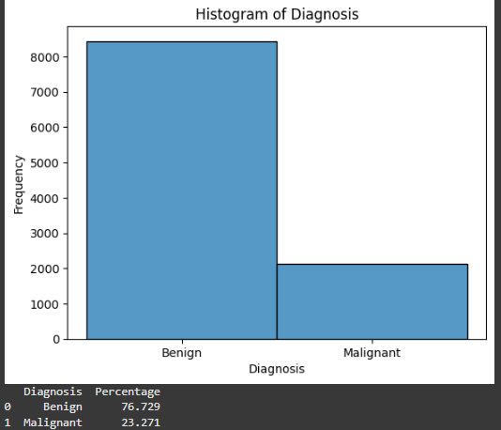
- One of the most significant challenges was the imbalance between benign and malignant cases. The dataset had far more benign cases, which caused models to predict benign cases with high accuracy.
- As a result, despite high overall accuracy, most models struggled to correctly identify malignant cases, leading to consistently low precision for this class.
- Efforts to address this, such as applying class weighting during model tuning, improved recall slightly but did not fully resolve the issue. Additional techniques like oversampling or SMOTE may be necessary to improve results.
Precision vs. Recall Trade-off
- Improving recall for malignant cases often came at the cost of lower precision. For example, models like SVM improved malignant recall but sacrificed precision, which then increased false positives.
- This trade-off was a challenge since balancing these metrics is critical in medical diagnosis, where both false negatives (missed malignant cases) and false positives (unnecessary medical interventions) must be minimized.
Overfitting During Model Tuning
- Tuning sometimes resulted in overfitting, especially with the Random Forest model. Although tuning typically improves performance, Random Forest’s accuracy dropped after tuning, suggesting that the adjusted parameters may have been too specific to the training data.
- This outcome reinforced the need for careful tuning and validation to avoid models that perform well on training data but poorly on unseen data.
Logistic Regression’s Limited Improvement:
- Despite various tuning attempts, Logistic Regression showed minimal improvement in performance. This was likely due to its linear nature, which may struggle to capture the complex, non-linear relationships present in medical data.
- While Logistic Regression performed reasonably well for benign cases, its limited flexibility hindered improvements in malignant detection.
Unexpected Feature Importance
- Traditional thyroid cancer risk factors such as TSH Level and Nodule Size were expected to play a key role in model performance. However, PCA-generated features (PC1, PC2, and PC3) emerged as the most influential predictors.
- While this finding was helpful, it complicated model interpretation, as PCA features lack clear medical meaning compared to traditional indicators.
Data Integration Issues
- During feature engineering, merging data to restore certain features (e.g., Age) resulted in index misalignment errors that required extra steps to resolve.
- Creating meaningful interaction terms (e.g., Age × Obesity) required careful alignment to avoid introducing data errors in the dataset.
Summary of Achievement in Prediction and Inference Goals:
The project analysis successfully achieved key objectives in both prediction and inference. The Random Forest and Gradient Boosting models delivered strong overall accuracy, demonstrating their effectiveness in capturing complex patterns within the data. Additionally, models such as Logistic Regression, SVM, and k-NN effectively improved recall for malignant cases, helping to reduce the risk of false negatives. This result is particularly important in a medical context where missed malignant cases could have serious consequences.
Through feature analysis using PCA loadings and feature importance methods, we identified key contributors to thyroid cancer risk, including TSH_Level, T4_Level, and Nodule_Size. These insights reinforce the importance of these features in guiding clinical assessment and informing model development strategies.

Conclusion
Despite these challenges, strategic adjustments such as feature engineering, tuning with class weighting, and refining model parameters helped improve performance. However, the consistently low precision for malignant cases emphasizes the need for further techniques like SMOTE, threshold adjustments, or ensemble methods to better address the data imbalance and improve positive case detection.

References
American Cancer Society. (2022). Thyroid Cancer: Facts and Figures. Retrieved from https://www.cancer.org/cancer/thyroid-cancer/about/key-statistics.htm
Davies, L., & Welch, H. G. (2014). Current thyroid cancer trends in the United States. JAMA Otolaryngology–Head & Neck Surgery, 140(4), 317-322.
Haugen, B. R., et al. (2016). 2015 American Thyroid Association management guidelines for adult patients with thyroid nodules and differentiated thyroid cancer. Thyroid, 26(1), 1-133.
Morris, L. G. T., et al. (2016). The increasing incidence of thyroid cancer: The influence of access to care. Thyroid, 26(7), 886-891.

