Respostas:

1. C

2. B

3. A

4. C

5. B

6. A

7. D

8. B

9. C

10. A

PROGRAMA 13:

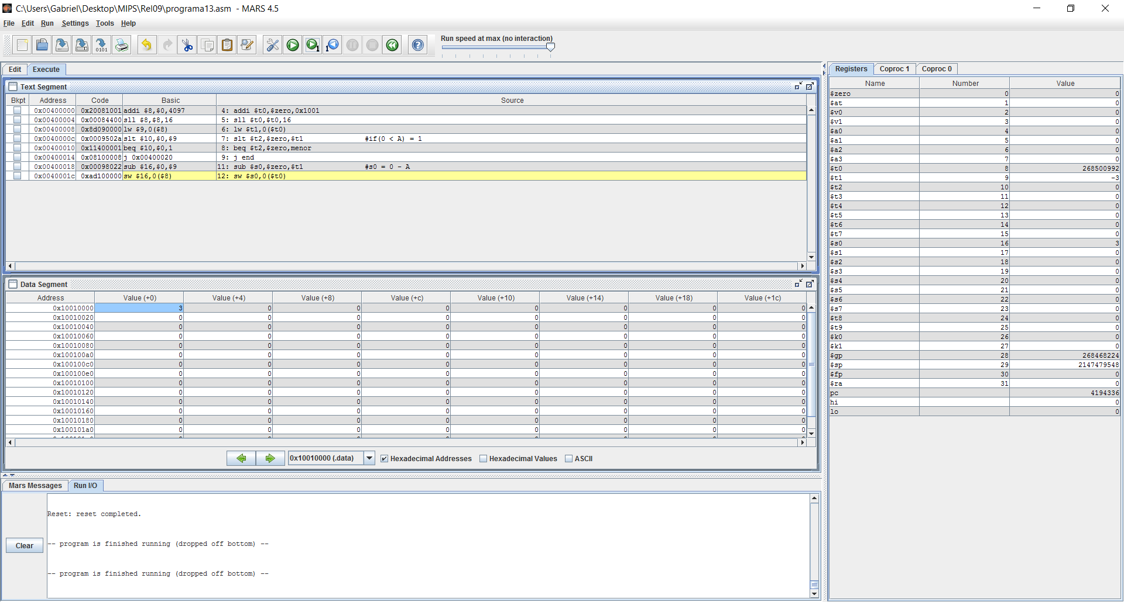

PROGRAMA 14:

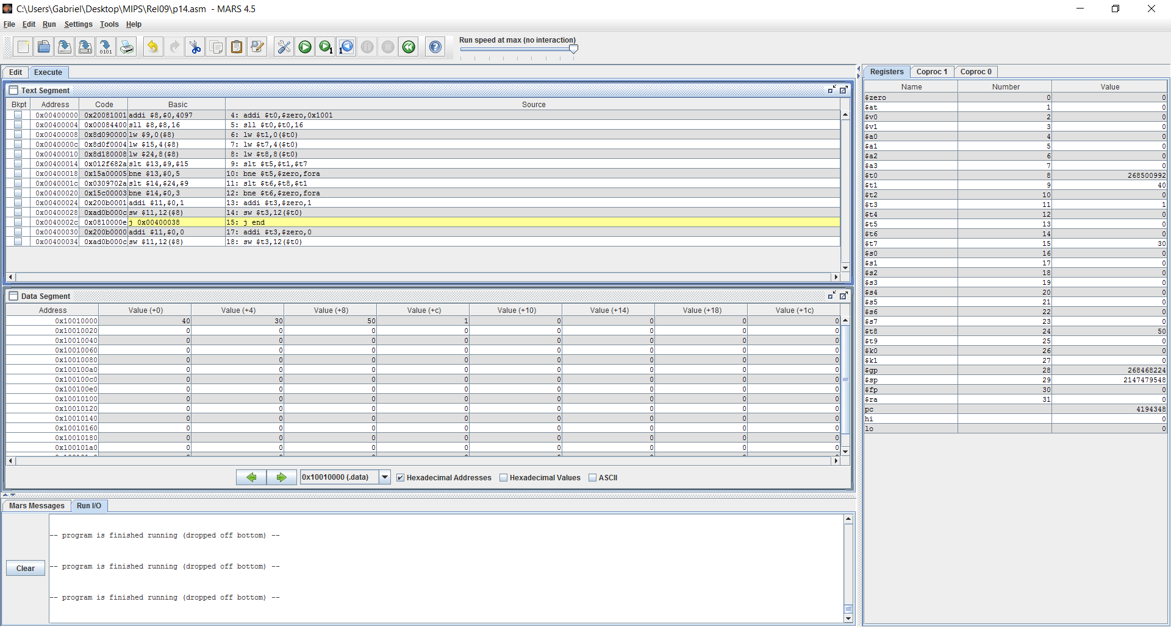

PROGRAMA 15:

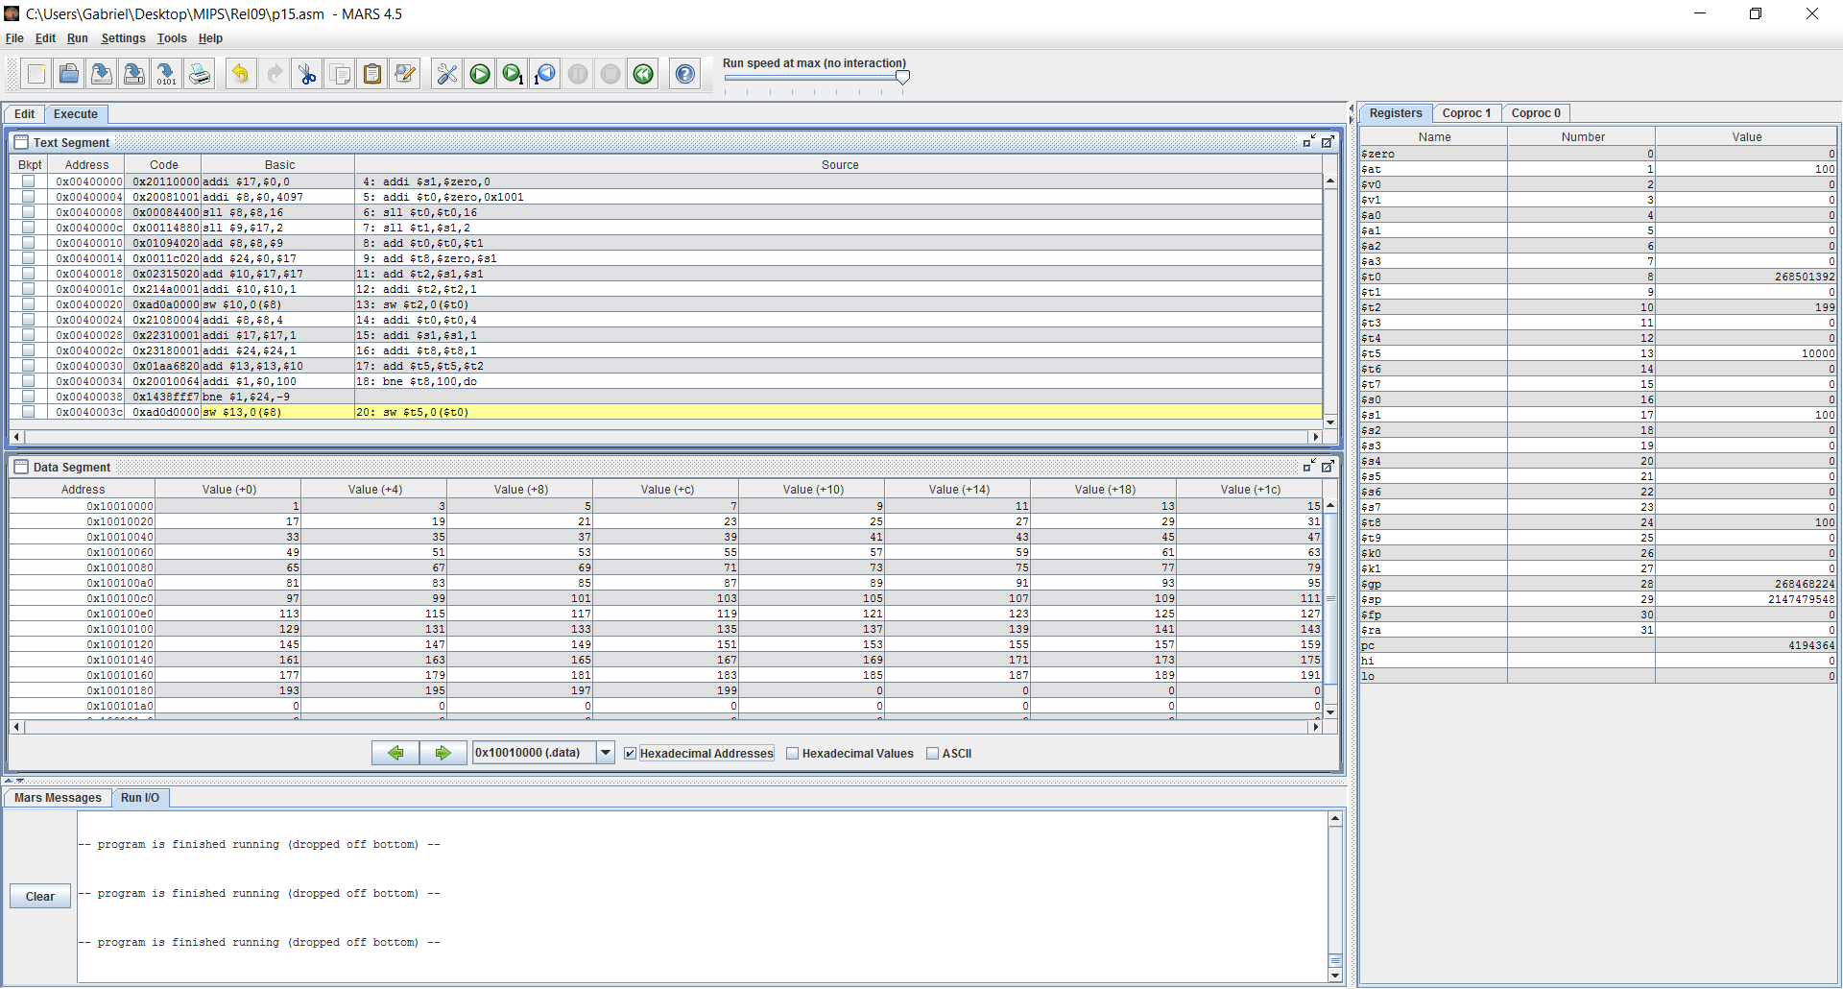

PROGRAMA 16:

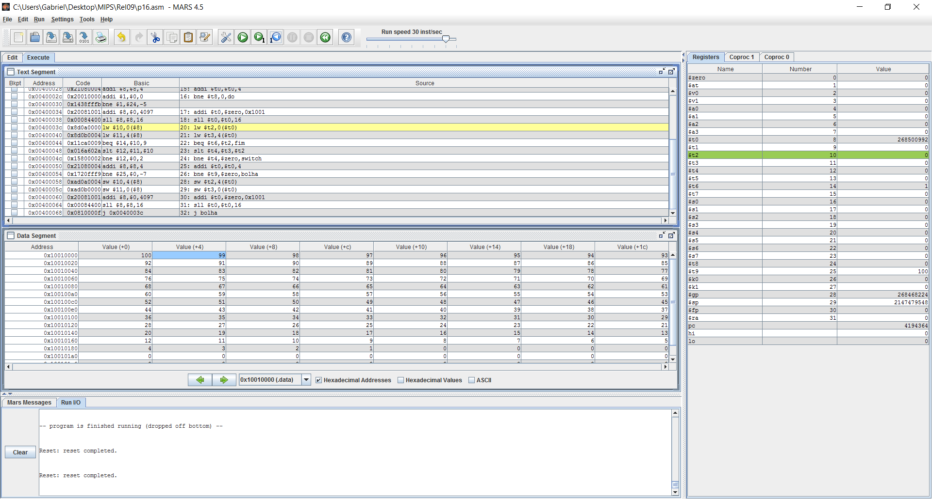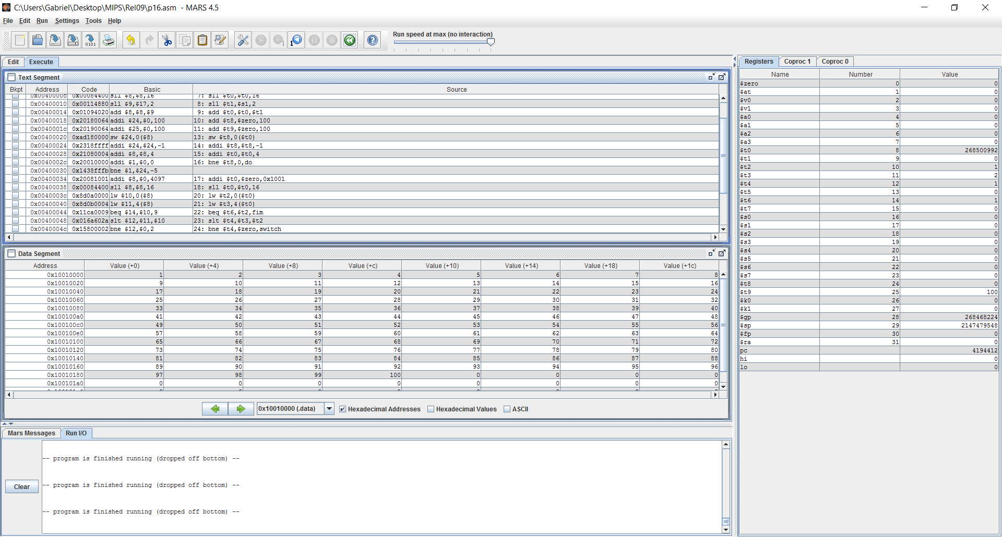

PROGRAMA 17

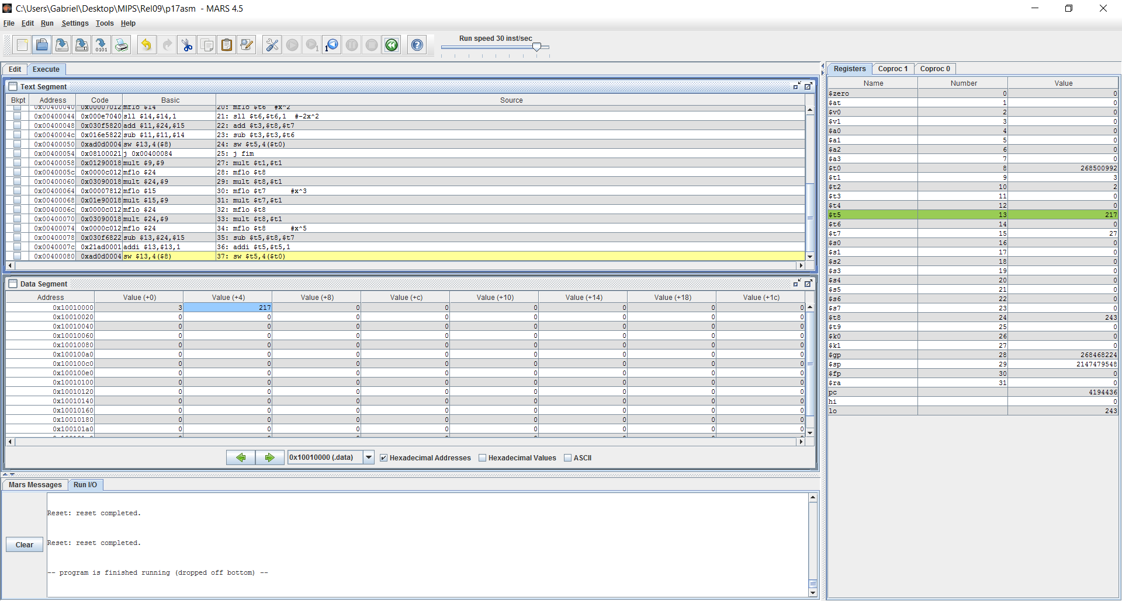

PROGRAMA 18:

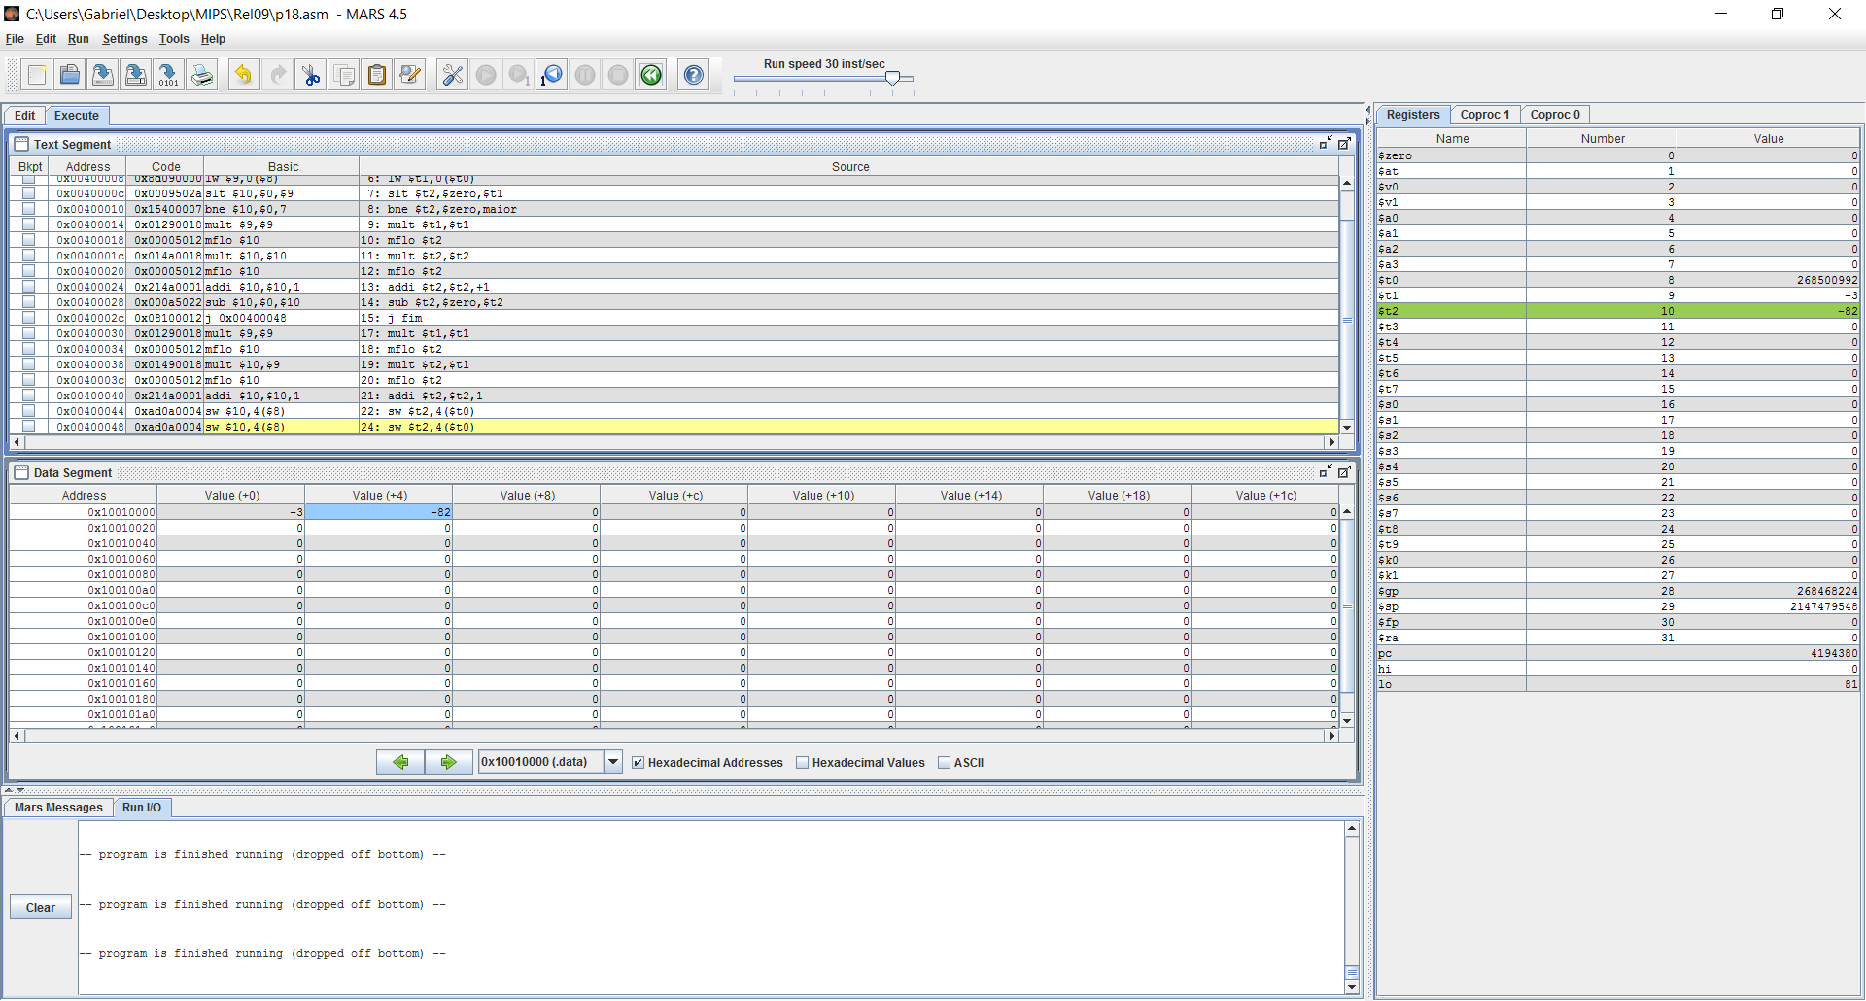

PROGRAMA 19:

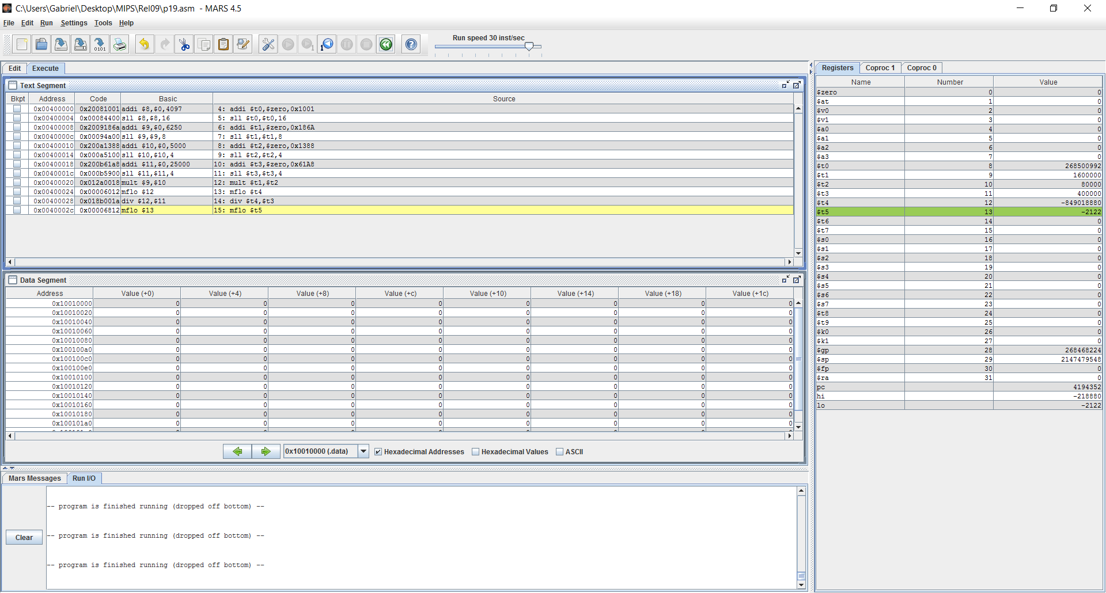

PROGRAMA 20:

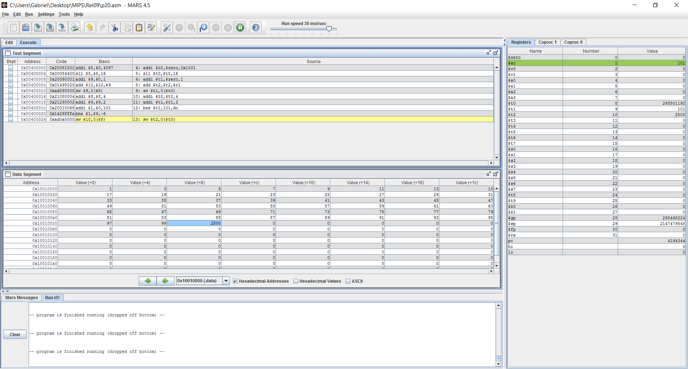

|  |  |  |  |
| --- | --- | --- | --- |
| ALU | 3 + 3.50 | 153 | 60% |
| MEM | 1.50 | 50 | 20% |
| DESV | 1 + 1.50 | 51 | 20% |
| TOTAL | 254 |  |  |

PROGRAMA 21:

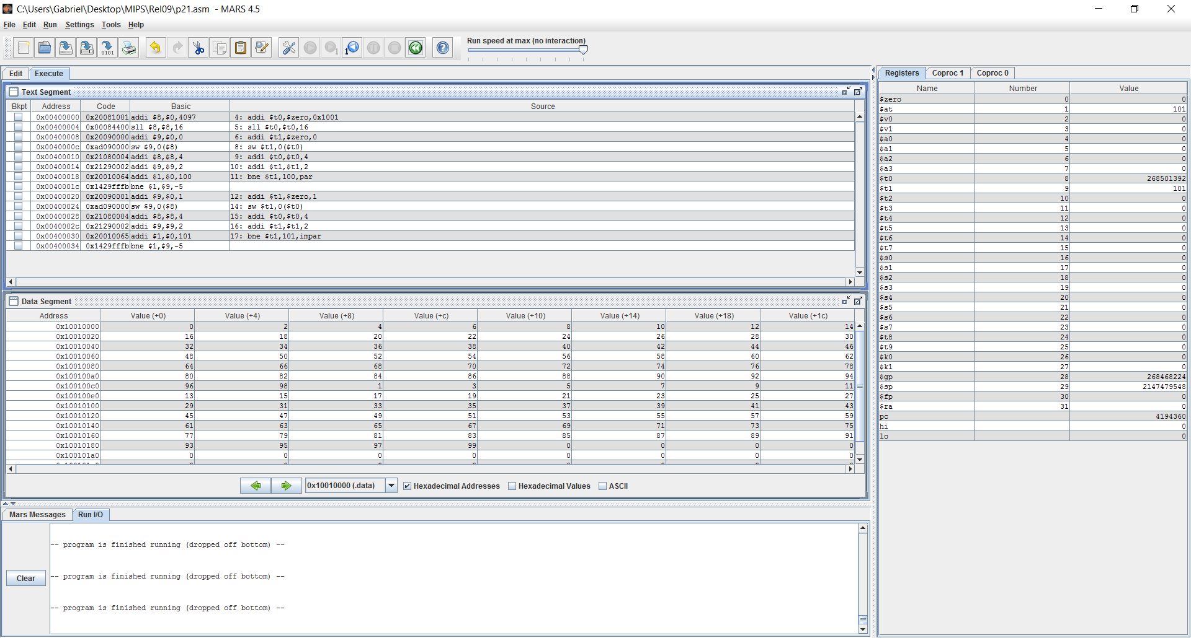

|  |  |  |  |
| --- | --- | --- | --- |
| ALU | 3 + 2.50 + 1 + 1.50 | 153 | 44% |
| MEM | 1.50 + 1.50 | 100 | 28% |
| DESV | 1.50 + 1.50 | 100 | 28% |
| TOTAL | 354 |  |  |

PROGRAMA 22:

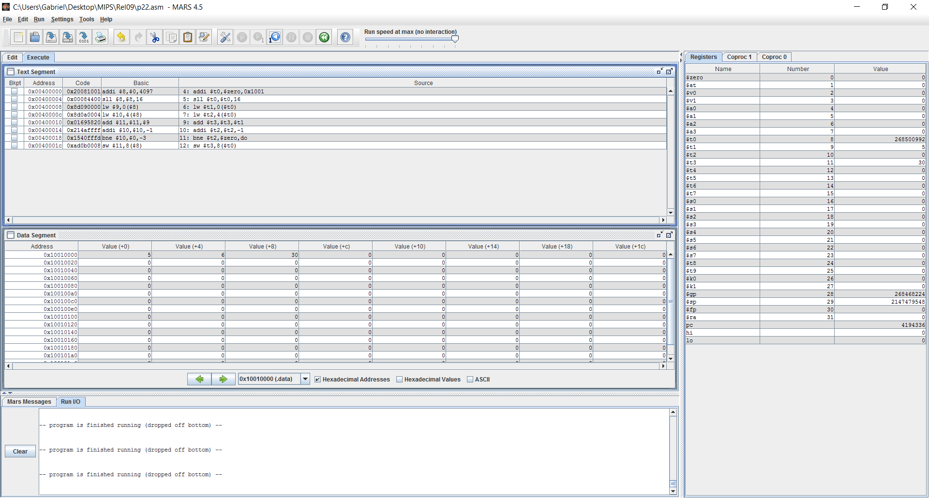

PROGRAMA 23:

