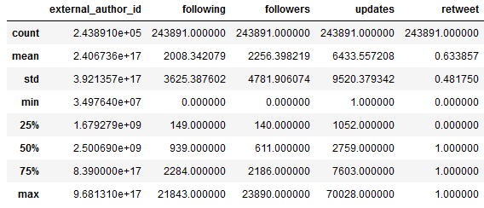

Average account follows 2008 with σ=3625.  
Average account has 2256 followers with σ=4781  
63% of tweets are retweets

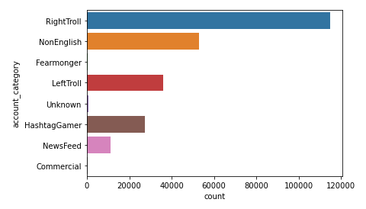

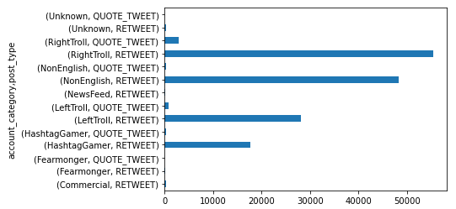

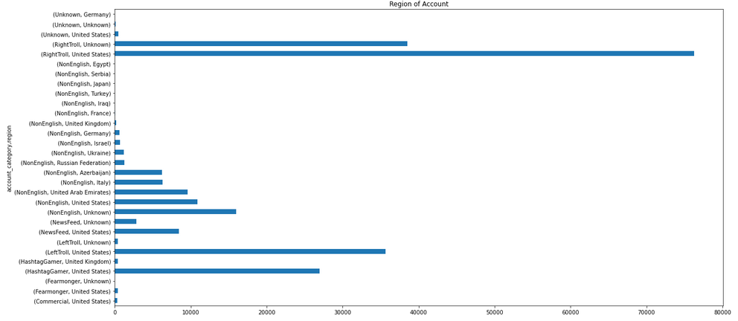

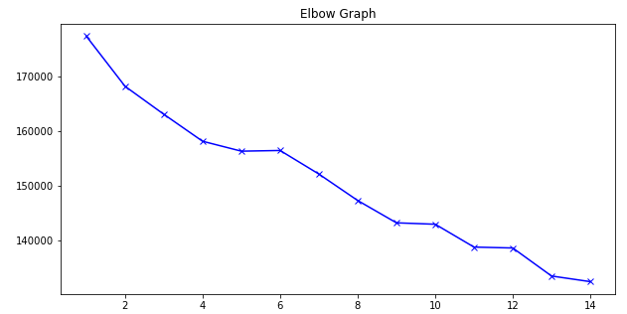

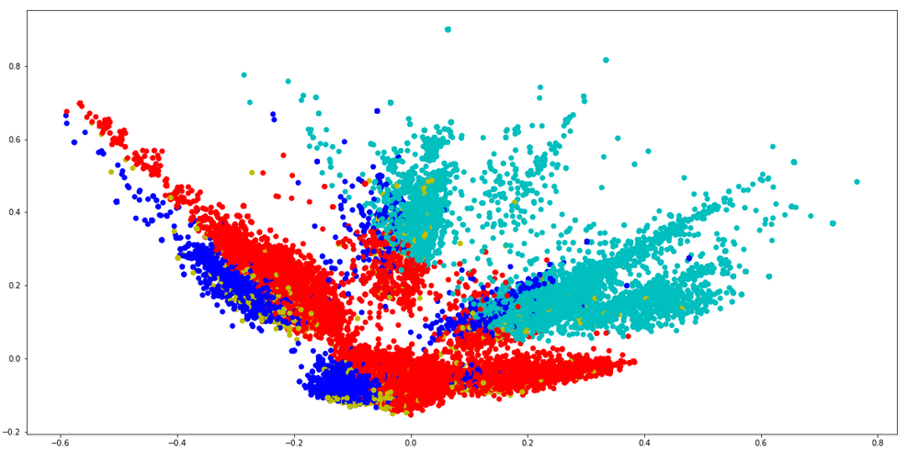

Top words per Cluster

Cluster 0:

trump

presid

rt

support

”

“

look

maga

thi

hi

Cluster 1:

rt

…

realdonaldtrump

thi

amp

potu

wa

ha

democrat

antifa

Cluster 2:

thi

get

new

break

wa

like

polic

peopl

amp

news

Cluster 3:

’

‘

trump

“

”

break

video

obama

new

call