Extreme events: a shift or a change in shape?
Environmental Economics | BSc AIDAMS | Track 2

Abstract
We compare heat and drought distributions in Spain, France, Germany and Sweden using country-level ERA5-Land indices. Fixed historical thresholds, mean-shift benchmarks and quantile regressions distinguish changes in overall levels from additional tail movement. Heat-threshold crossings increase across countries; a shift in the mean accounts for much of the rise. France and Germany also show wider pooled temperature distributions, while evidence of extra upper-tail movement remains imprecise. Drought results vary more across countries and thresholds. The estimates describe historical changes; small tail samples and limitations of the early reanalysis record constrain inference.

1. Question
Have heat and drought extremes become more frequent or more intense in Spain, France, Germany and Sweden, and how much of that change can be described by a shift in the mean? We compare 1961-1990 with 1996-2025 using country-level ERA5-Land data from the Copernicus Interactive Climate Atlas. Our central question is whether the recent distribution resembles the early distribution moved to a new level, or whether its extreme tail has moved further than the mean.
The distinction matters for risk assessment. A fixed historical threshold can be crossed much more often after the mean changes, even if variability around the mean stays constant. More exceedances therefore do not, by themselves, establish that a tail has become heavier. For water managers, agricultural producers and planners, both the level of the climate variable and the distribution around that level matter. Our data measure climate conditions; they do not measure economic losses or identify the benefits of an adaptation policy.
Three references frame the question. IPCC AR6 Chapter 11 documents changes in the frequency and intensity of temperature extremes and assesses their human contribution using evidence beyond simple historical comparisons (Seneviratne et al., 2021, Sections 11.2-11.3). Hansen, Sato and Ruedy (2012) show a shift toward hotter seasonal temperature anomalies and a larger occurrence of exceptionally hot summers. Rhines and Huybers (2013) question the inference of increased variability from those distributions: normalisation, trends and changing station coverage can produce apparent widening. Their result makes the empirical task clear. We must compare tail changes with a shift benchmark, rather than infer a change in shape from an increase in extremes alone. These papers concern seasonal temperatures and different spatial aggregations; our analysis is not a direct replication.
We use two complementary indices: monthly TXx for June-August, measuring the country average of local monthly temperature maxima, and September SPEI-6, summarising April-September climatic water balance. The four countries span southern to northern Europe, allowing us to compare contrasting climates within one dataset. TXx values are expressed relative to each country's early-period mean for the same calendar month. We examine its upper tail at P75, P90, P95 and P99. For SPEI-6, lower values mean drier conditions, so the corresponding thresholds are P25, P10, P5 and P1.
An answer requires three comparisons: the change in the mean and spread; the change in tail percentiles relative to the mean; and the frequency of crossing fixed early-period thresholds. Time trends and quantile regressions provide a further check on whether the centre and tails move at different rates. The results describe these four country-level series over the observed record. They do not attribute individual events to greenhouse gas emissions or predict future extremes.

2. Data
We use the Copernicus Interactive Climate Atlas v2.5, produced by the Copernicus Climate Change Service (C3S), with regional-information exports downloaded on 29 October 2026. The underlying dataset is ERA5-Land, ECMWF's land-surface reanalysis on a 0.1° grid (C3S, 2023; 2024b). The four countries, Spain, France, Germany and Sweden, span southern to northern Europe. All 16 downloaded series cover 1950-2025, with 76 annual observations each. The raw-data check confirms common dataset and version labels, complete coverage, unique years and no missing values. We perform no imputation or interpolation. The 1961-1990 label in the file headers identifies the Atlas chart baseline, not the downloaded coverage.
TXx is the monthly maximum of daily maximum near-surface temperature, in °C. Within each grid cell, the daily maximum is the highest hourly 2 m temperature; the Atlas then takes the month's highest daily value (C3S, 2023). Country averages weight land cells by cosine latitude (C3S, 2024a). TXx therefore averages local monthly maxima, rather than identifying the hottest reading anywhere in the country. We pool June-August, giving 90 values per 30-year period. Each value is expressed relative to the 1961-1990 mean of the same country and calendar month, removing differences in seasonal levels. The three observations from a summer remain correlated; Section 5 keeps them together in the bootstrap.
SPEI-6 is the Standardised Precipitation-Evapotranspiration Index over six months. It accumulates precipitation minus potential evapotranspiration (PET) at each grid cell, fits a probability distribution and standardises the result. PET uses the Hargreaves formulation, implemented through xclim (Hargreaves and Samani, 1985; C3S, 2023; 2024a). The country average is dimensionless; negative values indicate drier conditions. We retain September only, covering April-September water balance, with 30 observations per comparison period. These annual windows do not overlap, unlike consecutive monthly SPEI-6 values. We adopt the 1971-2005 reference period explicitly stated in the Atlas information panel for observations, reanalysis and projections (data/atlas_info_spei6.txt). The dataset documentation instead reports 1971-2010, while the v2.5 changelog gives 1971-2005 for projections; this inconsistency remains a documentation limitation.

Data limitations
These data have several limitations. ERA5-Land is a model-based reanalysis, not a collection of station measurements. The Atlas disables trends before 1978 because of potential inconsistency in the ERA5 forcing (C3S, 2024a). Our early comparison period overlaps those years, so early-recent changes may partly reflect data artefacts. The post-1978 check in Section 5 covers mean trends only.
National averaging smooths local extremes, especially in large or diverse countries, and the guide does not specify treatment of cells crossing national borders. SPEI-6 also depends on the PET method and reference period. Its standardisation occurs before spatial averaging: country-level SDs are 0.754-0.902 and full-record means range from -0.285 to -0.037. A country average therefore need not have unit variance or zero mean. We use each country's early-period percentiles rather than the rarely crossed fixed threshold of -1.5. Finally, extreme percentiles rest on few observations. Section 5 reports whole-year bootstrap intervals, which preserve dependence within summers but not across years.

3. Summary statistics
We compare 1961-1990 (early, E) with 1996-2025 (recent, R). TXx pools June-August anomalies relative to the early mean of the same country and month. SPEI-6 is used as published, one September value per year. The distributions contain 90 TXx values or 30 SPEI-6 values per country and period. Percentiles use linear interpolation.
Table 1. Summary statistics: early and recent distributions.
Index | Country | Period | N | Mean | SD | Min | P5 | P95 | Max
TXx | ESP | E | 90 | 0.00 | 1.61 | -5.05 | -2.86 | 2.03 | 4.06
TXx | ESP | R | 90 | 2.10 | 1.74 | -2.16 | -0.69 | 5.31 | 5.89
TXx | FRA | E | 90 | 0.00 | 1.83 | -3.57 | -2.73 | 3.16 | 4.27
TXx | FRA | R | 90 | 2.44 | 2.35 | -4.04 | -1.02 | 6.35 | 8.21
TXx | GER | E | 90 | 0.00 | 1.78 | -4.63 | -2.95 | 2.89 | 4.01
TXx | GER | R | 90 | 1.85 | 2.37 | -4.12 | -1.91 | 5.29 | 6.74
TXx | SWE | E | 90 | 0.00 | 2.06 | -4.85 | -3.76 | 3.18 | 4.61
TXx | SWE | R | 90 | 0.63 | 2.15 | -4.45 | -2.76 | 4.18 | 4.98
SPEI-6 | ESP | E | 30 | 0.15 | 0.75 | -1.02 | -0.89 | 1.44 | 2.30
SPEI-6 | ESP | R | 30 | -0.62 | 0.70 | -1.82 | -1.63 | 0.59 | 0.80
SPEI-6 | FRA | E | 30 | 0.05 | 0.86 | -1.70 | -1.40 | 1.15 | 1.25
SPEI-6 | FRA | R | 30 | -0.56 | 0.77 | -1.98 | -1.56 | 0.41 | 0.85
SPEI-6 | GER | E | 30 | 0.21 | 0.82 | -1.90 | -1.04 | 1.31 | 1.70
SPEI-6 | GER | R | 30 | -0.36 | 0.91 | -2.80 | -1.95 | 0.82 | 0.97
SPEI-6 | SWE | E | 30 | -0.10 | 0.68 | -1.99 | -1.27 | 0.99 | 1.26
SPEI-6 | SWE | R | 30 | 0.07 | 0.80 | -1.89 | -1.15 | 1.42 | 1.56
TXx: anomalies in °C. SPEI-6: dimensionless, negative = drier. E: 1961-1990; R: 1996-2025. Country codes: Spain (ESP), France (FRA), Germany (GER), Sweden (SWE). Source: C3S Atlas v2.5, ERA5-Land, accessed 29 October 2026; our calculations. Full quantiles: outputs/summary_stats.csv.
Table 2. TXx reference levels: 1961-1990 mean, °C.
Country | June | July | August
ESP | 30.14 | 33.31 | 32.90
FRA | 26.85 | 29.59 | 28.97
GER | 26.86 | 28.29 | 28.19
SWE | 23.27 | 24.06 | 22.27
TXx is higher in the recent period in all four countries. Mean shifts are larger in Spain, France and Germany than in Sweden. The P95 rises more than the mean in each country; Section 5 assesses the precision of that extra movement. France and Germany also show wider pooled distributions. SPEI-6 shifts toward drier conditions in Spain, France and Germany, while Sweden changes little. Tail precision is limited: each period has only five TXx observations above its own P95 and two SPEI-6 observations below its own P5.

4. Figures
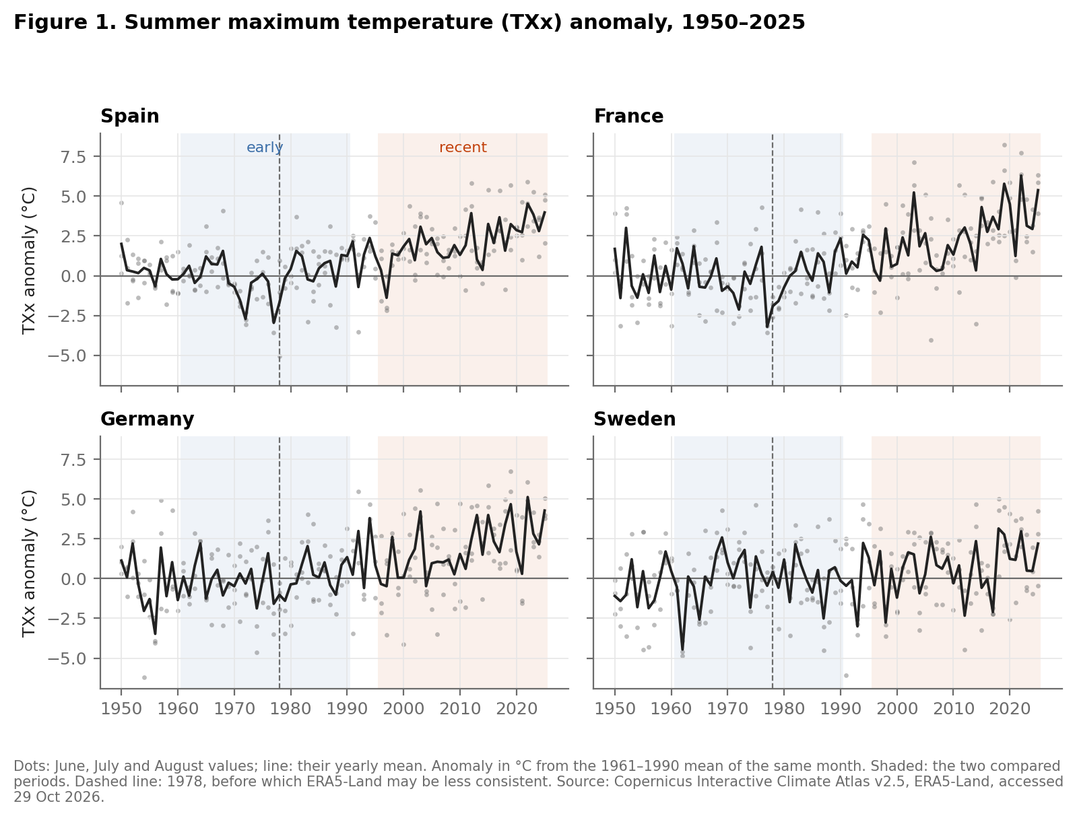
Figure 1. Country-average summer TXx anomalies show upward trends with substantial year-to-year variation.
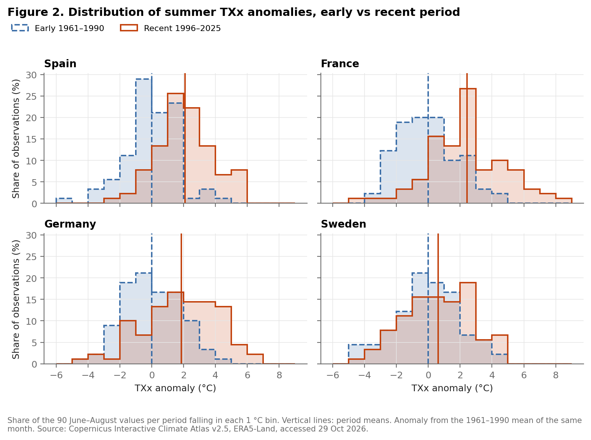
Figure 2. Recent TXx distributions lie further toward hot anomalies in Spain, France and Germany; Sweden's distributions overlap more.

4. Figures
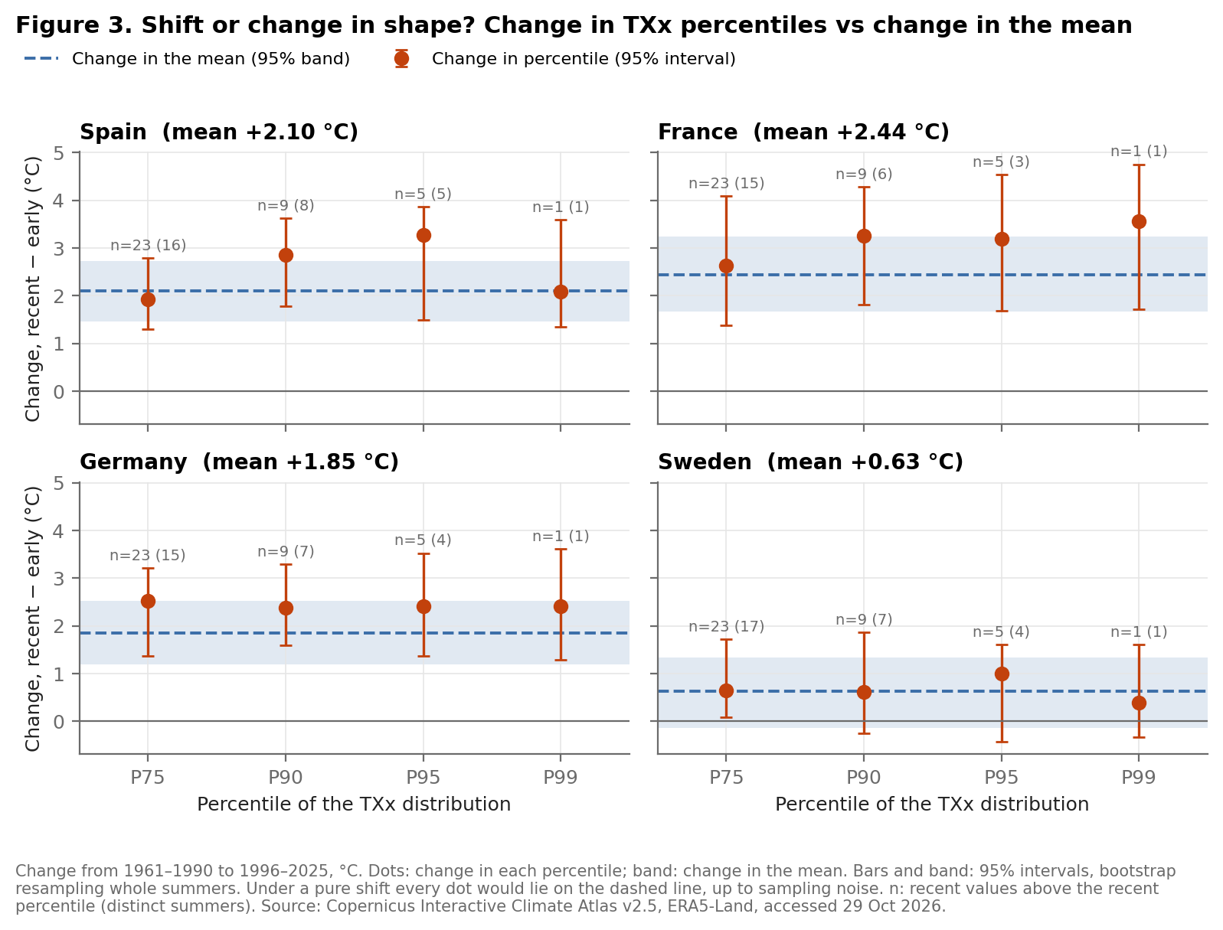
Figure 3. TXx upper percentiles rise, but their extra movement relative to the mean is imprecise in every country.
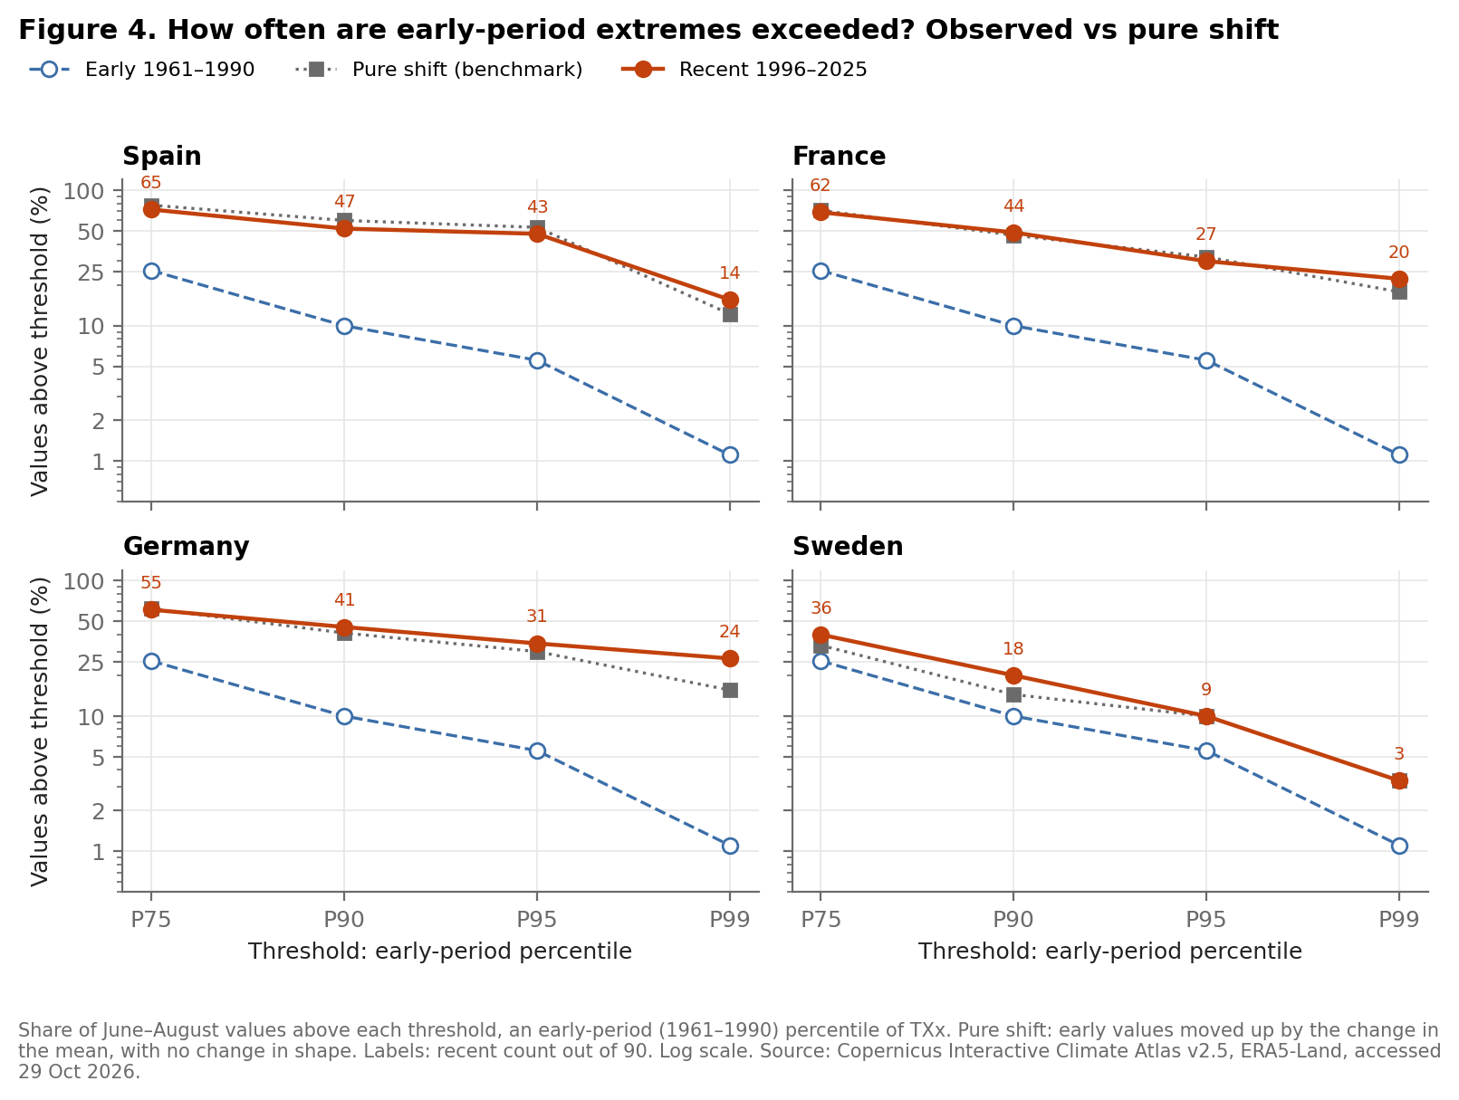
Figure 4. Heat exceedances increase at every threshold; the shift benchmark accounts for much of the rise, with a larger gap at Germany's P99.

4. Figures
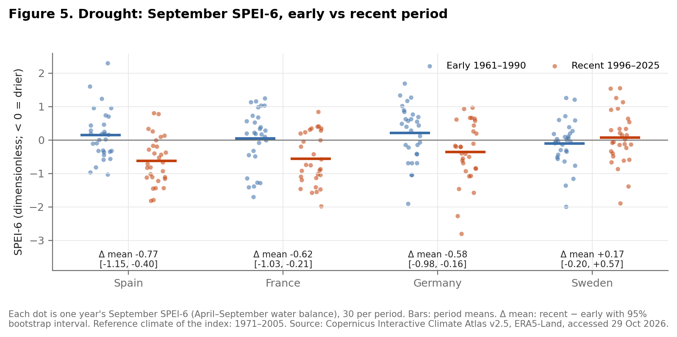
Figure 5. Mean September SPEI-6 falls in Spain, France and Germany; Sweden shows no clear change between periods.
Each point represents one September value, covering April-September climatic water balance; there are 30 observations per country and period. Mean changes are -0.77 in Spain, -0.62 in France and -0.58 in Germany, with 95% intervals excluding zero, and +0.17 in Sweden, with an interval including zero. Only two observations lie below each period's own P5. The estimates therefore provide limited information about changes in the most severe drought tail.
The fixed-threshold comparison and the quantile regressions in Section 5 assess whether these changes extend beyond a shift in the mean. A national index can change substantially without identifying a change in local event duration or an economic loss.

5. Econometrics

5.1. Fixed thresholds and a shift benchmark
We set each country's thresholds on 1961-1990 and apply the same values to 1996-2025. Frequency is the share of observations above the TXx threshold or below the SPEI-6 threshold, not a count of distinct heatwaves or drought episodes. Let the mean shift be
$$Δ={\overset{‾}{y}}_{R}−{\overset{‾}{y}}_{E}.$$
The shift benchmark adds delta to every early observation and recounts exceedances. It preserves the early distribution's shape and uses the observed mean change; it is a descriptive benchmark, not an independent forecast.
Table 3. Threshold sensitivity: early count / recent count / shift-benchmark count.
Index | Country | P75 / P25 | P90 / P10 | P95 / P5 | P99 / P1
TXx | Spain | 23 / 65 / 70 | 9 / 47 / 54 | 5 / 43 / 48 | 1 / 14 / 11
TXx | France | 23 / 62 / 64 | 9 / 44 / 42 | 5 / 27 / 29 | 1 / 20 / 16
TXx | Germany | 23 / 55 / 56 | 9 / 41 / 37 | 5 / 31 / 27 | 1 / 24 / 14
TXx | Sweden | 23 / 36 / 30 | 9 / 18 / 13 | 5 / 9 / 9 | 1 / 3 / 3
SPEI-6 | Spain | 8 / 20 / 21 | 3 / 16 / 15 | 2 / 12 / 11 | 1 / 11 / 11
SPEI-6 | France | 8 / 18 / 16 | 3 / 6 / 6 | 2 / 6 / 6 | 1 / 1 / 6
SPEI-6 | Germany | 8 / 15 / 13 | 3 / 9 / 9 | 2 / 6 / 6 | 1 / 2 / 1
SPEI-6 | Sweden | 8 / 7 / 5 | 3 / 3 / 3 | 2 / 2 / 1 | 1 / 1 / 1
Each TXx count is out of 90 country-month observations per period; each SPEI-6 count is out of 30 September observations. Thresholds are early-period percentiles, with strict inequalities and linear interpolation. Source: C3S, Copernicus Interactive Climate Atlas v2.5, ERA5-Land, accessed 29 October 2026; outputs/exceedance.csv.
Heat exceedances increase at every threshold in every country. At P95, Spain rises from 5 to 43 observations, France from 5 to 27, Germany from 5 to 31 and Sweden from 5 to 9. These recent exceedances come from 23, 19, 20 and 7 distinct summers, respectively. The early P95 rate is 5/90, or 5.6%, rather than exactly 5%. The shift benchmark gives 48, 29, 27 and 9 exceedances. Thus much of the increase can occur without a change in shape. Germany's P99 is the clearest discrepancy: 24 observed against 14 under the benchmark. No confidence interval is estimated for these count gaps, so they are not formal tests of a pure shift.
Drought results depend more on the threshold. Spain has more dry observations at all four cut-offs. France and Germany have more at P25, P10 and P5, but France's P1 count stays at one. Sweden's counts change little. At the headline P5, recent counts are 12, 6, 6 and 2; the shift benchmark gives 11, 6, 6 and 1. P99 for TXx and P1 for SPEI-6 each have only one early observation beyond the line, making frequency ratios particularly unstable.

5.2. Tail intensity relative to the mean
We measure departure from a shift by
$$S_{p}=(Q_{R,p}−Q_{E,p})−Δ,$$
where Q is the percentile at p and E and R denote the early and recent periods. A positive S_p means extra movement toward heat for TXx; a negative value means extra movement toward dryness for SPEI-6. For TXx at P95, S_p is 1.18 °C in Spain, 0.75 °C in France, 0.55 °C in Germany and 0.37 °C in Sweden. Their 95% bootstrap intervals are [-0.40, 1.72], [-0.54, 1.70], [-0.31, 1.47] and [-0.84, 1.03] °C. All include zero, as do the corresponding intervals at the other thresholds. This is limited evidence about tail departures, not proof of identical shapes. France and Germany nevertheless show wider pooled distributions: their SD changes are 0.52 °C [0.07, 0.93] and 0.59 °C [0.18, 0.98].
Intervals use 2,000 bootstrap draws, resampling years independently within each period and keeping a summer's three months together. At each period's own P95, only five TXx values lie above the line; at its own P5, only two SPEI-6 values lie below it. We do not detrend within periods, so changes in pooled spread can include changes in the mean within a period (Rhines and Huybers, 2013). Resampling single years preserves dependence within summers but does not preserve dependence across years; intervals are pointwise and do not adjust for multiple comparisons.

5.3. Mean and quantile trends
For each country and index, OLS estimates
$$y_{t}=α+β\frac{t−1950}{10}+u_{t}.$$
Here t is the calendar year; y_t is the annual June-August mean TXx anomaly (°C) or September SPEI-6 (dimensionless); alpha is the fitted level in 1950 and u_t the residual. Beta measures change per decade. Newey-West HAC standard errors use three annual lags. Quantile regression estimates
$$Q_{τ}(y∣t)=α_{τ}+β_{τ}\frac{t−1950}{10}$$
on pooled monthly TXx anomalies or annual SPEI-6. We fit tau = 0.05, 0.10, 0.25, 0.50, 0.75, 0.90 and 0.95; Table 4 reports the median and relevant extreme tail.
Table 4. Trends per decade; standard errors in parentheses.
Index | Country | OLS 1950-2025 | OLS 1978-2025 | QR median | QR tail
TXx | Spain | 0.440 (0.081) | 0.722 (0.085) | 0.452 (0.073) | 0.511 (0.114)
TXx | France | 0.550 (0.096) | 0.947 (0.117) | 0.562 (0.088) | 0.558 (0.173)
TXx | Germany | 0.459 (0.078) | 0.719 (0.103) | 0.466 (0.086) | 0.428 (0.158)
TXx | Sweden | 0.215 (0.068) | 0.296 (0.118) | 0.245 (0.114) | 0.226 (0.073)
SPEI-6 | Spain | -0.103 (0.048) | -0.243 (0.037) | -0.131 (0.052) | 0.017 (0.070)
SPEI-6 | France | -0.067 (0.053) | -0.248 (0.067) | -0.202 (0.095) | 0.024 (0.036)
SPEI-6 | Germany | -0.079 (0.053) | -0.223 (0.079) | -0.069 (0.072) | -0.126 (0.135)
SPEI-6 | Sweden | 0.027 (0.036) | -0.015 (0.064) | -0.015 (0.034) | 0.112 (0.132)
OLS: 76 annual values for 1950-2025 and 48 for 1978-2025, with HAC errors. Quantile regression: 1950-2025, 228 TXx observations or 76 SPEI-6 observations; 499 whole-year bootstrap draws for standard errors. Tail means tau = 0.95 for TXx and 0.05 for SPEI-6. Units: °C/decade for TXx, index units/decade for SPEI-6. Source: as Table 3; outputs/ols_trends.csv and outputs/quantile_trends.csv.
Full-record mean TXx trends are positive in all four countries. France's 0.55 °C per decade means a fitted rise of about half a degree per decade in the average of the three monthly maxima, not in annual mean temperature. Its median and P95 slopes are both about 0.56 °C per decade. In every country, the P95-minus-median slope interval includes zero; all SPEI-6 P5-minus-median intervals also include zero. These direct contrasts provide no clear evidence that the relevant extreme tail trends faster than the centre. They have low precision: only 12 observations lie above each fitted TXx P95 line and five below each SPEI-6 P5 line. Some quantile fits reach the iteration limit; series totals range from 1 to 10 across 3,500 point and bootstrap fits, so affected estimates remain approximate.
Re-estimating OLS from 1978 keeps positive mean TXx trends in every country and gives negative SPEI-6 trends in Spain, France and Germany whose 95% intervals exclude zero. Sweden's SPEI-6 interval includes zero. This addresses the documented concern about early ERA5-Land forcing only for mean trends: neither quantile regressions nor the early-recent comparison are re-estimated on a wholly post-1978 sample. Different slopes across these nested samples are not a formal test of acceleration. All regressions describe association with time; they do not identify a causal effect.

6. What we can and cannot conclude
The clearest result is a shift toward hotter summer maxima in Spain, France and Germany. Between 1961-1990 and 1996-2025, mean TXx anomalies rise by 2.10 °C, 2.44 °C and 1.85 °C, respectively. Sweden's estimated rise is smaller, 0.63 °C, and its period-difference interval includes zero, although its full-record mean trend is positive with a HAC interval excluding zero. A comparison of two periods and a trend over the full record answer different questions and need not have the same precision.
Heat observations cross fixed historical thresholds more often in all four countries, whichever of P75, P90, P95 or P99 defines the extreme. A shift of the early distribution by the observed mean change reproduces much of that increase. The upper percentiles also rise, but their extra movement relative to the mean is imprecise. The quantile regressions similarly do not establish a faster P95 trend than the median. The evidence therefore supports a substantial shift, while leaving moderate changes in the upper tail unresolved. France and Germany have wider pooled distributions, so the results do not justify a blanket claim that shape is unchanged.
For drought, mean September SPEI-6 falls in Spain, France and Germany, indicating a drier April-September climatic water balance. Sweden shows no clear mean drying. Spain's increase in dry-threshold crossings persists across all four cut-offs. The conclusion is less uniform elsewhere: France has more crossings at P25, P10 and P5, but no increase at P1. We find no clear extra deterioration of the P5 relative to the mean. With only 30 observations per comparison period, this is weak evidence about the most severe droughts.
Our method combines distribution comparisons, fixed-threshold counts, a shift benchmark, OLS trends and quantile regression. The results are descriptive changes and associations with time. A time coefficient absorbs many processes; it cannot isolate greenhouse gas forcing, land-use change or a particular economic mechanism. Causal attribution would require a credible counterfactual, such as climate-model ensembles with and without human forcing, together with evidence on model performance and observational uncertainty. The broader attribution evidence assessed by Seneviratne et al. (2021) does not turn our regressions into an attribution design.
Three limits are central. National averages smooth local extremes, and these indices do not count heatwave duration or observed crop and income losses. The most extreme percentiles rest on very few observations, while our bootstrap does not preserve dependence across years. Finally, the early baseline overlaps the documented pre-1978 ERA5-Land concern; the post-1978 mean-trend check cannot validate all early-period tail results. The practical implication is still clear: a change in the mean can substantially raise exposure to historically unusual conditions. The data support that conclusion more firmly than a claim that the extreme tails have systematically become heavier.

References
Hansen, J., Sato, M., and Ruedy, R. (2012). Perception of climate change. Proceedings of the National Academy of Sciences, 109(37), E2415-E2423. https://doi.org/10.1073/pnas.1205276109
Rhines, A., and Huybers, P. (2013). Frequent summer temperature extremes reflect changes in the mean, not the variance. Proceedings of the National Academy of Sciences, 110(7), E546. https://doi.org/10.1073/pnas.1218748110
Seneviratne, S. I., Zhang, X., Adnan, M., Badi, W., Dereczynski, C., Di Luca, A., Ghosh, S., Iskandar, I., Kossin, J., Lewis, S., Otto, F., Pinto, I., Satoh, M., Vicente-Serrano, S. M., Wehner, M., and Zhou, B. (2021). Weather and climate extreme events in a changing climate. In Climate Change 2021: The Physical Science Basis, Chapter 11, pp. 1513-1766. Cambridge University Press. https://doi.org/10.1017/9781009157896.013
Copernicus Climate Change Service (2026). Copernicus Interactive Climate Atlas, version v2.5, ERA5-Land regional-information exports for Spain, France, Germany and Sweden, 1950-2025 [Data]. Accessed 29 October 2026. https://atlas.climate.copernicus.eu/
Copernicus Climate Change Service (2023). Gridded data underpinning the Copernicus Interactive Climate Atlas: Description of the datasets and variables. Updated 28 May 2026; accessed 29 October 2026. https://confluence.ecmwf.int/x/UZZ-Fw
Copernicus Climate Change Service (2024a). Copernicus Interactive Climate Atlas: User Guide. Updated 29 May 2026; accessed 29 October 2026. https://confluence.ecmwf.int/x/aZZ-Fw
Copernicus Climate Change Service (2024b). Gridded dataset underpinning the Copernicus Interactive Climate Atlas [Data set]. ECMWF. https://doi.org/10.24381/cds.h35hb680
Hargreaves, G. H., and Samani, Z. A. (1985). Reference crop evapotranspiration from temperature. Applied Engineering in Agriculture, 1(2), 96-99. https://doi.org/10.13031/2013.26773

Statement on the use of AI
We used Claude Code and OpenAI Codex for code execution and help with concrete system design. Codex also assisted with formatting of the paper. Numerical statements were checked against the repository's computed outputs. The authors remain responsible for reviewing the submitted text, verifying its references and explaining the methods and results.

