**Questionnaire**

**1. Imagine you are tasked with designing a quality assurance strategy for a complex, multi-**

**platform application with tight release deadlines. What steps would you take to ensure**

**robust testing without delaying the release schedule?**

* Involve The QA team from the initial stages of a project for close collaboration with developers and early identification of test cases from user stories.
* Focus on high priority and complex test cases at the start as it allows qa engineers to identify any possible high risk issues that could arise early. During my experience as a developer it was very helpful that any bugs that are found in critical areas are found early as if this is not done it could be detrimental to the project.
* Create re-usable code for repeated steps for different user stories/ test cases.
* Ongoing documentation and team communication for multiple QA engineers to be able to work on the same project.
* Outline a clear process and best practices for the QA process and make this process known between different departments/teams of the company to streamline what is expected and delivered through the qa process.

**2. How would you design an automation framework that supports testing across multiple**

**applications, integrates seamlessly into the CI/CD pipeline, and is maintainable over**

**time? What tools and technologies would you use, and why?**

A small introduction to this section, in my current experience we overhauled the entire qa process from the way test cases are stored and maintained so therefore I will also mention some non-automation technologies and techniques which are industry standards that will assist in the automation process in the long run.

* Implement Jira test case tracking with Jira and Zephyr as an addon.
* Implement Behaviour Driven Development(BDD) and Gherkin Syntax(cucumber) to simplify the communication of testcases, then implement each step of a playwright(Coded) test case being equivalent to each step in a given gherkin based test case, this also increases the readability and maintainability of playwright code.
* Use Playwright as a base test automation framework as it is currently an industry standard also a Microsoft product which insures quality and regular updates.
* With regards to reporting for technical users I would use the default playwright reporting tool and for less technical users or management staff I would create a simple python code that extracts simple metrics from CI/CD pipeline runs to provide numbers on how many tests were performed, passed, failed and flaky over each application. The python code report would be more aimed towards keeping track on efficiency and automation performance over a long period of time.
* For CI/CD and version control I would implement gitlab as it is an all in one solution for the team to be able to perform code review to maintain the highest level of code quality and to ensure that company standards for Qa are being maintained, It is also a cleaner way of performing code merges when you have multiple developers working concurrently.

Gitlab also allows Scheduled CI/CD runs which allows us to have continuous testing on a daily basis. Also performing runs on push requests when a developer tries to add/ modify rest cases.

Gitlab also allows .env files and secret files to have seamless updates if a username/password, variable or web link need to be updated without modifying any code.

* Finally having regular reviews to ensure that the implemented standard is always being improved to ensure team performance.

**3. You discover that a critical production bug has escaped despite thorough testing. How**

**would you approach analyzing the root cause, preventing recurrence, and improving the**

**overall QA process?**

* Identify The steps taken for the issue to occur.
* Attempt to reproduce the bug on a test environment
* Document the cause of the bug and identify what the expected outcome and actual outcome of the steps that cause the issue are. ( This will assist the developer to solve the issue, this will also help the QA engineer in the long run as these steps and outcomes could shape and improve current and future test cases and conditions.
* Create test cases that perform the specific steps so if this bug re-occurs it is immediately caught.
* Identify possible oversights or gaps in other test cases that might be prone to similar bugs or exploits, this also helps the team improve in identifying possible bugs before they are released to production in the future.
* Add additional checks and error handling to flag similar issues.
* Share information and documentation with other teams for clarity on the incident to share knowledge and try to improve across the board.

**4. In your role, you`ll often work with diverse teams of developers, testers, and product**

**owners. How would you promote a culture of quality, mentor team members on testing**

**best practices, and align everyone towards achieving quality objectives?**

* I would encourage trust and ownership within the team along with regular communication and positive working relationships with other teams.
* Create and promote an ever evolving way of working which is constantly improving through experience, training ,research and performing retrospectives after milestones to ensure knowledge and lessons learnt are shared across the team and maintained
* As mentioned earlier BDD would also be a strong factor as it helps in ensuring alignment between the any development or testing being done.
* Promote team accountability and lead by example as that is very important when setting a standard way of working and ensuring that that level is maintained.
* Promote an environment of direct, supportive, positive and comfortable communication as it simplifies team work and helping each other to keep raising the bar when it comes to the process and out level of work.

**Practical Challenge**

**Part 1: Explanatory Test + Testing Cases + Bug Defect Report**

A little pretext before the test cases themselves, From experience with regards to the way test cases/ bug reports are documented, one of the best ways to handle this is to make use of Jira plugins(In my case I have had very good experience with Zephyr) Which allows you to have an organised, maintainable and audited environment where all test cases, their bug reports, logging of run tests(and outcomes) and update logs are stored and maintained. While also granting visibility to higher management and other team members.

Please find below a few test cases that I selected as a sample of cases that I saw as important when manually testing the product. Some bonus test cases I would have included for additional coverage would be Api Testing to ensure that the data is reaching the endpoint in proper format and in correct and expected fields. And of course some additional test cases based on every important element on the page

Below the test cases I have also included some concerns that are not necessarily concerned with the automated testing and qa but are things I would raise with developers in management if these occurred in a working environment.

**Feature: User Profile Form Validation**

Scenario: Valid mandatory fields

1. Given I navigate to the user profile form
2. When I fill first name with "Jane"
3. And I fill last name with "Doe"
4. And I fill email with [jane@example.com](mailto:jane@example.com)
5. And I fill password with "Test123!"
6. And I fill confirm password with "Test123!"
7. And I submit the form and capture dialog
8. Then I should not see a dialog

Scenario: Empty first name

1. Given I navigate to the user profile form
2. When I fill first name with ""
3. And I fill last name with "Doe"
4. And I fill email with [jane@example.com](mailto:jane@example.com)
5. And I fill password with "Test123!"
6. And I fill confirm password with "Test123!"
7. And I submit the form and capture dialog
8. Then I should see error message "First name"

Scenario: Numeric last name Given I navigate to the user profile form

1. When I fill first name with "Jane"
2. And I fill last name with "12345"
3. And I fill email with "jane@example.com"
4. And I fill password with "Test123!"
5. And I fill confirm password with "Test123!"
6. And I submit the form and capture dialog
7. Then I should see error message "last name must contain alphabetical characters only"

Scenario: Invalid email format Given I navigate to the user profile form

1. When I fill first name with "Jane"
2. And I fill last name with "Doe"
3. And I fill email with "not-an-email"
4. And I fill password with "Test123!"
5. And I fill confirm password with "Test123!"
6. And I submit the form and capture dialog
7. Then I should see native popup with "include an '@' in the email address"

Scenario: Password mismatch Given I navigate to the user profile form

1. When I fill first name with "Jane"
2. And I fill last name with "Doe"
3. And I fill email with [jane@example.com](mailto:jane@example.com)
4. And I fill password with "Test123!"
5. And I fill confirm password with "Test456!"
6. And I submit the form and capture dialog
7. Then I should see error message "passwords do not match"

Scenario: Valid LinkedIn URL Given I navigate to the user profile form

When I fill first name with "Jane" And I fill last name with "Doe"

1. And I fill email with "jane@example.com"
2. And I fill password with "Test123!"
3. And I fill confirm password with "Test123!"
4. And I fill LinkedIn with "https://linkedin.com/in/jane"
5. And I submit the form and capture dialog Then I should not see a dialog

Scenario: Invalid LinkedIn URL

1. Given I navigate to the user profile form
2. When I fill first name with "Jane"
3. And I fill last name with "Doe"
4. And I fill email with [jane@example.com](mailto:jane@example.com)
5. And I fill password with "Test123!"
6. And I fill confirm password with "Test123!"
7. And I fill LinkedIn with "https://google.com/in/jane"
8. And I submit the form and capture dialog
9. Then I should see native popup with "Not a Linkedin URL"

Scenario: Invalid GitHub URL

1. Given I navigate to the user profile form
2. When I fill GitHub with "not-a-valid-url"
3. And I submit the form and capture dialog
4. Then I should see native popup with "please enter a url"

Scenario: Invalid GitHub URL but still a URL

1. Given I navigate to the user profile form
2. When I fill first name with "Jane"
3. And I fill last name with "Doe"
4. And I fill email with [jane@example.com](mailto:jane@example.com)
5. And I fill password with "Test123!"
6. And I fill confirm password with "Test123!"
7. And I fill GitHub with "https://google.com"
8. And I submit the form and capture dialog
9. Then I should see native popup with "Not a github URL"

Bug Defect Report

**Test Case: Valid Mandatory Fields Submission**

* **Status**: Failed
* **Steps to Reproduce**:
  1. Fill in valid first name, last name, email, password, and confirm password.
  2. Click the Submit button.( View Test Case : **Valid mandatory** **fields** for exact steps)
* **Expected Result**: User should be successfully submitted as all mandatory fields are filled
* **Actual Result**:
  1. LinkedIn must be filled out error message is displayed
* Proof : Screenshot

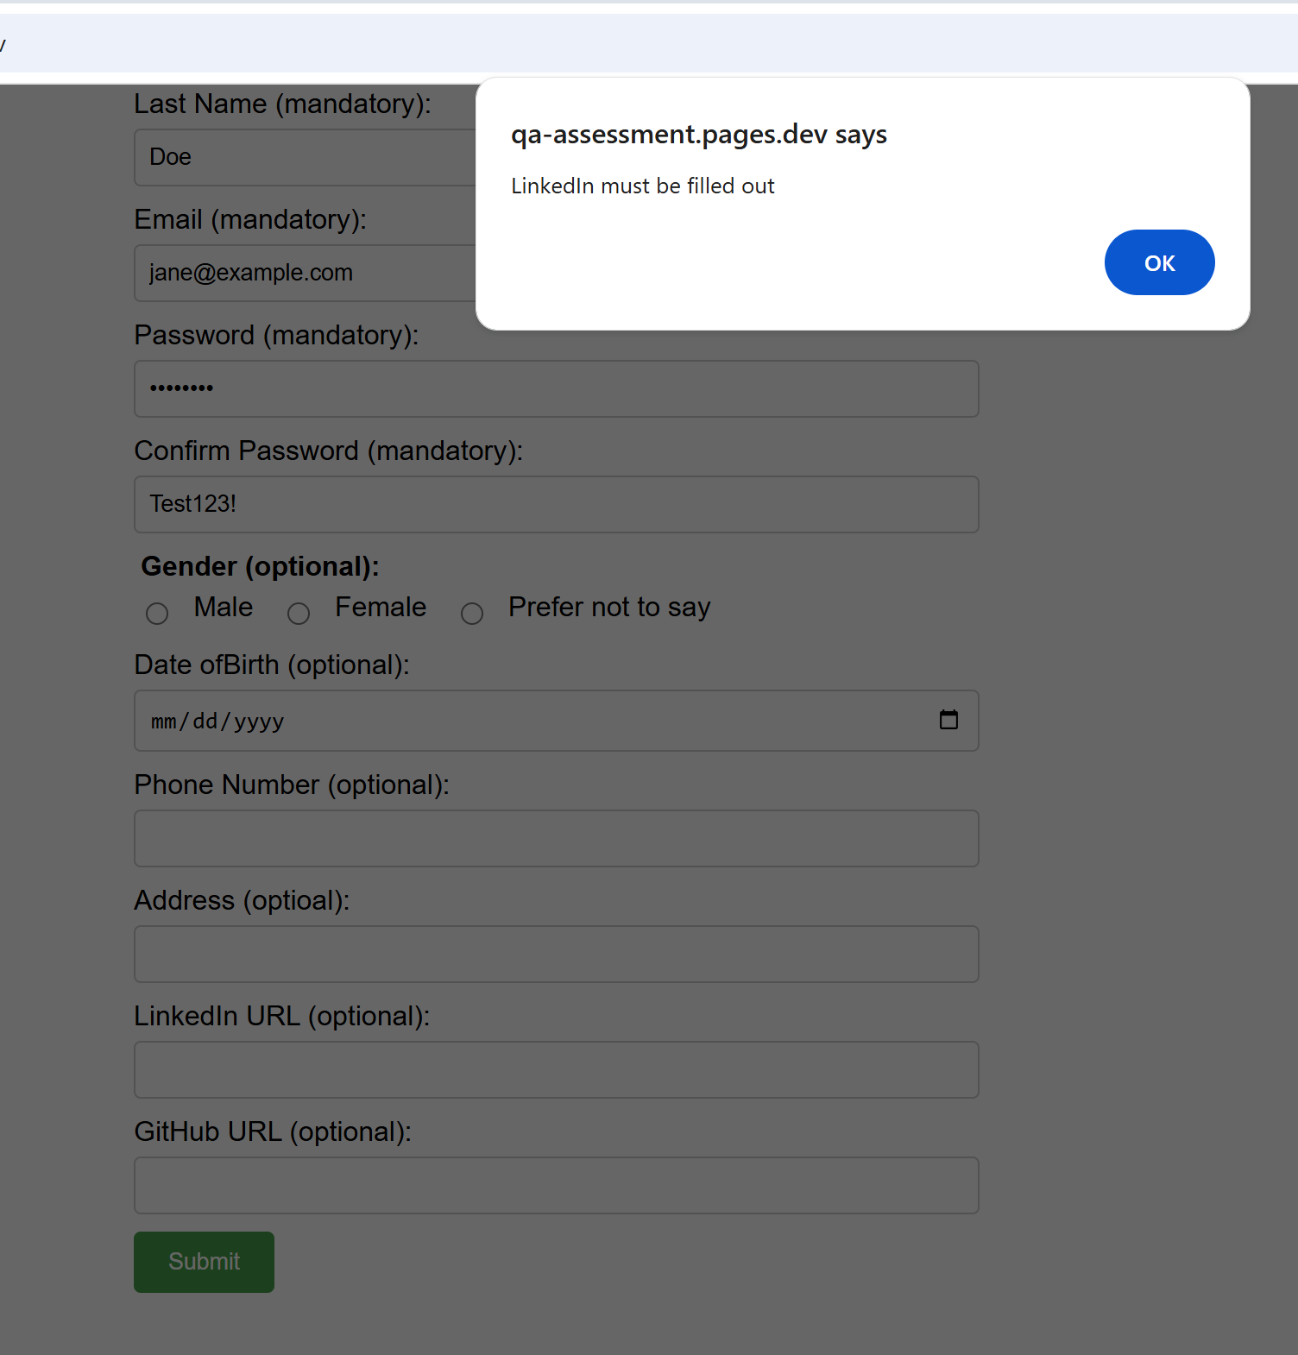

**Test Case: Invalid LinkedIn URL**

* **Status**: Failed
* **Steps to Reproduce**:
  1. Fill all mandatory fields.
  2. Enter a url which is not related to linkedin in LinkedIn field.
  3. Click Submit.
* **Expected Result**: Dialog: "Please enter a valid LinkedIn URL".
* **Actual Result**:
  1. Url Is Accepted and process moves forward
* Proof: Screenshot
* 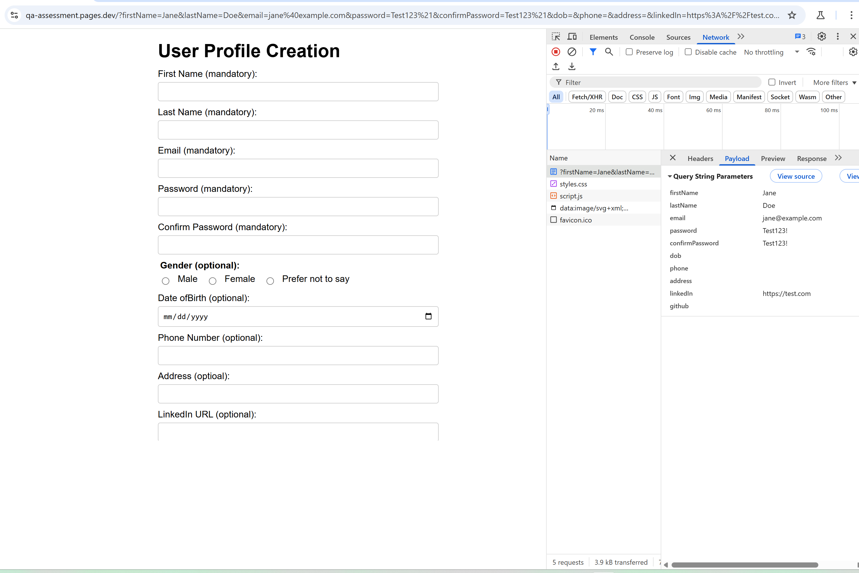

**Test Case: Invalid Github URL but still a Url**

* **Status**: Failed
* **Steps to Reproduce**:
  1. Fill all mandatory fields.
  2. Enter a url which is not related to Github in github field.
  3. Click Submit.
* **Expected Result**: Dialog: "Please enter a valid Github URL".
* **Actual Result**:
  1. Url Is Accepted and process moves forward
* Proof: Screenshot

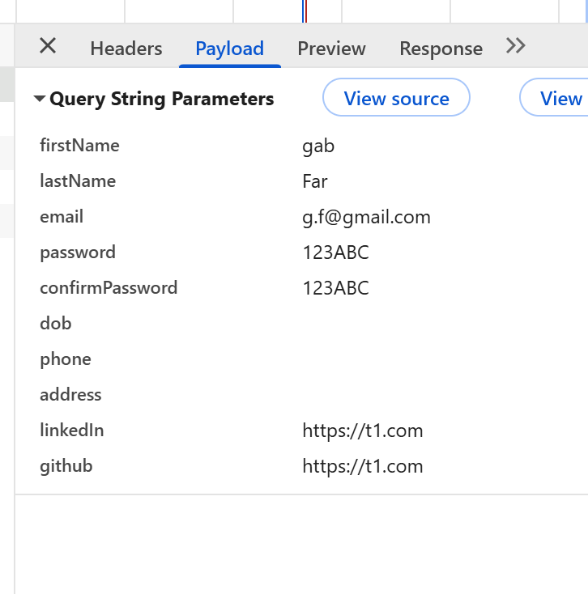

Among the user process bugs I have notices a few other Issues I would raise with management and Developers which pose more of a security risk,

1. The Confirm password field is not hidden(this could be considered for a future test case)

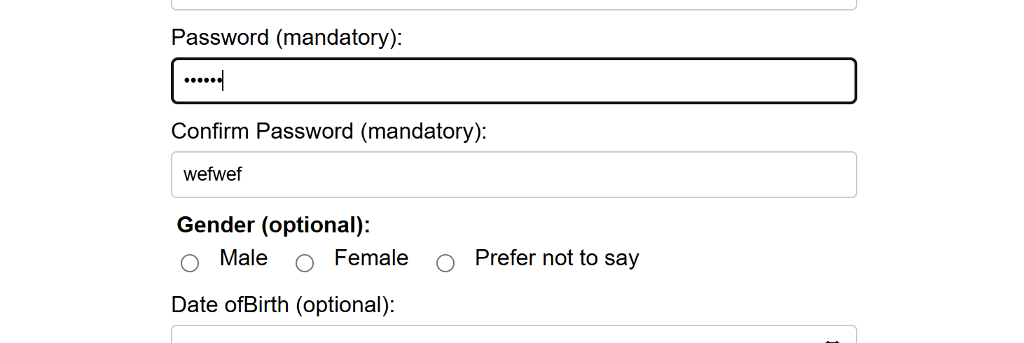

1. Sensitive data is visible in the top section of the browser (where the link is present), this can also become an automated test as we can monitor and log the changes to a website`s link.



1. Data is not hidden in the payload tab and is susceptible to payload interception which poses a gdpr and company risk. Where sensitive data could be present

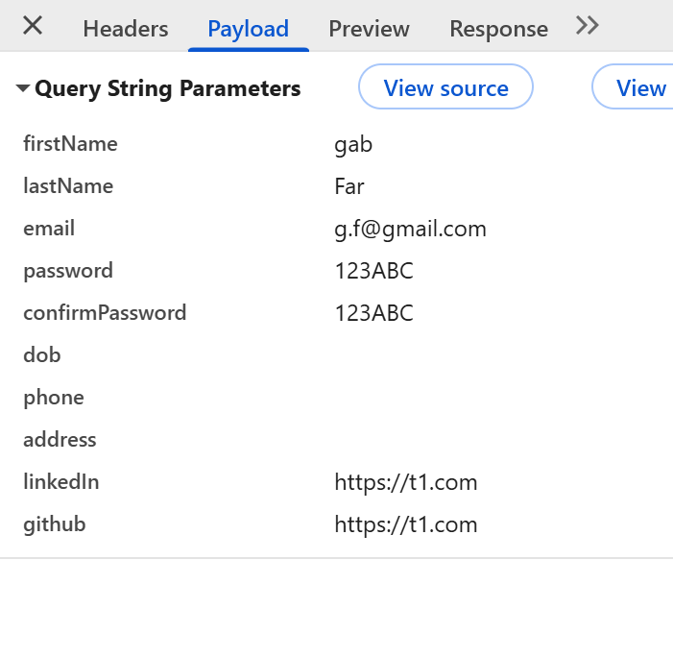

1. Another thing I would highlight is that there is no confirmation message when user`s data is successfully submitted, this could make the user re-submit data repeatedly which could pose a risk to data integrity due to duplicate data. More importantly this heavily hinders a user`s experience with the application.