Finding interactions among many molecules with a small fraction of exhaustive experiments
Gabriel Krouk^{a,1} and Dennis E. Shasha^{b}
ªInstitute for Plant Sciences of Montpellier (IPSiM), Univ Montpellier, CNRS, INRAE, Institut Agro, 34060 Montpellier, France; ^{b}Courant Institute of Mathematical Sciences, New York University, New York, NY 10012, USA
¹To whom correspondence may be addressed. Email: [to be completed]
Classification: Biological Sciences: Systems Biology; Physical Sciences: Statistics
Keywords: combinatorial design | synergy | interaction | experimental design | higher-order interactions
This PDF/Word file includes: Main text, Figures 1 to 5, Table 1. Supporting Information: Figures S1 to S3 (legends at the end of this file).

Abstract
Nutrients, hormones, drugs, and pollutants reach cells as mixtures, and synergy and antagonism appear only when molecules interact. Testing all combinations is out of reach: every pair among 100 molecules already means more than 5,000 conditions, and every mixture more than 10³⁰. We combined combinatorial designs, in which each molecule is present in half of the mixtures and every pair is observed in all four presence/absence states, with a parsimonious analysis that always estimates each molecule's own effect and adds interactions only when the data support them. In simulations with up to 100 molecules, the number of mixtures needed grew about linearly with the number of molecules. At 100 molecules, finding five interactions took 12 to 27 times fewer mixtures than an exhaustive pairwise screen, which, at equal replication, missed most moderate interactions. We then benchmarked the approach on three published complete factorial experiments (a plant transcriptome, plant root traits, and bacterial growth under antibiotics) by reanalyzing subsets of the data. With one third of the mixtures, combinatorial designs recovered 76 to 87% of single-molecule effects and predicted untested mixtures better than one-at-a-time strategies, whereas interactions needed most of the design. The weight of an effect fell steeply with its order: three-way and higher interactions were rare in gene expression and formed a diffuse background of small effects in phenotypes. Calibrating simulations on these empirical effect sizes removed most of their optimism and yields practical rules for sizing experiments.

Significance
Interactions between molecules, where a combination does more or less than its parts predict, drive drug efficacy, nutrient and hormone signaling, and toxicity. Testing every combination is impossible beyond a handful of molecules. We show that choosing which mixtures to test carefully, and analyzing them parsimoniously, finds the important interactions among dozens to a hundred molecules with a small fraction of the experiments of an exhaustive screen. We verify this on real complete datasets rather than on simulations alone. We also find that interactions involving three or more molecules are usually rare or weak. This explains why simple models predict untested mixtures well, and it gives experimentalists concrete rules to size their studies.

Introduction
Living systems integrate many chemical signals at once. A plant root senses nitrate, ammonium, phosphate, and several hormones simultaneously (1, 2). A bacterium in a patient or in soil meets several antibiotics or stressors together (3–5). A cancer cell is treated with drug cocktails (6, 7), and a microbial community assembles from many species and metabolites (8, 9). In each case, the effect of one molecule may depend on which others are present. Such interactions, synergy when the combination does more than expected and antagonism when it does less (10), are often what we most want to discover. They point to shared pathways and crosstalk between signals, and they are the basis of combination therapies.
Discovering interactions runs into a combinatorial wall. With K molecules that can each be present or absent, there are 2^{K} possible mixtures: 32 for five molecules, about a million for 20, and more than 10³⁰ for 100. Restricting attention to pairs still requires 1 + K + K(K − 1)/2 conditions (the control, each molecule alone, and each pair), which is 5,051 conditions for 100 molecules before any replication. Exhaustive pairwise screens of about 100 drugs have been carried out at considerable cost (7), and complete factorial experiments, which test every mixture, exist only for about five factors (1, 2, 5). For most laboratories, studying interactions among dozens of molecules therefore looks impossible.
Statistics and computer science offer a way out. Classical screening designs from agriculture and industry estimate many effects from few runs by exploiting three empirical regularities (11–14). Under effect sparsity, few effects are large. Under hierarchy, single-factor effects tend to be larger than two-factor interactions, which tend to be larger than three-factor interactions. Under heredity, interactions tend to involve factors that also act alone (15–17). Software engineers independently developed covering arrays, small sets of test configurations in which every pair (or triple) of parameters appears in every combination of settings (18–20). Twenty-five years ago, one of us and colleagues proposed using such combinatorial designs to study how biological systems respond to multiple input signals (21). Related ideas include group testing (22, 23), learning hidden interaction graphs with few queries (24, 25), compressed sensing (26) of sparse fitness landscapes (27, 28), and the prediction of multidrug responses from single drugs and pairs (29–33).
Despite this body of work, experimental biologists lack quantitative answers to practical questions. How many experiments are needed to find interactions, as a function of the number of molecules, the number of interactions, and their size? Do the simulations used to plan experiments reflect real data? How common are interactions among three or more molecules, and how should models deal with them? Here we address these questions with three complementary approaches. First, we simulated experiments with up to 100 molecules. Second, we benchmarked designs on three published complete factorial datasets, where the full answer is known. Third, we calibrated the simulations on the distribution of effect sizes measured in those real data. We find large and robust savings over exhaustive designs, together with an important caveat about weak and high-order interactions.

Results

A design in which every pair of molecules is seen in all four states
Fig. 1 contrasts two ways of studying 10 molecules. An exhaustive pairwise screen (Fig. 1A) measures a control, each molecule alone, and each of the 45 pairs, for 56 conditions. Each pair is informed by only the few conditions in which it is present or absent alone. A combinatorial design (Fig. 1B) instead measures mixtures in which each molecule is present in half of the conditions, chosen so that every pair of molecules appears in all four presence/absence states (both present, either one alone, both absent) several times. Every mixture then informs every molecule and every pair at once, a property known since Fisher as hidden replication (11, 13). In this example, 16 mixtures suffice to observe each pair in each of its four states at least 3 times. The smallest designs with this property are covering arrays of strength 2, whose size grows only with the logarithm of K (18, 34). Larger designs that reach the same property are easy to obtain by balanced random sampling or by greedy algorithms (19, 21).
We analyzed all designs in the same simple way, intended to be transparent to biologists (Materials and Methods). For each measured output (a gene, a trait, a growth rate), the model always includes the effect of each molecule alone. Candidate interactions are then added one at a time, the strongest first, as long as each addition is statistically significant after correction for the number of candidates tested (Bonferroni, α = 0.01). We report interaction size, d, as the classical factorial effect expressed in units of the replicate standard deviation (13). An interaction of size d = 1 means that the pair of molecules together departs from the additive expectation by two replicate standard deviations. For orientation, the interactions detected in the real datasets analyzed below had median sizes between 0.5 and 1.2.

The cost of finding interactions grows about linearly with the number of molecules
We simulated experiments with K = 10 to 100 molecules, of which half had an effect of their own, plus M = 1 to 10 pairwise interactions of size d = 0.5, 1, or 2, a diffuse background of very small interactions, and 3 replicates per mixture (Materials and Methods). For each scenario we increased the number of mixtures N until 95% of the planted interactions were recovered (Fig. 2A). At that point, single-molecule effects were recovered in 92–100% of cases, and on average 4% of reported interactions were false (at most 16% in any scenario).
The number of mixtures needed grew about linearly with K (Fig. 2B). For five interactions of size 1, it went from 87 mixtures for 18 molecules to 133 for 50 and 215 for 100, whereas the exhaustive pairwise screen grows quadratically, from 172 to 1,276 and 5,051 conditions. The saving therefore increases with the number of molecules (Fig. 1C and Fig. 2C). It was 2-fold for 18 molecules, 10-fold for 50, and 24-fold for 100. Weak interactions (d = 0.5) were more expensive (401 mixtures at K = 100), and the number of interactions mattered less than their size: going from 1 to 10 interactions raised the cost at K = 100 from 174 to 262 mixtures. Across all 72 scenarios, a simple rule summarized the simulations with a median error of 5% (R² = 0.97):
N₉₅ ≈ 1.6 K + 6 M + 50/d² − 15.
In words, each additional molecule costs about one and a half mixtures, each additional interaction about six, and halving the size of the interactions sought adds about 150 mixtures. Below about 15 molecules, the exhaustive pairwise screen required fewer conditions than the combinatorial design (Fig. 2C).
The comparison above counts conditions only and is therefore generous to the exhaustive screen. With the same 3 replicates and the same analysis, the exhaustive pairwise screen recovered only 15–22% of interactions of size 1 and almost none of size 0.5, despite measuring up to 10 times more conditions (Fig. 2E). Only strong interactions (d = 2) were found reliably. In an exhaustive screen, each pairwise interaction is estimated from the handful of conditions that contain the pair, so it is measured with far less precision than in a combinatorial design, where every mixture contributes. To recover 95% of interactions of size 1, the exhaustive screen needed about 10 replicates per condition instead of 3 (simulations at K = 18 and 30). Counting every measurement, the combinatorial design was thus 7-fold more economical for 18 molecules and 14-fold for 30 molecules at equal success, and the gap widens with K.
Three-way interactions were more costly to find, because the number of candidate triplets grows as K³ and each triplet is observed less often in its fully present state. Nonetheless, for 18 to 30 molecules, 81 to 134 mixtures sufficed to recover one to five three-way interactions of size 1 (Fig. 2D). An exhaustive screen of all pairs and triplets would need 988 and 4,526 conditions, respectively, 10- to 42-fold more.

Benchmark on real complete factorial experiments
Simulations depend on assumptions about effect sizes, noise, and the structure of interactions. To test the approach on real biology, we used three published experiments in which every one of the 32 mixtures of five factors was measured. These were the transcriptome of Arabidopsis thaliana roots exposed to all combinations of nitrate, ammonium, auxin, cytokinin, and abscisic acid (15,348 expressed genes, 2 replicates) (1); 15 root architecture traits of Arabidopsis grown under all combinations of nitrogen, phosphorus, potassium, and sulfur supply and light (about 16 plants per mixture) (2); and the growth of Escherichia coli under all combinations within thousands of five-antibiotic panels (2,000 panels sampled from 10,891, 3 replicates) (5). For each output, the complete design provided the reference answer: which single-factor effects and interactions are real, and what each mixture's true mean is. We then analyzed subsets of 6 to 32 mixtures chosen according to three strategies (Fig. 3). In the combinatorial strategy, a strength-3 covering array of 10 mixtures was followed by the remaining mixtures in random order. In the balanced random strategy, mixtures were drawn at random. In the one-at-a-time ladder, the control came first, then each factor alone, then pairs, triplets, and so on. For root traits, the reference and the subsets came from two independent halves of the plants, so that the benchmark was not evaluated on the data used to define the answer.
Single-factor effects were recovered quickly by all strategies, but fastest with the combinatorial design (Fig. 3A). With 10 of 32 mixtures (31%), the combinatorial design recovered 87%, 76%, and 85% of the reference single-factor effects in the three datasets, compared with 77%, 45%, and 72% for the one-at-a-time ladder. With 16 mixtures, recovery reached 98%, 83%, and 91%. The combinatorial design also predicted the mixtures that had not been measured more accurately (Fig. 3B). For the transcriptome with 10 mixtures, the prediction error of untested mixtures was 1.28 times the noise of a measured mixture, against 1.66 for the one-at-a-time ladder and 1.52 for random designs, and it approached 1.2 with 16 mixtures. For the phenotypes, prediction errors were higher because these outputs carry many interactions (below), but the ranking of strategies was the same.
Interactions, in contrast, required most of the design (Fig. 3C). With half of the mixtures, 20 to 30% of the reference interactions were recovered, and with all 32 mixtures, 94% for the transcriptome, 53% for root traits, and 62% for bacterial growth. The last two values are below 100% because, in these datasets, many reference interactions are barely above the noise; they are found in one half of the plants but not in the other, or only with the full design. For interactions, the three strategies performed similarly once more than a third of the mixtures had been measured. The advantage of combinatorial designs therefore lies chiefly in obtaining a reliable additive picture, and good predictions, early.

Interactions among three or more molecules are rare or weak
Because complete factorial data contain every possible term, they let us ask directly how important each order of interaction is (Fig. 4). We decomposed the variation of each output among the 32 mixture means into contributions of single-factor effects, pairs, triplets, and four- and five-way interactions, correcting for measurement noise (Materials and Methods). Single-factor effects explained 56 to 92% of the variation, pairs 7 to 22%, triplets 1 to 19%, and four- and five-way interactions together at most 3% (Fig. 4A). Because there are more possible terms of intermediate order, the weight of an individual term is more informative (Fig. 4B). It fell from 11–31% for a single-factor effect to 0.8–2.2% for a pair, 0.4–1.9% for a triplet, and less than 0.5% for a four- or five-way term. These values are upper bounds for the higher orders, which are close to the noise floor.
The frequency of detectable interactions differed sharply between kinds of output (Fig. 4C). In the two transcriptomes, only 2.2% and 3.8% of responsive genes showed a detectable pairwise interaction and fewer than 0.2% a three-way interaction. Most genes responded additively to the signals. In the two phenotypic datasets, by contrast, most outputs carried at least one pairwise interaction (89–93%), and many carried a three-way interaction (47% for bacterial growth, 73% for root traits). However, these interactions were small. The median size of detectable three-way interactions was 0.86 for bacterial growth and 0.37 for root traits, compared with 2.0 and 0.76 for single-factor effects. A mixture model of all effect sizes (Materials and Methods) confirmed this picture. Large interactions (above the noise) made up 0.2–39% of pairs and at most 8% of triplets, whereas small non-zero interactions were common in phenotypes. Consistent with their size, three-way interactions in the phenotypic datasets were recovered half as often as pairs, or less, at any design size; in the transcriptome, the few three-way interactions were large and were recovered as well as pairs once most mixtures were measured (Fig. 4D).

Calibrating the planning simulations on real data
We next asked whether our simulator, when given the real effects, reproduces the success observed on real data. A naive simulation, which keeps the significant effects of the complete design and adds Gaussian noise, was optimistic. It overestimated the recovery of interactions by 7 percentage points on average and by 10 points for three-way interactions (Fig. 5A). The reason is that real data contain, besides a few clear interactions, many small ones that the naive simulation sets to zero. These small effects blur the large ones and reduce the effective sample size. We therefore fitted, for each dataset and each order, an empirical distribution of effect sizes in which an effect is either zero, small, or large (Materials and Methods), and simulated new data from it. This calibrated simulation reduced the average bias from 7.2 to 4.2 points and the mean absolute error from 8.6 to 5.0 points (Fig. 5B). Using the empirical, heavy-tailed distribution of residuals in place of Gaussian noise brought a further small improvement (bias 3.7 points).
The calibrated view changes the planning of experiments in two ways. First, interactions in real data are often smaller than those typically assumed in planning (d ≈ 0.5–1 rather than 2), and the cost of finding them grows as 1/d². Second, a diffuse background of small interactions raises the cost further (Fig. 5C). With five interactions of size 1 among 50 molecules, 132 mixtures sufficed without background but 171 were needed with a background as dense as in the phenotypic datasets. With such a background, about 20% of the reported interactions were real but small background terms rather than the planted ones, and weak interactions (d = 0.5) among 18 molecules could not reach 95% recall at all within 15 K mixtures. In such systems, demanding that every interaction be found exactly is unrealistic. Targeting the recovery of the large interactions and the accurate prediction of mixtures is a better goal.

Experiments in waves and choice of analysis
Because the first mixtures of a combinatorial design already give a good additive model, experiments can be run in waves, stopping when the measurements of a new wave are predicted within the noise. On the transcriptome, this rule recovered the complete answer for 95% of outputs (97% when all 32 mixtures were measured) while using 16.6 mixtures on average, half of the complete design (SI Appendix, Fig. S1). On the phenotypic datasets, it stopped too early in about half of the cases, because many small interactions are each individually invisible yet together degrade predictions. This is again a signature of a dense background. Finally, the forward-selection analysis was as good as or better than a lasso regression with all pairs and triplets as candidates (35, 36). It recovered the exact set of interactions in 96–97% of transcriptome outputs, against 61–97% for the lasso, and in up to 43% of bacterial-growth outputs, against at most 22% (SI Appendix, Fig. S2).

Discussion
Our results support a simple message for anyone who wants to study how many molecules act together. Measuring all combinations, or even all pairs, is not necessary. A combinatorial design with a number of mixtures that grows about linearly with the number of molecules recovers single-molecule effects quickly, predicts untested mixtures well, and finds the clear pairwise interactions, at a small fraction of the cost of exhaustive designs. The saving reaches one to two orders of magnitude for 50 to 100 molecules. It is even larger at equal statistical power, because each mixture informs every pair. These conclusions hold on real complete datasets and not only in simulation. The rule N₉₅ ≈ 1.6 K + 6 M + 50/d² − 15, together with the interactive calculator that we provide, gives experimentalists a starting point to size their studies.
The second message concerns the structure of interactions in biology. In the four complete datasets we examined, the weight of an individual effect decreased steeply with its order. A pair carried 5 to 20 times less variation than a single molecule, and three-way and higher terms less still. This agrees with the hierarchy principle of industrial experimentation (14, 15, 17). It also agrees with studies of genetic and drug interactions, which found that higher-order epistasis and higher-order drug interactions exist but are usually modest compared with lower-order terms (5, 32, 37–39). It fits the observation that the effects of drug cocktails (29, 30, 33) and the functions of microbial communities (8, 9) can often be predicted from single components and pairs. Two different regimes, however, emerged. In gene expression, interactions were rare: most genes responded additively, and the few interactions were large. In integrated phenotypes such as growth and root architecture, interactions were common but small, forming a dense background in which few terms stand out.
These two regimes have distinct consequences for models. When interactions are rare and large, as in the transcriptomes, sparse models with all single-molecule effects and a few selected interactions are both interpretable and nearly exact. Forward selection with a strict threshold, or hierarchical sparse regressions (40, 41), is well suited to this regime, and adaptive experiments can stop early. When interactions are many and small, as in the phenotypes, no feasible experiment will identify each of them, and attempting to do so produces unstable lists of interactions that differ between replicate experiments, as we observed between the two halves of the root data. In this regime, models should aim at prediction rather than at an exact list of interactions. They should treat the background of small interactions as structured variation, for example through shrinkage or random effects (42, 43), and report only the few interactions that clearly exceed it. Simulations used for planning should include such a background, or they will promise more than experiments deliver, as we showed by calibration. The rarity of strong higher-order interactions also matters for interpretation. In a combinatorial design, a pairwise interaction is measured on average over the many backgrounds in which the pair occurs, whereas an exhaustive pairwise screen measures it against an empty background. The two definitions coincide when higher-order terms are negligible, which is what we observed in gene expression.
Our study has limitations. We considered molecules present or absent at a single dose, whereas many interactions depend on concentration. Combinatorial designs can include several dose levels, at the price of more mixtures (20). In balanced designs, each mixture contains about half of the molecules, which may raise solubility, toxicity, or osmotic issues when K is large. Designs in which each molecule is present in a smaller fraction of mixtures, or blocked designs that keep the number of molecules per mixture low, can address this, with some loss of efficiency. Whether a combination is called synergistic depends on the scale of measurement (for instance, logarithmic for growth and expression) and on the reference model of additivity (10). Finally, our benchmark datasets have five factors. Larger complete datasets do not exist, which is precisely why designs such as those studied here are needed, and why we calibrated simulations on the real data rather than relying on them blindly.
In practice, we suggest the following strategy. Start with a combinatorial design of about 1.6 K + 50/d² mixtures for the smallest interaction size of interest, measured in replicate. Fit an additive model with single-molecule effects, add interactions only when they are clearly supported, and check whether the next wave of mixtures is predicted within the noise. If it is, the system is close to additive and the experiment can stop. If not, extend the design, keeping in mind that some systems carry many small interactions that no reasonable experiment will resolve individually. Exhaustive pairwise screens remain sensible below about 15 molecules or when only very strong interactions matter.

Materials and Methods

Designs
Mixtures are coded as vectors of K binary values (molecule present or absent). In the simulations, designs were balanced, with each molecule present in exactly half of the N mixtures, assigned at random independently for each molecule. For the sizes needed to detect interactions, such designs place every pair of molecules in each of its four presence/absence states many times. In the benchmark, the combinatorial strategy started from a covering array of strength 3 for five factors (10 mixtures in which every triplet of factors appears in all eight presence/absence states), found by exhaustive search. Its foldover (all presences and absences swapped) is the array itself, and it was followed by the remaining mixtures in random order. Factor labels and the coding of presence and absence were randomly permuted for each draw, so that results do not depend on a particular array. The balanced random strategy used a random order of all 32 mixtures. The one-at-a-time ladder used the control, then all single factors, then all pairs, and so on, in random order within each level. Each strategy was evaluated at N = 6, 8, 10, 12, 14, 16, 20, 24, 28, and 32 mixtures, as the first N mixtures of its sequence.

Analysis model
Responses were modeled with a linear model in ±1 coding (−1 absent, +1 present), so that in a complete factorial all terms are orthogonal. The factorial effect of a term is twice its coefficient (13), and we express effect sizes d in units of the replicate standard deviation σ. Single-molecule effects were always included and tested with t tests (α = 0.05). Interaction terms (all pairs, or all pairs and triplets) were candidates for forward selection. At each step, the candidate that most reduced the residual sum of squares after orthogonalization against the terms already in the model was added if its partial F test was significant with a Bonferroni correction for the number of candidates (α = 0.01). At most M + 8 interactions (8 in the benchmark) could be selected. Responses were analyzed independently, using vectorized linear algebra so that tens of thousands of genes could be processed together.

Simulations
For each scenario (K, M, d), a balanced design of N mixtures with 3 replicates was generated. K/2 molecules received a single-molecule coefficient drawn from N(0, 1.1²), and M randomly chosen pairs (or triplets) received coefficients of ±d/2. All remaining interactions of the candidate orders received small coefficients with total variance B = 0.1 (diffuse background), and Gaussian noise with σ = 1 was added. Each simulation analyzed 30 independent outputs (40 for preliminary runs). For each scenario, N was increased geometrically from K + 2 + 2M by factors of 1.3 until recall exceeded 0.97 twice in a row. N₈₀ and N₉₅ were obtained by log-linear interpolation of the monotone envelope of recall against N. Pairs were simulated for K = 10, 18, 30, 50, 75, and 100; M = 1, 3, 5, and 10; and d = 0.5, 1, and 2. Triplets were simulated for K = 10, 18, and 30; M = 1, 3, and 5; and d = 1 and 2. Larger K was not simulated for triplets because the number of candidates (161,700 at K = 100) makes forward selection impractical. The effect of the background was studied for K = 18, 50, and 100 with M = 5 and B = 0 or 0.45, the latter matching the density of small interactions estimated in the phenotypic datasets. The exhaustive pairwise screen was simulated with the same model, the same replication, and the same analysis for K = 10 to 50. To find the replication needed by the exhaustive screen, we repeated its simulation with 3, 6, 10, 15, and 20 replicates per condition for K = 18 and 30 (M = 5, d = 1).

Real datasets
Plant transcriptome. Affymetrix ATH1 data for Arabidopsis roots treated with all 32 combinations of nitrate, ammonium, indole-3-acetic acid, cytokinin, and abscisic acid, in duplicate (1), were obtained from the Gene Expression Omnibus (GSE71737) (44). Values were log₂-transformed, and the 15,348 probes (Affymetrix controls excluded) with signal above 100 in at least half of the arrays were retained. As a check, the number of probes with any term significant at P < 0.01 in the complete model (9,508) matched the original report (9,507).
Plant root traits. Fifteen root system architecture traits of Arabidopsis plants grown under all 32 combinations of nitrogen, phosphorus, potassium, sulfur, and light, measured at day 10 (2), were taken from the supplementary data of the original publication. Counts and lengths were log(1 + x)-transformed. Within each mixture, plants were randomly split into two halves 20 times; the reference was defined on one half and the designs were evaluated on the other. A transcriptome of the same study (2³ combinations of nitrogen, phosphorus, and potassium; 10,751 genes) was used only for the analyses of Fig. 4.
Bacterial growth. Relative growth of E. coli in all 32 combinations within five-antibiotic panels drawn from eight antibiotics at several doses, in triplicate (5), was extracted from the supplementary data of the original publication (10,891 panels). Growth was expressed as log₂ of the percentage of the no-drug control, which was set to 0. A random subset of 2,000 panels was used in the benchmark to limit computation time.

Reference answers and metrics
For each output, the complete model with all 31 terms was fitted on all observations. Terms with a Benjamini–Hochberg false discovery rate below 1% across all outputs and terms were considered real (45). Single-factor recall was the fraction of real single-factor effects declared significant in the subset analysis. Interaction recall was the fraction of real pairs and triplets selected. Prediction error was the root mean square difference between predicted and observed means of the mixtures not included in the subset, divided by the standard error of a mixture mean. A second reference, defined as the conclusions of the same forward-selection analysis applied to all 32 mixtures, gave the same ranking of strategies. Results were averaged over 30 random draws for the transcriptome and bacterial growth, and over 20 splits × 5 draws for root traits.

Weight of each order of interaction
In a complete two-level factorial with ±1 coding, the variance of the 2^{K} true mixture means decomposes exactly into the sum of squared coefficients of all terms. For each output, we estimated each squared coefficient without bias as β̂² − SE(β̂)², truncated at zero. We summed these values by order and divided by the total, pooling over outputs with at least one real effect. Because truncation inflates near-zero terms, the values reported for high orders are upper bounds.

Empirical distribution of effect sizes and calibrated simulation
For each dataset and order, the standardized coefficients z = β̂/σ̂ were modeled as a mixture of three components convolved with their sampling error: zero, a small effect N(0, τ₁²), and a large effect N(0, τ₂²). The mixture was fitted by expectation–maximization, in the spirit of empirical Bayes deconvolution (43, 46). In the calibrated simulation, true effects for every term (including four- and five-way terms) were drawn from these mixtures, complete data were simulated with the real design and replication, the reference answer was re-estimated from the simulated complete design exactly as for real data, and subsets were analyzed as in the benchmark. In a variant, Gaussian noise was replaced by resampled standardized residuals of the real data. Predicted and observed recalls were compared for each dataset, order, strategy, and design size. Transcriptome triplets were excluded from the comparison because only five such reference interactions exist.

Stopping rule and lasso comparison
For the wave strategy, the combinatorial sequence was measured in waves of 10, 16, 24, and 32 mixtures. After each wave, the model was used to predict the next wave. The experiment stopped, after measuring that wave, when the root mean square prediction error was below 1.5 times the error expected from noise alone. For the lasso, all interaction candidates were orthogonalized against the single-factor effects and standardized, and the penalty was chosen by the Bayesian information criterion along the least-angle regression path (36, 47).

Software and data availability
All analyses were performed in Python with NumPy, SciPy, and scikit-learn (47). The code for designs, simulations, benchmarks, and figures, together with an interactive web calculator that returns the number of mixtures needed for given K, M, and d, will be deposited in a public repository upon publication [link to be added]. All data analyzed are publicly available from the original publications and GEO (GSE71737).

Acknowledgments
[To be completed: funding sources and acknowledgments.]

Author contributions
G.K. and D.E.S. designed research; G.K. performed research and analyzed data; G.K. and D.E.S. wrote the paper.

Competing interests
The authors declare no competing interest.

References
1. D. Ristova et al., Combinatorial interaction network of transcriptomic and phenotypic responses to nitrogen and hormones in the Arabidopsis thaliana root. Sci. Signal. 9, rs13 (2016).
2. F. Kellermeier et al., Analysis of the root system architecture of Arabidopsis provides a quantitative readout of crosstalk between nutritional signals. Plant Cell 26, 1480–1496 (2014).
3. P. Yeh, A. I. Tschumi, R. Kishony, Functional classification of drugs by properties of their pairwise interactions. Nat. Genet. 38, 489–494 (2006).
4. C. Beppler et al., Uncovering emergent interactions in three-way combinations of stressors. J. R. Soc. Interface 13, 20160800 (2016).
5. E. Tekin et al., Prevalence and patterns of higher-order drug interactions in Escherichia coli. NPJ Syst. Biol. Appl. 4, 31 (2018).
6. J. Lehár et al., Synergistic drug combinations tend to improve therapeutically relevant selectivity. Nat. Biotechnol. 27, 659–666 (2009).
7. S. L. Holbeck et al., The National Cancer Institute ALMANAC: A comprehensive screening resource for the detection of anticancer drug pairs with enhanced therapeutic activity. Cancer Res. 77, 3564–3576 (2017).
8. J. Friedman, L. M. Higgins, J. Gore, Community structure follows simple assembly rules in microbial microcosms. Nat. Ecol. Evol. 1, 0109 (2017).
9. A. Skwara et al., Statistically learning the functional landscape of microbial communities. Nat. Ecol. Evol. 7, 1823–1833 (2023).
10. C. I. Bliss, The toxicity of poisons applied jointly. Ann. Appl. Biol. 26, 585–615 (1939).
11. R. A. Fisher, The Design of Experiments (Oliver and Boyd, Edinburgh, 1935).
12. R. L. Plackett, J. P. Burman, The design of optimum multifactorial experiments. Biometrika 33, 305–325 (1946).
13. G. E. P. Box, J. S. Hunter, W. G. Hunter, Statistics for Experimenters: Design, Innovation, and Discovery (Wiley, Hoboken, NJ, ed. 2, 2005).
14. C. F. J. Wu, M. S. Hamada, Experiments: Planning, Analysis, and Optimization (Wiley, Hoboken, NJ, ed. 2, 2009).
15. M. Hamada, C. F. J. Wu, Analysis of designed experiments with complex aliasing. J. Qual. Technol. 24, 130–137 (1992).
16. H. Chipman, Bayesian variable selection with related predictors. Can. J. Stat. 24, 17–36 (1996).
17. X. Li, N. Sudarsanam, D. D. Frey, Regularities in data from factorial experiments. Complexity 11, 32–45 (2006).
18. N. J. A. Sloane, Covering arrays and intersecting codes. J. Comb. Des. 1, 51–63 (1993).
19. D. M. Cohen, S. R. Dalal, M. L. Fredman, G. C. Patton, The AETG system: An approach to testing based on combinatorial design. IEEE Trans. Softw. Eng. 23, 437–444 (1997).
20. C. J. Colbourn, Combinatorial aspects of covering arrays. Le Matematiche 59, 125–172 (2004).
21. D. E. Shasha, A. Y. Kouranov, L. V. Lejay, M. F. Chou, G. M. Coruzzi, Using combinatorial design to study regulation by multiple input signals. A tool for parsimony in the post-genomics era. Plant Physiol. 127, 1590–1594 (2001).
22. R. Dorfman, The detection of defective members of large populations. Ann. Math. Stat. 14, 436–440 (1943).
23. D.-Z. Du, F. K. Hwang, Combinatorial Group Testing and Its Applications (World Scientific, Singapore, ed. 2, 2000).
24. D. Angluin, J. Chen, Learning a hidden graph using O(log n) queries per edge. J. Comput. Syst. Sci. 74, 546–556 (2008).
25. C. J. Colbourn, D. W. McClary, Locating and detecting arrays for interaction faults. J. Comb. Optim. 15, 17–48 (2008).
26. D. L. Donoho, Compressed sensing. IEEE Trans. Inf. Theory 52, 1289–1306 (2006).
27. F. J. Poelwijk, M. Socolich, R. Ranganathan, Learning the pattern of epistasis linking genotype and phenotype in a protein. Nat. Commun. 10, 4213 (2019).
28. D. H. Brookes, A. Aghazadeh, J. Listgarten, On the sparsity of fitness functions and implications for learning. Proc. Natl. Acad. Sci. U.S.A. 119, e2109649118 (2022).
29. K. Wood, S. Nishida, E. D. Sontag, P. Cluzel, Mechanism-independent method for predicting response to multidrug combinations in bacteria. Proc. Natl. Acad. Sci. U.S.A. 109, 12254–12259 (2012).
30. A. Zimmer, I. Katzir, E. Dekel, A. E. Mayo, U. Alon, Prediction of multidimensional drug dose responses based on measurements of drug pairs. Proc. Natl. Acad. Sci. U.S.A. 113, 10442–10447 (2016).
31. A. Zimmer, A. Tendler, I. Katzir, A. Mayo, U. Alon, Prediction of drug cocktail effects when the number of measurements is limited. PLoS Biol. 15, e2002518 (2017).
32. I. Katzir, M. Cokol, B. B. Aldridge, U. Alon, Prediction of ultra-high-order antibiotic combinations based on pairwise interactions. PLoS Comput. Biol. 15, e1006774 (2019).
33. D. Russ, R. Kishony, Additivity of inhibitory effects in multidrug combinations. Nat. Microbiol. 3, 1339–1345 (2018).
34. D. J. Kleitman, J. Spencer, Families of k-independent sets. Discrete Math. 6, 255–262 (1973).
35. R. Tibshirani, Regression shrinkage and selection via the lasso. J. R. Stat. Soc. B 58, 267–288 (1996).
36. B. Efron, T. Hastie, I. Johnstone, R. Tibshirani, Least angle regression. Ann. Stat. 32, 407–499 (2004).
37. D. M. Weinreich, Y. Lan, C. S. Wylie, R. B. Heckendorn, Should evolutionary geneticists worry about higher-order epistasis? Curr. Opin. Genet. Dev. 23, 700–707 (2013).
38. Z. R. Sailer, M. J. Harms, Detecting high-order epistasis in nonlinear genotype-phenotype maps. Genetics 205, 1079–1088 (2017).
39. J. Otwinowski, D. M. McCandlish, J. B. Plotkin, Inferring the shape of global epistasis. Proc. Natl. Acad. Sci. U.S.A. 115, E7550–E7558 (2018).
40. J. Bien, J. Taylor, R. Tibshirani, A lasso for hierarchical interactions. Ann. Stat. 41, 1111–1141 (2013).
41. M. Lim, T. Hastie, Learning interactions via hierarchical group-lasso regularization. J. Comput. Graph. Stat. 24, 627–654 (2015).
42. A. Gelman, J. Hill, Data Analysis Using Regression and Multilevel/Hierarchical Models (Cambridge University Press, Cambridge, 2007).
43. M. Stephens, False discovery rates: A new deal. Biostatistics 18, 275–294 (2017).
44. R. Edgar, M. Domrachev, A. E. Lash, Gene Expression Omnibus: NCBI gene expression and hybridization array data repository. Nucleic Acids Res. 30, 207–210 (2002).
45. Y. Benjamini, Y. Hochberg, Controlling the false discovery rate: A practical and powerful approach to multiple testing. J. R. Stat. Soc. B 57, 289–300 (1995).
46. B. Efron, Large-Scale Inference: Empirical Bayes Methods for Estimation, Testing, and Prediction (Cambridge University Press, Cambridge, 2010).
47. F. Pedregosa et al., Scikit-learn: Machine learning in Python. J. Mach. Learn. Res. 12, 2825–2830 (2011).

Table 1. Number of mixtures needed to recover 95% of five pairwise interactions
Molecules (K) | Exhaustive pairwise screen | Combinatorial, size 2 | Combinatorial, size 1 | Combinatorial, size 0.5 | Saving (size 1)
10 | 56 | 49 | 74 | – | 0.8×
18 | 172 | 62 | 87 | 231 | 2.0×
30 | 466 | 87 | 114 | 264 | 4.1×
50 | 1,276 | 120 | 133 | 290 | 9.6×
75 | 2,851 | 146 | 183 | 371 | 15.6×
100 | 5,051 | 187 | 215 | 401 | 23.5×
Interaction size is expressed in replicate standard deviations (Materials and Methods); 3 replicates per mixture; half of the molecules have an effect of their own; diffuse background of small interactions (total variance 0.1). Saving = exhaustive conditions / combinatorial mixtures for size 1. –, 95% recall not reached within 15 K mixtures. The rule N95 ≈ 1.6 K + 6 M + 50/d² − 15 reproduces these values with a median error of 5%.

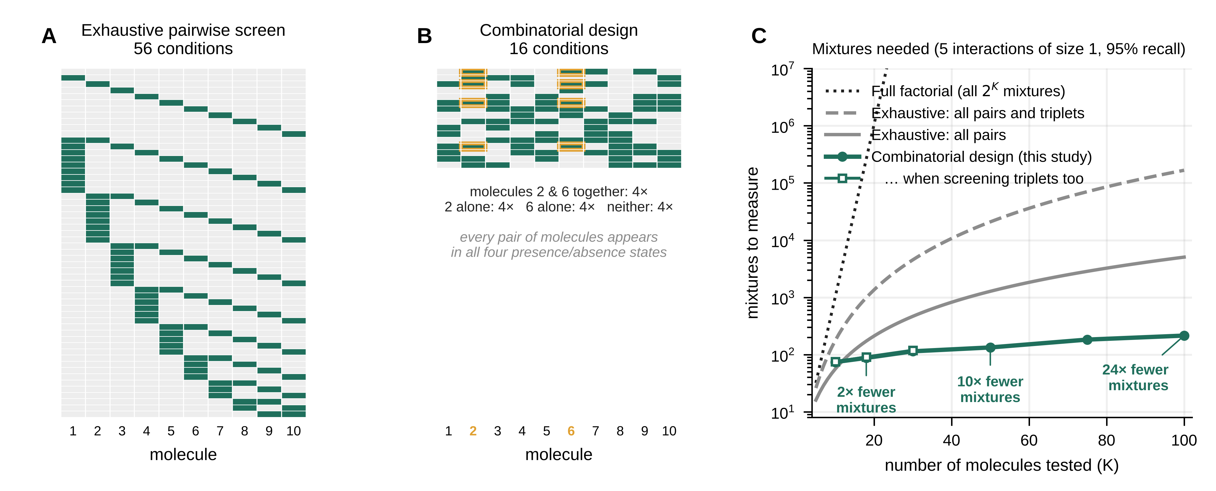
Fig. 1. Exhaustive versus combinatorial designs.
(A) An exhaustive pairwise screen of 10 molecules measures the control, each molecule alone, and each of the 45 pairs (56 conditions; rows, conditions; columns, molecules; green, present). (B) A combinatorial design of 16 mixtures for the same 10 molecules. Each molecule is present in half of the mixtures, and every pair of molecules occurs in all four presence/absence states; the cells outlined in orange show the mixtures in which molecules 2 and 6 are both present. Because every mixture informs every molecule and every pair, the design is both smaller and statistically more efficient. (C) Number of conditions needed as the number of molecules K grows: all 2^{K} mixtures (dotted), all pairs and triplets (dashed), all pairs (solid gray), and the combinatorial design needed to recover 95% of five pairwise interactions of size 1 with 3 replicates (green circles; open squares, three-way interactions, K ≤ 30). Numbers give the fold reduction relative to the exhaustive pairwise screen.

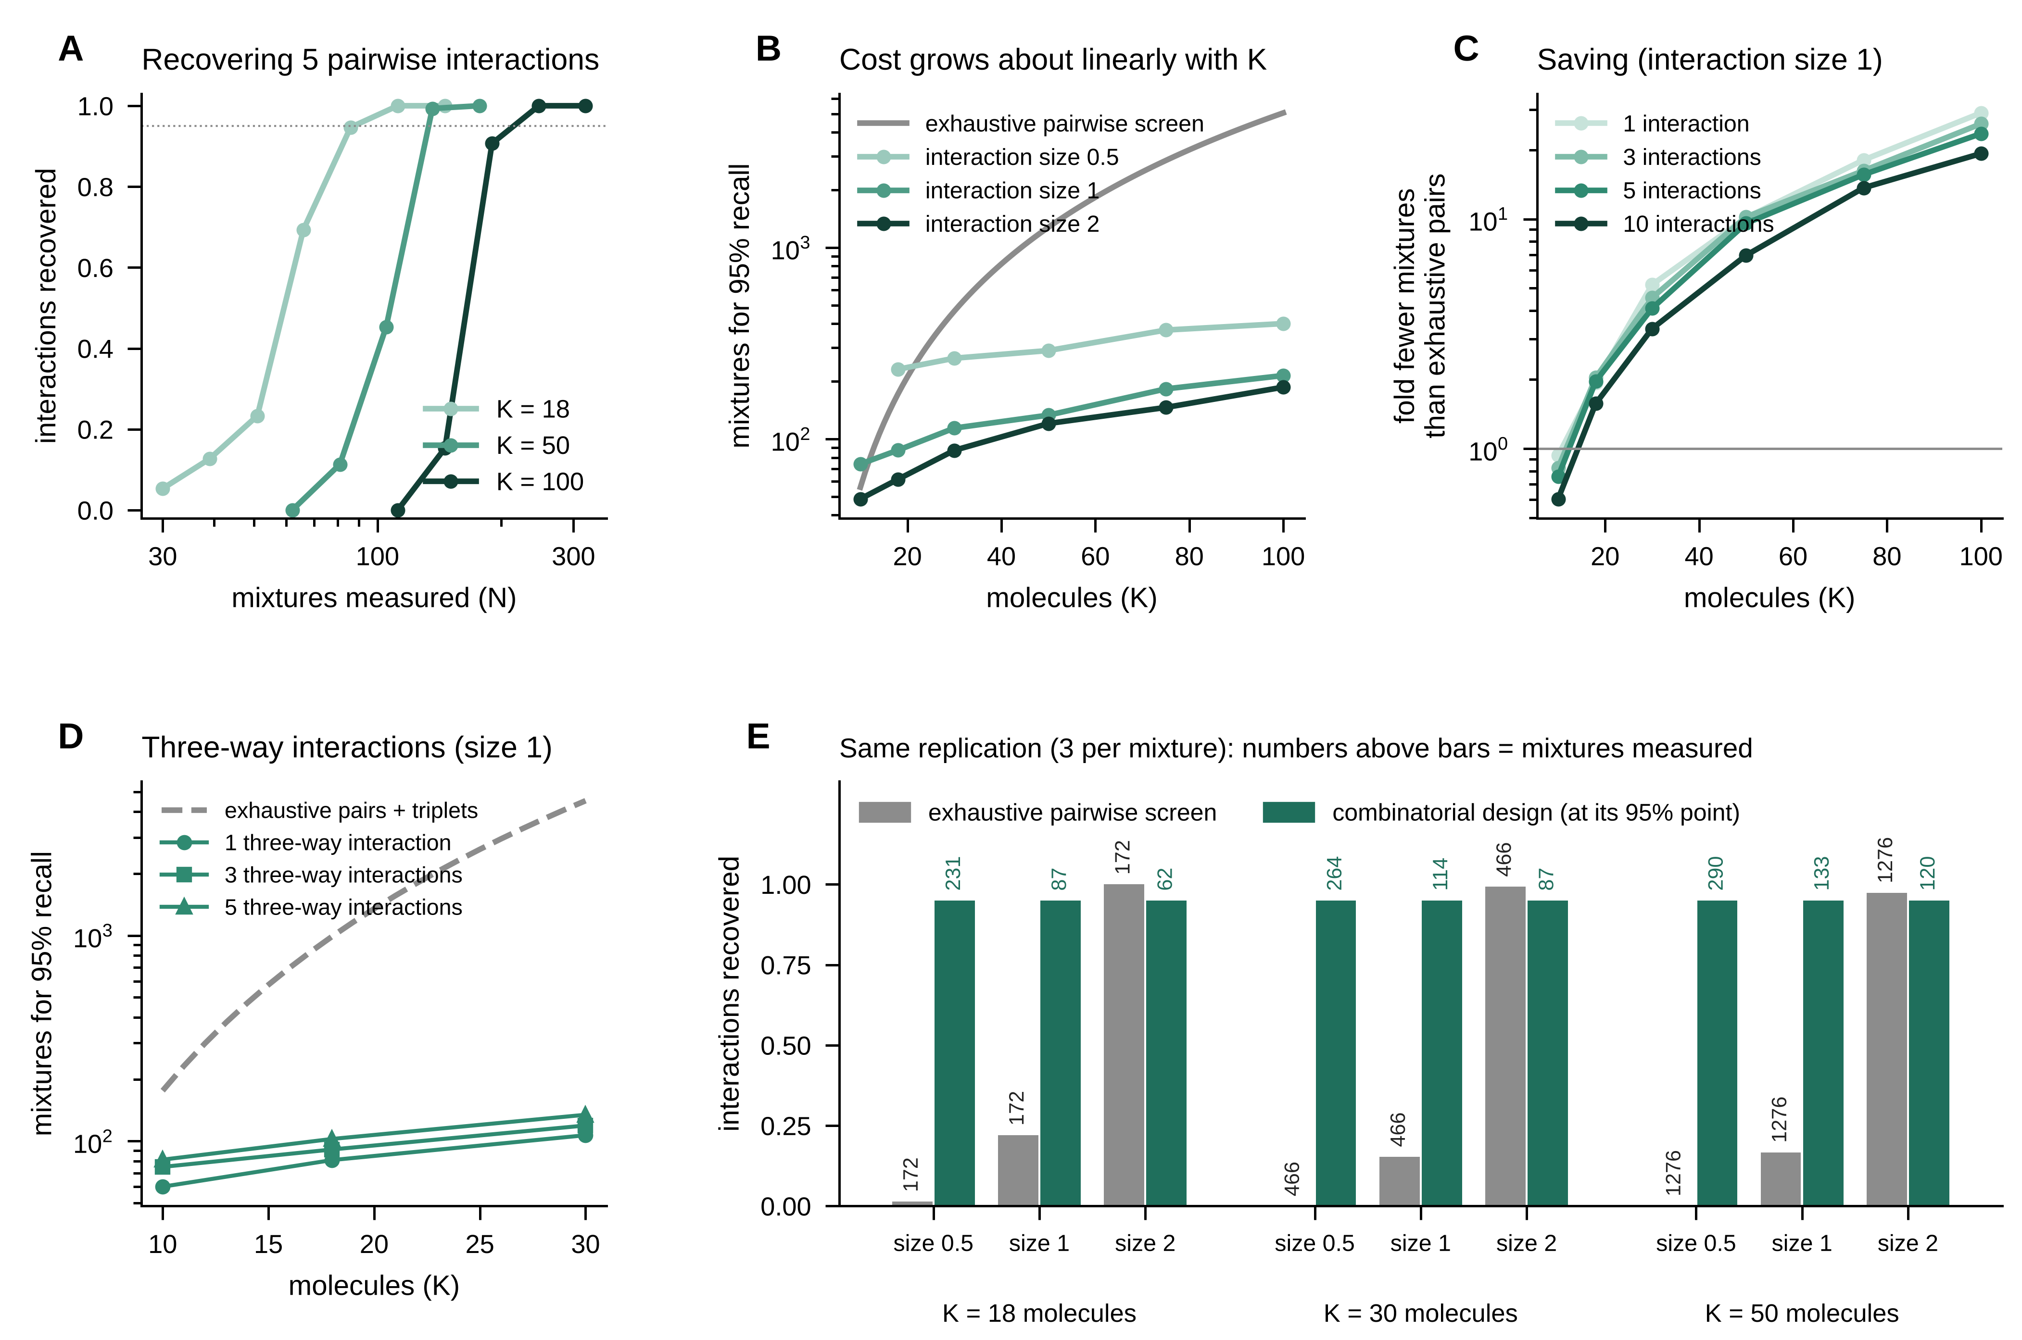
Fig. 2. Simulations with up to 100 molecules.
(A) Fraction of five planted pairwise interactions (size d = 1) recovered as a function of the number of mixtures measured, for 18, 50, and 100 molecules. The dotted line marks 95% recall. (B) Number of mixtures needed for 95% recall of five interactions of size 0.5, 1, or 2, compared with the size of the exhaustive pairwise screen (gray). (C) Fold reduction in the number of conditions relative to the exhaustive pairwise screen, for 1 to 10 interactions of size 1. Values below 1 (K = 10) indicate that the exhaustive screen is smaller. (D) Number of mixtures needed to recover 95% of one to five three-way interactions of size 1, compared with an exhaustive screen of all pairs and triplets (dashed). (E) With the same replication (3 per condition) and the same analysis, the exhaustive pairwise screen (gray) recovers few interactions of size 0.5 or 1, whereas the combinatorial design reaches 95% with far fewer mixtures. Numbers above bars give the number of conditions measured. In all panels, half of the molecules have an effect of their own, a diffuse background of very small interactions is present (total variance 0.1), and results are averages over 30 simulated outputs per point.

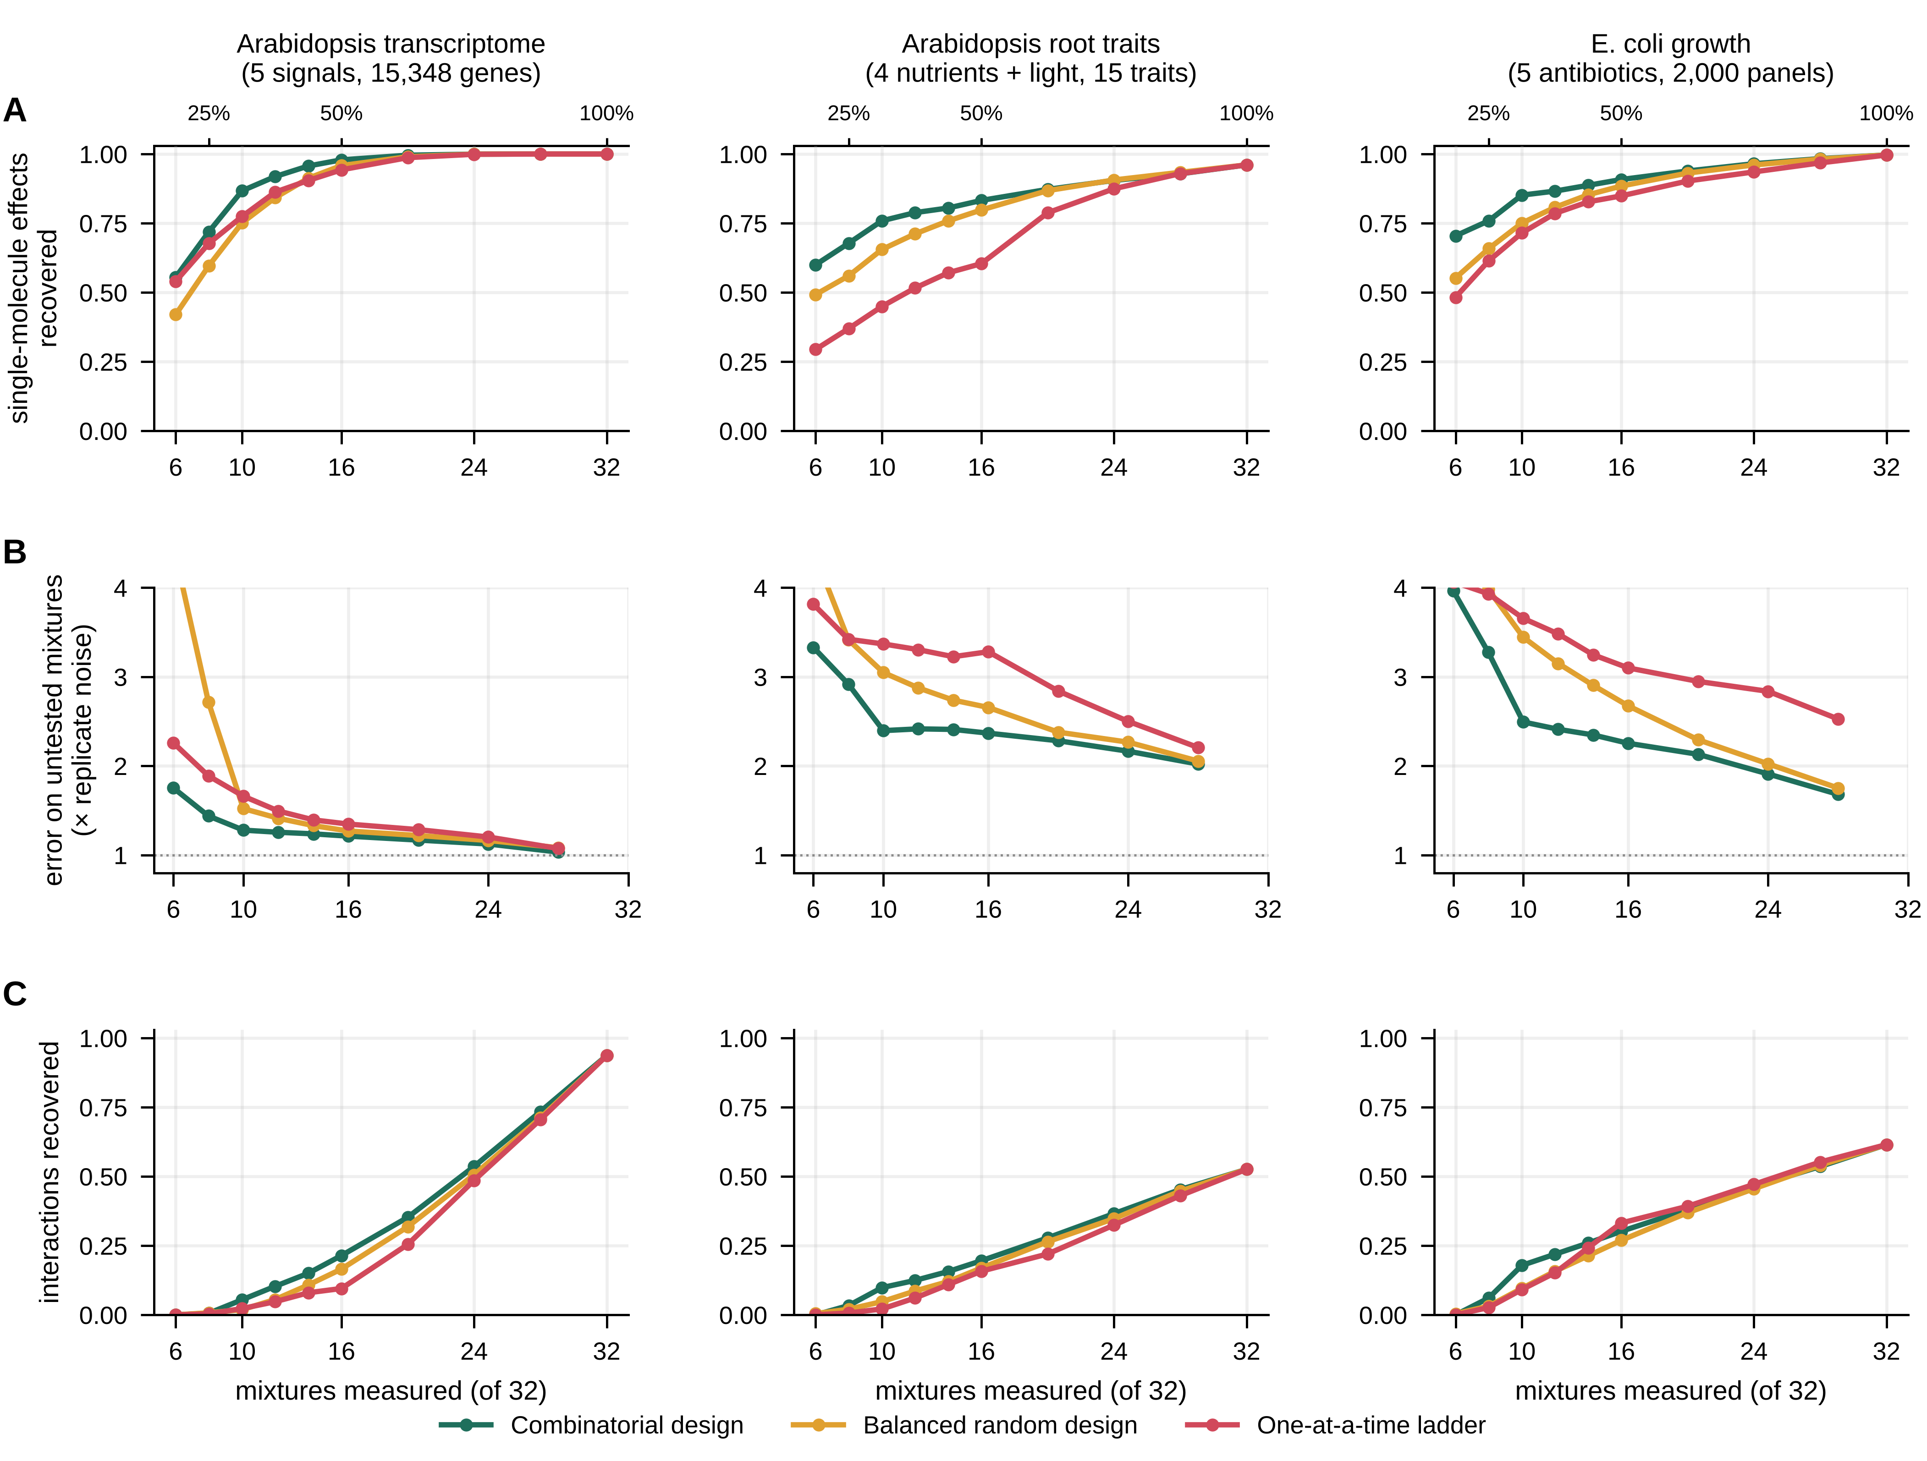
Fig. 3. Benchmark on three real complete factorial experiments.
For each dataset (columns), every one of the 32 mixtures of five factors had been measured, which defines the reference answer. Subsets of 6 to 32 mixtures were analyzed following a combinatorial design (green), a balanced random design (orange), or a one-at-a-time ladder (control, single factors, then pairs, and so on; red). The top axis gives the fraction of the complete design. (A) Fraction of the reference single-factor effects recovered. (B) Error in predicting the mixtures that were not measured, relative to the noise of a measured mixture mean (dotted line, 1). (C) Fraction of the reference interactions (pairs and triplets) recovered. Curves are averages over 30 random draws (transcriptome, bacterial growth) or 20 independent splits of the plants × 5 draws (root traits). Transcriptome, Arabidopsis roots under nitrate, ammonium, auxin, cytokinin, and abscisic acid (15,348 genes) (1); root traits, Arabidopsis under nitrogen, phosphorus, potassium, sulfur, and light (15 traits) (2); bacterial growth, E. coli under five-antibiotic panels (2,000 panels) (5).

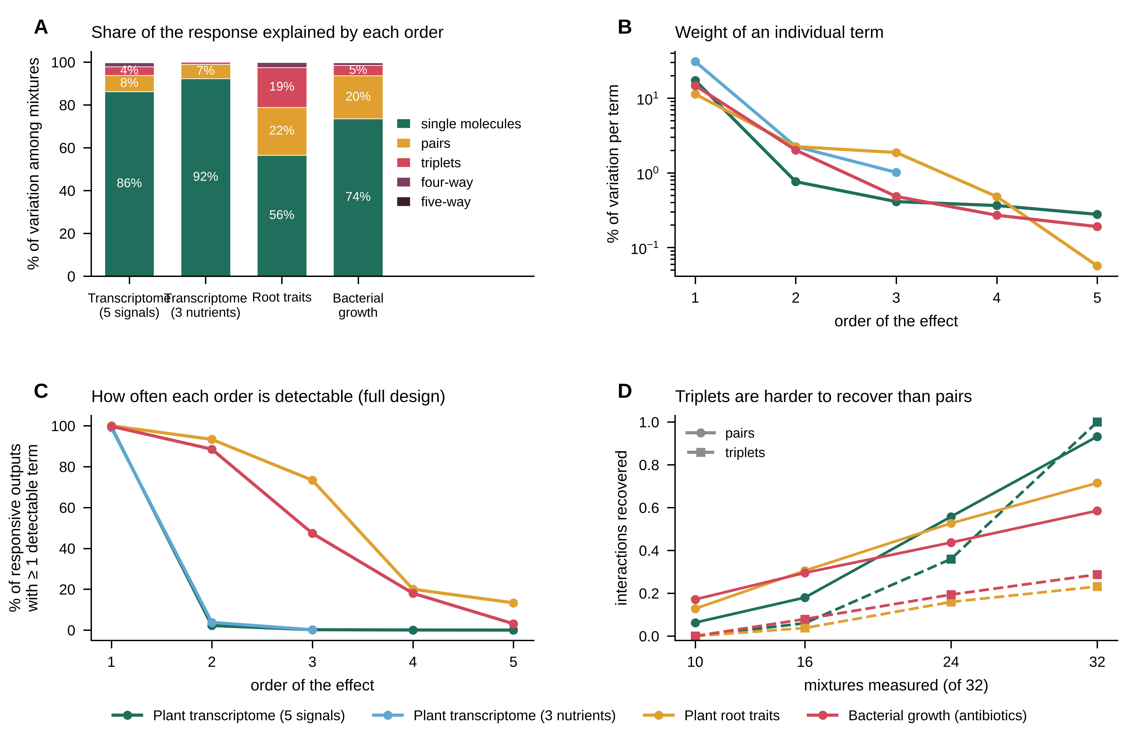
Fig. 4. Interactions among three or more molecules are rare or weak.
(A) Share of the variation among the true mixture means explained by single-factor effects and by interactions of each order, corrected for measurement noise and pooled over responsive outputs. (B) Same quantity divided by the number of possible terms of each order, which gives the average weight of an individual term (log scale). Values for high orders are upper bounds. (C) Percentage of responsive outputs with at least one detectable term of each order in the complete design (false discovery rate 1%). Transcriptome (5 signals), 2,612 responsive genes; transcriptome (3 nutrients), 4,996 genes; root traits, 15 traits; bacterial growth, 10,780 panels. (D) Recovery of pairwise (solid) and three-way (dashed) interactions by the combinatorial design in the benchmark of Fig. 3 (colors as in A–C). The transcriptome contains only five reference three-way interactions.

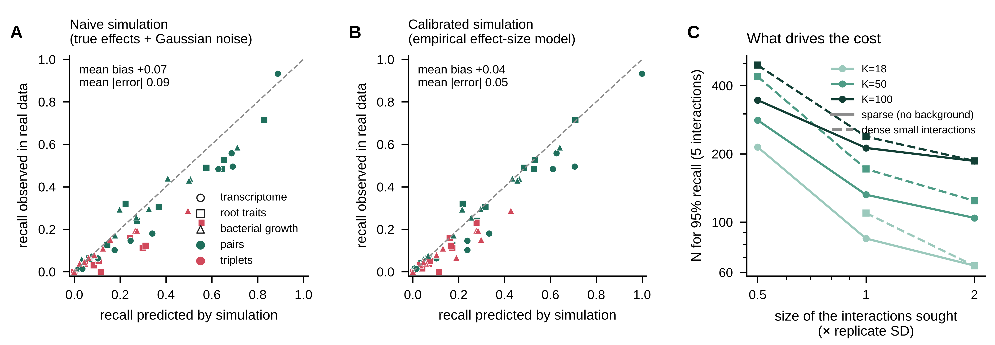
Fig. 5. Calibrating the planning simulations on real data.
(A) Interaction recovery predicted by a naive simulation (significant effects of the complete design plus Gaussian noise) versus recovery observed on real data, for each dataset, design strategy, number of mixtures, and order (green, pairs; red, triplets). Points below the diagonal indicate optimism. (B) Same comparison for the calibrated simulation, in which effects of every order are drawn from the empirical distribution (zero, small, or large) estimated from each dataset. (C) Number of mixtures needed to recover 95% of five interactions as a function of their size, without background (solid) or with a dense background of small interactions as in the phenotypic datasets (dashed), for 18, 50, and 100 molecules. Missing points did not reach 95% within the range simulated.

Supporting Information figure legends (SI Appendix)
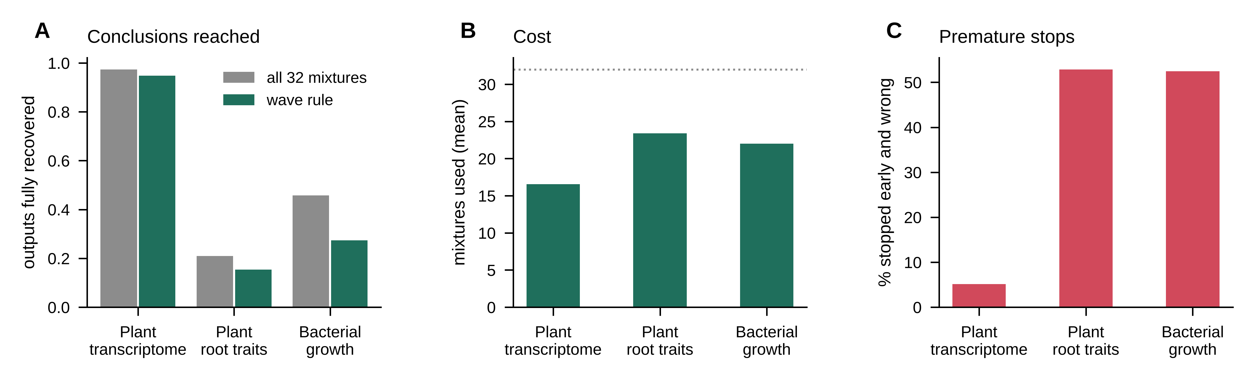
Fig. S1. Experiments in waves.
The combinatorial sequence was measured in waves of 10, 16, 24, and 32 mixtures; after each wave the model predicted the next wave, and the experiment stopped when the prediction error was within 1.5 times the noise. (A) Fraction of outputs for which the complete answer was recovered, with the wave rule (green) or with all 32 mixtures (gray). (B) Average number of mixtures used. (C) Percentage of outputs for which the rule stopped early with an incomplete answer.

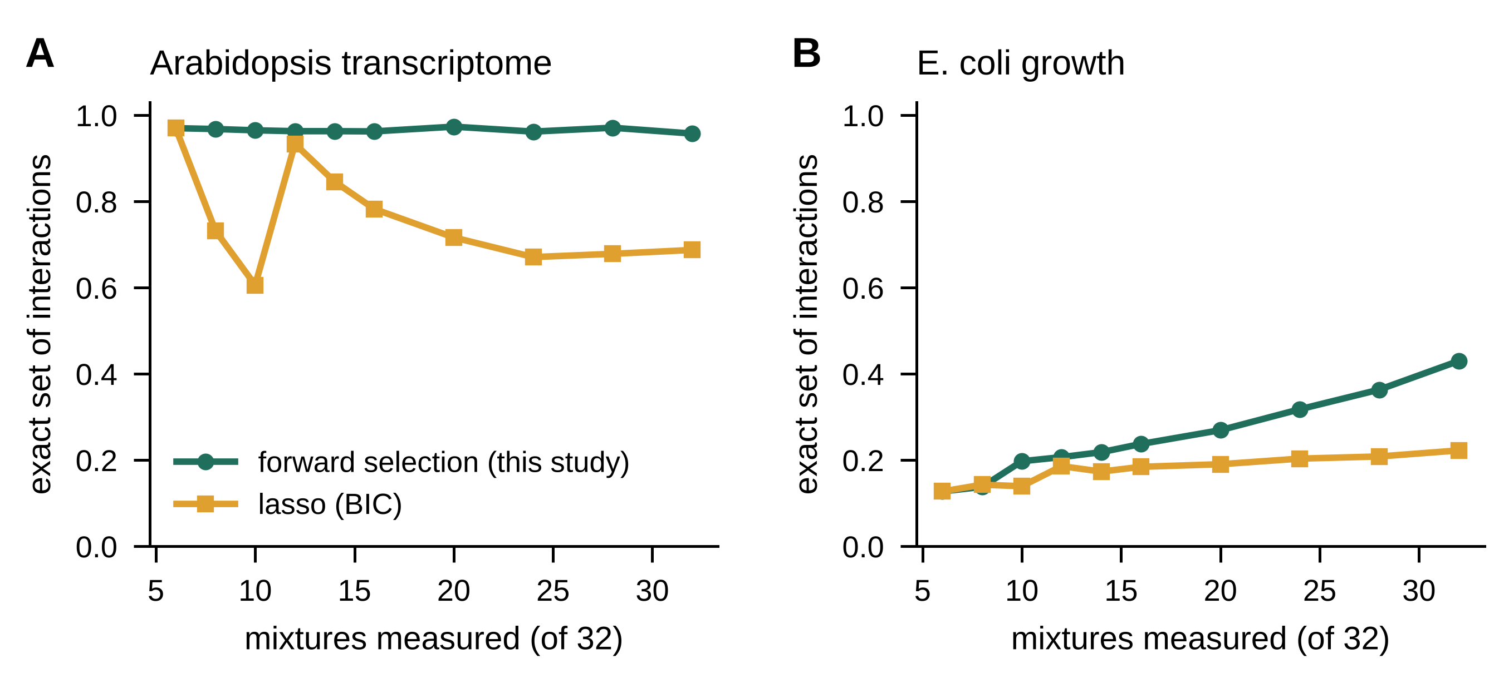
Fig. S2. Forward selection versus lasso.
Fraction of outputs for which the exact set of reference interactions was recovered by the forward-selection analysis used throughout (green) or by a lasso with all pairs and triplets as candidates and the penalty chosen by the Bayesian information criterion (orange), for the combinatorial design. (A) Plant transcriptome (400 outputs with effects). (B) Bacterial growth (400 panels).

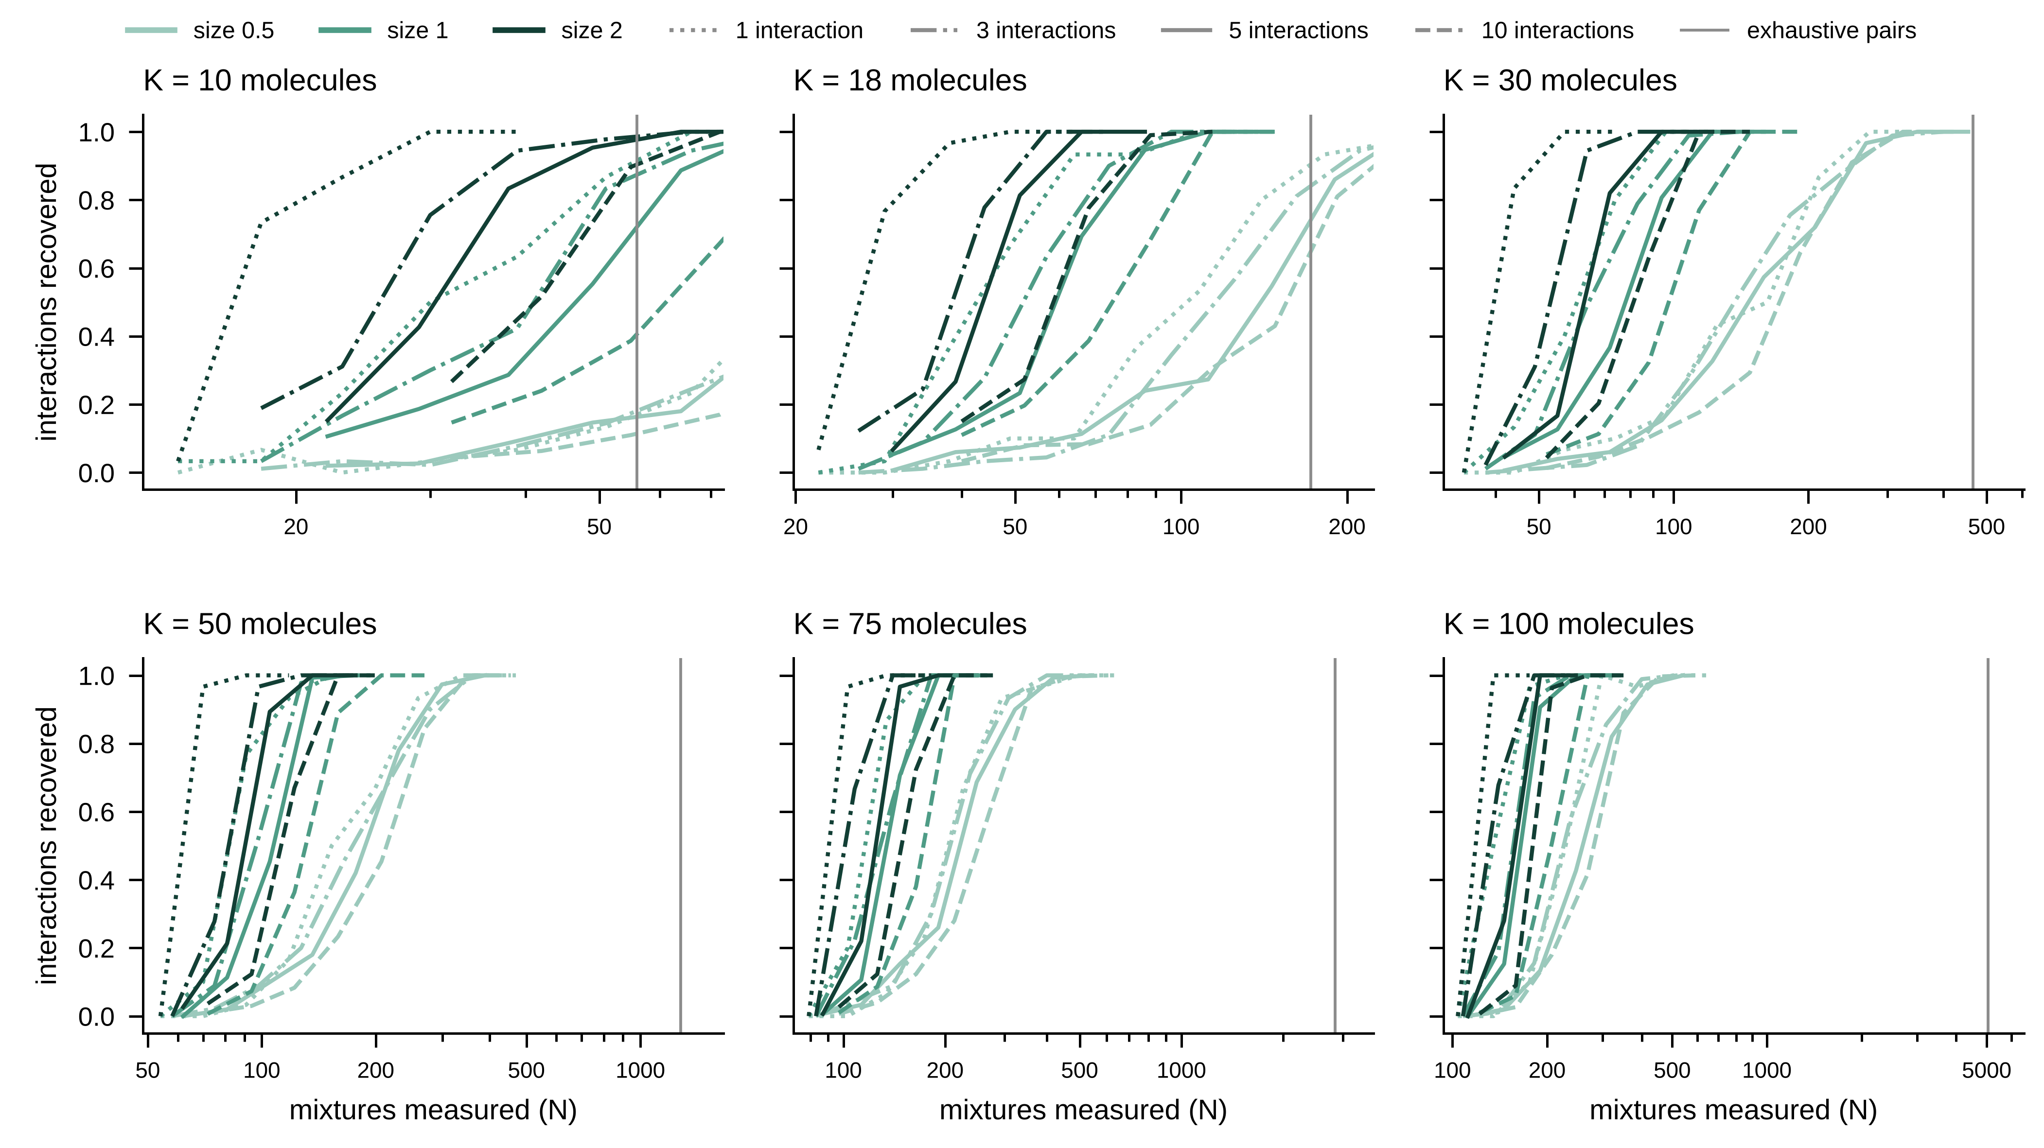
Fig. S3. Recovery curves for all simulated scenarios with pairwise interactions.
Each panel shows one number of molecules K; colors give the size of the interactions and line styles their number. The vertical line marks the size of the exhaustive pairwise screen.

