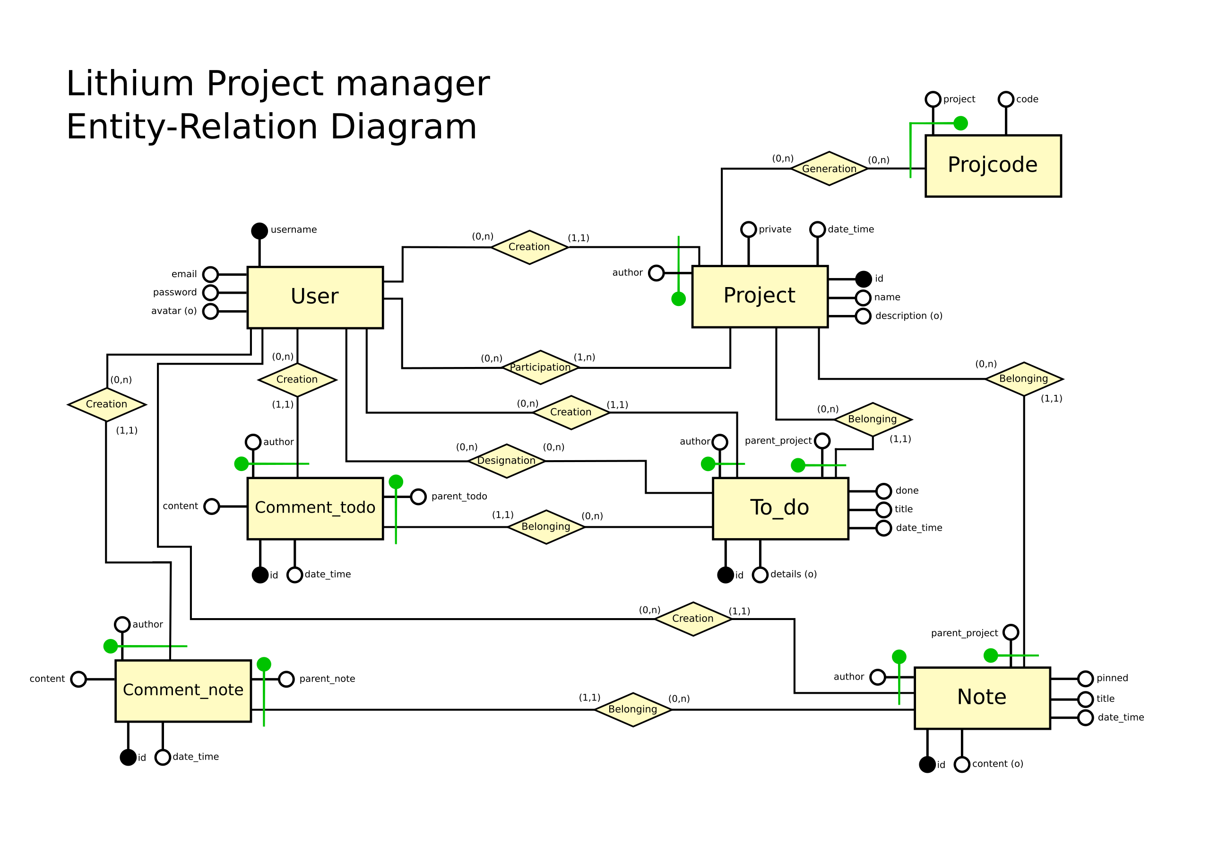

Entities Glossary
Entity | Description | Attributes | Identificator
User | User registered to the Lithium Project Management platform | Username, email, password, avatar | Username
Project | User created instance of a project to manage | Id, author, name, description, private, date_time | Id
To_do | Activity to be done in a project | Id, parent_project, author, title, details, done, date_time | Id
Note | A note containing informations relevant to the project it belongs to | Id, parent_project, title, content, pinned, date_time | Id
Comment_todo | A comment to a To_do instance | Id, content, author, parent_todo, date_time | Id
Comment_note | A comment to a Note instance | Id, content, author, parent_note, date_time | Id

Relations Glossary
Relation | Description | Involved entities | Attributes
Creation | Indicates which user created an entity (ie: any Project has to have been created by a User) | User (0, n)  Project (1, 1)  To_do (1, 1)  Note (1, 1)  Comment_todo (1, 1)  Comment_note (1, 1) | Author
Participation | Indicates the projects a user is participating to | User (0, n)  Project (1, n)
Belonging | Indicates the belonging of an entity to its parent entity (ie: any To_do instance has to belong to a project) | To_do (1, 1)  Project (0, n)  Comment_todo (1,1)  To_do (0, n)  Note (1, 1)  Project (0, n)  Comment_note (1, 1)  Note (0, n) | parent_project  parent_todo  parent_project  parent_note
Designation | Indicates the User(s) designated to accomplish a certain To_do | User (0, n)  To_do (0, n)

Functional dependencies

- User.username → User.password

Restriction Rules

- A project author must be participating said project

Operations

- OP1: Create a new user
- OP2: A user creates a project
- OP3: A user creates a new To_do
- OP4: A user changes (adds, removes) the designation to a To_do
- OP5: A user edits the title/details of a To_do
- OP6: A user creates a comment on a To_do
- OP7: A user completes a To_do
- OP8: A user creates a project Note
- OP9: A user edits a Note
- OP10: A user pins a Note on top
- OP11: A user creates a comment to a Note
- OP12: A user deletes a To_do
- OP13: A user deletes a Note
- OP14: A user leaves a Project
- OP15: A user deletes its Project
- OP16: A user deletes a comment_todo
- OP17: A user deletes a comment_note
- OP18: A user changes the privateness of a project
- OP19: A user kicks another user from his project
- OP20: A user invites another user to his project
- OP21: Show all the To_do entries for a project, showing first the ones with done==False, ordering by date_time
- OP22: Show all the Note entries for a project, showing first the ones with pinned==True, ordering by date_time
- OP23: Show all the partecipants of a project, showing the Project author first.
- OP24: Show the information of a User
- OP25: Show a particular To_do entry, with all the relative comments ordered by date_time
- OP26: Show a particular Note entry, with all the relative comments ordered by date_time
- OP27: Show all the projects started by a particular User
- OP28: Show all the projects that a particular User participates to

