Otieco, Juan Gabriel L.   
2-ECE-B  
Advance Comprog

Experiment 8_Assignment_Panda: Screenshots of Proof

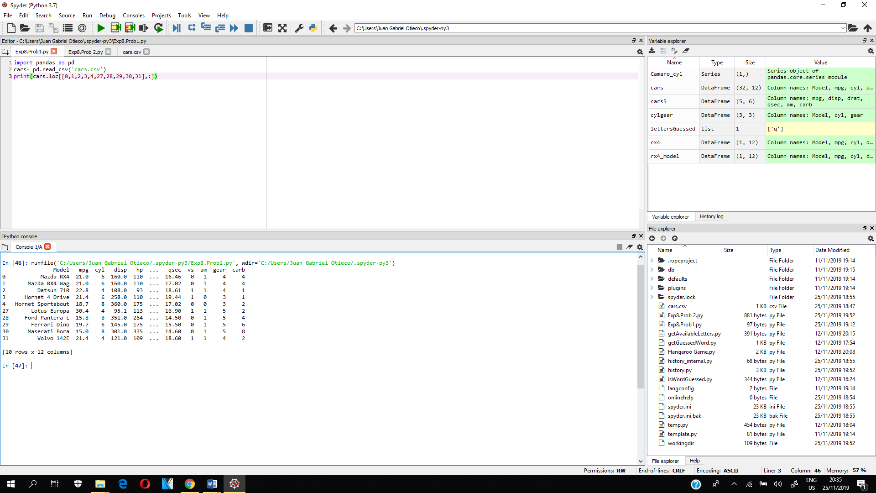PROBLEM 1

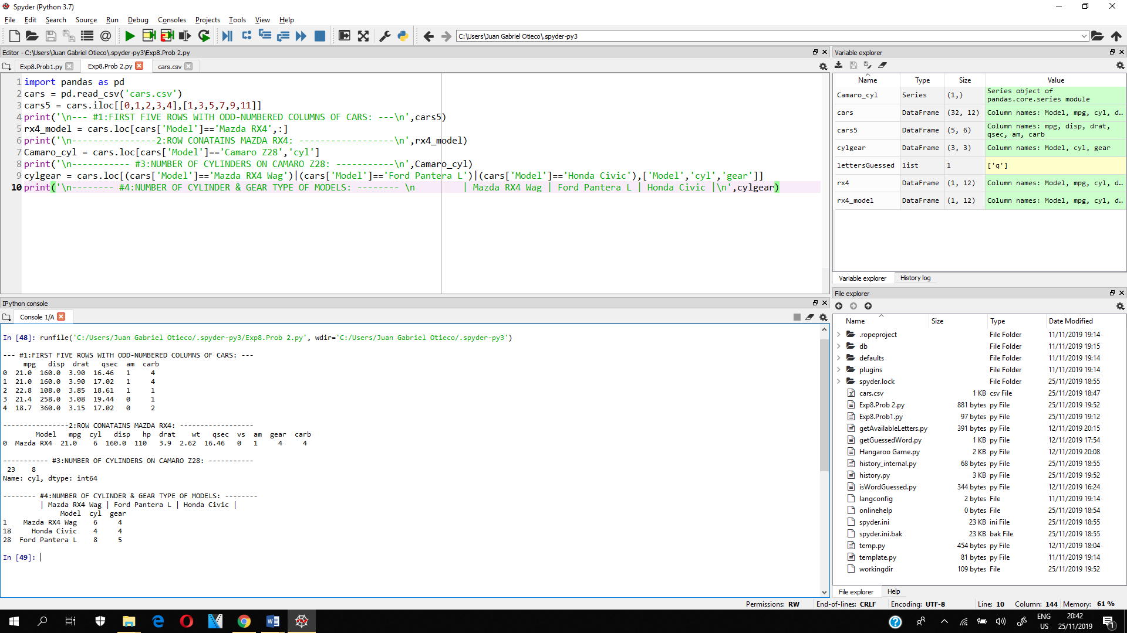PROBLEM 2