**Instituto Politécnico Nacional**

**ESC Superior de Cómputo**

**“EVOLUTIONARY COMPUTING”DNA COMPUTING EXPOSITION**

**Jorge Luis Rosas Trigueros**

Saldaña Aguilar Gabriela

**11/30/16**

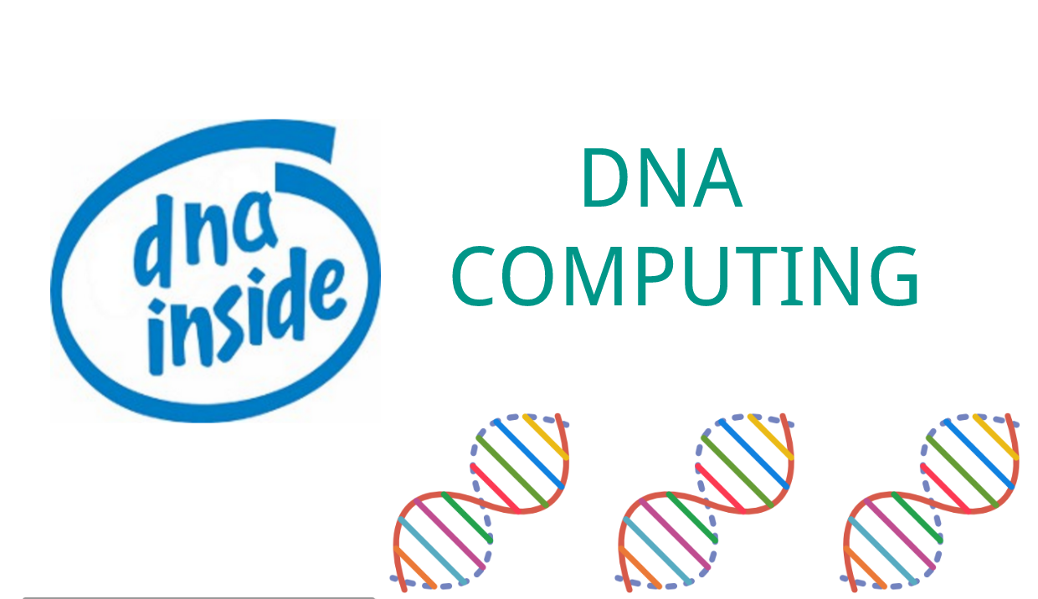

THEORETICAL FRAMEWORK

**DNA COMPUTERS**

Even as you read this article, computer chip manufacturers are furiously racing to make the next [microprocessor](http://computer.howstuffworks.com/microprocessor.htm) that will topple speed records. Sooner or later, though, this competition is bound to hit a wall. Microprocessors made of silicon will eventually reach their limits of speed and miniaturization. Chip makers need a new material to produce faster computing speeds.

You won't believe where scientists have found the new material they need to build the next generation of microprocessors. Millions of natural supercomputers exist inside living organisms, including [your body](http://science.howstuffworks.com/). DNA (deoxyribonucleic acid) molecules, the material our [genes](http://science.howstuffworks.com/life/cellular-microscopic/cell.htm) are made of, have the potential to perform calculations many times faster than the world's most powerful human-built computers. DNA might one day be integrated into a computer chip to create a so-called biochip that will push computers even faster. DNA molecules have already been harnessed to perform complex mathematical problems.

Adleman is often called the inventor of DNA computers. His article in a 1994 issue of the journal [Science](http://www.scienceonline.org/) outlined how to use DNA to solve a well-known mathematical problem, called the directed Hamilton Path problem, also known as the "traveling salesman" problem. The goal of the problem is to find the shortest route between a number of cities, going through each city only once. As you add more cities to the problem, the problem becomes more difficult. Adleman chose to find the shortest route between seven cities.

You could probably draw this problem out on paper and come to a solution faster than Adleman did using his DNA test-tube computer. Here are the steps taken in the Adleman DNA computer experiment:

1. Strands of DNA represent the seven cities. In genes, genetic coding is represented by the letters A, T, C and G. Some sequence of these four letters represented each city and possible flight path.
2. These molecules are then mixed in a test tube, with some of these DNA strands sticking together. A chain of these strands represents a possible answer.
3. Within a few seconds, all of the possible combinations of DNA strands, which represent answers, are created in the test tube.
4. Adleman eliminates the wrong molecules through chemical reactions, which leaves behind only the flight paths that connect all seven cities.

but it took days for Adleman to narrow down the possibilities.

Instead of using electrical signals to perform logical operations, these DNA logic gates rely on DNA code. They detect fragments of genetic material as input, splice together these fragments and form a single output.

For instance, a genetic gate called the "And gate" links two DNA inputs by chemically binding them so they're locked in an end-to-end structure, similar to the way two Legos might be fastened by a third Lego between them.

**DNA COMPUTING**

Catalytic DNA ([deoxyribozyme](https://en.wikipedia.org/wiki/Deoxyribozyme) or DNAzyme) catalyze a reaction when interacting with the appropriate input, such as a matching [oligonucleotide](https://en.wikipedia.org/wiki/Oligonucleotide). These DNAzymes are used to build logic gates analogous to digital logic in silicon; however, DNAzymes are limited to 1-, 2-, and 3-input gates with no current implementation for evaluating statements in series.

The DNAzyme logic gate changes its structure when it binds to a matching oligonucleotide and the fluorogenic substrate it is bonded to is cleaved free. While other materials can be used, most models use a fluorescence-based substrate because it is very easy to detect, even at the single molecule limit. The amount of fluorescence can then be measured to tell whether or not a reaction took place. The DNAzyme that changes is then “used,” and cannot initiate any more reactions. Because of this, these reactions take place in a device such as a continuous stirred-tank reactor, where old product is removed and new molecules added.

Two commonly used DNAzymes are named E6 and 8-17. These are popular because they allow cleaving of a substrate in any arbitrary location. Stojanovic and MacDonald have used the E6 DNAzymes to build the [MAYA I](https://en.wikipedia.org/w/index.php?title=MAYA_I&action=edit&redlink=1)[and [MAYA II](https://en.wikipedia.org/wiki/MAYA_II) machines, respectively; Stojanovic has also demonstrated logic gates using the 8-17 DNAzyme. While these DNAzymes have been demonstrated to be useful for constructing logic gates, they are limited by the need for a metal cofactor to function, such as Zn2+ or Mn2+, and thus are not useful [in vivo](https://en.wikipedia.org/wiki/In_vivo).

A design called a *stem loop*, consisting of a single strand of DNA which has a loop at an end, are a dynamic structure that opens and closes when a piece of DNA bonds to the loop part. This effect has been exploited to create several [logic gates](https://en.wikipedia.org/wiki/Logic_gate). These logic gates have been used to create the computers MAYA I and [MAYA II](https://en.wikipedia.org/wiki/MAYA_II) which can play [tic-tac-toe](https://en.wikipedia.org/wiki/Tic-tac-toe)to some extent.

**HOW DNA WORKS**

Like the one ring of power in Tolkien's "Lord of the Rings," deoxyribonucleic acid (DNA) is the master molecule of every [cell](http://science.howstuffworks.com/life/cellular-microscopic/cell.htm). It contains vital information that gets passed on to each successive generation. It coordinates the making of itself as well as other molecules (proteins). If it is changed slightly, serious consequences may result. If it is destroyed beyond repair, the cell dies.

CONCLUSION

DNA computing is a new way of seeing how problems are solved today, everything has depended on the technology of circuits and its progress, but the last revolution of computers is where they are no longer dependent on materials as silicon, possibly the only problem that remains is that the software can not live without the hardware so the only thing we can do for the moment is simply to improve the hardware, how much? What science allows us to try.

New super materials will be created but they will never reach the perfection of nature.

BIBLIOGRAPHY

Microsoft and University of Washington DNA Storage Research Project - Extended

<http://computer.howstuffworks.com/dna-computer.htm>

<https://en.wikipedia.org/wiki/DNA_computing>