Lab 1: Switching, VLANs, & EtherChannel (Domain 2.0)
- Topology: 2 Access Switches (SW1, SW2) connected via a 2-link bundle to 1 Distribution L3 Switch (DSW1).
- Key Configuration Tasks:
  - Create VLANs 10 (Engineering) and 20 (Sales) on all switches.
  - Configure a 2-port LACP EtherChannel (channel-group 1 mode active) between SW1 and DSW1, and set it as an 802.1Q Trunk.
  - Change the Native VLAN on all trunk links to VLAN 99 and ensure untagged traffic maps correctly.
  - Configure SVIs on DSW1 for VLAN 10 and VLAN 20 to act as inter-VLAN gateways.
Lab 2: Single-Area OSPFv2 & Floating Static Backup (Domain 3.0)
- Topology: 3 Routers (R1, R2, R3) in a triangle topology representing Area 0, plus an ISP router off R1.
- Key Configuration Tasks:
  - Enable router ospf 1 on all 3 routers and assign static Router IDs using loopback addresses (1.1.1.1, 2.2.2.2, 3.3.3.3).
  - Configure passive-interface on all user-facing LAN interfaces so Hello packets are suppressed while connected subnets are advertised.
  - Set R1’s GigabitEthernet interface priority to 255 to ensure it wins the DR election on the shared segment.
  - Configure a primary static default route on R1 pointing to the ISP, and a Floating Static Default Route (`ip route 0.0.0.0 0.0.0.0
Lab 3: First Hop Redundancy Protocol - HSRP (Domain 3.0)
- Topology: 2 Gateway Routers (R1, R2) sharing a LAN segment with host PCs.
- Key Configuration Tasks:
  - Configure HSRP Group 10 on R1 and R2 using virtual IP 192.168.1.254.
  - Make R1 the Active Router by raising its HSRP priority to 110 (standby 10 priority 110) and enabling Preemption (standby 10 preempt).
  - Verify that the virtual MAC address generated matches the HSRPv1 structure (0000.0c07.ac0a).
  - Shut down R1's LAN interface to test automatic failover to R2.
Lab 4: Layer 2 Security & Hardening (Domain 5.0)
- Topology: 1 Access Switch connected to host PCs and an unauthorized rogue switch.
- Key Configuration Tasks:
  - Configure Port Security on access ports: set maximum MAC limit to 2, enable sticky learning, and set the violation mode to restrict (switchport port-security violation restrict).
  - Enable PortFast and BPDU Guard on all access ports (spanning-tree portfast, spanning-tree bpduguard enable).
  - Enable DHCP Snooping globally and on VLAN 10; mark the uplink to the legitimate DHCP server as trusted while leaving host ports untrusted.
  - Enable Dynamic ARP Inspection (DAI) on VLAN 10 (ip arp inspection vlan 10) and verify ARP packets are validated against the DHCP Snooping binding table.
Lab 5: IP Services - PAT Overload & DHCP Relay (Domain 4.0)
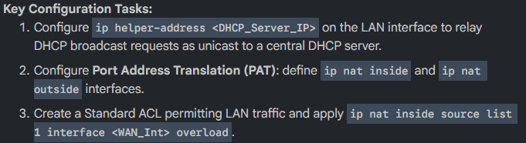
- Topology: Branch Router connected to a internal LAN and an ISP Router.

