Report 01 - Distributions of distances from seed species and its relationships with speciation and duplication events
Moisès Bernabeu & Toni Gabaldón

Here we show the preliminary and exploratory results of the obtained distance between the seed sequence and all tips sequences which Most Recent Common Ancestor (MRCA) was an speciation node. Also we retrieved the number of duplications and speciations events occurred in the comparison lineage.

Yeast phylome
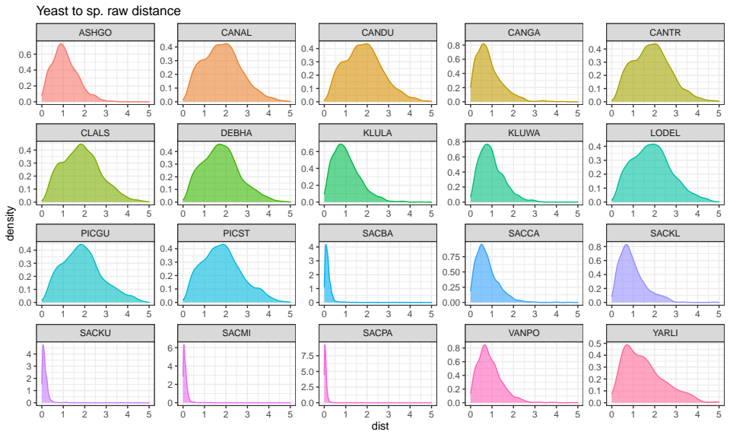

All distributions are skewed to the right, a good fit for this could be a Gamma distribution, this is characterized by 2 parameters (\alpha, \beta) and has a mean \alpha / \beta. Modeling distances as Gamma distributed quantity is interesting to make inferential statistics.

As we can see we distinguish different types of distributions, ones with values around 0 means species which are so close to S. cerevisiae, and wider distributions, these means more distant species. Note that distant species distributions means there is more uncertainty in the distances from the seed, a kind of noise is making these distributions wider, we have trees where Yeast and the tip sequences are so close, otherwise there are extreme distances (around 5) which only occurs in these species. Genetic processes involving horizontal transfer could be involved in these peaks, evolutionary rates of some proteins can be also explaining the behaviour in this short distances.

Note some of wider distributions have a left peak. These corresponds to 8 species mainly from Candida, Pichia, Lodderomyces and Debaryomyces genera. We checked the trees having distances shorter than 1.2 and we obtain that there were 3708 trees from 493 different proteins, and 262 proteins were at the 8 species, these means that there is a core of proteins with shorter distances at these species. We checked these and obtained...

Human phylome
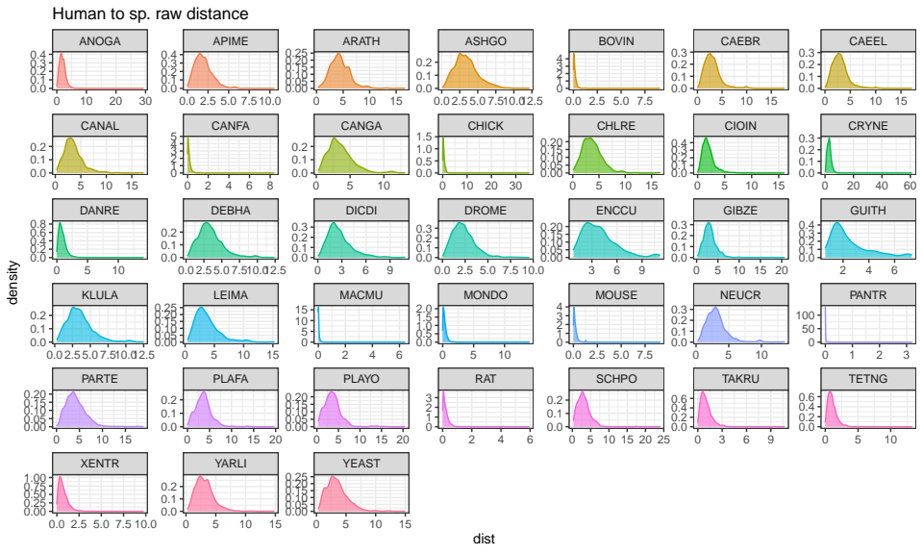

Situation in human phylome is quite similar, distributions are right skewed and there are some of them with medians at shorter values and those with higher medians have higher

