|  |  |
| --- | --- |
| Protfolio of evidence  ST10391534 | wede5020  This assignment equips students with essential skills for web development in a specified field. By the completion of this segment, students will be proficient in identifying key success indicators for a website within a given domain.  Nicol Black  15 November 2023 |

### Bridging the Gap: The Urgency of Affordable Veterinary Care for Impoverished Communities

In the realm of pet ownership, the well-being of our furry companions is paramount. Unfortunately, not all pet owners have the financial means to access emergency veterinary care, a reality that became painfully apparent to me during a harrowing night when my dog, Ash, faced a life-threatening condition. This personal experience ignited my commitment to explore the critical issue of affordable veterinary care for impoverished communities and those residing in low-income housing.

Amid a traumatic incident, Ash, my loyal canine companion, suddenly twisted his gut, necessitating immediate medical attention. Filled with dread, my family and I rushed him to an emergency vet hospital, only to be confronted with an overwhelming financial barrier. The veterinarian informed us that a staggering R4,000 deposit was required upfront to initiate any treatment, and the estimated cost of surgery to save Ash ranged between R20,000 and R30,000. The crushing reality hit us: without the funds, the only option presented was euthanasia.

As an 18-year-old residing in a single-income household provided by my mother, the financial strain was unbearable. Desperation set in as I pleaded, borrowed, and scraped together enough funds for the exorbitant deposit. It was a gut-wrenching decision, forcing us to grapple with the unthinkable choice of whether Ash's life was worth the astronomical cost.

Amid this heart-wrenching ordeal, a beacon of hope emerged in the form of a non-profit animal organization. We were astounded to discover that the cost of surgery and treatment at this facility was significantly less than the deposit demanded by the previous vet hospital. The financial burden lifted, we proceeded with the necessary treatment, saving Ash from the brink of euthanasia.

This transformative experience illuminated the stark disparities in access to veterinary care based on economic circumstances. It prompted me to delve into the broader issue, recognizing that countless families faced similar dilemmas.

Motivated by this, I have chosen to focus my assignment on creating a website dedicated to a vet clinic that caters to impoverished communities and low-income housing. The objective is to provide a centralized platform where pet owners facing financial constraints can easily locate an affordable veterinary care option. This website aims to bridge the gap between those in need and compassionate veterinary services, ensuring that no family is forced to make a heartbreaking decision based on financial constraints.

In conclusion, my commitment to addressing the disparities in veterinary care access stems from a personal journey with Ash. Through the creation of a website, I aspire to empower pet owners in underserved communities, offering a resource that can alleviate the financial stress associated with critical veterinary care decisions and, ultimately, save the lives of cherished animal companions.

### Improvements Part 2:

**External Stylesheet:**

Before: In the first code, styles were applied using inline styles within the HTML document.

After: The second code uses an external stylesheet (style.css), promoting better code organization and separation of concerns.

**Navigation Bar Enhancement:**

Before: The first code had a simple navigation structure without much styling.

After: The second code includes a styled navigation bar with a more visually appealing layout.

**Mission Section:**

Before: The first code didn't have a specific section for the mission.

After: The second code introduces a mission section, making the webpage structure clearer.

**Use of Font Awesome:**

After: The second code includes the use of Font Awesome for icons, enhancing the visual appeal of the webpage.

**Footer Styling:**

After: The second code improves the styling of the footer with a background colour.

These improvements contribute to better code organization, visual appeal, and overall user experience on the webpage.

**New Sections:**

### Improvements Final:

**Meta Tags for SEO:**

The second code includes additional meta tags in the head section. These meta tags provide information about the webpage for search engines, such as a description, keywords, and revisit information. This can improve the site's search engine optimization (SEO) and make it more discoverable.

**Improved Alt Text in Images:**

In the second code, the images in the gallery section have improved alt text that provides more meaningful descriptions. Alt text is essential for accessibility and SEO.

**Newsletter Section:**

The second code includes a new section for a newsletter with an embedded Google Form. This allows users to subscribe to the newsletter, providing a way for the website to engage with its audience.

**Improved Image Paths:**

While not directly visible in the code, the file paths for images and other resources are correct and updated in the second code. This ensures that all resources are properly linked and displayed.

These improvements contribute to better SEO, accessibility, and user engagement on the website.

**Form Enhancements:**

The form in the second code includes additional input fields such as "Type of animal" and makes the "Name" and "Reason" fields required, enhancing the user interaction and providing more detailed information.

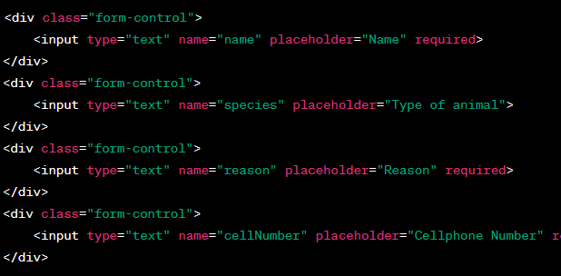

**Introduction of Lightbox CSS and JavaScript:**

