* augmented reality applied to medical devices
  + Improvements the app needed:
    - Difficult to use app whilst image vibrated
    - Touch zoom function was unavailable
    - Ability to keep using the app while not focusing on object
* Potentials of Augmented Reality in Training
  + Data on demand provided
    - Situation specific
    - Enriching real time situations
  + Practice oriented learning
  + Frame depends on context in which they’re used
  + Learning objectives due to digitalization
    - Training of workflow
    - Training of decision making
    - Training of problem solving
  + Training on the job
  + Training near the job
* Innovative Food Science and Emerging Technologies
  + Sensory evaluation
  + Sensory perception and consumer behaviour
  + AR + VR with potential to transform landscape for collecting and processing sensory and consumer information
  + Ar effect on the food industry
  + VR is more immersive and brings up more feelings within a user
  + 360 VR limited
    - Cannot explore around and interact
* Robotics and Computer Integrated Manufacturing
  + indicate that AR supported tasks are more efficient in terms of task completion time and error rates [4–7]. However, it has been found that the increase in performance through AR depends on the complexity and nature of the task [5,8].
  + Technology adaption and implementation models
    - TOE
      * 3 elements
        + Org context
        + Env context
        + Tech context
  + Pilot studies are part of a sound system configuration
  + Hypothesis 1
    - System config is +vly associated with the impl success of AR systems
  + Hypothesis 2
    - Tech readiness is +vly associated with the impl success of AR systems
  + Hypothesis 3
    - Tech compatibility is +vly associated with the impl success of AR systems
  + Research model and hyp based on TOE framework
    - Tech context
      * Sys config
      * Tech hardware readiness
      * Tech compatibility
    - Env context
      * External support
    - Org context
      * Org fit
      * Use barrier
  + Hypothesis 6
    - User barrier is -vly assoc with the impl success of AR systems
* Towards augmented reality manuals for industry
  + 4th industrial revolution
    - Internet of things
  + 6 design principles to implement industry 4.0 in their factories
    - Interoperability
      * Internet of things + internet of service
    - Virtualization
      * Virtual copy of physical world
    - Decentralization
      * Knowledge not central
      * Technical doc can be prod by any cps
    - Real time capability
      * Data collected and analysed in real time
    - Service orientation
      * Plants of the future based on a service-oriented architecture
    - Modularity
  + Nowadays digital manual have a lot of pictures
    - Use ar to make these pictures lively
  + Possibility to convert technical doc to AR
    - System generates interactive AR presentations from 2d doc as a collection of images and a 3d cad model of the target object.
      * Solution limitations
        + Propagation of post estimation errors
        + Extraction of invisible elements + small ones
  + Methodology proposed to manage existing technical instructions for their use in visual manuals
    - Read and analyse the instruction
    - Chunk the instruction
    - Categorize the instruction
    - Apply the suggested action/s
      * concepts
        + Eliminate useless details
        + Use descriptive images
        + Use ste
      * Tasks
        + Steps

Use annotated images

Use graphic symbols

* + - * + Descriptions

Use ste

* + - * References
        + Use descriptive images
        + Use ste
        + Use tables
    - Organize information using im principles
  + Improve readability of text instructions
    - Controlled Natural Languages
      * Uses a well defined subset of a language’s grammar and lexicon
      * Adds terminology needed in a technical domain
  + Principles of info mapping for development of a digital manual on screen
    - Chunking
    - Relevance
      * One relevant point should be covered in each unit
    - Labelling
    - Consistency
    - Integrated graphics
    - Accessible detail
    - Hierarchy
* General Requirements for Industrial Augmented Reality Applications
  + Industrial AR apps are expected to perform well in the following areas
    - Product-design
    - Plant-design
    - Training
    - Product assistance
    - Quality assurance
    - Production logistics
    - Remote maintenance
    - Cost-effectiveness
    - Data security
    - Applicable regulations
  + Requirements during set-up
    - Set-up time
      * Time to set up ar apps should be minimal
    - System reliability
      * Apps require minimal maintenance and be reliable as possible
  + Requirements during operation
    - Accuracy of presentation
    - Real time capability
    - Ergonomy
  + Ar based assistance system for wind energy technicians
    - Ar maintenance system architecture
      * 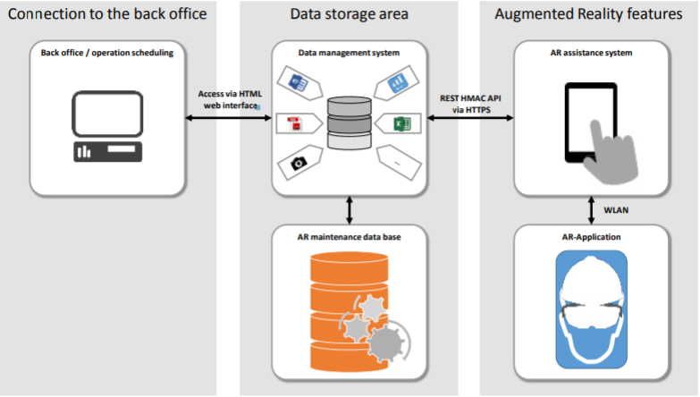
    - Ar assistance system: Fulfilllment of general requirements
      * 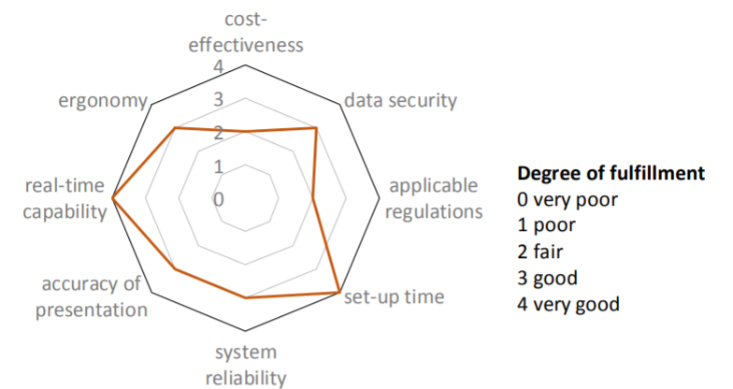
  + Augmented Reality training simulators for welders
    - 